4A Distant Learning:4th May to 8th May

Hello 4A!
I hope you have all had a good couple of weeks and managed to make the most of the sunshine in your garden! It was so lovely to speak to you all last week and I really enjoyed hearing what you have been up to! You all sounded so positive and I was very impressed with your commitment to learning at home! Keep up the great work!
This unit of work is for the next week only, which takes us up to the end of the 3 week extended lockdown. If you would like to further your learning, I highly recommend online BBC Bitesize daily lessons. This is a wonderful resource which may teach new concepts but also revisits previously learned material and is a great way to refresh our knowledge whilst on lockdown. Find your year group on https://www.bbc.co.uk/bitesize/dailylessons
Stay safe and I look forward to the day we meet again!
Mrs Allen

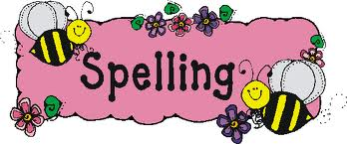

Literacy
On 22nd April, it was Earth Day. This links in nicely with our new RE Topic. Under 4A Distant Learning, you will see the link ‘Earth Day reading comprehension’. Can you read the text and answer the questions alongside it? Remember to underline the answer in the text to help you.
There are 3 different versions available; 1 star, 2 stars and 3 stars. You will find the stars at the bottom of the pages. It is your choice which one you complete, with the 3 star text and comprehension being the most challenging. I have also included the answers, which you might like to give to your parents to mark your answers.
Spellings

Please spend time learning the Year 3 and 4 National Curriculum spelling list which you will find in the front of your reading planners. Can you find these words in a dictionary and write a sentence for each word?

Reading
We read in class every day, so it would be really nice if you could spend some time every day reading a book. This can be a home book, a newspaper, magazine or anything alike. Do not forget to record this in your reading record.
It would also be good practise to complete some book reviews in the back of you reading record.

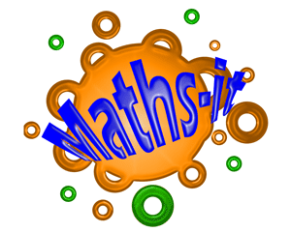
Extras
May is National Walking Month. Can you keep a diary of when you go for a walk and how far you think you have walked? It will be really fun when we get back to school to share how far you think you have walked during lockdown!

Maths
Please see ‘Maths’ information page, which explains your daily tasks.
Times Tables
I have provided you with the times tables test you complete weekly in school. Once you have completed and scored full marks on the multiplication sheet in 5 minutes then you can move onto the division sheet. You have 5 minutes to complete as many as you can, column by column. You could also have a look on the times tables page for websites to help you.
RE
Our new RE topic this term is ‘Beautiful world, wonderful God’. We will be exploring the meanings in the creation stories of the Bible, the impact of believing in God and showing appreciation for the natural world. See the grid below for some project based ideas.

Times Table Activities

https://play.ttrockstars.com/auth/school - Times Table Rock Stars is a great way to practise your times tables
https://play.edshed.com/ - Practise your times tables
https://www.timestables.co.uk/ - learn and practise
https://www.topmarks.co.uk/maths-games/7-11-years/times-tables
https://www.oxfordowl.co.uk/for-home/maths/help-with-times-tables/ -
https://www.themathsfactor.com/times-tables-check/#/- A Times Tables Check in the same format the Multiplication Test will be.

Maths Activities

Please continue to complete your daily maths lesson, using the White Rose resources from the website I provided you with on the last work sent out. You should now be ready to move onto ‘Summer term- Week 3 (w/c 4th May)’.
Each day, there will be a short video of a lesson to watch, then try your best to complete the activity. We have completed a few of these worksheets in class so they should be familiar to you. Don’t worry if you can’t print out the worksheet, just write your answers on a piece of paper or in a notebook. You’ll also have an answer sheet to check your work – you might like to ask Mum or Dad to do that for you (but only if they’re not busy working!).
Follow this link to find your daily lessons and follow the instructions on the website: https://whiterosemaths.com/homelearning/year-4/
In addition to this, Mathletics activities will be set.

Extra Maths Games
https://play.prodigygame.com/ - Pokemon style game with maths questions!
https://play.edshed.com/ - practise your number bonds, power of 10 and addition and subtraction
www.topmarks.co.uk –interactive games
https://www.oxfordowl.co.uk/for-home/kids-activities/fun-maths-games-and-activities/#maths-7-9 – games and activities
https://www.mathswithparents.com/KWeb?startTime=1584558592239#menu584883 – Free access to parents – videos and activities across the maths curriculum.
2x table |  | 5x table |  | 10x table |  | 3x table |  | 4x table |  | 8x table
1 x 2 = |  | 3 x 5 = |  | 2 x 10 = |  | 4 x 3 = |  | 3 x 4 = |  | 2 x 8 =
6 x 2 = |  | 8 x 5 = |  | 6 x 10 = |  | 10 x 3 = |  | 1 x 4 = |  | 10 x 8 =
10 x 2 = |  | 11 x 5 = |  | 8 x 10 = |  | 1 x 3 = |  | 9 x 4 = |  | 8 x 8 =
2 x 2 = |  | 2 x 5 = |  | 3 x 10 = |  | 5 x 3 = |  | 7 x 4 = |  | 1 x 8 =
4 x 2 = |  | 4 x 5 = |  | 7 x 10 = |  | 9 x 3 = |  | 2 x 4 = |  | 5 x 8 =
5 x 2 = |  | 6 x 5 = |  | 10 x 10 = |  | 6 x 3 = |  | 12 x 4 = |  | 7 x 8 =
7 x 2 = |  | 10 x 5 = |  | 4 x 10 = |  | 2 x 3 = |  | 8 x 4 = |  | 9 x 8 =
12 x 2 = |  | 1 x 5 = |  | 11 x 10 = |  | 11 x 3 = |  | 11 x 4 = |  | 3 x 8 =
3 x 2 = |  | 5 x 5 = |  | 9 x 10 = |  | 8 x 3 = |  | 5 x 4 = |  | 6 x 8 =
8 x 2 = |  | 9 x 5 = |  | 1 x 10 = |  | 12 x 3 = |  | 10 x 4 = |  | 11 x 8 =
11 x 2 = |  | 12 x 5 = |  | 12 x 10 = |  | 3 x 3 = |  | 6 x 4 = |  | 4 x 8 =
9 x 2 = |  | 7 x 5 = |  | 5 x 10 = |  | 7 x 3 = |  | 4 x 4 = |  | 12 x 8 =
Total: |  | Total: |  | Total: |  | Total: |  | Total: |  | Total:
6 x table |  | 7 x table |  | 9 x table |  | 11 x table |  | 12 x table
2 x 6 = |  | 2 x 7 = |  | 1 x 9 = |  | 4 x 11 = |  | 3 x 12 =
6 x 6 = |  | 10 x 7 = |  | 6 x 9 = |  | 10 x 11 = |  | 1 x 12 =
8 x 6 = |  | 8 x 7 = |  | 10 x 9 = |  | 1 x 11 = |  | 9 x 12 =
3 x 6 = |  | 1 x 7 = |  | 2 x 9 = |  | 5 x 11 = |  | 7 x 12 =
7 x 6 = |  | 5 x 7 = |  | 4 x 9 = |  | 9 x 11 = |  | 2 x 12 =
10 x 6 = |  | 7 x 7 = |  | 5 x 9 = |  | 6 x 11 = |  | 4 x 12 =
4 x 6 = |  | 9 x 7 = |  | 7 x 9 = |  | 2 x 11 = |  | 8 x 12 =
11 x 6 = |  | 3 x 7 = |  | 12 x 9 = |  | 3 x 11 = |  | 11 x 12 =
9 x 6 = |  | 6 x 7 = |  | 3 x 9 = |  | 8 x 11 = |  | 5 x 12 =
1 x 6 = |  | 11 x 7 = |  | 8 x 9 = |  | 12 x 11 = |  | 10 x 12 =
12 x 6 = |  | 4 x 7 = |  | 11 x 9 = |  | 11 x 11 = |  | 6 x 12 =
5 x 6 = |  | 12 x 7 = |  | 9 x 9 = |  | 7 x 11 = |  | 12 x 12 =
Total: |  | Total: |  | Total: |  | Total: |  | Total:

2÷ table |  |  | 5÷ table |  |  | 10÷ table |  |  | 3÷ table |  | 4÷ table |  |  | 8÷ table
2÷2 = |  |  | 15 ÷ 5 = |  |  | 20 ÷ 10 = |  |  | 12 ÷ 3 = |  | 12 ÷ 4 = |  |  | 16 ÷ 8 =
12÷ 2 = |  |  | 40 ÷ 5 = |  |  | 60 ÷ 10 = |  |  | 30 ÷ 3 = |  | 4 ÷ 4 = |  |  | 80 ÷ 8 =
20 ÷ 2 = |  |  | 55 ÷ 5 = |  |  | 80 ÷ 10 = |  |  | 3 ÷ 3 = |  | 36 ÷ 4 = |  |  | 64 ÷ 8 =
2 ÷ 2 = |  |  | 10 ÷ 5 = |  |  | 30 ÷ 10 = |  |  | 15 ÷ 3 = |  | 28 ÷ 4 = |  |  | 8 ÷ 8 =
8 ÷ 2 = |  |  | 20 ÷ 5 = |  |  | 70 ÷ 10 = |  |  | 27 ÷ 3 = |  | 8 ÷ 4 = |  |  | 40 ÷ 8 =
10 ÷ 2 = |  |  | 30 ÷ 5 = |  |  | 10 ÷ 10 = |  |  | 18 ÷ 3 = |  | 48 ÷ 4 = |  |  | 56 ÷ 8 =
14 ÷ 2 = |  |  | 50 ÷ 5 = |  |  | 40 ÷ 10 = |  |  | 6 ÷ 3 = |  | 32 ÷ 4 = |  |  | 72 ÷ 8 =
24 ÷ 2 = |  |  | 5 ÷ 5 = |  |  | 110 ÷ 10 = |  |  | 33 ÷ 3 = |  | 44 ÷ 4 = |  |  | 24 ÷ 8 =
6 ÷ 2 = |  |  | 25 ÷ 5 = |  |  | 90 ÷ 10 = |  |  | 24 ÷ 3 = |  | 20 ÷ 4 = |  |  | 48 ÷ 8 =
16 ÷ 2 = |  |  | 45 ÷ 5 = |  |  | 10 ÷ 10 = |  |  | 36 ÷ 3 = |  | 40 ÷ 4 = |  |  | 88 ÷ 8 =
22 ÷ 2 = |  |  | 60 ÷ 5 = |  |  | 120 ÷ 10 = |  |  | 9 ÷ 3 = |  | 24 ÷ 4 = |  |  | 32 ÷ 8 =
18 ÷ 2 = |  |  | 35 ÷ 5 = |  |  | 50 ÷ 10 = |  |  | 21 ÷ 3 = |  | 16 ÷ 4 = |  |  | 96 ÷ 8 =
Total: |  |  | Total: |  |  | Total: |  |  | Total: |  | Total: |  |  | Total:
6 ÷ table |  | 7 ÷ table |  |  | 9 ÷ table |  |  | 11 ÷ table |  |  |  | 12 ÷ table
12 ÷ 6 = |  | 14 ÷ 7 = |  |  | 9 ÷ 9 = |  |  | 44 ÷ 11 = |  |  |  | 36 ÷ 12 =
36 ÷ 6 = |  | 70 ÷ 7 = |  |  | 54 ÷ 9 = |  |  | 110 ÷ 11 = |  |  |  | 12 ÷ 12 =
48 ÷ 6 = |  | 56 ÷ 7 = |  |  | 90 ÷ 9 = |  |  | 11 ÷ 11 = |  |  |  | 108 ÷ 12 =
18 ÷ 6 = |  | 7 ÷ 7 = |  |  | 18 ÷ 9 = |  |  | 55 ÷ 11 = |  |  |  | 84 ÷ 12 =
42 ÷ 6 = |  | 35 ÷ 7 = |  |  | 36 ÷ 9 = |  |  | 99 ÷ 11 = |  |  |  | 24 ÷ 12 =
60 ÷ 6 = |  | 49 ÷ 7 = |  |  | 45 ÷ 9 = |  |  | 66 ÷ 11 = |  |  |  | 48 ÷ 12 =
24 ÷ 6 = |  | 63 ÷ 7 = |  |  | 63 ÷ 9 = |  |  | 22 ÷ 11 = |  |  |  | 96 ÷ 12 =
66 ÷ 6 = |  | 21 ÷ 7 = |  |  | 108 ÷ 9 = |  |  | 33 ÷ 11 = |  |  |  | 132 ÷ 12 =
54 ÷ 6 = |  | 42 ÷ 7 = |  |  | 27 ÷ 9 = |  |  | 88 ÷ 11 = |  |  |  | 60 ÷ 12 =
6 ÷ 6 = |  | 77 ÷ 7 = |  |  | 72 ÷ 9 = |  |  | 132 ÷ 11 = |  |  |  | 120 ÷ 12 =
72 ÷ 6 = |  | 28 ÷ 7 = |  |  | 99 ÷ 9 = |  |  | 121 ÷ 11 = |  |  |  | 72 ÷ 12 =
30 ÷ 6 = |  | 84 ÷ 7 = |  |  | 81 ÷ 9 = |  |  | 77 ÷ 11 = |  |  |  | 144 ÷ 12 =
Total: |  | Total: |  |  | Total: |  |  | Total: |  |  |  | Total:

RE Topic Activities
The world we live in is a very special place, for which we all have responsibility. Can you create a symbol to show how the world should be treated and respected? |  | A story board or comic includes a number of pictures and captions with speech bubbles which summarise a story. Can you create a storyboard or comic for either the Christian Creation Story or Hindu Creation Story? See the following pages for an outline of these Creation Stories.
Can you write a poem about either the Christian or Hindu Creation Story? See the following pages for an outline of these Creation Stories. | It is everyone’s responsibility to look after the Earth. Unfortunately, not all human impacts are positive. One way we can protect our environment is to recycle our waste. Can you make a campaign to encourage recycling in your local area? | 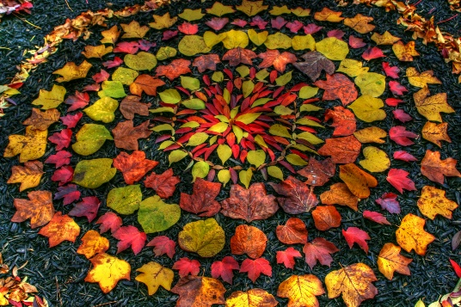  Andy Goldsworthy is a fabulous artist who is inspired by using natural items to represent the Earth. Can you create your own piece of art using natural resources? Research Andy Goldsworthy and his art to give you some ideas. Take a photo of your creation so you can share it with 4A when we return to school!
In assembly and hymn practice we always sing a number of hymns, even with actions when you are lucky! I am sure you have a favourite! Two of my favourites are; ‘One more step along the world I go’ and ‘He’s got the whole world in his hands’. Can you find your favourite hymn on YouTube and teach your family the words and maybe actions to go with it?

Beautiful World, Wonderful God

Creation through religion and science - https://www.youtube.com/watch?v=ARyWE8e50yM

The Christian Creation Story - https://www.youtube.com/watch?v=bLHB_hNk42g

One of the Hindu Creation Stories - https://www.youtube.com/watch?v=Y9yWwFWpbRo

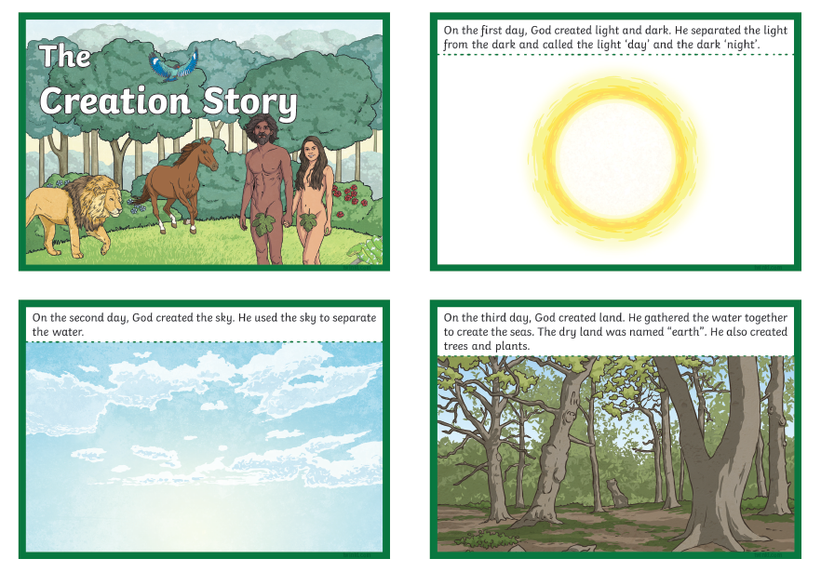
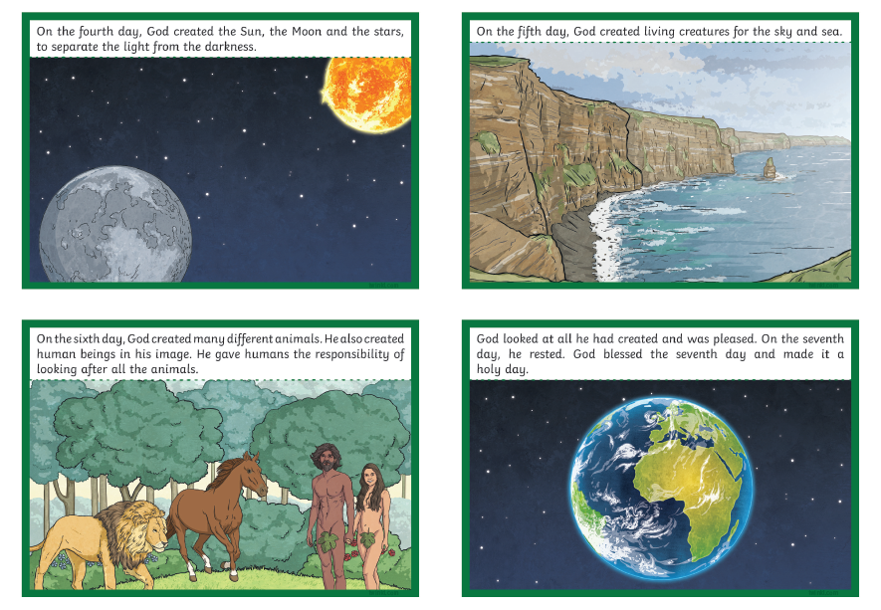

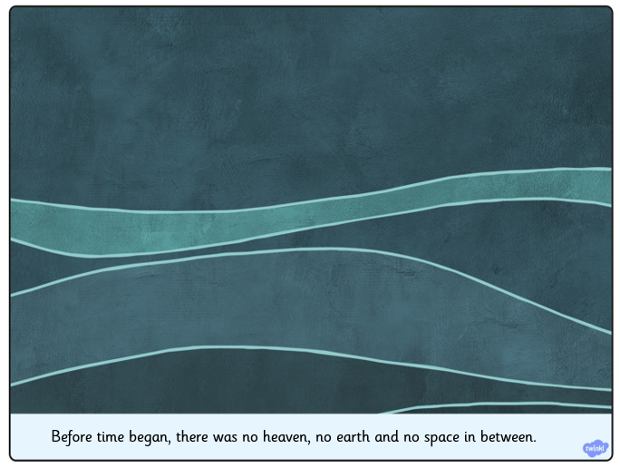
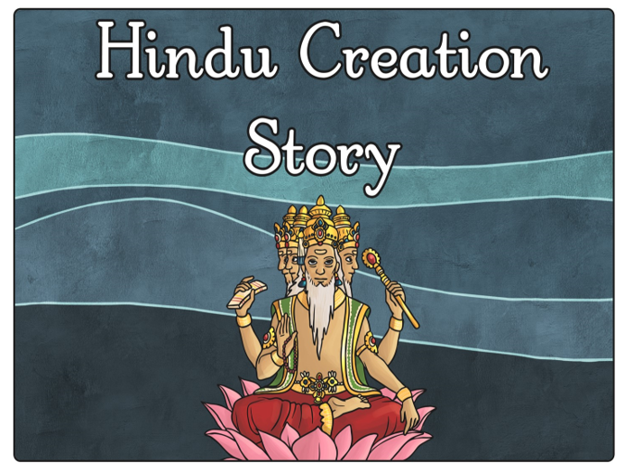

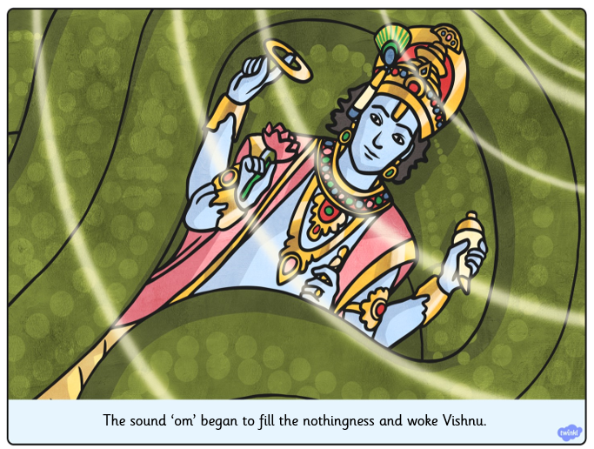

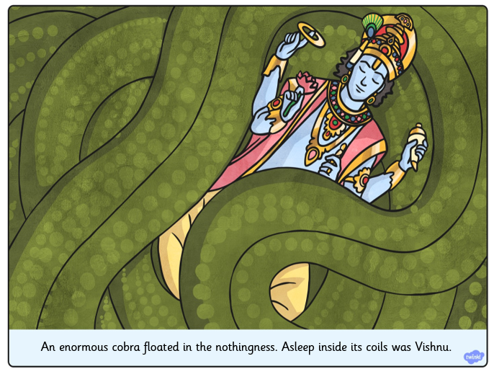

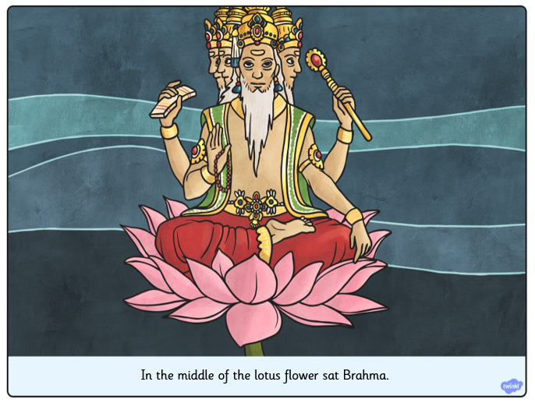
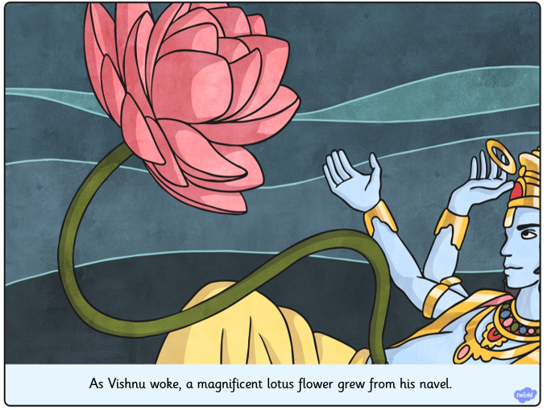

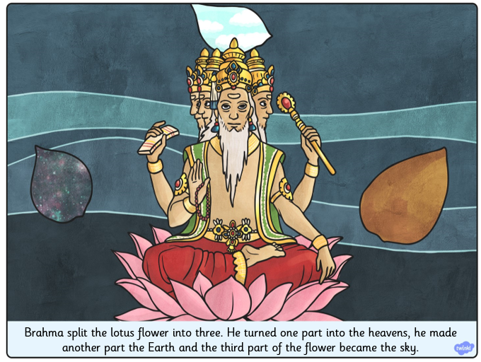
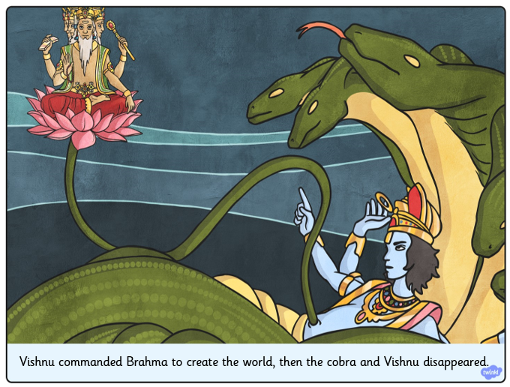

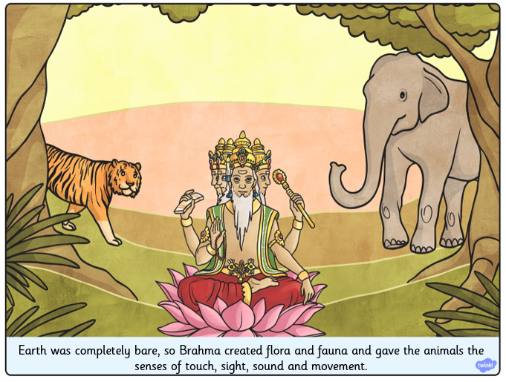

Andy Goldsworthy: The Art of Nature
Art can be created using nearly any medium; artists use paint, clay, charcoal, and ink to create their works. Artists like Andy Goldsworthy, though, use materials that are a little more unexpected. Andy Goldsworthy is a renowned British artist who works with found natural elements, and his work has been inspiring children and adults alike all around the world!
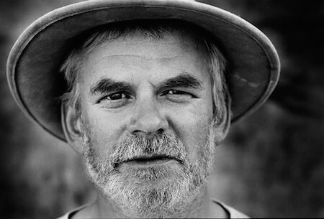
The Artist
Andy Goldsworthy was born in England July 1956 and grew up working on farms as a general labourer, which he has said is related to his current work as a sculptor.
He graduated from university with a Bachelor of Fine Arts in 1978. Since then, he has been creating art all around the world, in England, Scotland, Japan, Australia, and the United States. Goldsworthy currently lives in Scotland.
The Inspiration
Andy Goldsworthy is a naturalist, meaning that all of his art is derived from or related to nature. Goldsworthy is inspired by all aspects of the natural world, including snowflakes, twigs, icicles, reeds, tree roots, and rocks. He has said that his goal is to understand nature by becoming a part of it, and he considers his creations to be transient or ephemeral because they, like any other part of nature, are destined to change over time. He has said that "movement, change, light, growth, and decay" are the lifeblood of nature, and his work is designed to reflect that as well as participate in it.
The Method
Goldsworthy almost always uses found materials to make art. He tries to use exclusively natural elements, and has been known to make ice sculptures using his own saliva to keep the pieces together!
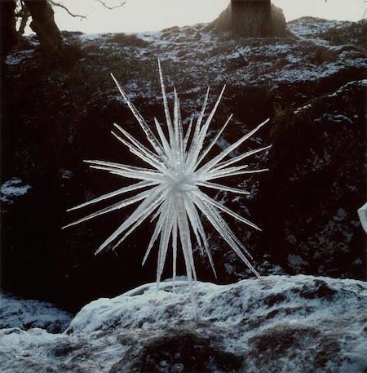
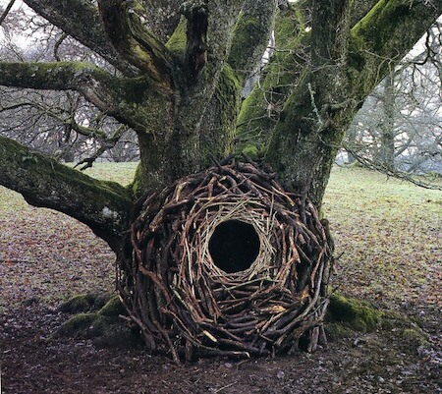
Because of the nature of his art, he always photographs a sculpture after it is complete. Because pieces will naturally change over time, this is the only way for him to record what he has made.
Can I Try?
You can take inspiration from Andy Goldsworthy's art to make your own!
Use found materials - your goal is not to interrupt nature's processes by picking plants and flowers, but to use what you can find on the ground, like branches, thorns, leaves, etc. You can make any kind of art you want. Goldworthy typically makes sculptures, but you can create natural collages on the grass, weave branches and fallen bark, or follow the artist's example and create a rock sculpture.
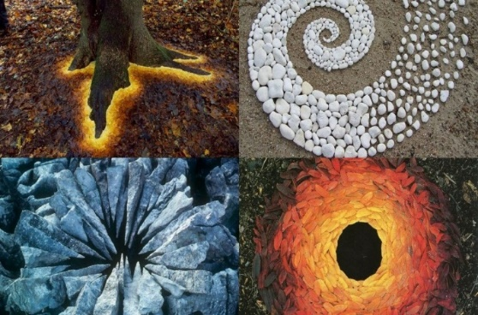
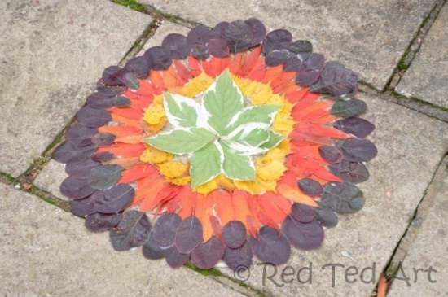
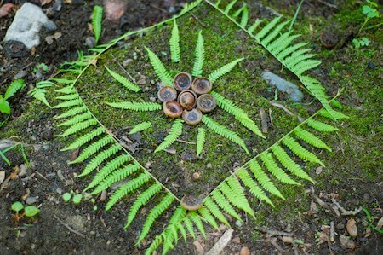
If you've been looking for a way to feel closer to the natural world and to express your feelings by making art, you might really enjoy experimenting with this type of creativity. Next time you're out for a walk, try picking up loose objects that look interesting to you. All you have to do to be inspired by nature is to look around!
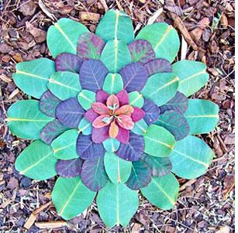

PE Activities

https://www.cosmickids.com/category/watch/- Cosmic Kids Yoga. These activities vary from under 10 minutes to over 15 minutes.
https://www.youtube.com/results?search_query=body+coach+kids- Tune in with Joe Wicks for some HITT sessions!
https://www.youtube.com/user/thebodycoach1 - Joe Wicks is also providing live workout, every morning at 9am, called "PE with Joe" on his YouTube channel The Body Coach TV.
https://www.cranwell.lincs.sch.uk/ Follow our school twitter feed on the school website or visit our twitter page, or Carre’s Grammar School Outreach support https://twitter.com/CranwellSchool, https://twitter.com/CGSOutreach for fun daily challenges.

Additional Websites

These websites are offering free, fun and interactive resources to help learning at home.

Twinkl- https://www.twinkl.co.uk/resources/parents
Mrs Mactivity- You can claim a free resource pack by signing up with your email- https://www.mrsmactivity.co.uk/
White Rose Maths- This is the Maths scheme we follow in school. They have provided free, really helpful lessons online that include a short video showing you clearly and simply how to help your child to complete the activity-.https://whiterosemaths.com/homelearning/
Classroom Secrets- They have created fun, interactive and practical home learning packs to ensure all children can continue to learn- https://classroomsecrets.co.uk/
Teach Starter- They are offering a 1 month free membership and a collection of free home learning packs-https://www.teachstarter.com/
Newsround- Watch Newsround live at 9:15am, 12:10pm and 4:00pm for the latest news- https://www.bbc.co.uk/newsround

