Dear children and parents

Welcome to your next week of home learning, for the third week of the ‘not quite Summer Term’! I hope you and your family are well and have been enjoying the lovely sunshine. It’s wonderful to see how many birds and butterflies are visiting our gardens at the moment; they particularly seem to like weeds, of which there are many in my garden! I hope that you enjoyed having a go at last week’s activities; I’ve been really impressed by how many of you have been completing tasks on Mathletics - well done! This week you have daily Maths, History/English, SPAG, Reading and PE to do, along with some other activities to keep you busy. Remember that you can contact me, through school reception (01400 659001), if you have any questions about the work I’ve set or if you need help with anything else.

Just a reminder about the 11+: keep doing a bit of practice, using the YouTube videos (for example, https://www.youtube.com/watch?v=FZkBpIAy62k ) and any workbooks you have at home. You should be working on resources written for ‘GL assessment’ exams; VR, NVR and Spatial Reasoning. Little and often is the best way to practise.

Mums and Dads: if you need extra ideas for work, or support in structuring a ‘learning day’ there are lots of great ideas on https://www.twinkl.co.uk/home-learning-hub . Please don’t hesitate to contact me, through school, if you need any help.

Mrs Bullement
Maths  Please continue to complete your daily maths lesson, using the White Rose resources from the website. Each day, you can watch a short video of a lesson, then complete the worksheet. You’ll also have an answer sheet to check your work – you might like to ask Mum or Dad to do that for you (but only if they’re not busy working).  You can find your lessons on this website: https://whiterosemaths.com/homelearning/year-5/ Please move onto the section labelled ‘Summer Term Week 3 w/c 4th May’. The videos are also available on Facebook, if the website is overloaded.  Of course, I’ll continue to set tasks on Mathletics, but only do these if you have spare time!  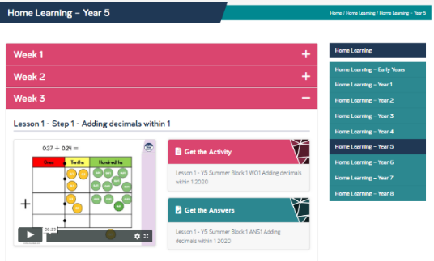  Want an extra challenge? This week, have a look at what happens when you add money. Can you find a pattern? Can you write a rule? Can you explain why this happens? See if you can explain to an adult! | English / History  We’ll will continue to explore the history of inventions and innovations this week, moving forwards on our timeline to the Victorian period. This was a golden age of science and innovation, when many of the devices we take for granted today were invented. I’d like you to do some research, choose the innovation or invention that you think was the most interesting, and write a short report about it.  Here are some useful websites:  http://www.primaryhomeworkhelp.co.uk/victorians/inventiotimeline.html  https://www.bbc.co.uk/bitesize/clips/zhwqxnb  https://kidskonnect.com/history/victorian-inventions/  Please do a little bit of work on this each day:  Mon – read about the different inventions; decide which one you like best.  Tues – research the invention and the inventor in detail; make notes.  Wed – Draft your report, remembering to use subheadings and paragraphs.  Thurs – Edit and improve your report; ask an adult to check it makes sense. Have you included your writing target?  Fri – Write up your report in your very best handwriting (no typing this week!). Share your super work with Mum or Dad.
SPAG  Spelling practise this week! If you scroll down, you’ll find the Year 5/6 Spelling List – words we have been learning this year – and five pieces of text for you to correct. I suggest doing one each day. Ask an adult to check whether you’ve found every one of Mr Woops’ mistakes. | 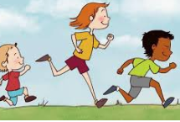  PE  It’s really important that we all stay fit and active. Try to do at least an hour of playing in the garden or walking out with a parent every day. Fresh air makes us all feel better! If you’re stuck inside, try a Joe Wicks workout:  https://www.youtube.com/watch?v=-TGEdzRzSbw  Or if you’re in the mood for a dance, have a look at the Go Noodle channel on YouTube – lots of great tunes and some fantastic dancing to get you moving! https://www.youtube.com/results?sp=mAEB&search_query=go+noodle
Reading
Please make sure you read for at least 20 mins every day this week. If you don’t have a book at home, you can use the book on: https://www.twinkl.co.uk/home-learning-hub (Guided Reading) or try Oxford Owl’s free online library https://www.oxfordowl.co.uk/for-home/find-a-book/library-page which has lots of your favourites from school!
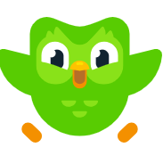
French
I’m really enjoying practising my French each day on Duolingo and I hope you are too! Keep that streak going!
https://www.duolingo.com/
Science – Earth and Space  So, you know about the planets of our Solar System now. Next we’re going to find out whether the Sun goes around the Earth, or the Earth goes around the Sun. Find out about the work of Copernicus by watching https://www.bbc.co.uk/teach/class-clips-video/science-ks2-the-work-of-nicolaus-copernicus/z64skmn and Galileo by watching https://www.bbc.co.uk/bitesize/clips/z6shfg8 .  Let’s take it outside! Ask Mum or Dad to go out constellation spotting with you! Try to find somewhere (in your front or back garden) that is away from streetlights, wrap up warm and see how many of the constellations on the sheets below you can spot. You might like to lie on a blanket and look up, to get a really good view. You could also use the ‘Star Tracker’ app (check with an adult first), which is brilliant in helping you identify them. Fun fact: the light from the nearest star (other than our sun), Proxima Centauri, has taken 4 years to reach us – it left the star when you were in Year 1! | DT  This week, ask and adult to show you how to do something practical that they enjoy doing. Some suggestions:  - How to mend a puncture  - How to sew on a button  - How to knit or chochet  - How to plant some seeds  - How to make scrambled eggs on toast  - How to make bread  These are just ideas; I bet the adults in your house have lots of great skills that you don’t even know about! Remember to only ask when they aren’t busy working though!
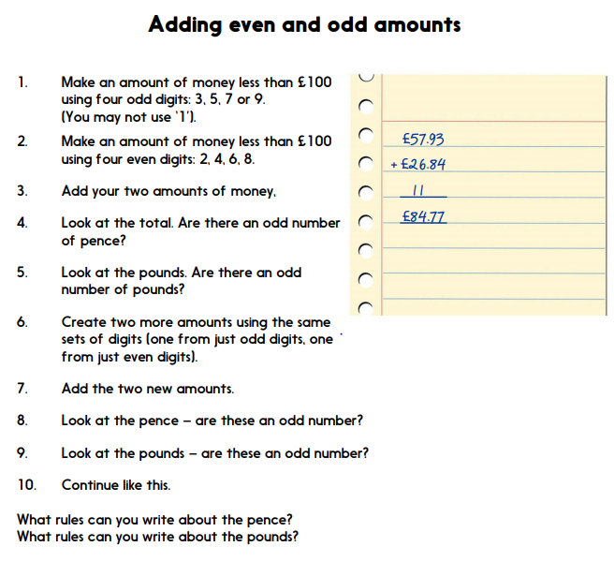
*Reproduced from The Hamilton Trust

SPAG Task – word bank
*SPAG resources from Twinkl
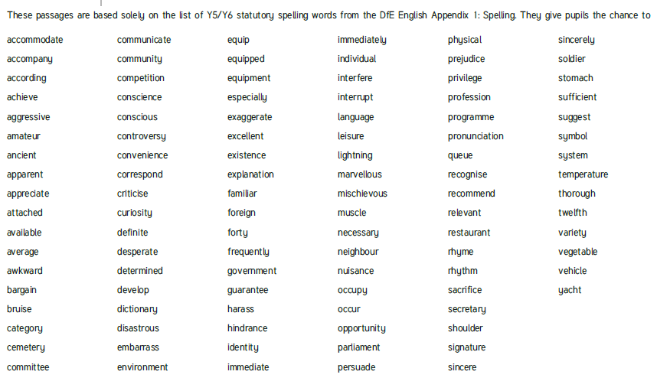

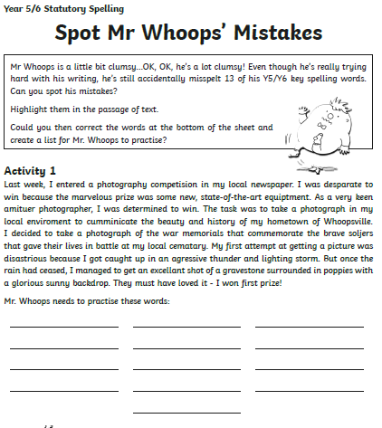
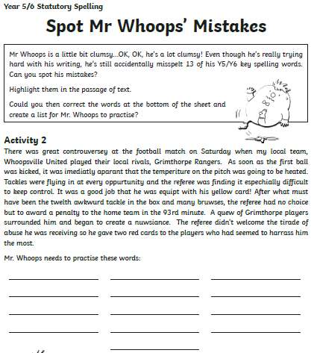

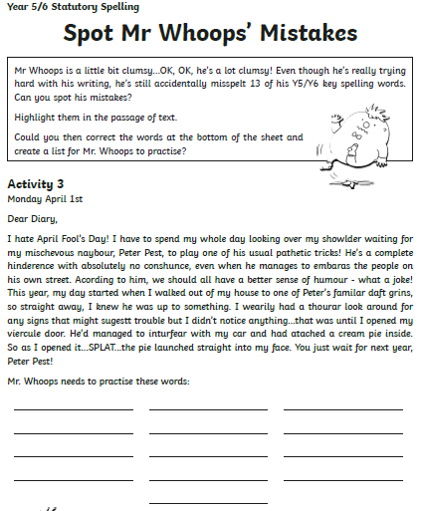
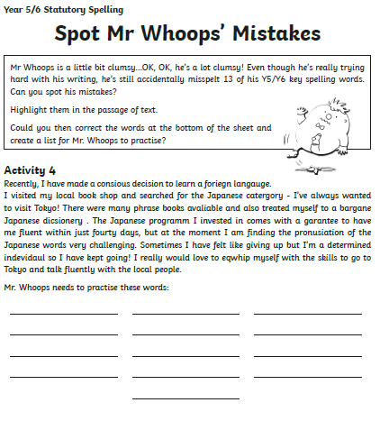

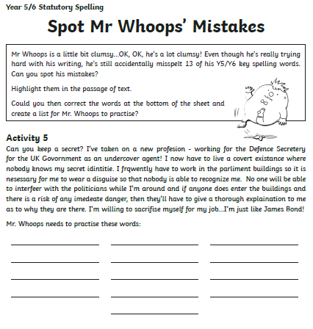

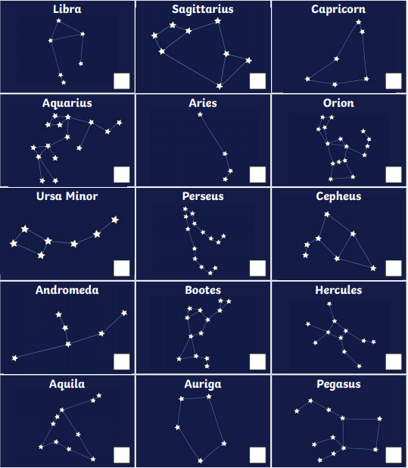
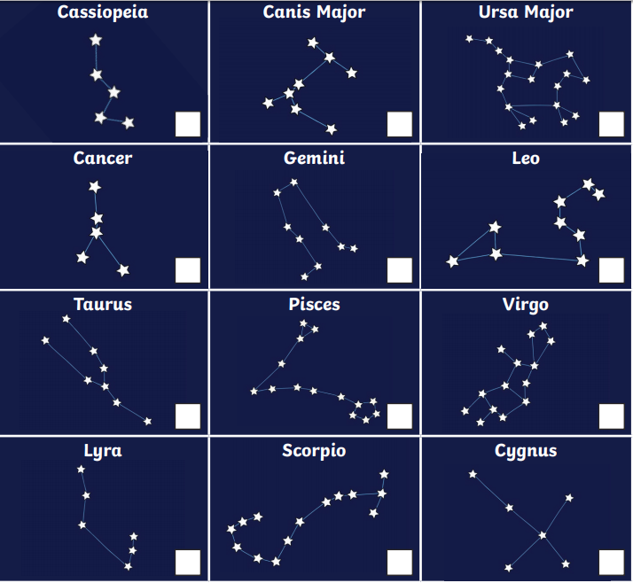
*Courtesy of Twinkl

