Numeracy  Keep doing the home learning lesson each day on the White Rose website for year 3. Remember to do Mathletics activities too and the money activities below.  Try Education City or Prodigy for fun games and Times Table Rockstars.  Remember you need to know 2x, 5x, 10x, 3x, 4x and 8x table and division facts out of order. Can you make cards to help you practise? | Literacy  Try to read a new book and then do a book review. You could listen to free books on audible.com.  Look at the key words for Year 3/4 and practise spelling another ten this week.  Write a letter to yourself about your activities and feelings whilst we are staying at home. Hide it somewhere to open in ten years time.  Can you include lots of VCOP? | PE  Keep practising throwing and catching in lots of different ways. Challenge yourself to get to 20 then 30 without dropping it. Can you play simple games of tennis, cricket or rounders? You could practise against a wall or with a balloon, soft toy or beanbag if you are inside.  The main thing is to keep active so invent a circuit of exercises around your house and try to do it twice a day.  Remember you could try Joe Wicks to energise you every morning or Cosmic yoga or Just Dance.  Hopefully you are getting out everyday for a walk, scooter or bike ride. How many different flowers can you spot each day?
Science  Can you prove that plants need water? Ask first but try putting celery stalks (or daisies) in water, which is coloured in different ways to see if the flower changes colour. You could try coffee, beetroot juice or food colouring etc.  Do the activities on Education City “In Bloom” and “Flower Power” (Science Year 3 Plants) and try to draw and label the function of each part.  Maybe you could make a junk model? | 3CO  Well done for working hard so far! We can see lots of you have been busy on Mathletics.  This work is for the week  4th to 8th May. | History  Our topic is local history, especially the development of RAF Cranwell.  Research about the first air ships as they helped designers to invent planes. Present your information on a poster or PowerPoint.  https://kids.kiddle.co/Airship  https://www.dkfindout.com/uk/transport/history-aircraft/airships/  https://www.rafmuseum.org.uk/documents/Cosford/Educational-Visits/Key-stage-2/Science-of-Flight-Compilation.pdf  https://study.com/academy/lesson/blimp-facts-lesson-for-kids.html
RE  This week look at the Creation story from the Bible. Summarise the story by writing a sentence for each day and drawing a picture. Use the powerpoint on twinkl to help you.  https://www.twinkl.co.uk/resource/t2-re-237-new-christian-creation-story-powerpoint | Home learning for 3CO  Each day try to do an hour’s exercise, some numeracy and some literacy or another subject.  However, imaginative play, baking, art work, playing card and board games (anything not electronic!) is just as important to keep happy and healthy.  Just do the best you can! | French  Use Education City to practise your French.  Remember to repeat phrases out loud and try to impress your family with your accent.  This week try to revise numbers.  “Un deux trois” and “Une Vingtaine”  (French Year 3)  Now try the matching pairs card game.

L.O. Can you solve these money problems?

There are 100p in £1, so how many p in £2?

There are 100p in £1, so how many p in £2.50?

There are 100p in £1, so how many p in £4?

There are 100p in £1, so how many p in £4.75?

There are 100p in £1, so how many p in £5.99?

Which coin is missing from these pictures?

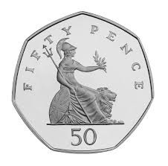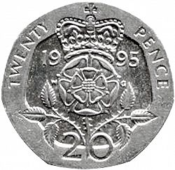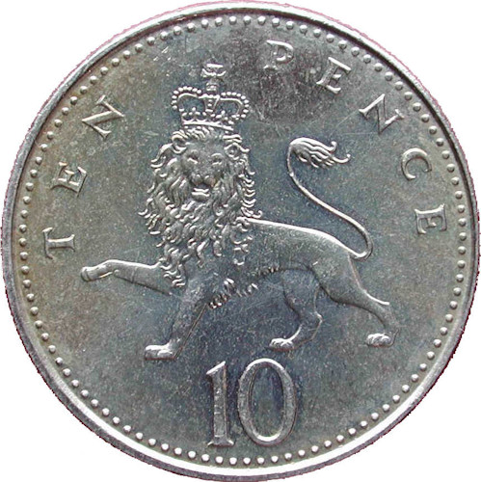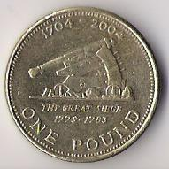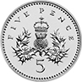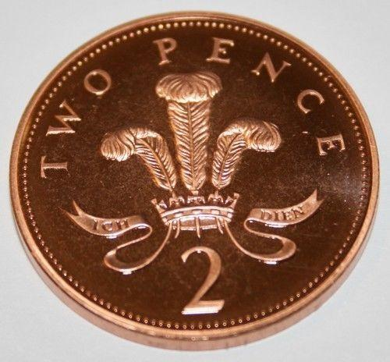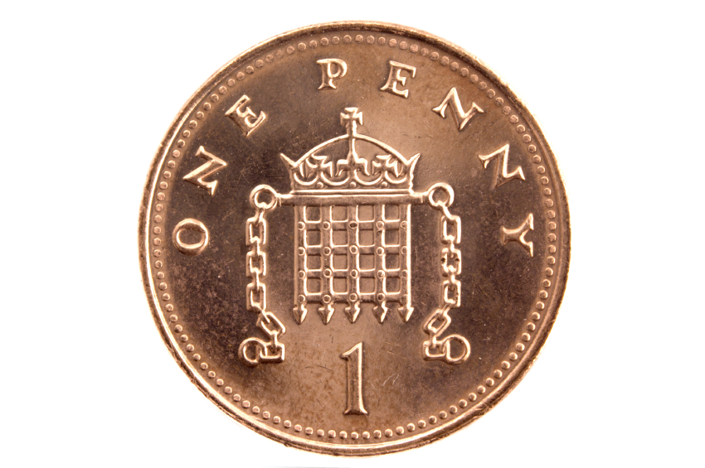

Which 2 coins could you use to pay 25p?

Which 3 coins could you use to pay 35p?

Which 5 coins could you use to pay 87p?

James has 2 x 50p and spends 60p. How much change should he get?

Jake has 3 x 50p and spends 70p. How much change should he get?

Jonah has 3 x 50p and spends 90p. How much change should he get?

If Sophie buys an apple at 60p and sweets at £1, how much change does she get from £2?

If Hollie buys 2 cokes at 70p each and a magazine at £1.50, how much change does she get from £3?

If Ella buys 2 bananas at 60p each and an ice cream at £1, how much change does she get from 2 x £2?

Now make up your own money word problems.

Role-play maths. Can you invent your own shop?

Decide what sort of shop you want to create. Maybe you want to make a toyshop or a snack shop?

Gather your stock of different things together and make a poster to advertise what you are selling.

Make price labels for your goods and then have fun selling, finding totals and change.

You could make your own money or maybe you have a game that has pretend money.

