Beautiful World, Wonderful God

Creation through religion and science - https://www.youtube.com/watch?v=ARyWE8e50yM

The Christian Creation Story - https://www.youtube.com/watch?v=bLHB_hNk42g

One of the Hindu Creation Stories - https://www.youtube.com/watch?v=Y9yWwFWpbRo
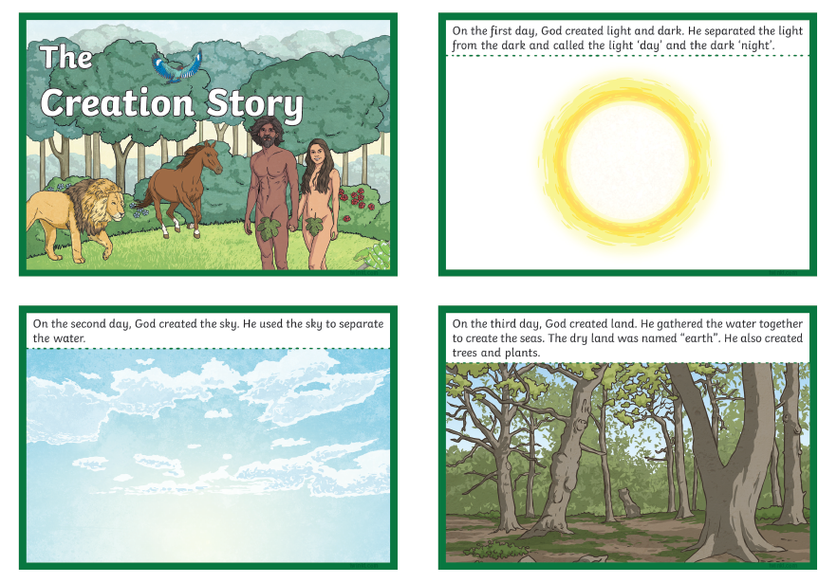

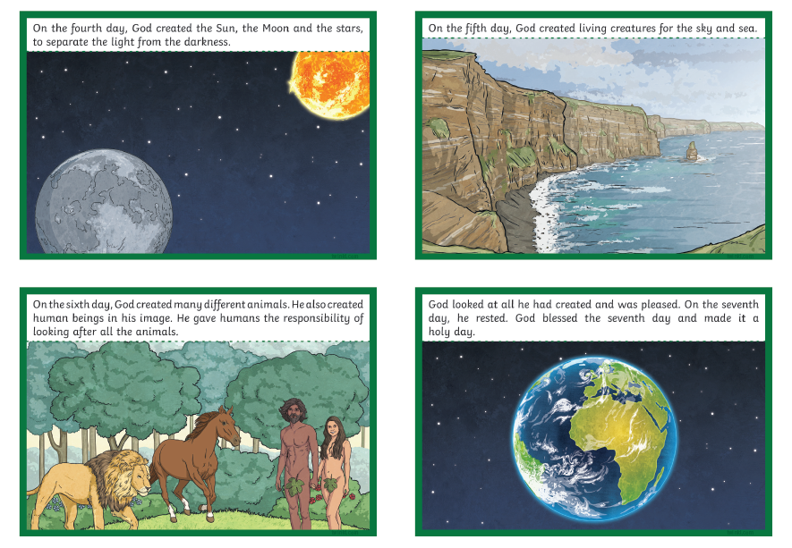
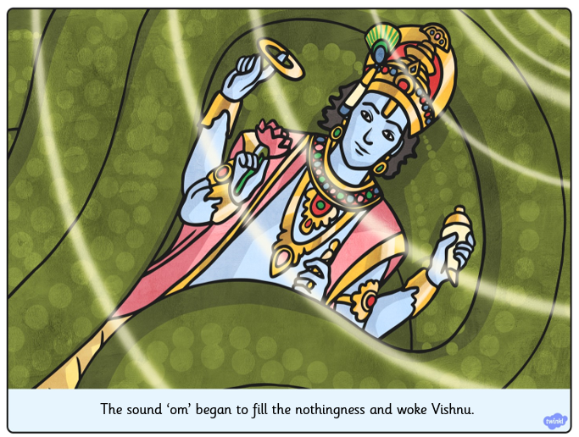
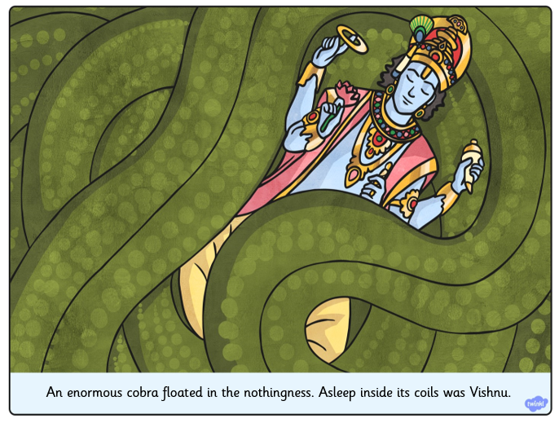
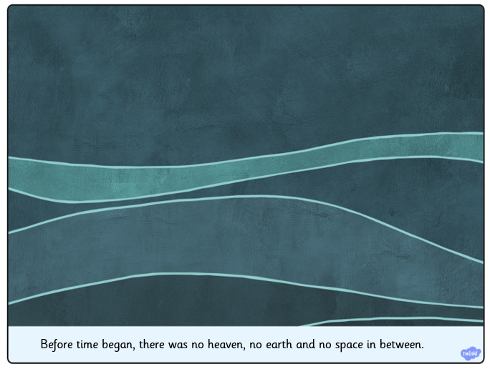
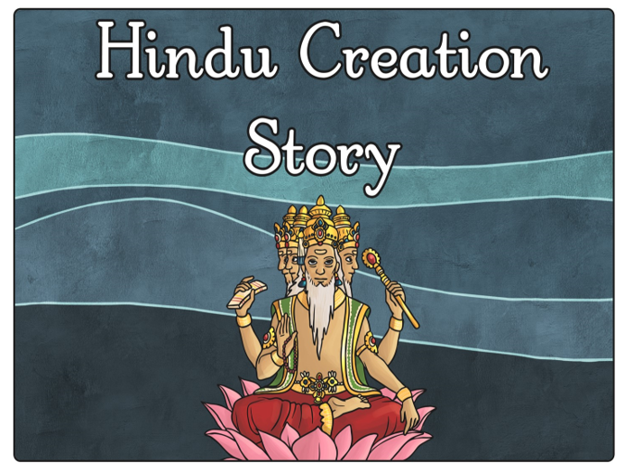
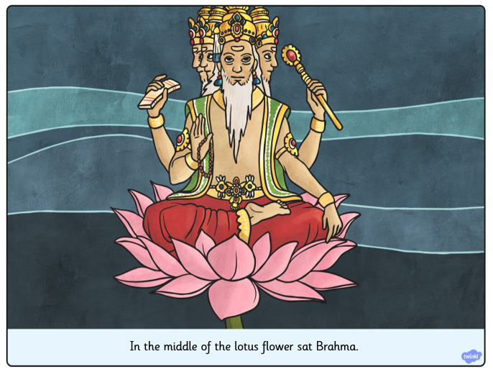
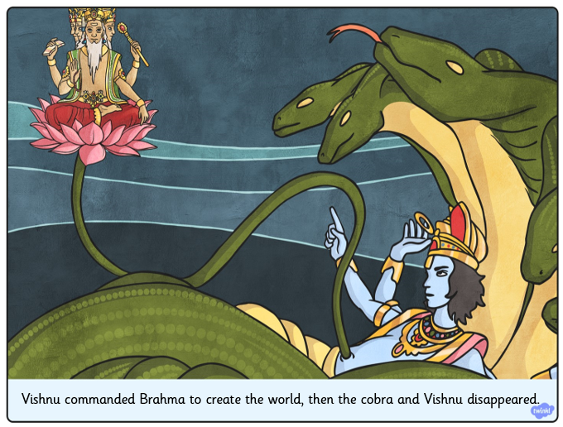
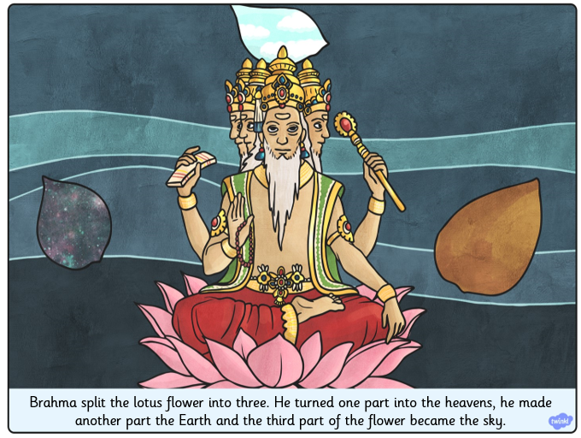
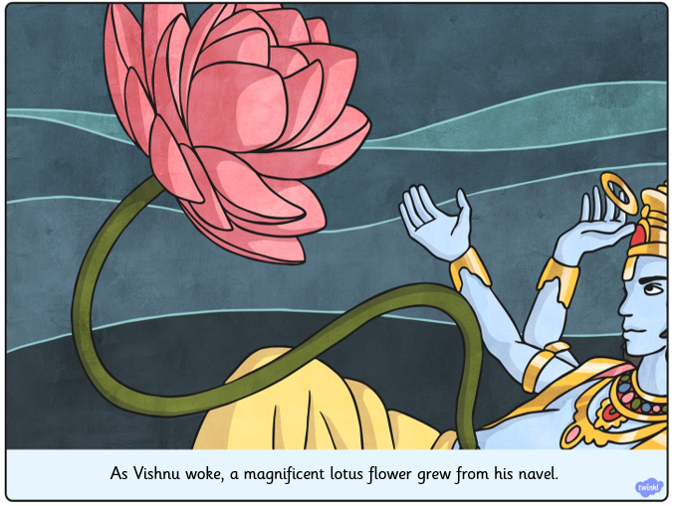

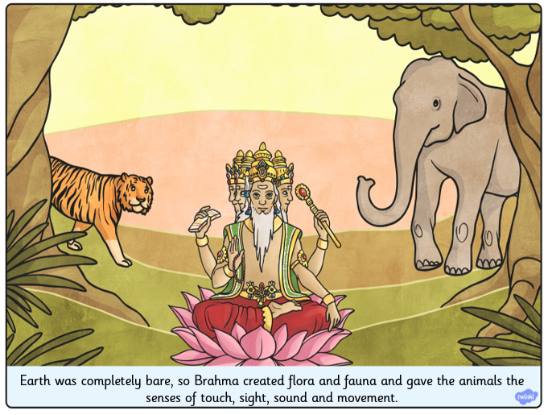

Andy Goldsworthy: The Art of Nature
Oct 13, 2015
Art can be created using nearly any medium; artists use paint, clay, charcoal, and ink to create their works. Artists like Andy Goldsworthy, though, use materials that are a little more unexpected. Andy Goldsworthy is a renowned British artist who works with found natural elements, and his work has been inspiring children and adults alike all around the world!

The Artist
- Andy Goldsworthy was born in England July 1956 and grew up working on farms as a general laborer, which he has said is related to his current work as a sculptor.
- He graduated from university with a Bachelor of Fine Arts in 1978.
- Since then, he has been creating art all around the world, in England, Scotland, Japan, Australia, and the United States.
- Goldsworthy currently lives in Scotland.
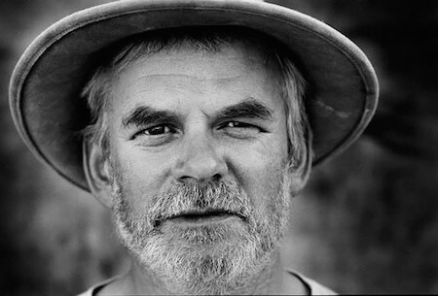The artist himself!Courtesy of thinglink.com

The Inspiration
- Andy Goldsworthy is a naturalist, meaning that all of his art is derived from or related to nature.
- Goldsworthy is inspired by all aspects of the natural world, including snowflakes, twigs, icicles, reeds, tree roots, and rocks.
- He has said that his goal is to understand nature by becoming a part of it, and he considers his creations to be transient or ephemeral because they, like any other part of nature, are destined to change over time.
- He has said that "movement, change, light, growth, and decay" are the lifeblood of nature, and his work is designed to reflect that as well as participate in it.
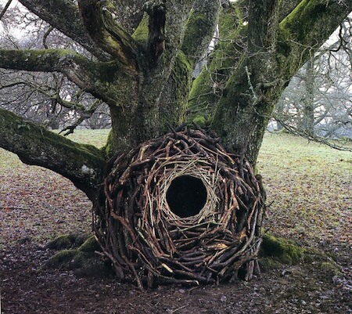Goldsworthy's art interacts with the surrounding environment.Courtesy of visualmelt.com

The Method
- Goldsworthy almost always uses found materials to make art.
- He tries to use exclusively natural elements, and has been known to make ice sculptures using his own saliva to keep the pieces together!
- Because of the transient nature of his art, he always photographs a sculpture after it is complete. Because pieces will naturally change over time, this is the only way for him to record what he has made.
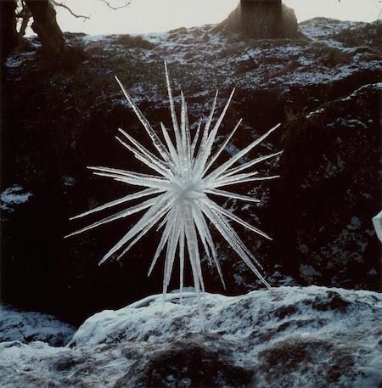Goldsworthy's beautiful ice star.Courtesy of gac.culture.gov.uk

Can I Try?
- You can take inspiration from Andy Goldsworthy's art to make your own!
- Use found materials - your goal is not to interrupt nature's processes by picking plants and flowers, but to use what you can find on the ground, like branches, thorns, leaves, etc.
- You can make any kind of art you want. Goldworthy typically make sculptures, but you can create natural collages on the grass, weave branches and fallen bark, or follow the artist's example and create a rock sculpture
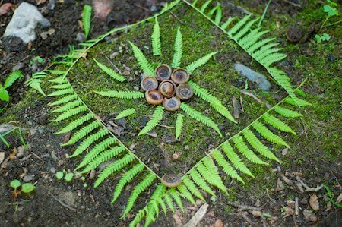This is an example of the kind of Andy Goldsworthy-inspired art you can create on your own!Courtesy of ipadartroom.com
If you've been looking for a way to feel closer to the natural world and to express your feelings by making art, you might really enjoy experimenting with this type of creativity. Next time you're out for a walk, try picking up loose objects that look interesting to you. All you have to do to be inspired by nature is to look around!
