**4A Distant Learning: 20th April to 1st May**

Hello 4A!

Mrs Allen here! I hope you are all keeping well and staying safe at home! I am missing seeing all your wonderful happy faces every day! I have been enjoying the beautiful weather we have had, making sure I get my daily exercise, whether it be a walk or a run. We even had a BBQ the other night which was delicious! I hope you have all been enjoying the sunshine in the garden!

I want you all to remain being positive and enjoy spending quality time with your families! Don’t be frightened. You may hear some things that you are worried about, but these are not worries for you. Tell an adult you live with and let them look after it for you. I want you to continue doing your bit by staying at home to help stop the spread of this nasty bug and don’t forget to keep washing your hands! Amongst the bad things that are happening at the minute, there are also positive things to take away from this. There is less air travel and as a result the environment is getting a bit of a rest, and, who knows, maybe we can work out new and better ways of doing things in the future because we have had to. People are talking to and looking out for each other more than ever and it has certainly made me realise how lucky I am to live a healthy life with lots of wonderful people in. Even though you will be missing your friends at school, remember how lucky you are to live the life you do. You are all very special and don’t ever forget that!

Please keep singing, playing, making, drawing, writing, problem-solving, and learning about our amazing world. We are on an adventure and like all real adventurers, we have to be brave. I can’t wait to hear and I am sure laugh about everything you got up to during these times! I have included lots of ideas to support your learning at home, maybe whilst mum or dad are busy working you may also choose to complete one of these activities.

Stay safe and I look forward to the day we meet again!

Mrs Allen

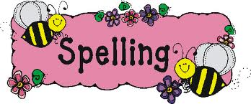

Spellings

Please spend time learning the Year 3 and 4 National Curriculum spelling list which you will find in the front of your reading planners. Can you find these words in a dictionary and write a sentence for each word?

Writing

Our new writing topic this term is persuasive writing. See below for features of a persuasive text. There are several different forms of persuasive writing, however we are going to concentrate on leaflets. Can you design and write a leaflet, persuading someone to visit a place in the UK? Our Geography topic for this term is ‘UK and the British Isles’ so I thought it would be nice to try and link the two. I have included 2 examples for you to have a look at; one persuading someone to visit Budapest and the other Austria.

Reading

We read in class every day, so it would be really nice if you could spend some time every day reading a book. This can be a home book, a newspaper, magazine or anything alike. Do not forget to record this in your reading record.

It would also be good practise to complete some book reviews in the back of you reading record.





Extras

If you do anything else whilst at home such as play board games, bake, go on a bike ride or a walk, draw me a picture, write a recount, tell me a story about it or take some fabulous pictures. Not all learning can be done in the classroom!

Maths

Please see ‘Maths’ information page, which explains your daily tasks.

Times Tables

I have provided you with the times tables test you complete weekly in school. Once you have completed and scored full marks on the multiplication sheet in 5 minutes then you can move onto the division sheet. You have 5 minutes to complete as many as you can, column by column. You could also have a look on the times tables page for websites to help you.

Topic

See the grid below for some project based ideas on our new topic ‘Local history study-RAF Cranwell’ for you to complete.

Writing

Features of Persuasive Writing

Purpose:

To argue the case for a point of view.

To attempt to convince the reader.

Language Features:

* Usually written in present tense.
* Includes logical connectives to link ideas (therefore, however)
* Use emotive language (powerful verbs and strong adjectives)
* Ask rhetorical questions
* Dare the reader to disagree
* Counter arguments from the other point of view.
* Try and use some facts as well as opinions.

Visit Austria, the land of mountains

The Alps is the highest mountains in Europe. It remains the best kept secret for nature lovers and families. With lots to keep you busy everyone can find a great choice of exciting activities while people who search for a more relaxing stay can discover the unspoilt environment, stunning scenery and the glorious sunshine!

Activities

Some resorts in Austria have up to 40 different activities for adults and children of all ages. There are plenty of rivers and lakes which provide an endless playground for those who love water.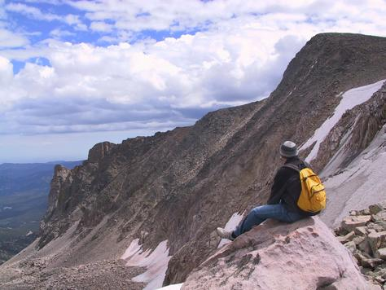

Walking/Hiking

Do you want to experience the mountains from an amazing height? The ski lifts take you higher up than you can imagine. There are plenty of hiking trails with signposts to keep you on track. You can have a rest and take in the views with many opportunities to take photographs and impress your family and friends. You can also find lovely hidden cafes on the way to have a hot drink and a delicious lunch.

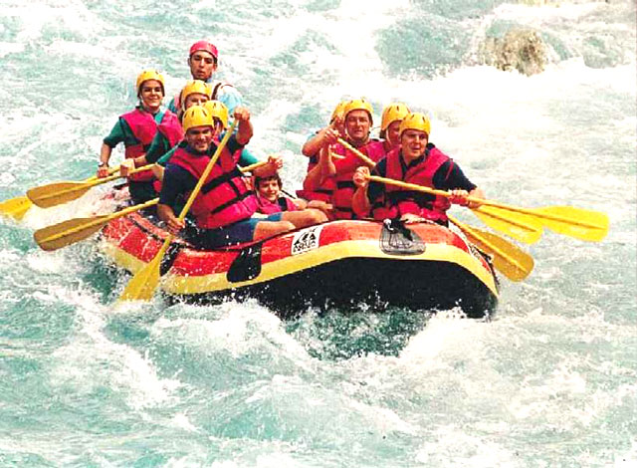Rafting

There are lots of lakes in Austria among the mountains. Lake Leman and Annecy are the favourite spots for water sports. Discover your sense for adventure and what it is like to be soaked to the skin with a white water rafting experience. You will start by being kitted out with all the equipment before a full safety training. Then and experienced guide will take you onto the water for a series of runs down the breathtaking twists, turns and drops of the rushing mountain rivers. It is a fantastic and unforgettable experience!

So what are you waiting for??

Come to Budapest!

**Budapest is the capital of Hungary in the heart of Europe. Come and visit this diamond to experience the kindness of Hungarian people and to enjoy the food and wine of the region!**

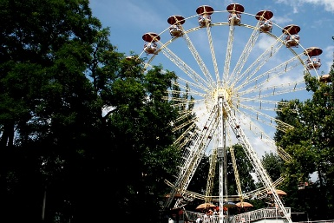Things to do

Do you have small children? Why not go and visit the Budapest Zoo and Theme Park which is one of the most amazing zoos in Europe with more than 1000 different species from Polar bears to crocodiles and tigers? Or have a ride in the theme park on the Ferris wheels and enjoy the breathtaking views of the city below?

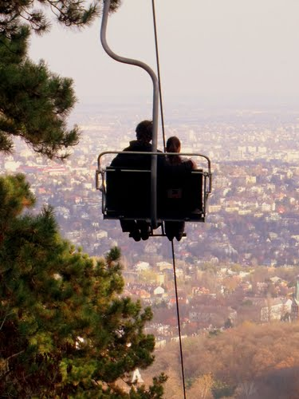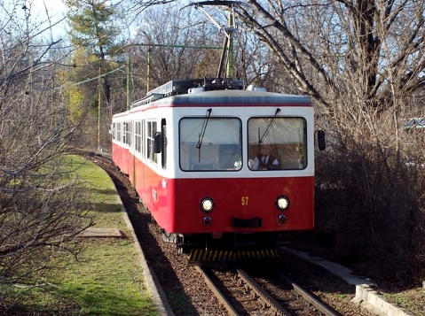

Budapest is surrounded by hills and forests. Another family friendly program is to have a day trip out to Liberty Mountain where you can take the cogwheel train up the steep mountain tracks which is a brilliant experience and then travel on the century old children’s steam train where the controllers are children. At the final destination you can take the chair lift down to the valley. Don’t forget your camera! You will take the most amazing photos!

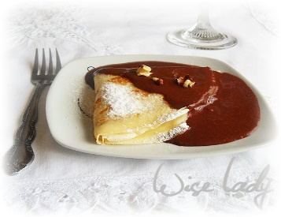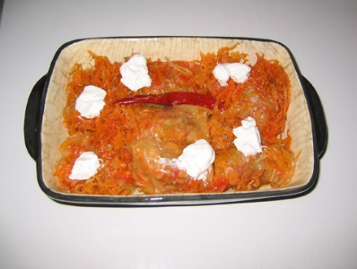Are you hungry yet?

You must try traditional Hungarian food! Everyone’s favourite is stuffed cabbage with soft sour cream and the most famous delicious Hungarian bread! And what is for dessert? The brilliant and mouthwatering Gundel pancakes filled with walnut cream and soaked in chocolate custard. Best choice ever!

If you are ready for adventure then why not get on a plane and experience the fun?

Times Table Activities

<https://play.ttrockstars.com/auth/school> - Times Table Rock Stars is a great way to practise your times tables

<https://play.edshed.com/> - Practise your times tables

<https://www.timestables.co.uk/> - learn and practise

<https://www.topmarks.co.uk/maths-games/7-11-years/times-tables>

<https://www.oxfordowl.co.uk/for-home/maths/help-with-times-tables/> -

<https://www.themathsfactor.com/times-tables-check/#/-> A Times Tables Check in the same format the Multiplication Test will be.

Maths Activities

As we are missing out on valuable lesson time, from now on there will be a **daily maths lesson** for you to complete, using the White Rose resources we use in class. Each day, there will be a short video of a lesson to watch, then try your best to complete the activity. We have completed a few of these worksheets in class so they should be familiar to you. Don’t worry if you can’t print out the worksheet, just write your answers on a piece of paper or in a notebook. You’ll also have an answer sheet to check your work – you might like to ask Mum or Dad to do that for you (but only if they’re not busy working!).

Follow this link to find your daily lessons and follow the instructions on the website: <https://whiterosemaths.com/homelearning/year-4/>

**Please complete ‘Summer term- Week 1 and Week 2’, a lesson a day.**

Extra Maths Games

<https://play.prodigygame.com/> - Pokemon style game with maths questions!

<https://play.edshed.com/> - practise your number bonds, power of 10 and addition and subtraction

[www.topmarks.co.uk](http://www.topmarks.co.uk) –interactive games

<https://www.oxfordowl.co.uk/for-home/kids-activities/fun-maths-games-and-activities/#maths-7-9> – games and activities

<https://www.mathswithparents.com/KWeb?startTime=1584558592239#menu584883> – Free access to parents – videos and activities across the maths curriculum.

|  |  |  |  |  |  |  |  |  |  |  |  |
| --- | --- | --- | --- | --- | --- | --- | --- | --- | --- | --- | --- |
| **2x table** | | **5x table** | | **10x table** | | **3x table** | | **4x table** | | **8x table** | |
| 1 x 2 = |  | 3 x 5 = |  | 2 x 10 = |  | 4 x 3 = |  | 3 x 4 = |  | 2 x 8 = |  |
| 6 x 2 = |  | 8 x 5 = |  | 6 x 10 = |  | 10 x 3 = |  | 1 x 4 = |  | 10 x 8 = |  |
| 10 x 2 = |  | 11 x 5 = |  | 8 x 10 = |  | 1 x 3 = |  | 9 x 4 = |  | 8 x 8 = |  |
| 2 x 2 = |  | 2 x 5 = |  | 3 x 10 = |  | 5 x 3 = |  | 7 x 4 = |  | 1 x 8 = |  |
| 4 x 2 = |  | 4 x 5 = |  | 7 x 10 = |  | 9 x 3 = |  | 2 x 4 = |  | 5 x 8 = |  |
| 5 x 2 = |  | 6 x 5 = |  | 10 x 10 = |  | 6 x 3 = |  | 12 x 4 = |  | 7 x 8 = |  |
| 7 x 2 = |  | 10 x 5 = |  | 4 x 10 = |  | 2 x 3 = |  | 8 x 4 = |  | 9 x 8 = |  |
| 12 x 2 = |  | 1 x 5 = |  | 11 x 10 = |  | 11 x 3 = |  | 11 x 4 = |  | 3 x 8 = |  |
| 3 x 2 = |  | 5 x 5 = |  | 9 x 10 = |  | 8 x 3 = |  | 5 x 4 = |  | 6 x 8 = |  |
| 8 x 2 = |  | 9 x 5 = |  | 1 x 10 = |  | 12 x 3 = |  | 10 x 4 = |  | 11 x 8 = |  |
| 11 x 2 = |  | 12 x 5 = |  | 12 x 10 = |  | 3 x 3 = |  | 6 x 4 = |  | 4 x 8 = |  |
| 9 x 2 = |  | 7 x 5 = |  | 5 x 10 = |  | 7 x 3 = |  | 4 x 4 = |  | 12 x 8 = |  |
| Total: |  | Total: |  | Total: |  | Total: |  | Total: |  | Total: |  |

|  |  |  |  |  |  |  |  |  |  |
| --- | --- | --- | --- | --- | --- | --- | --- | --- | --- |
| **6 x table** | | **7 x table** | | **9 x table** | | **11 x table** | | **12 x table** | |
| 2 x 6 = |  | 2 x 7 = |  | 1 x 9 = |  | 4 x 11 = |  | 3 x 12 = |  |
| 6 x 6 = |  | 10 x 7 = |  | 6 x 9 = |  | 10 x 11 = |  | 1 x 12 = |  |
| 8 x 6 = |  | 8 x 7 = |  | 10 x 9 = |  | 1 x 11 = |  | 9 x 12 = |  |
| 3 x 6 = |  | 1 x 7 = |  | 2 x 9 = |  | 5 x 11 = |  | 7 x 12 = |  |
| 7 x 6 = |  | 5 x 7 = |  | 4 x 9 = |  | 9 x 11 = |  | 2 x 12 = |  |
| 10 x 6 = |  | 7 x 7 = |  | 5 x 9 = |  | 6 x 11 = |  | 4 x 12 = |  |
| 4 x 6 = |  | 9 x 7 = |  | 7 x 9 = |  | 2 x 11 = |  | 8 x 12 = |  |
| 11 x 6 = |  | 3 x 7 = |  | 12 x 9 = |  | 3 x 11 = |  | 11 x 12 = |  |
| 9 x 6 = |  | 6 x 7 = |  | 3 x 9 = |  | 8 x 11 = |  | 5 x 12 = |  |
| 1 x 6 = |  | 11 x 7 = |  | 8 x 9 = |  | 12 x 11 = |  | 10 x 12 = |  |
| 12 x 6 = |  | 4 x 7 = |  | 11 x 9 = |  | 11 x 11 = |  | 6 x 12 = |  |
| 5 x 6 = |  | 12 x 7 = |  | 9 x 9 = |  | 7 x 11 = |  | 12 x 12 = |  |
| Total: |  | Total: |  | Total: |  | Total: |  | Total: |  |

|  |  |  |  |  |  |  |  |  |  |  |  |  |  |  |  |  |
| --- | --- | --- | --- | --- | --- | --- | --- | --- | --- | --- | --- | --- | --- | --- | --- | --- |
| **2÷ table** | | | **5÷ table** | | | **10÷ table** | | | **3÷ table** | | **4÷ table** | | | **8÷ table** | | |
| 2÷2 = |  | | 15 ÷ 5 = |  | | 20 ÷ 10 = |  | | 12 ÷ 3 = |  | 12 ÷ 4 = | |  | 16 ÷ 8 = | |  |
| 12÷ 2 = |  | | 40 ÷ 5 = |  | | 60 ÷ 10 = |  | | 30 ÷ 3 = |  | 4 ÷ 4 = | |  | 80 ÷ 8 = | |  |
| 20 ÷ 2 = |  | | 55 ÷ 5 = |  | | 80 ÷ 10 = |  | | 3 ÷ 3 = |  | 36 ÷ 4 = | |  | 64 ÷ 8 = | |  |
| 2 ÷ 2 = |  | | 10 ÷ 5 = |  | | 30 ÷ 10 = |  | | 15 ÷ 3 = |  | 28 ÷ 4 = | |  | 8 ÷ 8 = | |  |
| 8 ÷ 2 = |  | | 20 ÷ 5 = |  | | 70 ÷ 10 = |  | | 27 ÷ 3 = |  | 8 ÷ 4 = | |  | 40 ÷ 8 = | |  |
| 10 ÷ 2 = |  | | 30 ÷ 5 = |  | | 10 ÷ 10 = |  | | 18 ÷ 3 = |  | 48 ÷ 4 = | |  | 56 ÷ 8 = | |  |
| 14 ÷ 2 = |  | | 50 ÷ 5 = |  | | 40 ÷ 10 = |  | | 6 ÷ 3 = |  | 32 ÷ 4 = | |  | 72 ÷ 8 = | |  |
| 24 ÷ 2 = |  | | 5 ÷ 5 = |  | | 110 ÷ 10 = |  | | 33 ÷ 3 = |  | 44 ÷ 4 = | |  | 24 ÷ 8 = | |  |
| 6 ÷ 2 = |  | | 25 ÷ 5 = |  | | 90 ÷ 10 = |  | | 24 ÷ 3 = |  | 20 ÷ 4 = | |  | 48 ÷ 8 = | |  |
| 16 ÷ 2 = |  | | 45 ÷ 5 = |  | | 10 ÷ 10 = |  | | 36 ÷ 3 = |  | 40 ÷ 4 = | |  | 88 ÷ 8 = | |  |
| 22 ÷ 2 = |  | | 60 ÷ 5 = |  | | 120 ÷ 10 = |  | | 9 ÷ 3 = |  | 24 ÷ 4 = | |  | 32 ÷ 8 = | |  |
| 18 ÷ 2 = |  | | 35 ÷ 5 = |  | | 50 ÷ 10 = |  | | 21 ÷ 3 = |  | 16 ÷ 4 = | |  | 96 ÷ 8 = | |  |
| Total: |  | | Total: |  | | Total: |  | | Total: |  | Total: | |  | Total: | |  |
| **6 ÷ table** | | **7 ÷ table** | | | **9 ÷ table** | | | **11 ÷ table** | | | | **12 ÷ table** | | |
| 12 ÷ 6 = |  | 14 ÷ 7 = | |  | 9 ÷ 9 = | |  | 44 ÷ 11 = | |  | | 36 ÷ 12 = |  | |
| 36 ÷ 6 = |  | 70 ÷ 7 = | |  | 54 ÷ 9 = | |  | 110 ÷ 11 = | |  | | 12 ÷ 12 = |  | |
| 48 ÷ 6 = |  | 56 ÷ 7 = | |  | 90 ÷ 9 = | |  | 11 ÷ 11 = | |  | | 108 ÷ 12 = |  | |
| 18 ÷ 6 = |  | 7 ÷ 7 = | |  | 18 ÷ 9 = | |  | 55 ÷ 11 = | |  | | 84 ÷ 12 = |  | |
| 42 ÷ 6 = |  | 35 ÷ 7 = | |  | 36 ÷ 9 = | |  | 99 ÷ 11 = | |  | | 24 ÷ 12 = |  | |
| 60 ÷ 6 = |  | 49 ÷ 7 = | |  | 45 ÷ 9 = | |  | 66 ÷ 11 = | |  | | 48 ÷ 12 = |  | |
| 24 ÷ 6 = |  | 63 ÷ 7 = | |  | 63 ÷ 9 = | |  | 22 ÷ 11 = | |  | | 96 ÷ 12 = |  | |
| 66 ÷ 6 = |  | 21 ÷ 7 = | |  | 108 ÷ 9 = | |  | 33 ÷ 11 = | |  | | 132 ÷ 12 = |  | |
| 54 ÷ 6 = |  | 42 ÷ 7 = | |  | 27 ÷ 9 = | |  | 88 ÷ 11 = | |  | | 60 ÷ 12 = |  | |
| 6 ÷ 6 = |  | 77 ÷ 7 = | |  | 72 ÷ 9 = | |  | 132 ÷ 11 = | |  | | 120 ÷ 12 = |  | |
| 72 ÷ 6 = |  | 28 ÷ 7 = | |  | 99 ÷ 9 = | |  | 121 ÷ 11 = | |  | | 72 ÷ 12 = |  | |
| 30 ÷ 6 = |  | 84 ÷ 7 = | |  | 81 ÷ 9 = | |  | 77 ÷ 11 = | |  | | 144 ÷ 12 = |  | |
| Total: |  | Total: | |  | Total: | |  | Total: | |  | | Total: |  | |

|  |  |  |
| --- | --- | --- |
| Using the map of the UK on the next page, can you locate Cranwell? What county do we live in? Where is our closest city? What region do we live in? Can you name all other regions of the UK? Clue…. there are 12 regions altogether. You might like to use maps, atlases, books or the internet to help you research these questions.  Topic Activities | | Using any resources you have at home, can you design and **make** a RAF aircraft? |
| Can you draw a map of your route you take to school? Try and include the key features of a map and the use of a key (we have discussed these in class when looking at four figure grid references). Think about what points of interest you pass on your journey. | Thinking about the history of RAF Cranwell, can you research the following street names and find out why they got their names:   * Airship Road * Lighter-Than-Air Road   You might like to create a fact file to present your results. | Using the RAF Cranwell station crest below as your inspiration, create your own family crest denoting a motto you abide by (try to find the Latin translation), and an animal that you think represents your personality. This might be a nice activity to discuss and work on together with your family. |
| RAF Cranwell plays an important part in a lot of our daily lives. Can you research the history and find any interesting facts about RAF Cranwell? You might like to make a presentation to display your findings. | |
| Can you design and **draw** a new, futuristic aeroplane that could be used within the RAF, considering all features an aircraft might need? | Where, when and how did the RAF begin? Can you find out all about the history of the RAF?  Present your findings how you wish. | |

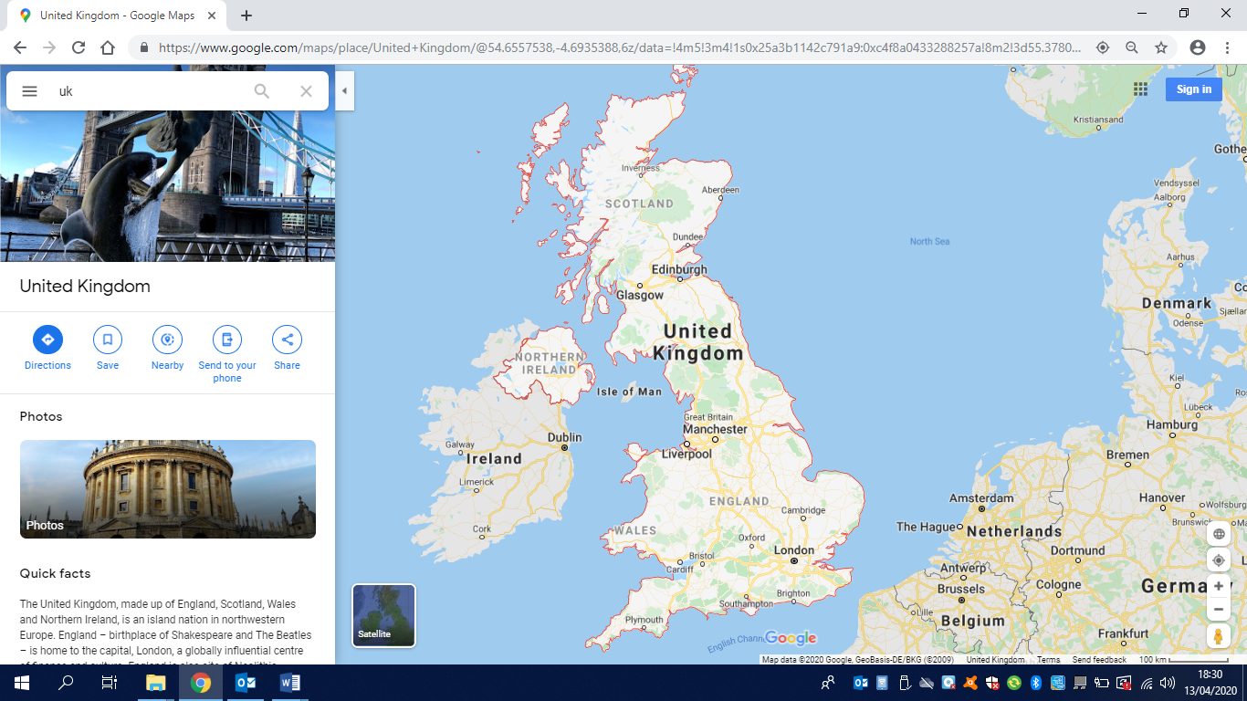

PE Activities

<https://www.cosmickids.com/category/watch/-> Cosmic Kids Yoga. These activities vary from under 10 minutes to over 15 minutes.

<https://www.youtube.com/results?search_query=body+coach+kids-> Tune in with Joe Wicks for some HITT sessions!

<https://www.youtube.com/user/thebodycoach1> - Joe Wicks is also providing live workout, every morning at 9am, called "PE with Joe" on his YouTube channel The Body Coach TV.

<https://www.cranwell.lincs.sch.uk/> Follow our school twitter feed on the school website or visit our twitter page, or Carre’s Grammar School Outreach support <https://twitter.com/CranwellSchool>, <https://twitter.com/CGSOutreach> for fun daily challenges.

Additional Websites

These websites are offering free, fun and interactive resources to help learning at home.

Twinkl- <https://www.twinkl.co.uk/resources/parents>

Mrs Mactivity- You can claim a free resource pack by signing up with your email- <https://www.mrsmactivity.co.uk/>

White Rose Maths- This is the Maths scheme we follow in school. They have provided free, really helpful lessons online that include a short video showing you clearly and simply how to help your child to complete the activity-.<https://whiterosemaths.com/homelearning/>

Classroom Secrets- They have created fun, interactive and practical home learning packs to ensure all children can continue to learn- <https://classroomsecrets.co.uk/>

Teach Starter- They are offering a 1 month free membership and a collection of free home learning packs-<https://www.teachstarter.com/>

Newsround- Watch Newsround live at 9:15am, 12:10pm and 4:00pm for the latest news- <https://www.bbc.co.uk/newsround>