WEEK COMMENCING: 20/04/20 |  | HOME ACTIVITIES |  | CLASS 2C
 |  | Continue reading every day!
Art & DT - Models  Create a model of your choice using only recyclable objects. Identify the shapes of the different objects and look at the properties of these objects before putting them together to create your own 3d model. |  | 2d shape Pictures  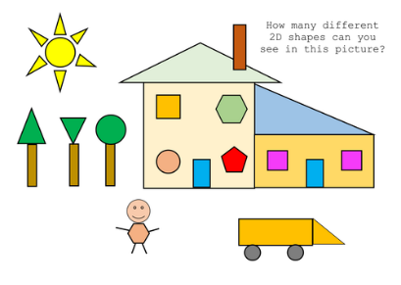  Create a variety of pictures using the 2d shapes on your shape board. You could do this on the computer or you could draw them using 2d shapes or shape stencils. |  | Describe the properties of 3d shapes.  What am I?  Write a set of clues to describe each of the 3d shapes on the shape board. E.g.  My shape has…  2 flat faces and 1 curved face.  2 flat faces are circular.  0 vertices  2 curved edges.  Which shape am I? A cylinder  Then complete the Shape Riddle Challenge.
Write a daily diary to tell us what you are busy doing! |  | SHAPE |  | Keep Exercising!
ICT  You all have your log-ins; they are in the front of your Reading Record.  Mathletics  There are lots of shape related activities for you to complete over the next two weeks on Mathletics.  Education City  I have selected a variety of shape related activities to carry out on Education City. |  | 3d shape hunt.  Look around your house and find 9 3D shapes found in your home environment.  Complete the activity worksheet, have a go to draw the 3d shapes you find. |  | Recognising and Naming  Look at the pictures of the different 2D and 3D shapes. By the end of year 2 you are expected to be able to recognise and name all of these 2D and 3D shapes.  Practise recognising and naming these common 2d and 3d shapes. Can you create your own game using these shapes?
Continue to learn your 2, 5 and 10 times tables off by heart!
3d Shape Hunt
Name of shape __________________  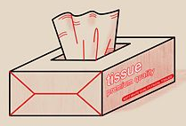  Object _________________________  Faces ______  Edges ______  Vertices _____ | Name of shape __________________  Object _________________________  Faces ______  Edges ______  Vertices _____ | Name of shape __________________  Object _________________________  Faces ______  Edges ______  Vertices _____
Name of shape __________________  Object _________________________  Faces ______  Edges ______  Vertices _____ | Name of shape __________________  Object _________________________  Faces ______  Edges ______  Vertices _____ | Name of shape __________________  Object _________________________  Faces ______  Edges ______  Vertices _____
Name of shape __________________  Object _________________________  Faces ______  Edges ______  Vertices _____ | Name of shape __________________  Object _________________________  Faces ______  Edges ______  Vertices _____ | Name of shape __________________  Object _________________________  Faces ______  Edges ______  Vertices _____

