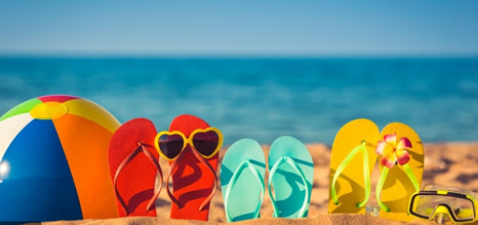
Hello 4/5N,
This is your final 3 weeks of Home Learning so there is a lot of content covered but hope everybody can find activities they enjoy here. After speaking to parents, I have included more science into this set of home learning – our class showed great enthusiasm for science at school so I hope you’ll enjoy the activites.
Thank you for those of you who completed their ‘Acts of Kindness’ worksheets. I have a nice collection of Headteacher stickers that I’m keeping safe for you.
I have compiled and created a variety of activities. You can start with the tasks that you are most interested in, but please remember to allow for some daily maths and literacy work.
If you would like to supplement your learning further, I highly recommend online BBC Bitesize daily lessons. This is a wonderful resource which may teach new concepts but also revisits previously learned material and is a great way for our class to refresh knowledge whilst on lockdown. Find your year group on https://www.bbc.co.uk/bitesize/dailylessons
I feel very fortunate to work alongside a fantastic team of UKS2 teachers and, while I shall miss those of you that do move on to a new teacher for Year 5, I expect all of you to prosper, under their outstanding guidance. My best wishes to all of you for a bright future ahead; it has been a privilege to teach you this year.
Mrs Bennett, Miss McVicker, Mrs McMillan and I wish you all a very happy Summer Holiday and we look forward to seeing your smiling faces again very soon.
Mrs New

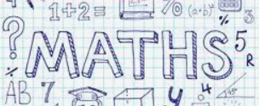 | 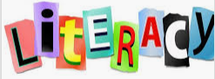
Please continue to complete your daily maths lesson, using the White Rose resources from the website.  Each day, watch a short video of a lesson. If there is a worksheet use it, otherwise write your answers in your exercise book.  You can find your lessons on this website: https://whiterosemaths.com/homelearning/year-4/ Please move onto the section labelled ‘Summer Term Week 8-10’. The videos are also available on Facebook, if the website is overloaded.  In addition, Mathletics tasks will be set.  Extension challenge:  - Try this memory game where you need to match equivalent fractions, decimals or percentages (if you complete level 1, there are 4 more levels to try further down): https://nrich.maths.org/1249  - You can extend your maths knowledge using any of the maths activities included at the end of this document. | Please follow the link below to access a home learning booklet called ‘The Impossibly Possible Bookshop’ (this can either be printed or you can write your answers and ideas in your exercise books):  https://www.talk4writing.com/wp-content/uploads/2020/06/Y4-Impossibly-Possible.pdf  This booklet is designed for you to work at your own pace, taking you through a series of literacy tasks related to the story including: reading comprehension, grammar, vocabulary and planning tasks. The booklet culminates in you producing your own story!  Please don’t try to complete this in one sitting. Try to complete a couple of pages per session as you work towards creating a fantastic leaflet – good luck!  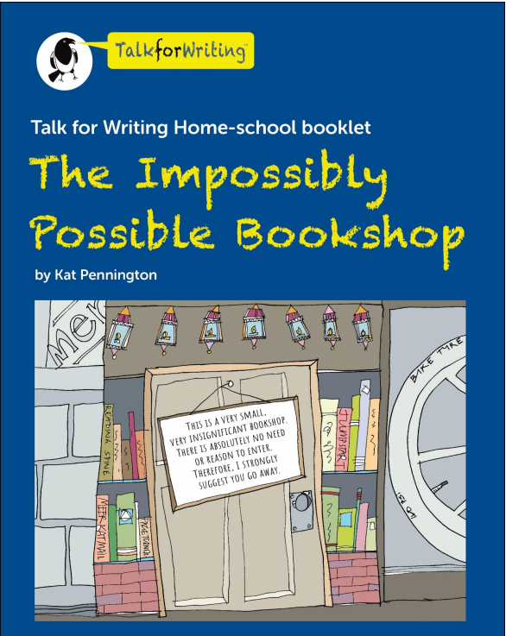
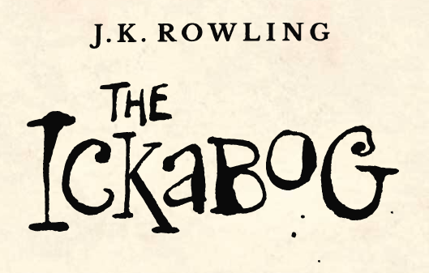
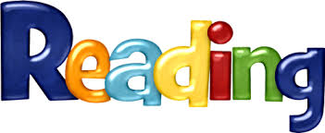

Reading – The Ickabog by J.K.Rowling

J.K. Rowling, author of the Harry Potter series, has recently released a new book which is available, in instalments, for free online!

It is a wonderful book (from what I’ve read so far) which we will be reading in school.

Please follow this link to read the chapters online:

https://www.theickabog.com/read-the-story/

J.K.Rowling is inviting children to create illustrations for each chapter and she will suggest themes for these illustrations (https://theickabogcompetition.com/illustration-themes)

In addition, the publisher for the book (Hachette) are running a competition open to 7-12 year olds whereby a parent/guardian can enter your drawings or paintings (https://theickabogcompetition.com/) for a chance for your illustration to be featured in the print version of the book with an intended due date of November 2020. Plus, you would receive a signed copy of the printed book, plus a school or public library of your choice will receive £500 of Hachette children’s books! What a fantastic set of prizes!

If you choose to enter the competition, please be mindful of the illustration instructions, these are quite specific and non-adherence can mean your entry could be rejected: https://theickabogcompetition.com/illustration-instructions Please be sure to read all the instructions on the competition website as I am unable to include all the details here.

J.K. Rowling has also written the following advice on The Ickabog site:

I won’t be judging the competition. Each publisher will decide what works best for their editions. However, if you, your parent or your guardian would like to share your artwork on Twitter using the hashtag #TheIckabog, I’ll be able to see it and maybe share and comment on it!

I hope you enjoy creating your own illustrations, and perhaps entering the competition, but, most of all, I hope you enjoy the story as much as I have been.

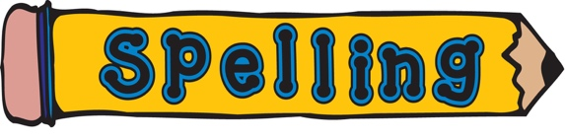  Can you use a dictionary to find out what these words mean and then learn how to spell them?  Don’t worry if you don’t have a dictionary at home, you can, with your parents’ permission, google it or use these online ones:  https://www.wordsmyth.net/  https://kids.britannica.com/kids/browse/dictionary.  - acid  - alkali  - base  - pH  - neutral  - indicator |  | Please access the following links which will take you to spelling games, which use words from the statutory spelling list for your year:  Spooky Spellings: This spelling game uses the words listed in the UK National Curriculum as being ‘Common Exception Words’ or tricky words.  http://www.ictgames.com/mobilePage/spookySpellings/index.html  Look, Cover, Write, Check: Test yourself on high frequency words, spellings patterns, tricky words or enter your own words easily to test your knowledge.  http://www.ictgames.com/mobilePage/lcwc/index.html

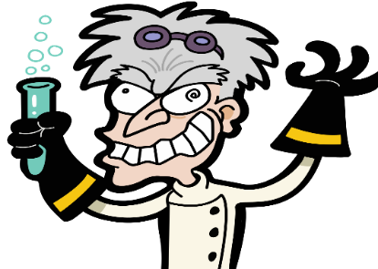

Science – Climate Change

What do you know about acidity?

Liquids can range from acids to alkali, with pure water considered neutral because it is neither acidic or alkaline. We can measure the pH of a liquid and this will tell us whether it is an acid (pH less than 7), neutral (pH of 7), or an alkali (pH greater than 7).

Acids may taste sour – can you think of any liquids that taste sour?
We have also learnt about the acids present in our stomachs, which help us break down food.

If your parents give you permission, I would like you to carry out the following experiments (with adult supervision) which will help us gain a better understanding of acids and how this relates to climate change.

You can buy pH Universal Indicator Paper online, but I know this probably won’t be readily available at home. If you don’t manage to obtain the indicator paper, you can use red cabbage juice which is a natural indicator. Make sure an adult is available to help you prepare the cabbage juice as this will involve boiling liquid.

How to prepare red cabbage juice:

- Chop up your red cabbage into small pieces. Place 2-3 cups in a saucepan and cover with water.
- Bring the solution to a boil and then turn off the heat. Let it sit for about 30 minutes to cool down.
- Pour the cabbage water through a strainer into a jar or large measuring cup. The dark purple liquid in the jar is your indicator.

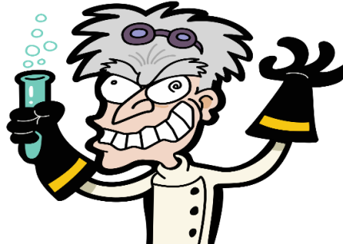

Science – Climate Change

Experiment 1: what effect does carbon dioxide have on water?

For this experiment you will need:
- Glass with 200ml still water
- Glass with 200ml sparkling water
- pH indicator paper (or red cabbage juice)
- pH scale (on a sheet below)
- lemons
- soap

- Test the lemons and soap for pH. If you’re using indicator paper, this will involve a dip test and then match the colour to the pH scale below. If you’re using red cabbage indicator use a very small amount of the indicator at the bottom of a cup, then slowly add the lemon or soap – if the solution turns reddish-pink, you have an acid. If it turns bluish-green (or yellow), you have an alkaline solution.
- Next, predict what pH the two waters (still and sparkling) may have. Then, test for pH.
- What difference in acidity did you observe? Why do you think this is? Are the results what you expected? What implications does this have for your teeth (choices of beverage)?
- Fill in the ‘Working Scientifically’ recording sheet attached at the end of this document.

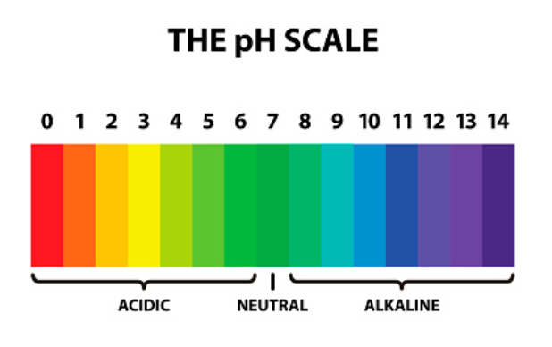

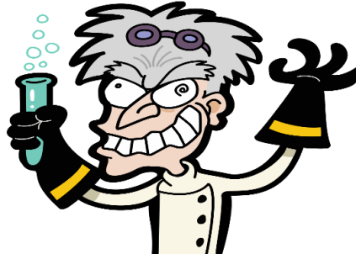

Science – Climate Change

Experiment 2: what effect does acid have on sea life?

For this experiment you will need:
- Glass of 200ml clear vinegar
- Glass of 200ml sparkling water
- Glass of 200ml still water
- Sea shells
- pH indicator paper (or red cabbage juice)
- pH scale

- Test the 3 liquids for pH (using indicator paper or red cabbage juice).
- Add a similar shell to each glass and observe any reactions.
- How might a more acidic ocean affect organisms that rely on shells for protection? How might it affect organisms that depend on these animals for food? Do you know the effect that more acidic oceans can have on a coral reef? What is causing the increase in acidity in our oceans?
- Fill in the ‘Working Scientifically’ recording sheet attached at the end of this document.

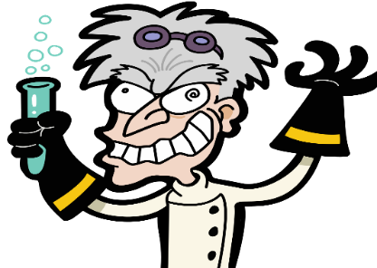

Science – Climate Change

I hope you enjoyed your experiments and now have deeper insight into the effect of acid in our oceans. For the science behind these experiments, and to extend your understanding, these links provide a wonderful starting point for your research:

https://climatekids.nasa.gov/acid-ocean/#:~:text=Acids%20can%20break%20down%20the,slowly%20and%20weaken%20coral%20reefs.

https://archive.epa.gov/climatechange/kids/impacts/signs/acidity.html

https://archive.epa.gov/climatechange/kids/expeditions/temp-acidity/index.html

You could also ask an adult if you can the ‘Blue Planet’ or ‘Blue Planet II’ documentary series on BBC iPlayer (you can also watch parts of the series on YouTube), which addresses the impact of climate change on our oceans.
https://www.bbc.co.uk/iplayer/episodes/b008044n/the-blue-planet

Finally, since Lockdown, I have become a huge Maddie Moate Live fan and the experiment she performs in this video is a brilliant example of how to use red cabbage as an indicator (the experiment starts 13 minutes into the video):

https://www.youtube.com/watch?v=uMqJW0SWCLA

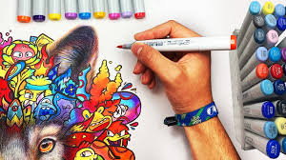

Art: Roll a Picasso

Pablo Picasso (1881-1973) was born in Spain and co-founded the Cubist movement. Cubism was a new way of painting, in which artists would paint a person or object from different angles using geometric shapes. The artists created a picture of something by breaking it up into different blocks. Picasso’s painting are amongst the most expensive in the world. To learn more about Picasso visit: https://www.tate.org.uk/kids/explore/who-is/who-pablo-picasso

Here are a few examples of his work:

Can you draw a Picasso? On the following worksheet there is a ‘Roll a Picasso’ game where you can roll a die and complete your own Picasso face. The following video will give you an idea of what you can produce:
https://www.youtube.com/watch?v=jNImtSGQwiY
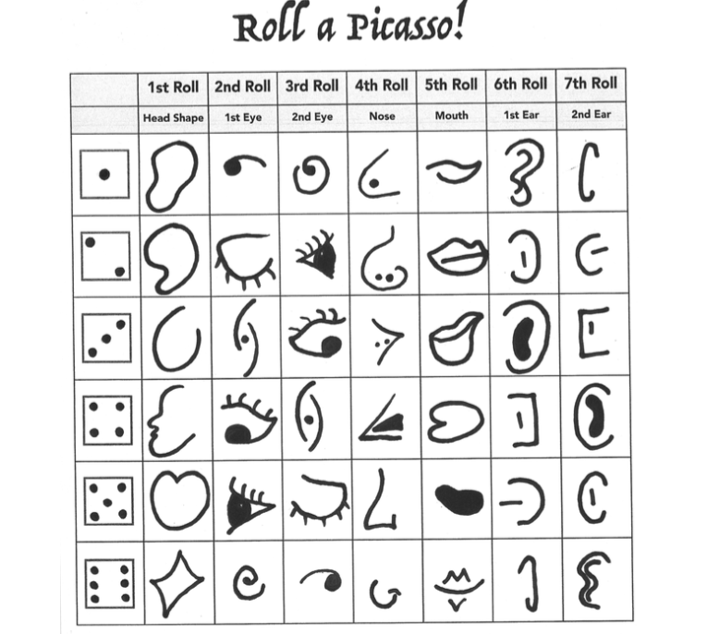
Modern Foreign Languages - German  This is a great opportunity to learn languages: at your own pace and in your own home. In class, we will be learning the basics of German.  Try Duo Lingo, which is a free language course online, to help you grasp the basics of German.  https://www.duolingo.com/  When you register you can choose the pace at which you would like to learn.  In addition, the fabulous Bitesize has plenty of lessons to help you learn German, which can be found via the following link:  https://www.bbc.co.uk/bitesize/subjects/zg8jmp3 | Art / DT / Science  Covid 19 has been in the news constantly this year. It has a weird appearance, with lots of spiky projections! Your challenge is to build a 3-d model of the virus. You might like to use papier mache and cardbaord, and lots of brightly coloured paint. Here is an image to inspire you.  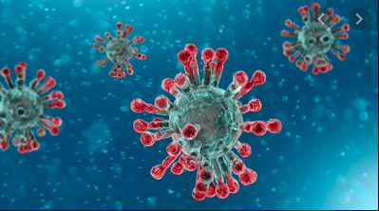
 |  | 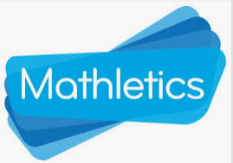
Please try to learn spellings from the Statutory spelling list provided, and remember to highlight any you get correct on the sheet. | SPAG (spelling, punctuation and grammar) activities will be set online. | Mathletics activities will be set in addition to White Rose tasks.
Please complete your weekly times table test, giving yourself 5 minutes to write answers in your book, then self-mark and keep a record of your total along with the date.  For further challenge, you can choose to complete the division test. | Please read for at least 30 minutes every day this week.  Try to read aloud with an adult, at least once, and discuss what you’ve read with them.  Once you have read a book, please complete a book review in your exercise books. | ICT  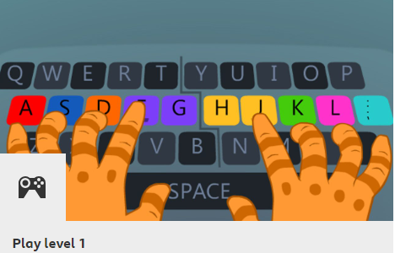  It’s a great skill to be able to type fluently and there is a fantastic free resource, called ‘Dancemat’ available on the BBC Bitesize website to help you to learn how: https://www.bbc.co.uk/bitesize/topics/zf2f9j6/articles/z3c6tfr

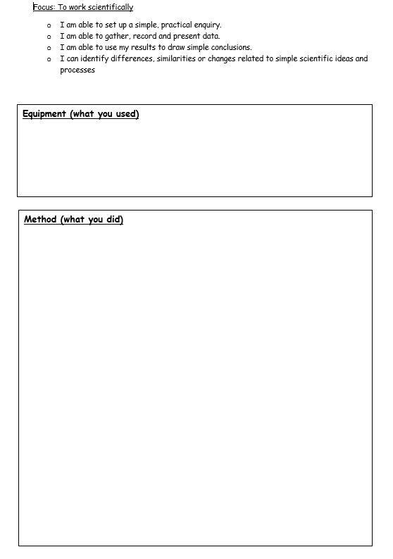
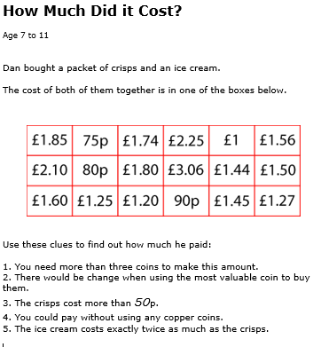

Marshmallow Engineering
You will need:
- Mini marshmallows
- Toothpicks or spaghetti

Can you build some 3D shapes using the above materials? See how many you can make – you could then complete a table in your exercise book to show the names of the shapes you’ve made as well as columns to record the number of faces, edges and vertices.
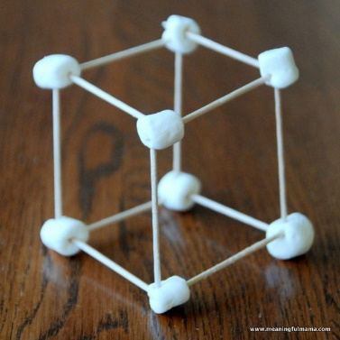

Extension: Can you build a more elaborate structure? This might be a bridge or tower. Can you test the robustness of your design by placing objects on top and seeing if your structure can withstand their weight?

Measuring angles
Look at the learning going on in this picture!
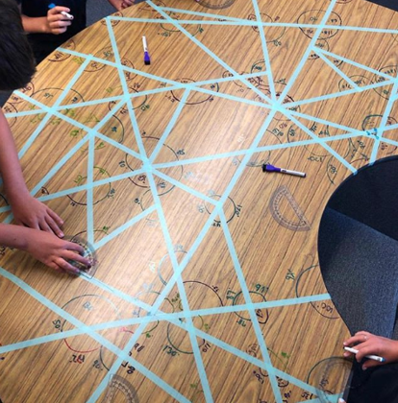
I am not suggesting you start drawing on the tables at home, but you could try the same activity on a large piece of paper.
To get you started you will need:
- A large piece of paper
- Some masking tape
- A protractor
- A pencil
What do you notice about the sum of the angles in a triangle?

Missing Angles in Triangles
Can you find out the sum of the angles of any triangle?
Once you’ve found the answer, have a go at the following activity:
