Numeracy  Congratulations to Thomas, Harry, Amelia L, Matthew, Elizabeth, Joseph and Tristan who have all completed the Mathletics program for Year 3.  Mathletics will be closing during the summer holidays so please try to finish the course in the next few weeks if you haven’t done so yet.  Please also try the sheets below to consolidate all our learning this year. Practise adding totals and finding change with money too. | Literacy  Practise spelling another ten key words each week and keep reading.  Can you improve your grammar with the activities below?  Also try to write your own play scripts like the one on the sheet.  If you want to do more writing, draw the map of a theme park and create an information leaflet. You could also design the café menu and shop.  You might also design your dream house and garden and write the estate agent’s brochure. | PE  Keep doing your regular exercise/sport.  If you want to try new things, have a look at these on Youtube.  Get kids moving- Harry Potter and other themes including Supergirl.  Pop sugar family fun cardio workout  Go noodle, Cosmic yoga  BBC supermovers  Kidz bop daily dance break  Debbie Doo dance and movement  Little sports and Just Dance.
If you have run out of reading books sign up to www.oxfordowl.co.uk for free e books.  Can you join in the summer reading challenge organised by the library? The website will tell you how to access even more books.  https://summerreadingchallenge.org.uk/  PSHE  Healthy living and kindness to yourself and others is our theme for the rest of this term.  Perhaps you can design a healthy meal plate and make a list of healthy foods/drinks/recipes you would like to try next.  You could find words/quotes about kindness and make a paper chain or mobile of clouds and rainbows to display them. | 3CO  We would love to see your photos and work.  tamasin.craven@cranwell.lincs.sch.uk  jill.owen@cranwell.lincs.sch.uk  This is for the rest of the school year.  We hope to see you all again in September.  Thank you for being our best class ever and for all your lovely emails showing us that you are still enjoying yourselves. | Geography  Our topic this half term is all about the United Kingdom. Find out about the mountains, counties and how London has grown.  Record your findings on the maps below. Can you label some counties of the UK? Where is Lincolnshire? Which counties are our neighbours? Where have you visited? Where are the mountains in England, Ireland, Scotland and Wales? Which are the highest?  Can you find out more about London through time and how its geography has changed?
Art/DT  Find out about famous artists of the UK and try to recreate some of their famous works. (David Hockney, Banksy, Blake, Constable, Turner, Rossetti, Rennie Mackintosh etc)  https://www.tate.org.uk/kids  https://www.metmuseum.org/art/online-features/metkids/  Check out Rob Biddulph’s how to draw series on Youtube too. | Home learning for 3CO  Keep trying to do an hour’s exercise, some numeracy and some literacy or another subject.  However, imaginative play, baking, art work, playing card and board games and chatting to friends and family is just as important to keep happy and healthy.  Just do the best you can! | ICT  Choose a county or city of the United kingdom to research in more detail and present your information as a PowerPoint. Add pictures and photos if you have been there. Maybe you could record yourself speaking too and include a quiz.  Can you try cooking a popular sweet or savoury dish from your chosen county?  (If someone in your family can use Excel perhaps they could show you how to organise number information and to calculate sums.)
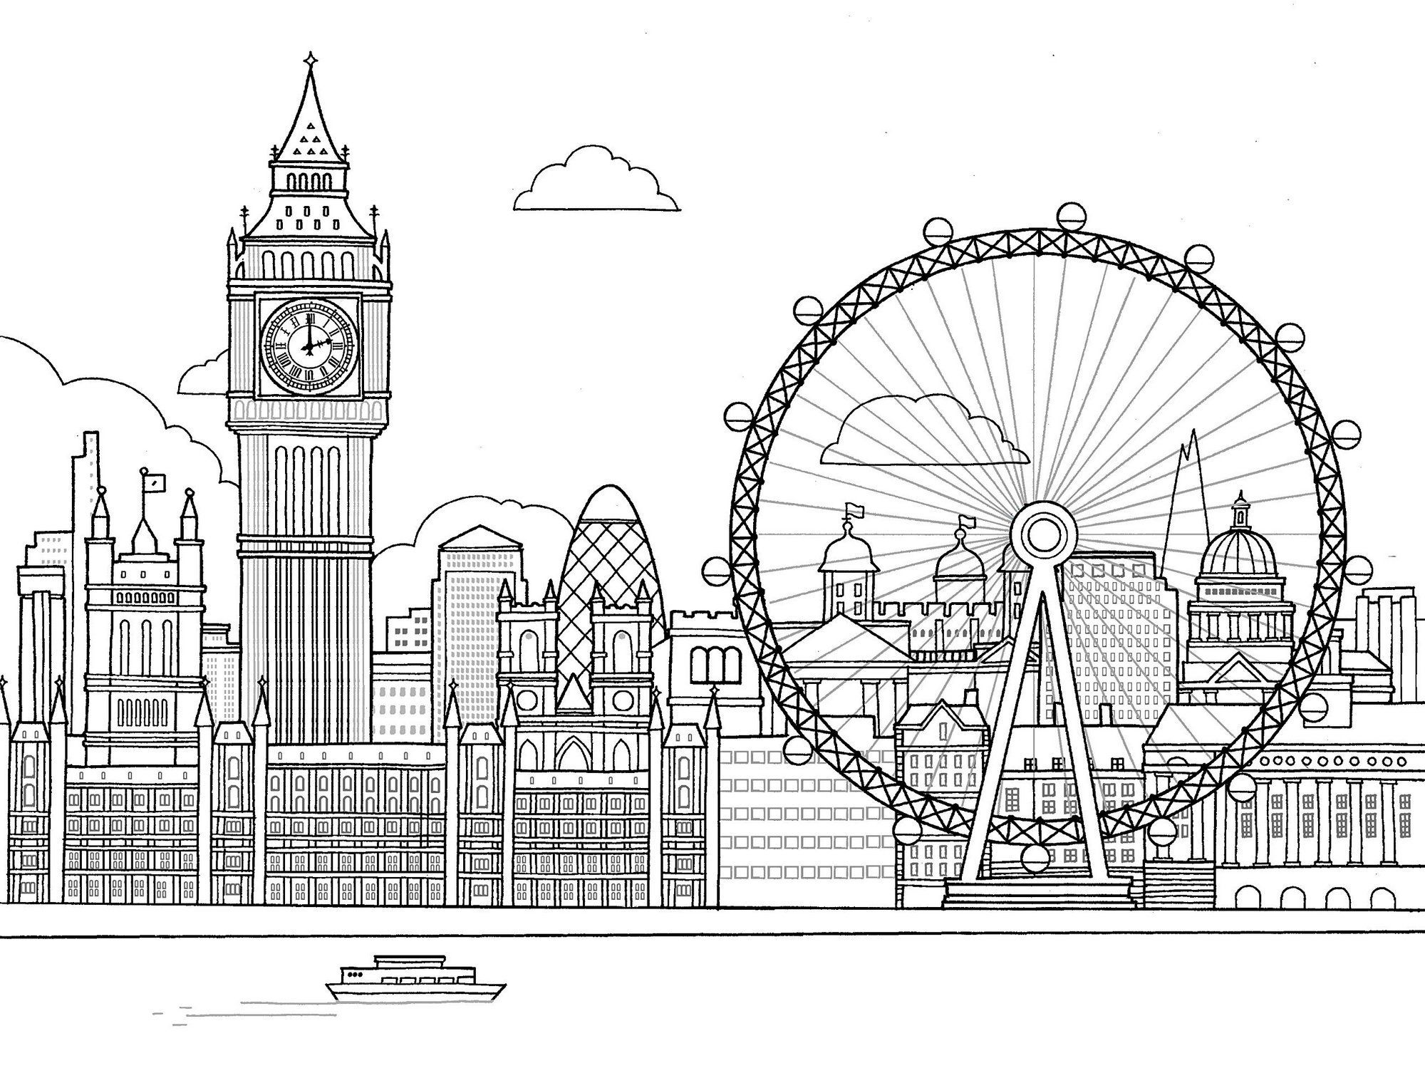
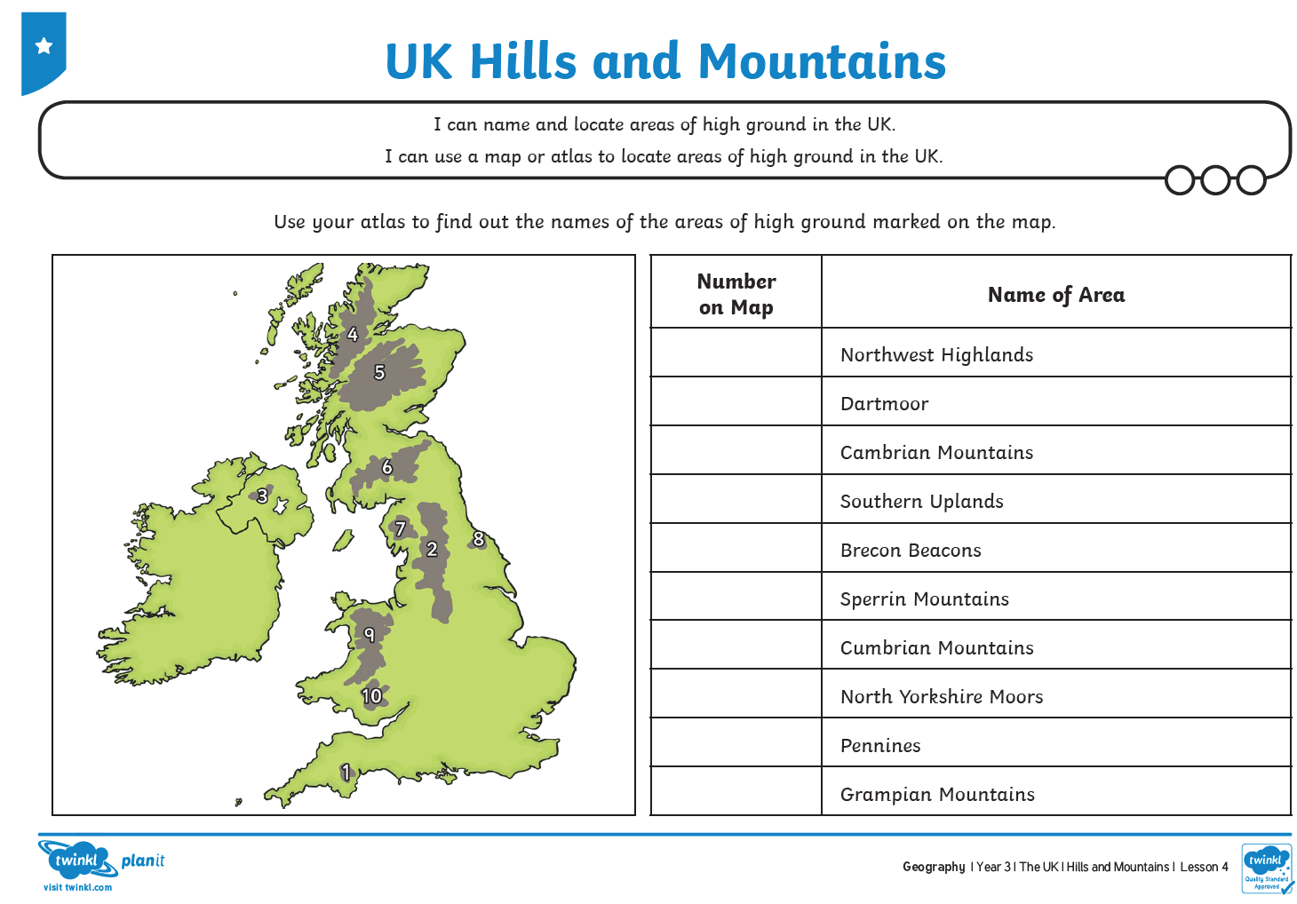

Which are in England, Ireland, Scotland and Wales? Which are the highest mountains in each country?

Which of these statements are about London in a) AD 60 (Just after the Roman times) b) AD1666 (The Great Fire) c) AD2012?
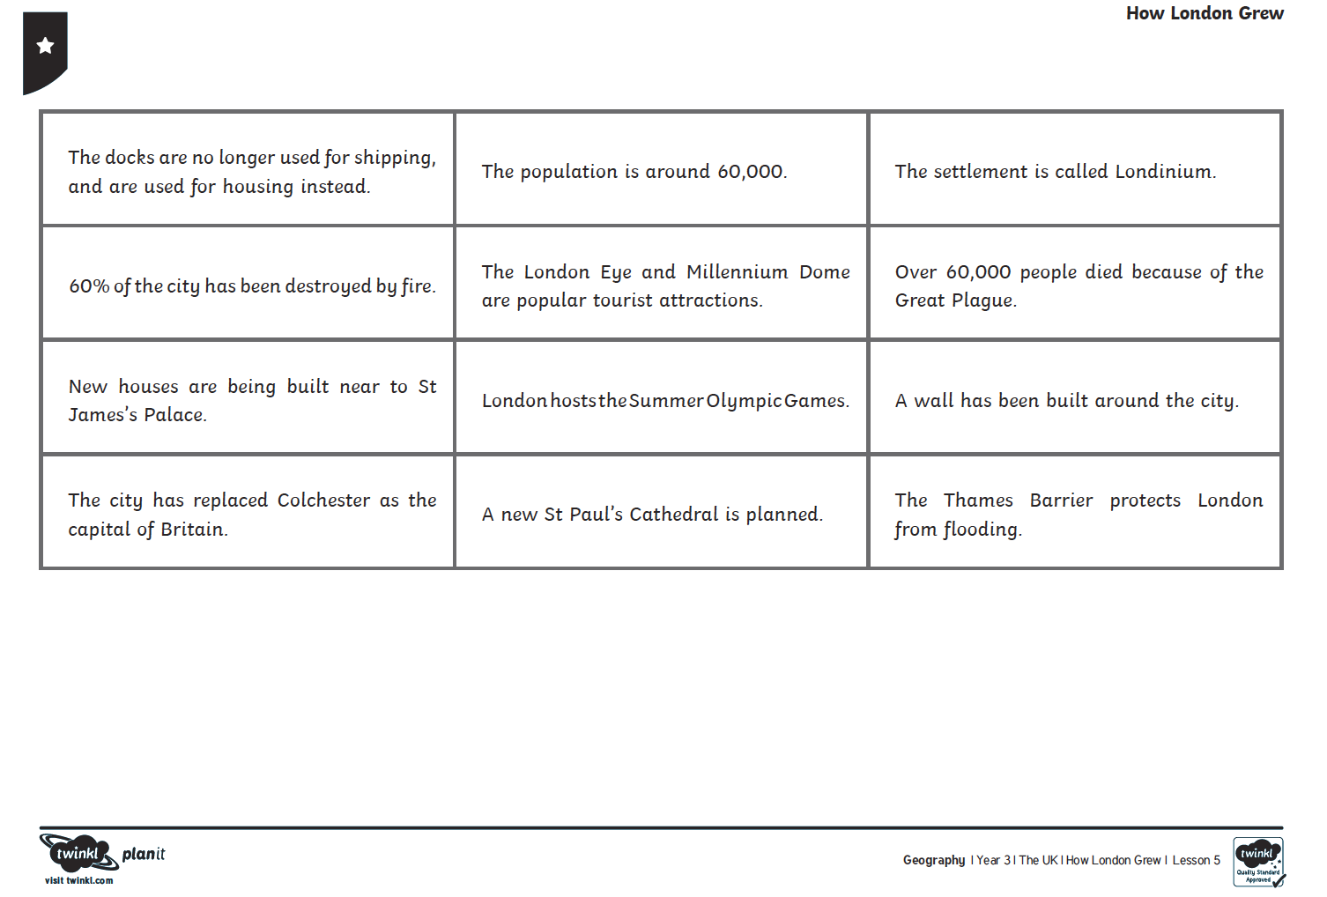

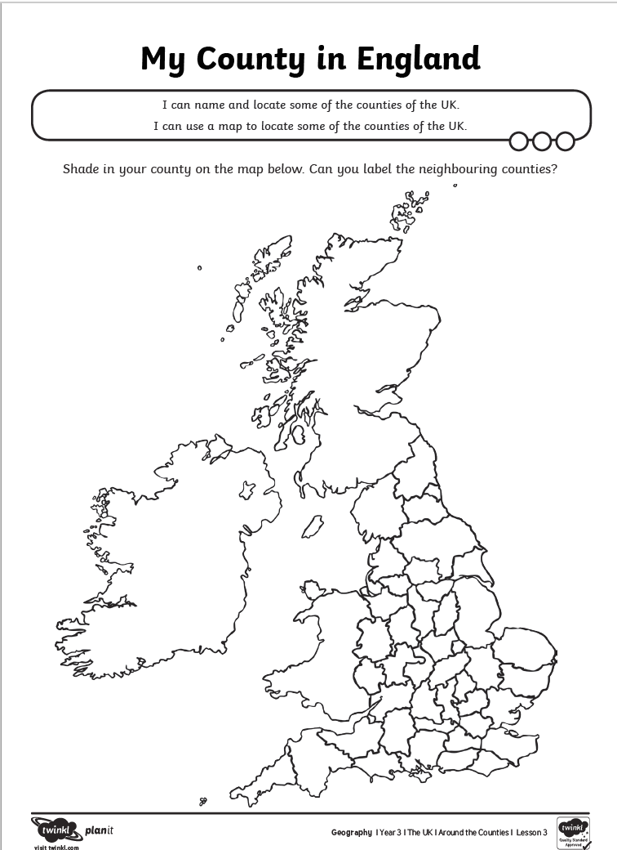
Colour code Lincolnshire, some neighbouring counties and some others you have visited or heard of. Make a key to show which county is which colour.

Try the fun compass directions puzzle.
Can you make a treasure hunt in your house using them too?

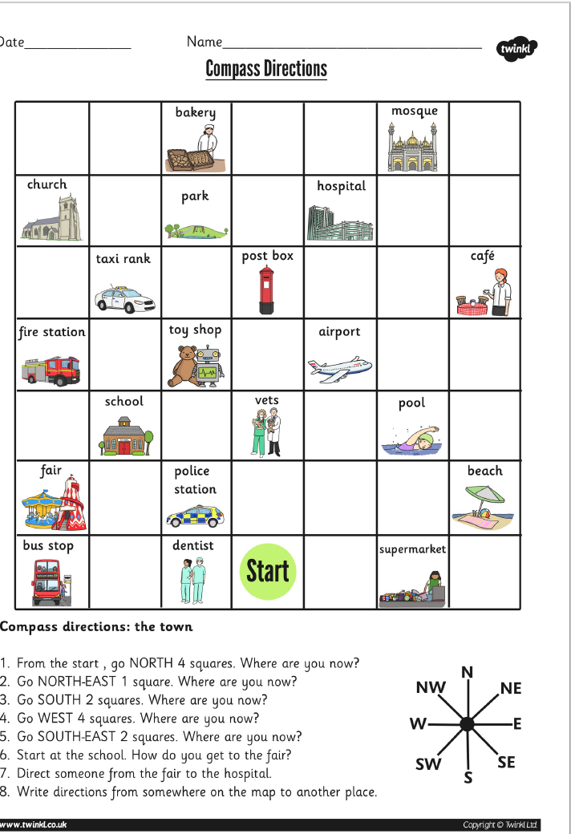

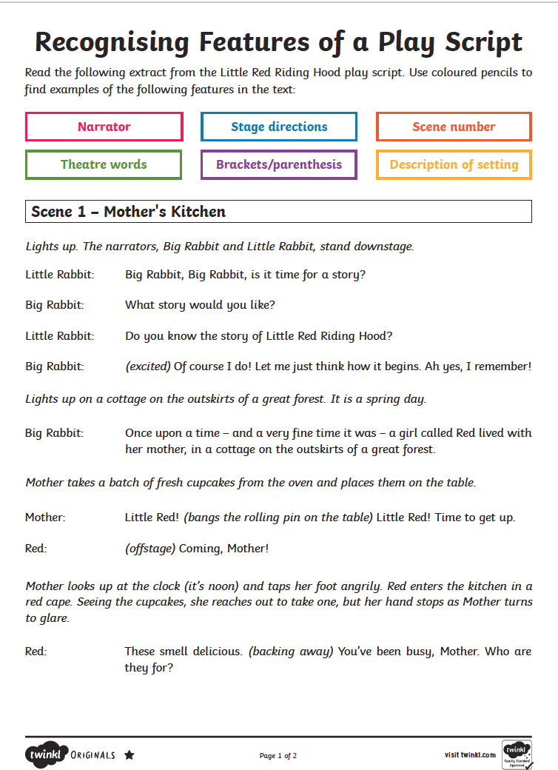

Now try to carry on the story of Little Red Riding Hood as a playscript using character names, no speech marks, stage directions and different scenes.
Year 3 mixed maths Date
Use the column methods for addition and subtraction, grid for multiplication and bus stop for division.

642 + 137 = | 357+246 =
373 + 644 = | 413 + 796 =
567 – 213 = | 987 – 753 =
540 – 238 = | 895 – 478 =
______= 26 x 4 | 37 x 3 =
3/5 + 1/5 = | ¾ - ¼=
1/3 of 15 = | ¼ of 20 =
2/3 of 18 = | ¾ of 16 =
75 divided by 5 | 64 divided by 4
6 x 2 = 3 x ______ | Make 234 in 2 different ways  ______ + _______+ __________= 234  ______ + _______+ __________= 234
Now finish Mathletics activities.

L.O. How many questions can you answer in the Year 3 Maths quiz?

What unit of measure would you use to find the following?
(Litres/millilitres-l/ml, grams/kilograms-kg/g, metres/centimetres-m/cm, degrees centigrade- C)

capacity of a cup= mass of an apple= height of a door =

How many hours in 1 day? How many days in a week?
How many weeks in a fortnight? How many weeks in a year?
Say the days of the week/months of the year out loud.
Learn:- 30 days has September, April, June and November.
All the rest have 31 except February alone, which has 28 and 29 in a leap year.

What is the time if the big hand is on the 3 and the little hand on the 4?
What would the time be if the big hand turned through 2 right angles?
Draw coins to show 2 ways to make £2.53

Draw a square with sides 2 cm long and mark the vertical line of symmetry.
What is its perimeter?________Put crosses on 2 parallel lines, tick 2 lines that are perpendicular.

Now draw and label 2 D shapes that have 1 side, 5 sides and 8 sides.
Put R in right angle corners, A in acute and O in obtuse.

What 3D shape has two circle faces? What 3D shape has 4 triangle faces?
How many edges does it have? How many edges does it have?
How many vertices? How many vertices?

LOOK AT THE KEY FIRST! 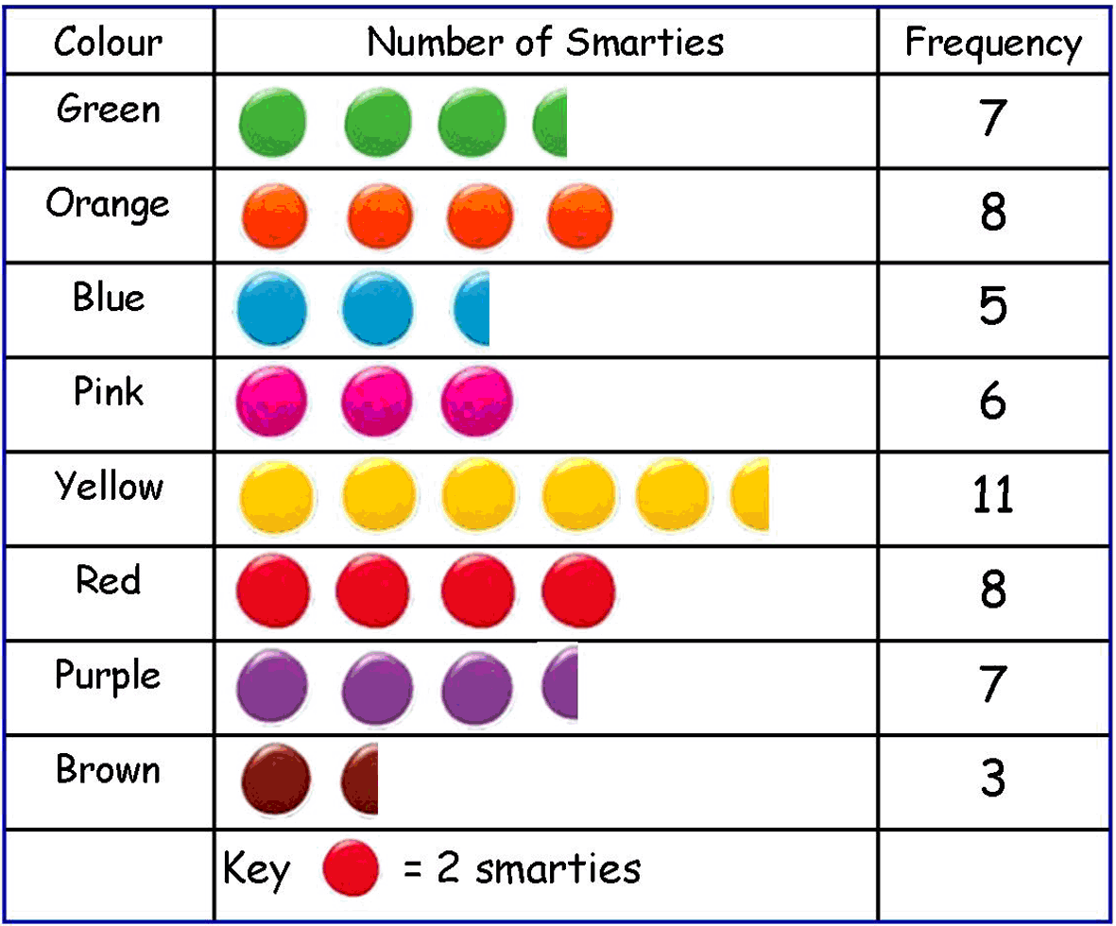
What does one smartie picture mean?
How many children like orange best?
Which colour was the least favourite?
How many more children prefer purple than brown?
How many children like blue or pink?
How many children were asked altogether?
Which colour did one fifth of children like?

