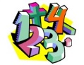
Maths
For the next three weeks we are using the White Rose alternative plan for summer Week 9, 10 and 11.
The topics are; angles, shape and mass

Times tables
You need to keep practising your times tables. Have a look on the times table page for websites to help you.
Writing/Topic
Hamilton Trust Home Learning Pack Week 9 & 10
Science – Forces and Magnets

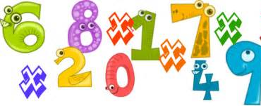

Extras – PSHE
Be Kind – Pat Zeitlow Miller

Reading
We would normally read every day in class – try to read every day and record this in your reading record. If you have finished your reading record could you make your own or just write down your page number on paper.
Hamilton Trust Learning Pack – Reading comprehension (W9)
Ham

Spelling Punctuation and Grammar
Use this time to learn the words from the 3/ 4 Word list you can find in the front of your planner.
Hamilton Trust Home Learning Pack – Description, dialogue and adverbs.
Maths Activities
It was great to hear that you all have been working hard on your maths whether that is through the White Rose videos, BBC Bitesize or Mathletics! This work is to last you three weeks.
These three topics are from the White Rose website.
https://whiterosemaths.com/homelearning/year-3/
Click on the weeks 9, 10 and 11 when they are available. Watch the videos and complete the questions as you go along. I have provided the worksheets to match in Extra Resources.
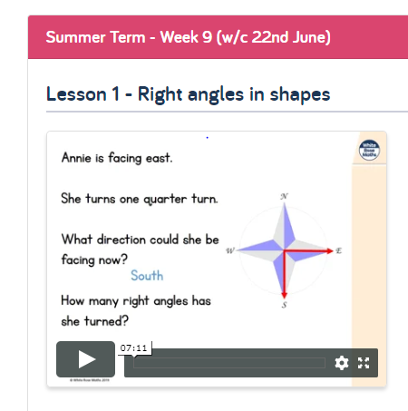

Don’t forget to check Mathletics and Education city for extra activities.
https://login.mathletics.com/ https://www.educationcity.com/

Extra Maths Games
https://play.prodigygame.com/ - Pokemon style game with maths questions!
https://play.edshed.com/ - practise your number bonds, power of 10 and addition and subtraction
www.topmarks.co.uk –interactive games
https://www.oxfordowl.co.uk/for-home/kids-activities/fun-maths-games-and-activities/#maths-7-9 – games and activities
https://www.mathswithparents.com/KWeb?startTime=1584558592239#menu584883 – Free access to parents – videos and activities across the maths curriculum.

Times Table Activities
I have had a few questions about the expectations of times tables in Year 3 so to make you all aware by the end of Year 3 children should be able to know (off by heart and in any order) the 2,3,10,3,4 & 8 times tables. Year 4’s are expected to know all of their times tables by the end of the year ready for the National Multiplication Check.

https://play.ttrockstars.com/auth/school - Times Table Rock Stars is a great way to practise your times tables
https://www.timestables.co.uk/ - Learn and practise
https://www.topmarks.co.uk/maths-games/7-11-years/times-tables
https://www.oxfordowl.co.uk/for-home/maths/help-with-times-tables/
Literacy Activities
Week 9
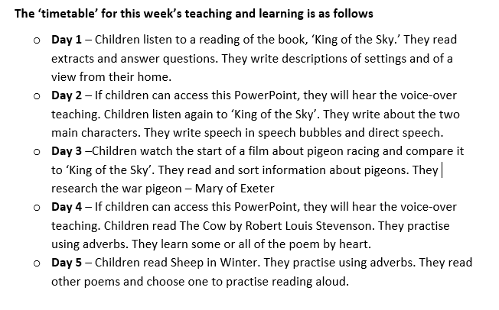
Hamilton Trust Literacy Home Learning Pack.
https://www.hamilton-trust.org.uk/blog/learning-home-packs/
Scroll down the page to find the YEAR 3 English links
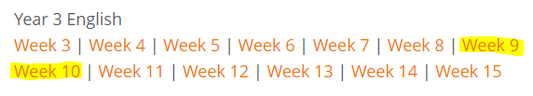

Week 10
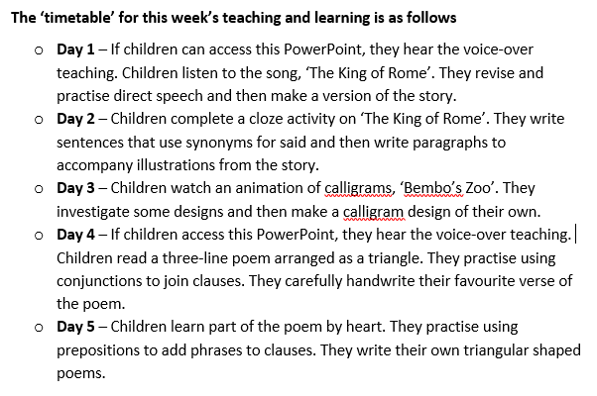
Click on Week 9 and 10 to download all of the rources and plans needed. There are about three activities per day. I understand this is a lot so do not feel you have to stick to the “Day” structure as long as the activities are completed in order.

Spelling Punctuation and Grammar Activities
Hamilton Trust English Pack Week 9 & 10 (See Literacy Page) have activities based on descriptive writing, direct speech, adverbs, conjunctions and prepositions.

You have a list of words in your planner than you need to know by the end of Year 4. Learn some of these that you did not know before. Find them in a dictionary and write them in a sentence.
https://go.educationcity.com/ - Log in and select classwork to find a selection of SPaG activities to complete.
https://www.topmarks.co.uk/english-games/7-11-years/spelling-and-grammar - A selection of different games and activities to help you learn and practise SPaG topics.
https://www.bbc.co.uk/bitesize/dailylessons - If you want to extend your learning this is a great resource which may teach new concepts but also revisits previously learned material and is a great way to refresh your knowledge whilst on lockdown.
Science activities – Forces and Magnets
Log on to Education city to find some games and activities based on Forces and Magnets.  https://www.educationcity.com/ | What is a force?  https://www.bbc.co.uk/bitesize/topics/zvpp34j/articles/zywcrdm  Watch these videos which help to explain what friction is.  https://www.bbc.co.uk/bitesize/clips/z79rkqt  https://www.bbc.co.uk/bitesize/topics/zsxxsbk/articles/zxqrdxs  Watch these videos which explain magnets and their invisible force.  https://www.bbc.co.uk/bitesize/clips/zk9rkqt  https://www.bbc.co.uk/bitesize/clips/z3gvr82 | Magnet strength investigation. Can you conduct an investigation to find the strongest magnet you have at home?! See the ‘Magnet Strength’ sheet included in the extra resources.
Can you complete the forces and magnets quiz? Perhaps you could do a family quiz or test someone in your house once you have worked out the answers. |  | Can you make a magnetic compass? Follow the instructions on the ‘Make a Magnetic Compass’ sheet included in the extra resources.  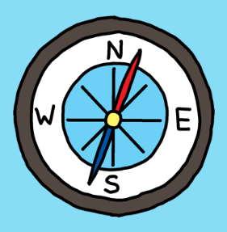
Can you design and make your own magnetic game?! Use the ‘Magnetic Game’ sheet included in the extra resources to design, make and evaluate your game.
Extras!
https://www.youtube.com/watch?v=vmixodlT3T4 – Listen to the story how can you try to be kind to your family and friends?
Make a kindness rainbow https://colorations.com/activities/rainbow-of-kindness-mobile/

If you want some extra PE resources these are things we use in class;
https://www.cosmickids.com/ - Yoga
https://www.youtube.com/watch?v=gCzgc_RelBA – Just Dance
https://www.youtube.com/watch?v=mhHY8mOQ5eo – Joe Wicks Fitness video

