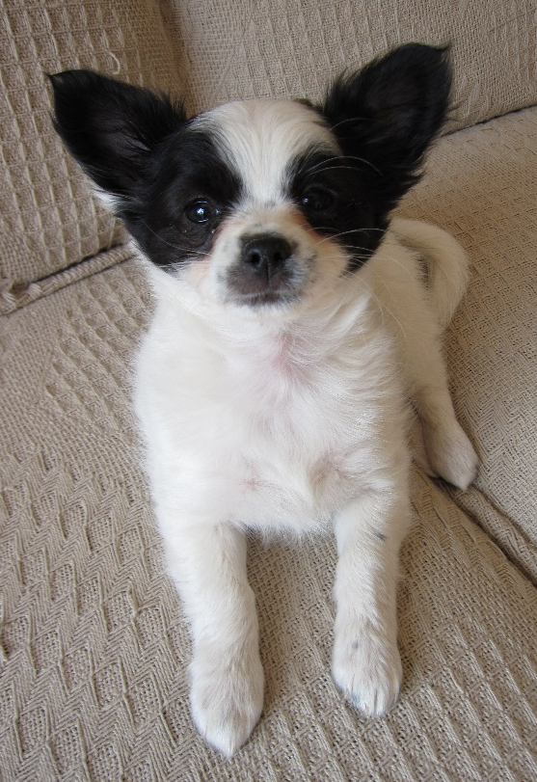
Hello 4/5N,
We are not at school for the next two weeks, but I hope we all use this time to both enjoy being at home and to keep your learning going until we meet again on 5th October!
I have attached lots fo work for you to progress through during the next two weeks. I have provided various options for you to complete your work. You may not finish everything, but please make sure your focus is on maths and literacy activities.
You should be able to complete these independently but ask Mum or Dad if you need help. Please email the school at enquiries@cranwell.lincs.sch.uk if you need assistance with logins, etc.
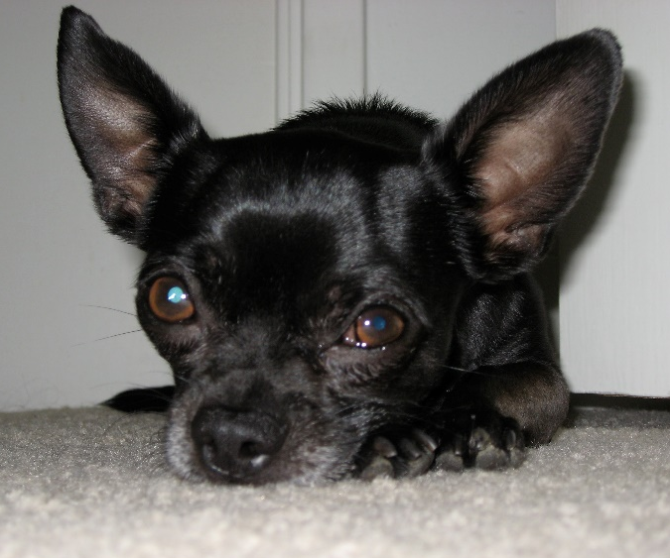
I wanted to introduce you to my dogs, Alfie and Charlie, who are both very excited to have me at home to give them an extra ‘walkies’. I hope all of you enjoy some extra time with your loved ones at home. I can’t wait to hear about what you have done during your time off when we get back to school.
Take care and see you all soon, Mrs New

Week 1 |  | Week 2
For maths we will be using a combination of videos and worksheets. We will access materials available online from White Rose Maths and The National Academy. Please follow the links given below for each objective.  Please continue to complete your daily maths lessons as follows:  Mon Find 10,100 or 1,000 more/less (1)  https://classroom.thenational.academy/lessons/finding-10-100-or-1000-more-than-a-given-number-cmu62c  Tues Find 10,100 or 1,000 more/less (2)  https://classroom.thenational.academy/lessons/finding-10-100-or-1000-less-than-a-given-number-c8w3gc  Wed Order and compare 4-digit numbers (1)  https://classroom.thenational.academy/lessons/ordering-and-comparing-numbers-beyond-1000-cmr66c  Thurs Order and compare 4-digit numbers (2)  https://classroom.thenational.academy/lessons/ordering-  and-comparing-a-set-of-numbers-beyond-1000-6nh36r  Fri Round to nearest 1,000  https://classroom.thenational.academy/lessons/  rounding-numbers-to-the-nearest-1000-crr66d |  | For maths we will be using a combination of videos and worksheets. We will access materials available online from White Rose Maths and The National Academy. Please follow the links given below for each objective.  Please continue to complete your daily maths lessons as follows:  Mon Count in 25s  See worksheet below  Tues Negative Numbers  https://www.bbc.co.uk/bitesize/topics/znwj6sg/articles/zxthnbk  Video, game and short quiz  Wed Negative Numbers (2)  See worksheet below  Thurs Roman Numerals  https://www.youtube.com/watch?v=P84MK_wJsPc  You only need to know up to 100, so watch the first 9 minutes.  Fri Roman Numerals / Place Value Assessment  Worksheet / Mathletics
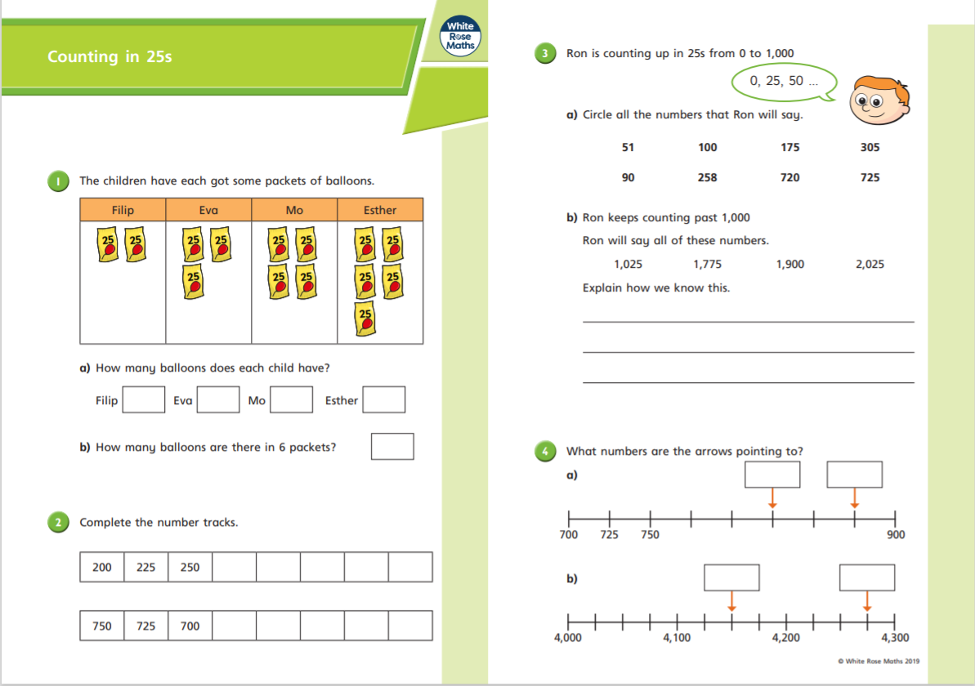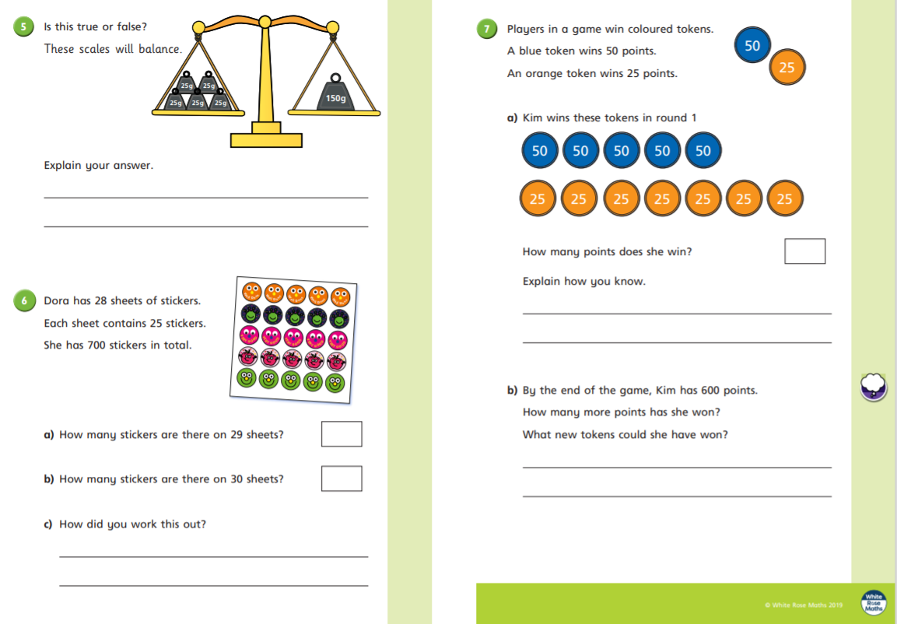
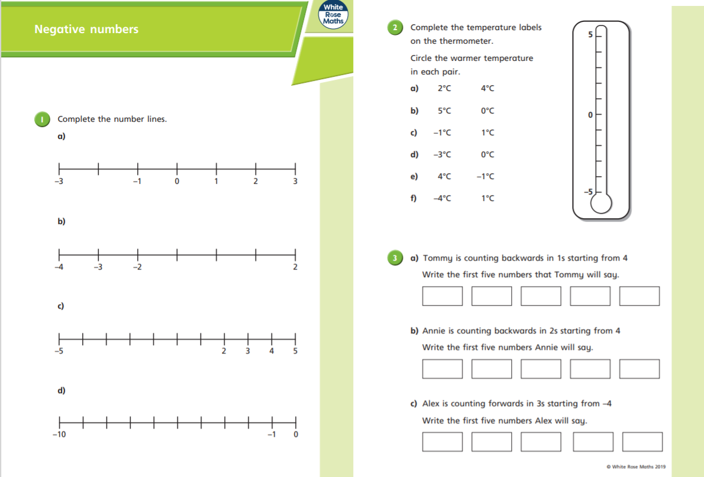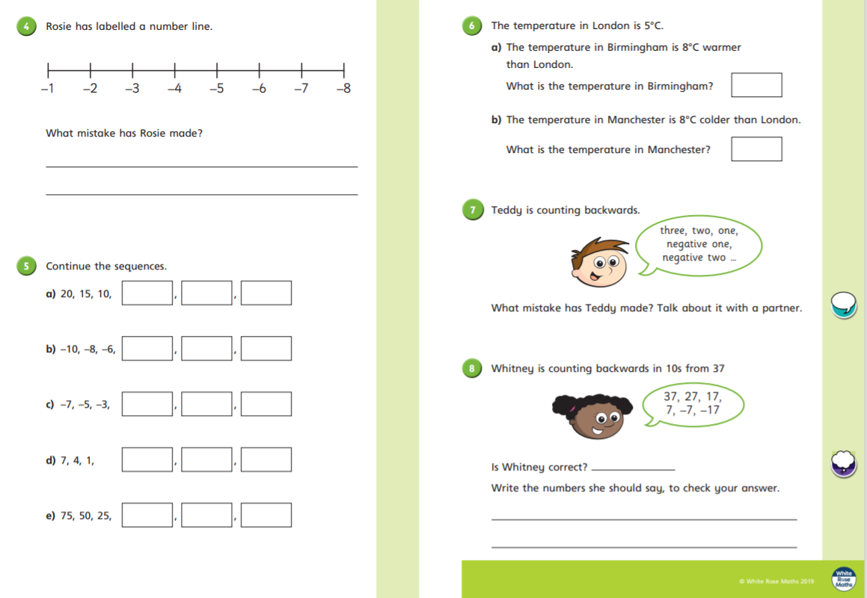
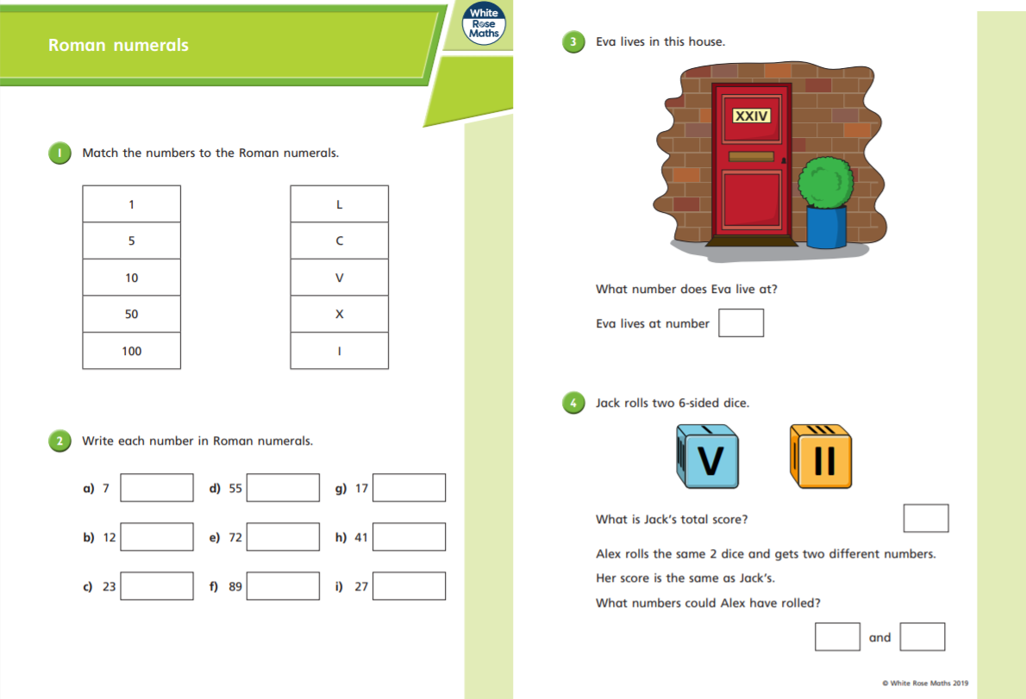
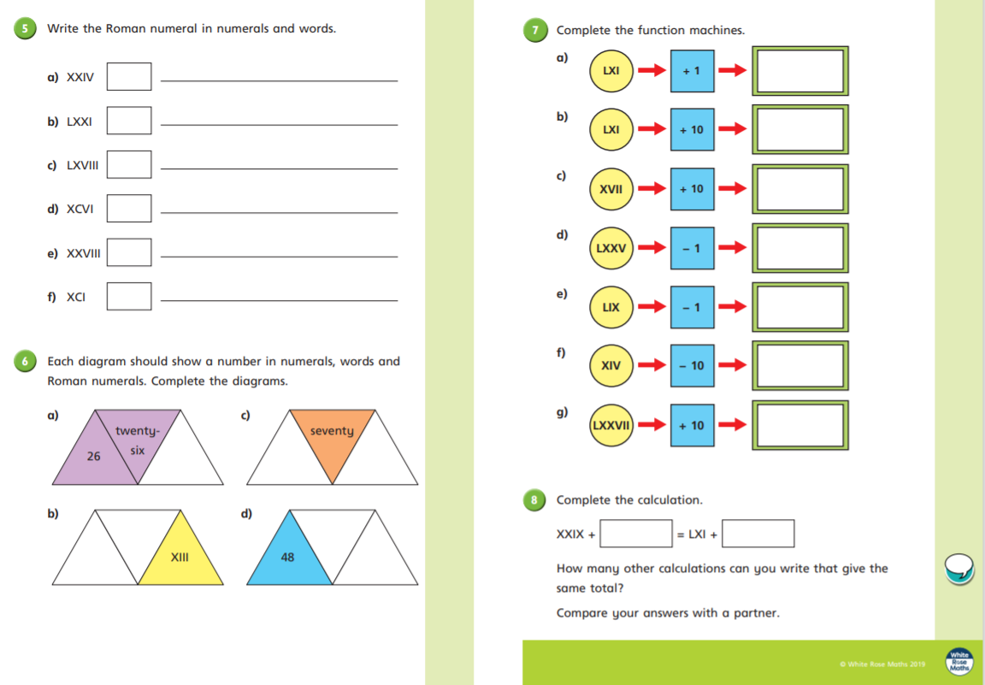

Please follow the link below to access a home learning booklet called ‘The King of Fishes’ (this can either be printed or you can write your answers and ideas in your exercise books):

https://www.talk4writing.com/wp-content/uploads/2020/04/Y4-Unit.pdf

This booklet is designed for you to work at your own pace over a two-week period, taking you through a series of literacy tasks related to the story including: reading comprehension, grammar, vocabulary and planning tasks. The booklet culminates in you producing your own story!

Please don’t try to complete this in one sitting. Try to complete a couple of pages per session as you work towards creating a fantastic story – good luck!

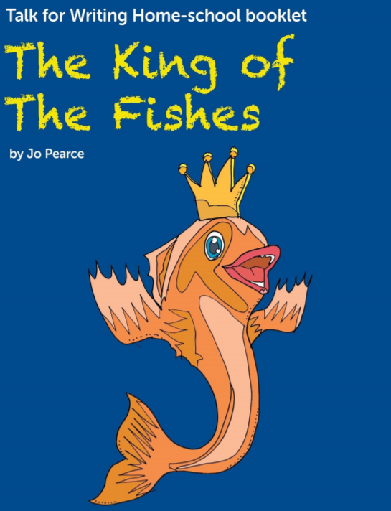

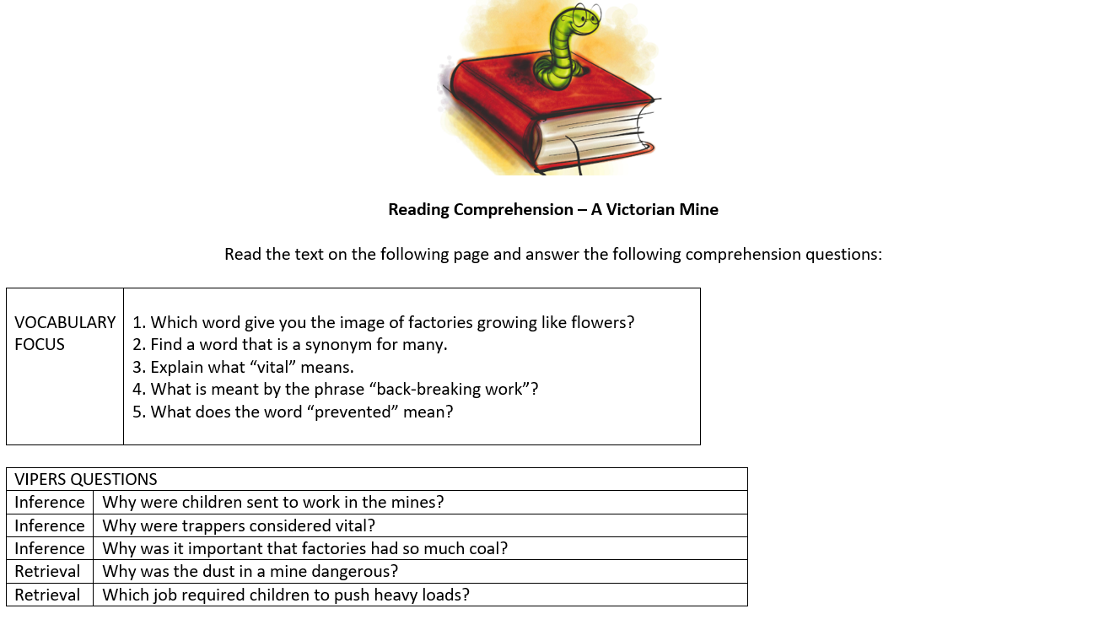
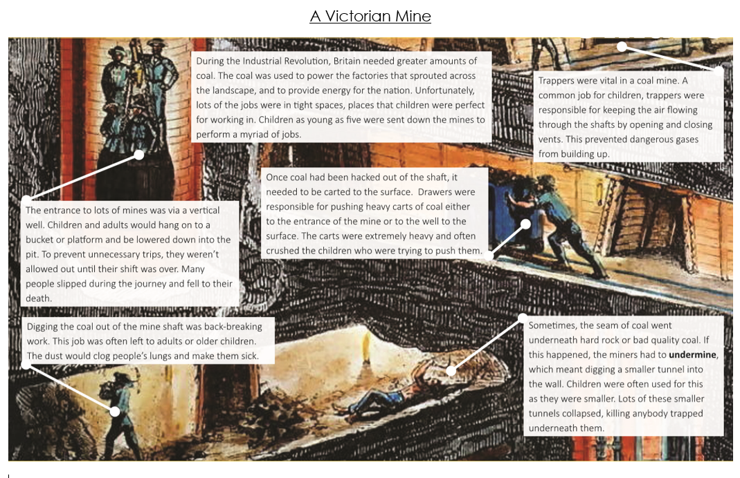

Reading Comprehension – Worst Jobs For Kids

Read the text on the following page and answer the following comprehension questions:

VOCABULARY  FOCUS | 1. What word tells the reader how loud a noise was?  2. Find and write a definition for the word “reign”.  3. Explain what the phrase “horrific conditions” means.  4. What is meant by “dainty”?  5. What is meant by “toxic”?

VIPERS QUESTIONS
Summarise | What were most children lucky to do?
Summarise | Which features of children made them perfect for many jobs?
Summarise | What did all of the jobs have in common in terms of children’s health?
Summarise | What happened that meant more children were needed in railway stations?
Inference | How do you think the author felt about Victorian children? What tells you this?

Worst Jobs For Kids
Ever moaned about having to do your homework? What about cleaning your bedroom, or hoovering the ﬂoor? Count yourself lucky you weren’t a child during Queen Victoria’s reign. You were lucky if you were sent to school back then; most children were sent out to work in some of the most horrific conditions you can imagine. You’ve probably heard about chimney sweeps and ﬂower sellers, but there were much worse jobs out there if you were desperate.
Do you love rolling around in the mud? How about scraping through the dirt to find any coins or lost bits of jewellery? If that sounds good, then a job as a tosher might have been right up your street. It wasn’t just the muck and fi lth on the street though, you’d spend most of your time down in the sewers rummaging around for anything that the rich folk up above might have dropped into the drains.
Tiny children have tiny hands, and they were perfect for fixing the fiddly little mechanisms on the enormous looms that factories used to weave fabric. The sound of the shuttles ﬂying backwards and forwards would have caused quite a din; however, they couldn’t stop working just to fi x a machine. Instead, children would scuttle around underneath the vast wooden machines and try to time their movements perfectly. Quite often they would get it wrong. The lucky ones only lost a finger. The unlucky ones? Well, I’m sure you can guess.
It wasn’t just fixing the looms that children’s dainty digits were perfect for. The rise of the steam train meant that lots of children were needed to scrape out the cinders and clean the undercarriage of the engine. Not only did this involve a lot of choking dust and ash, but the cinders were often still red-hot, and many children suﬀered horrific burns.
Most houses were lit by candles back then, and so matches were needed by the thousands. Dipping the sticks in the toxic phosphorus was another job saved for the cursed children. The horrible chemical would rot their teeth and often led to fatal lung disease. Not sure it was worth it for a penny a day.
Dick Whittington said that the streets of London were paved with gold. More accurately, they were often paved with filth, particularly dog droppings. Luckily for the children of the time, they could earn money by scraping it up and selling it to the tanners - people who turned the hide of a cow into leather. If they really wanted to earn some money, they could help the tanners by stamping the poo into an odorous mix of chemicals (barefoot, of course) and using it to soak the skins. Unfortunately, many poor children didn’t have access to a bath afterwards!
So there you have it. There were some pretty vile jobs for luckless lads and lasses in Victorian times, and we haven’t even mentioned leech collectors, coal miners, rat catchers, navvies (canal diggers) and grave robbers. No wonder so many children were desperate to go to school!

Science – Rocks  Using the two study sheets about rocks and soil at the end of this document, can you answer the following questions?  - Which of the following is a property of some types of rock: sedimentary / permeable / igneous / metamorphic?  - Put the stages of fossil formation in the correct order:  - A shape or imprint of the plant or animal is formed in the rock.  - A plant or animal dies  - The layers become compressed and form rock over and around the plant or animal.  - Over time, the plant or animal gets covered by sand and mud.  - Complete the sentence: Soil is made of four things: organic material, water, air and _______________.  - Can you describe sedimentary, igneous and metamorphic rocks and give examples of each type?  You could present this information in the form of an information text along with illustrations and labelled diagrams. | Geography – UK & British Isles  We are revisiting a topic from your previous year: UK & British Isles. Using the worksheets provided below, can you complete the following tasks?  - Match the UK Country to its capital and then draw that country’s flag (using the worksheet provided below).  - A UK map activity – follow the worksheet instructions, you will be labelling countries, bodies of water and colouring them according to instructions.  - Using the map, record which cities of the United Kingdom can be found at each latitude and longitude coordinate. You will need to round to the nearest degree.
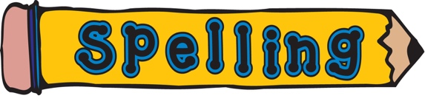  Week 1  Please learn your spellings for this week:  treasure  measure  leisure  enclosure  pleasure  closure  picture  adventure  capture  mixture  creature  puncture  Can you use these words in a sentence? |  |  | Week 2  Please learn your spellings for this week:  trouble  enough  toughest  rougher  young  country  double  touch  youngest  younger  Can you use these words in a sentence?

Please try to keep fit around the home and garden – you could take pictures of all the physical challenges you attempt. | SPAG (spelling, punctuation and grammar) activities will be set online. | Mathletics activities will be set in addition to White Rose tasks.
Please complete your weekly times table test, giving yourself 5 minutes to write answers in your book, then self-mark and keep a record of your total along with the date.  For further challenge, you can choose to complete the division test. | Please read for at least 20 minutes every day this week.  Try to read aloud with an adult, at least once, and discuss what you’ve read with them.  Once you have read a book, please complete a book review in your exercise books. | Can you create a PowerPoint (or written information sheet) to educate children about E-safety and how to stay safe online?

Birds of Prey Sudoku
Can you fill in the gaps so that every bird of prey appears only once in each row and column? Write the first letter of their name in each of the squares to complete the challenge (see key provided below, e.g., write R for Red Kite in the right square)!

 |  |  | 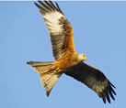 | 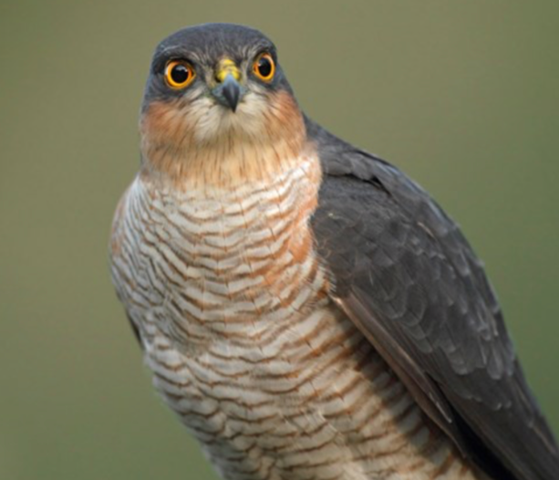 | 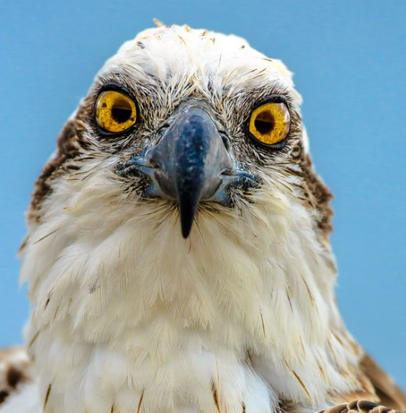
 |  |  |  |  | 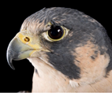
 | 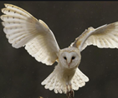

Key: |  | R | Red Kite |  | W | White Tailed Eagle
 |  | S | Sparrow Hawk |  | P |  | Peregrine Falcon
 |  | O | Osprey |  | B |  | Barn Owl

Answers to Sudoku puzzle:
W | P | B
O |  | S |  | B
B | O | R | S
 |  | P | B | O | R
 | S |  | P |  | B
 |  |  | O | R | S

