Hello 4/5B,
So, we have an unexpected two weeks at home! I’m sure you’re all experts at home learning by now; here are some tasks to keep you busy and to make sure that we don’t fall behind in our learning this term. It’s important to try to do some work each day, so we have included a timetable to help you to organise your studies. You may not finish everything, but please make sure your focus is on maths and literacy activities. You should be able to complete these independently but please ask Mum or Dad if you need help.
Please email the school at enquiries@cranwell.lincs.sch.uk if you need assistance with logins, etc., or if you need any support from me – I am available every day to help!
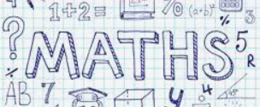  Week 1 | Week 2
For maths we will be using a combination of videos and worksheets. We will access materials available online from White Rose Maths and The National Academy. Please follow the links given below for each objective.  Please continue to complete your daily maths lessons as follows:  Mon Counting in Intervals  https://vimeo.com/454736934  Tues Number lines  https://login.mathletics.com  Wed Compare and order numbers  https://classroom.thenational.academy/lessons/comparing-5-digit-numbers-cnhk6c  Thurs Compare and order numbers (2)  https://classroom.thenational.academy/lessons/comparing-6-digit-numbers-using-inequalities-6crkje  Fri Rounding  https://classroom.thenational.academy/lessons/rounding-5-digit-numbers-to-the-nearest-100-1000-and-10-000-6hgk2d | For maths we will be using a combination of videos and worksheets. We will access materials available online from White Rose Maths and The National Academy. Please follow the links given below for each objective.  Please continue to complete your daily maths lessons as follows:  Mon Rounding to a million  https://vimeo.com/456943660  plus, worksheet below  Tues Negative Numbers  https://vimeo.com/457420739  plus, worksheet below  Wed Negative Numbers (2)  https://login.mathletics.com/  Thurs Roman Numerals  https://classroom.thenational.academy/lessons/investigating-roman-numerals-up-to-100-6guk8c  https://classroom.thenational.academy/lessons/investigating-roman-numerals-up-to-1000-61k32r  Fri Roman Numerals / Place Value Assessment  https://classroom.thenational.academy/lessons/solving-problems-involving-roman-numerals-6gt36d  https://login.mathletics.com/
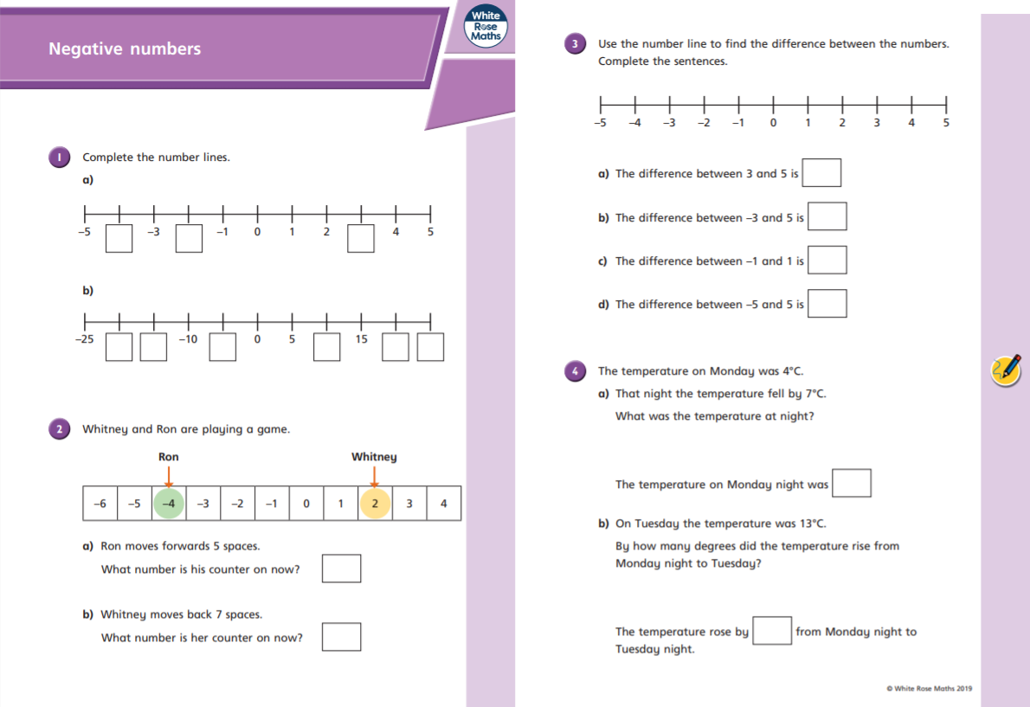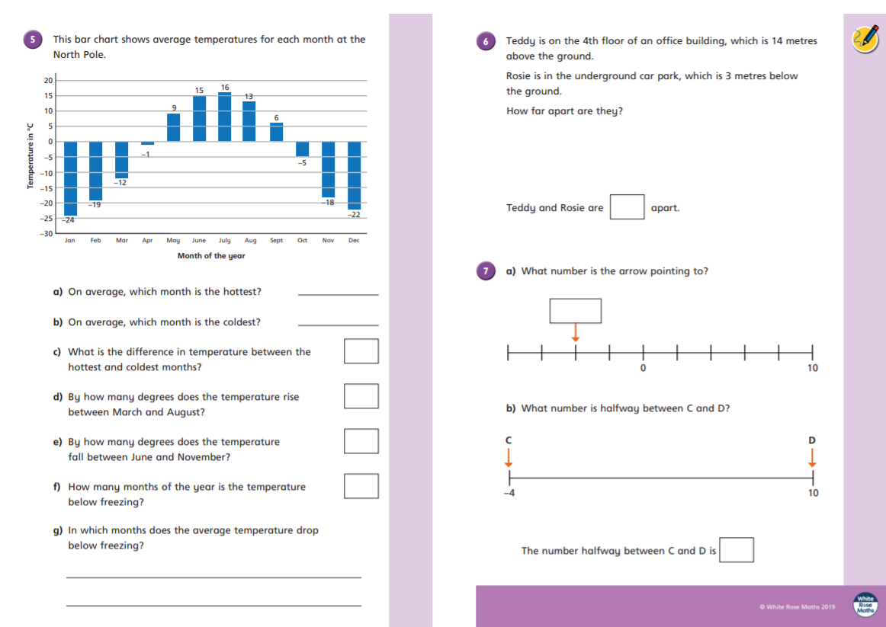
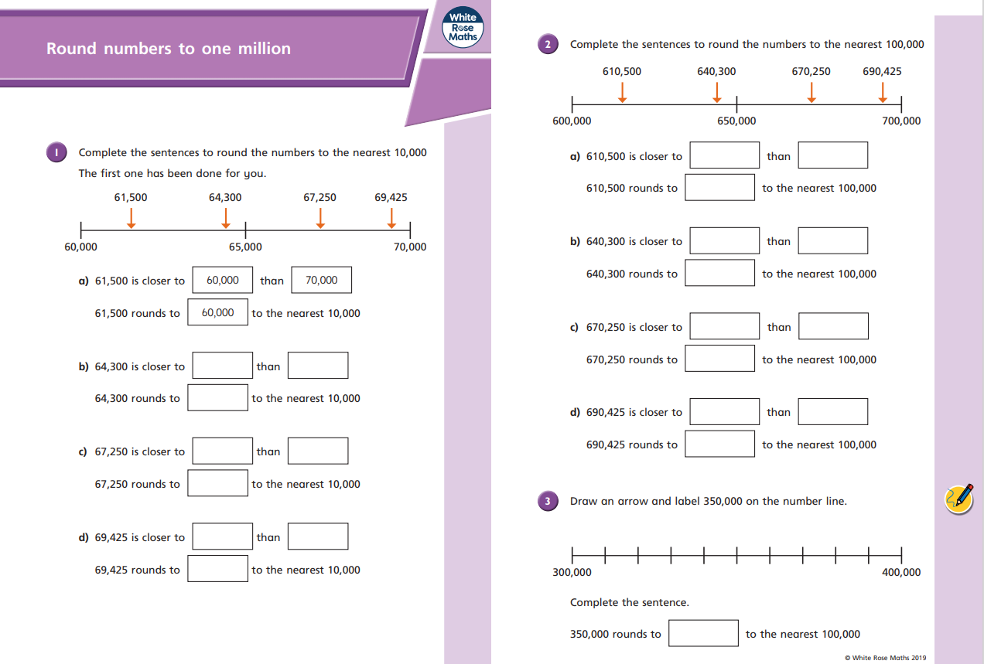
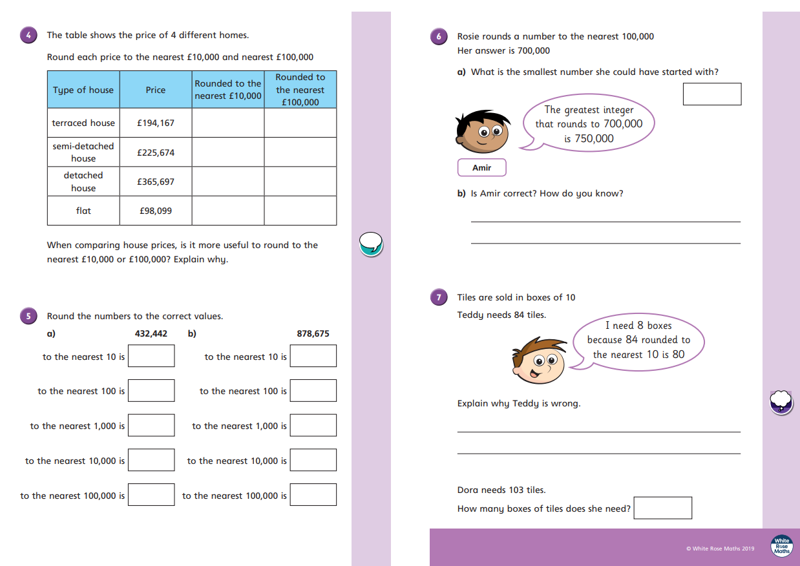
Please follow the link below to access a home learning booklet called ‘The Game’ (this can either be printed or you can write your answers and ideas in your exercise books):

https://www.talk4writing.com/wp-content/uploads/2020/04/Y5-Unit.pdf

This booklet is designed for you to work at your own pace over a two-week period, taking you through a series of literacy tasks related to the story including: reading comprehension, grammar, vocabulary and planning tasks. The booklet culminates in you producing your own story!

Please don’t try to complete this in one sitting. Try to complete a couple of pages per session as you work towards creating a fantastic story – good luck!

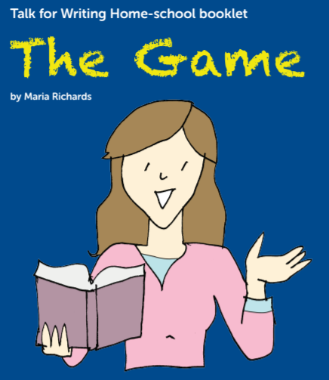

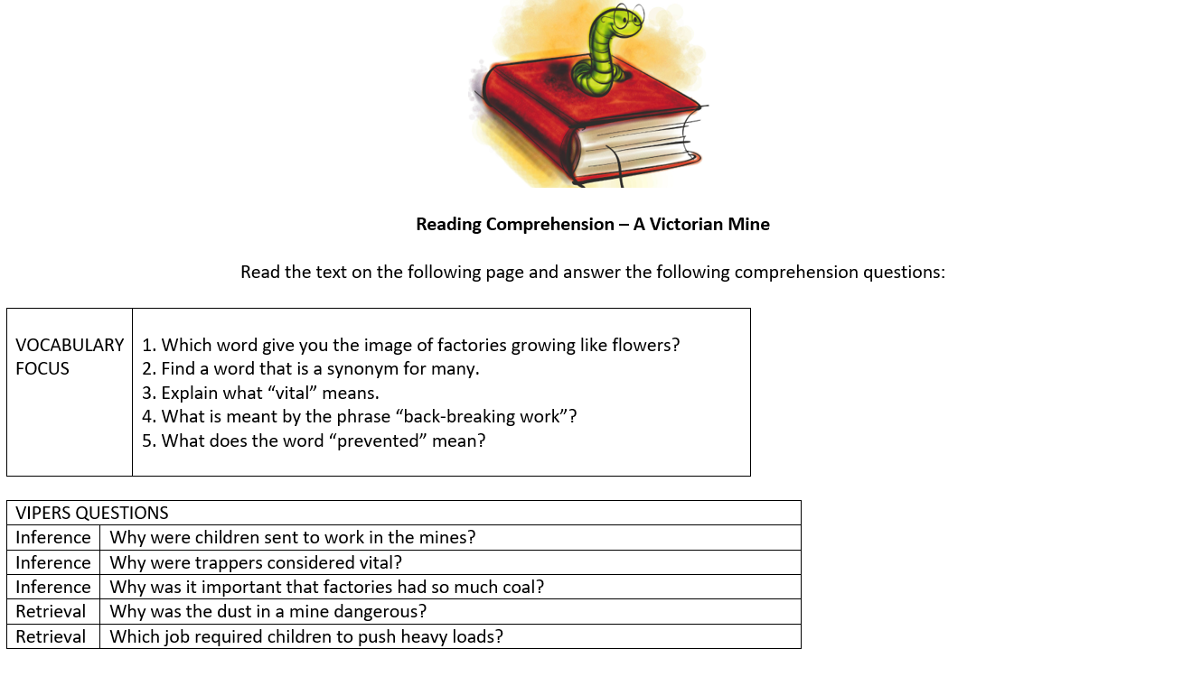
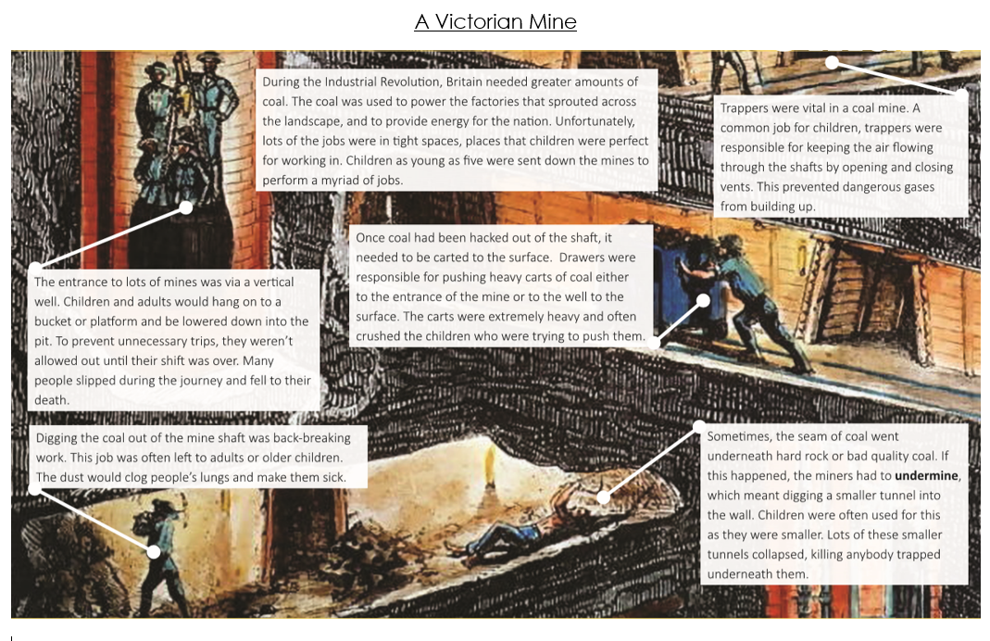

Reading Comprehension – Worst Jobs For Kids

Read the text on the following page and answer the following comprehension questions:

VOCABULARY  FOCUS | 1. What word tells the reader how loud a noise was?  2. Find and write a definition for the word “reign”.  3. Explain what the phrase “horrific conditions” means.  4. What is meant by “dainty”?  5. What is meant by “toxic”?

VIPERS QUESTIONS
Summarise | What were most children lucky to do?
Summarise | Which features of children made them perfect for many jobs?
Summarise | What did all of the jobs have in common in terms of children’s health?
Summarise | What happened that meant more children were needed in railway stations?
Inference | How do you think the author felt about Victorian children? What tells you this?

Worst Jobs For Kids
Ever moaned about having to do your homework? What about cleaning your bedroom, or hoovering the ﬂoor? Count yourself lucky you weren’t a child during Queen Victoria’s reign. You were lucky if you were sent to school back then; most children were sent out to work in some of the most horrific conditions you can imagine. You’ve probably heard about chimney sweeps and ﬂower sellers, but there were much worse jobs out there if you were desperate.
Do you love rolling around in the mud? How about scraping through the dirt to find any coins or lost bits of jewellery? If that sounds good, then a job as a tosher might have been right up your street. It wasn’t just the muck and fi lth on the street though, you’d spend most of your time down in the sewers rummaging around for anything that the rich folk up above might have dropped into the drains.
Tiny children have tiny hands, and they were perfect for fixing the fiddly little mechanisms on the enormous looms that factories used to weave fabric. The sound of the shuttles ﬂying backwards and forwards would have caused quite a din; however, they couldn’t stop working just to fi x a machine. Instead, children would scuttle around underneath the vast wooden machines and try to time their movements perfectly. Quite often they would get it wrong. The lucky ones only lost a finger. The unlucky ones? Well, I’m sure you can guess.
It wasn’t just fixing the looms that children’s dainty digits were perfect for. The rise of the steam train meant that lots of children were needed to scrape out the cinders and clean the undercarriage of the engine. Not only did this involve a lot of choking dust and ash, but the cinders were often still red-hot, and many children suﬀered horrific burns.
Most houses were lit by candles back then, and so matches were needed by the thousands. Dipping the sticks in the toxic phosphorus was another job saved for the cursed children. The horrible chemical would rot their teeth and often led to fatal lung disease. Not sure it was worth it for a penny a day.
Dick Whittington said that the streets of London were paved with gold. More accurately, they were often paved with filth, particularly dog droppings. Luckily for the children of the time, they could earn money by scraping it up and selling it to the tanners - people who turned the hide of a cow into leather. If they really wanted to earn some money, they could help the tanners by stamping the poo into an odorous mix of chemicals (barefoot, of course) and using it to soak the skins. Unfortunately, many poor children didn’t have access to a bath afterwards!
So there you have it. There were some pretty vile jobs for luckless lads and lasses in Victorian times, and we haven’t even mentioned leech collectors, coal miners, rat catchers, navvies (canal diggers) and grave robbers. No wonder so many children were desperate to go to school!

Science – Plants  We are revisiting a topic from your previous year: plants. Using the four study sheets about plants at the end of this document, can you answer the following questions?  - Which part of a plant absorbs water from the soil?  - Why is the flower of a flowering plant usually brightly coloured?  - How do plants get water to their leaves?  - Why do plants need light?  - In pollination, pollen from the ______________ sticks to the ________________.  - Give two examples of pollination.  - Why are minerals important to a plant?  - Explain the role of the leaves of a plant.  - Give two different ways in which seeds of a plant can be dispersed.  You could present this information in the form of an information text along with illustrations and labelled diagrams. |  | Science / DT – Properties of Materials  We are having lots of fun exploring the properties of materials this term. Now it’s time for you to put your engineering skills to the test by researching and then building bridges (inspired by Isambard Brunel – a famous engineer from the Victorian era).  There are four tasks to complete, if you can:  - Research four main bridge types and find examples to complete the table in the worksheet below.  - Produce an information sheet on one type of bridge (your choice) – this can be typed up or handwritten.  - Make a bridge from card using the cut-out sheet provided – can you place weights on it and record how much it held? You could use maths cubes, sugar cubes, coins – use your imagination, just be sure to record your results.  - Bridge challenge – build a bridge from materials you may have at home (as listed on the info sheet below) that is able to hold 500g – e.g. a bag of sugar or rice – for 10 seconds without collapsing.  You should discover lots about structures and forces through this learning – and I hope you have fun too!
BRIDGE TYPE | FEATURES | A REAL-LIFE EXAMPLE IN THE UK | A REAL-LIFE EXAMPLE IN THE WORLD
THE BEAM BRIDGE
THE TRUSS BRIDGE
THE ARCH BRIDGE
THE SUSPENSION BRIDGE
Your task is to research the basic types of bridges. Find out the main features of each of the bridges and then research to see if you can find examples of each of these types of bridges in the UK and then the rest of the world. Good luck! The website we went on in school was this one: http://www.pbs.org/wgbh/buildingbig/bridge/basics.html You can copy the table onto a piece of paper if you like (or print).

Here is some homework that links our DT (bridges), Science (Materials and their Properties) and History (Victorians) topics together!
Your task is to find out about one of the basic types of bridges. You can choose an example from the UK or from abroad; however, there will be an extra HP available for those children who research a bridge from Victorian times which is one of the basic types that we have looked at. Here are the basic types to remind you: Beam, Truss, Arch and Suspension. Your research should fill one side of an A4 sheet of paper. It can be created by hand or on the computer but you will need to include the following:
Information about the features which make it either a beam, truss, arch or suspension bridge.
Include a picture of the actual bridge (may be hand drawn or printed out).
Provide information about the bridge – where it is built; when it was built; who designed it; how long it took to build; where it is; the span of the bridge; any special features; and finally, what materials were used to build it.
Good luck and enjoy your task!
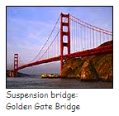
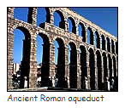
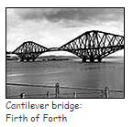
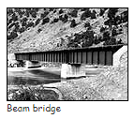
P.S. Remember to think about how you present your work. Any writing must be neat and easy to read and include all punctuation as needed. Your work must be orderly and neat. Why not try a few designs to see which layout works best for you?

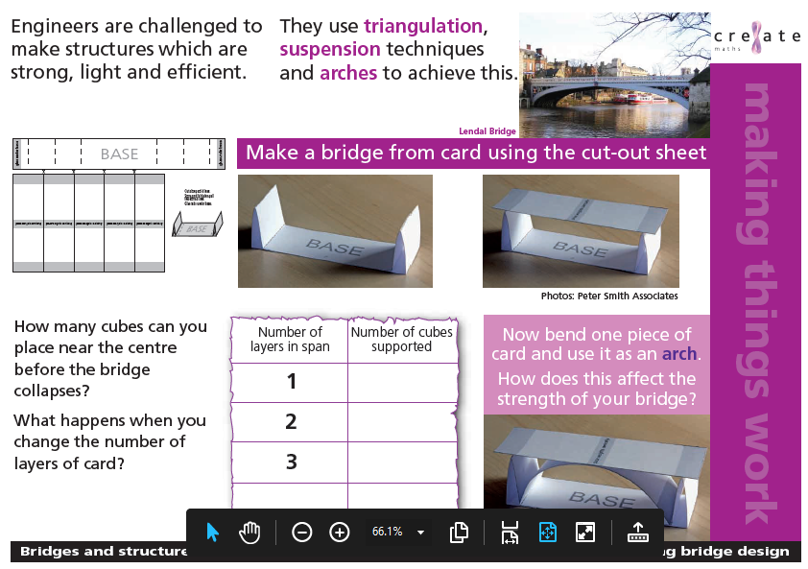
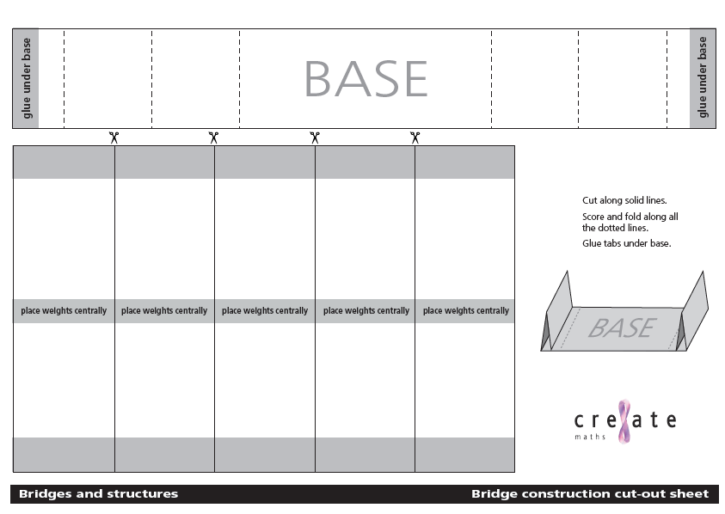
The challenge
We are challenging you to build a bridge that has a span of 30cm wide and a minimum of 15cm high in the centre, that is able to hold 500g – e.g. a bag of sugar or rice – for 10 seconds without collapsing.
What you will need:
Get together some things that you can use to build it before you start. There are no rules for this - you can do this just with things you have around your home. Some examples of things you might use are:
- Straws
- Blutack/playdough
Remember: these can all be (clean) items from the recycling rubbish. Be inventive and resourceful. All great designers have a budget to work to and need to make their bridges cost-effective. What better way than to use only recycled items.
- Rubber bands
- String/wool
- Paper/newspaper/old magazines
- Egg cartons/cardboard tubes
- Scissors
- Sellotape/glue
- Card/cereal boxes/packaging
Things to think about before you start:
- Think about the types of bridge you have seen. The different types of bridge (beam, arch, truss etc) are called its ‘form’. You can see more about these below. Which form of bridge are you going to build?
- Your bridge will need to be strong enough to 500g. How will you make your bridge strong enough? In the past bridges were often made of stone or timber, but modern bridges are commonly made of materials like concrete and steel, which are heavy but very strong.
Did You Know?
Did you know that some shapes are better at absorbing loads than others? For example, triangles are particularly strong because they create a very rigid structure that spreads the load from a single point to a wider area. Think about what shapes you could use in your bridge.

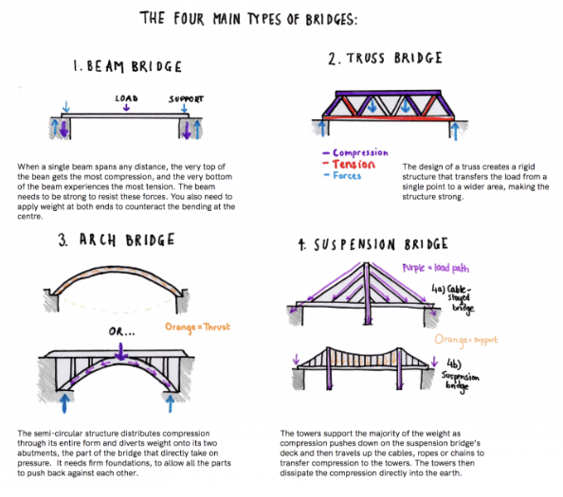
Information to remind you and to help you with your design
There are four main types of bridges:
1. Beam bridges are made of horizontal beams supported by piers at each end.
2. Truss bridges are a combination of triangles.
3. Arch bridges are made up of arches supporting the bridge and are naturally strong.
4. Suspension bridges are long bridges, such as the Golden Gate Bridge.
Two key types of forces involved in building any structure are tension and compression. A tension force is one that pulls materials apart (like two teams pulling a rope during a game of tug-of-war). A compression force is one that squeezes material together (like pushing down a spring and making it shorter). Each type of bridge deals with the important forces of tension and compression. Remember the information on the website: http://www.pbs.org/wgbh/buildingbig/lab/forces.html

Evidence!!
We would like you to take a photo of your finished bridge design before testing; during the test; and shortly after the test to see what state your bridge is in. Please ask an adult to help you with this. You will need to ask the adult to send your bridge photos by email to enquiries@cranwell.lincs.sch.uk with your teacher’s name in the subject of the email. You will also need to ensure your name is clear too! Alternatively, you could save it to a memory stick and bring that instead so we can see your wonderful hard work.

Good Luck everyone, we are really looking forward to seeing your wonderful designs - Mrs Bullement & Mrs New

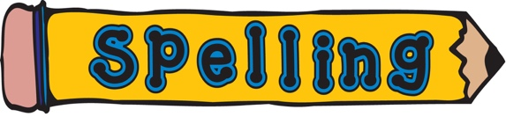  Week 1  Please learn your spellings for this week:  terrible  possible  sensible  visible  invisible  reversible  edible  legible  credible  incorrigible  gullible  fallible  Can you use these words in a sentence? |  | Week 2  Please learn your spellings for this week:  rough  tough  enough  thought  bough  borough  plough  drought  although  doughnut  thoroughly  fought  Can you use these words in a sentence?

Please try to keep fit around the home and garden – you could take pictures of all the physical challenges you attempt. | SPAG (spelling, punctuation and grammar) activities will be set online. | Mathletics activities will be set in addition to White Rose tasks.
Your timetable asks you to learn your 3, 6, 9 and 12x tables. Please also have a play on Times Tables Rockstars each Friday! | Please read for at least 20 minutes every day this week.  Try to read aloud with an adult, at least once, and discuss what you’ve read with them.  Once you have read a book, please complete a book review in your exercise books. | Can you create a PowerPoint (or written information sheet) to educate children about E-safety and how to stay safe online?

Birds of Prey Sudoku – just for fun!
Can you fill in the gaps so that every bird of prey appears only once in each row and column? Write the first letter of their name in each of the squares to complete the challenge (see key provided below, e.g., write R for Red Kite in the right square)!

 |  |  | 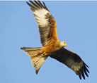 | 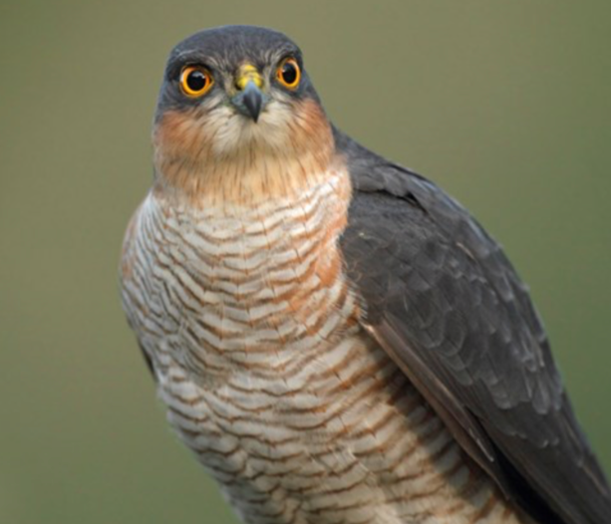 | 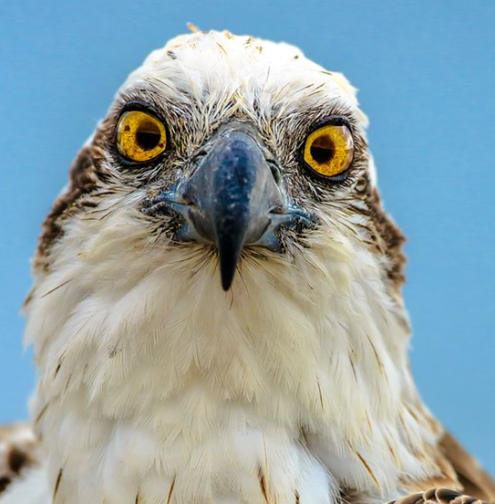
 |  |  |  |  | 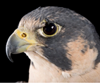

Key: |  | R | Red Kite |  | W | White Tailed Eagle
 |  | S | Sparrow Hawk |  | P |  | Peregrine Falcon
 |  | O | Osprey |  | B |  | Barn Owl

Answers to Sudoku puzzle:
W | P | B
O |  | S |  | B
B | O | R | S
 |  | P | B | O | R
 | S |  | P |  | B
 |  |  | O | R | S

