Class 6H

Hello, everyone! I hope that you are all doing ok at home! Please see below for this fortnight’s tasks.

Take care and I hope to see you all very soon.

Miss Hill xx

If you were in school and received a pack of work, you will have been given activities and the mark schemes. Please do not rush to do all of these in the first few days/weeks! Instead, use these to supplement the activities that will be published on the School website for our class.

For the activities sent home as paper copies, I suggest that on one day, you do a test/activity. Then, ideally, the next day mark the test/activity (perhaps with an adult’s help) and try to do your corrections. If there are topics that you are struggling with, try to go online and find out more – you could just do a google search, use BBC Bitesize, Twinkle, Education City, etc.

MATHS:
You have two maths booklets compiled by Mrs. Bennett & I over the years – revision booklets with key facts to help.
- Maths Easter revision booklet;
- Arithmetic Paper 7
- Arithmetic Paper 8
- Maths Reasoning 1a
- Maths Reasoning 1b
- Maths Reasoning 2a
- Maths Reasoning 2b
- Maths Revision booklet – Multiplication & Division
- Maths Revision booklet – Fractions, Decimals & Percentages
- Maths Revision booklet – Position & Direction
- Maths Revision booklet – Statistics
- Maths Revision booklet – Algebra
- Maths Revision booklet – Addition & Subtraction
- Maths Revision booklet – Properties of Shape

LITERACY:
Reading Activity Booklet – Fiction, Non-Fiction & Poetry
SPAG Test Paper 1
Ninja SPAG test
SPAG Revision Booklet – Grammatical Terms and Word Classes
SPAG Revision Booklet – Sentences, Phrases and Clauses
SPAG Revision Booklet – Verb Forms & Tenses
SPAG Revision Booklet – Punctuation
SPAG Revision Booklet – Vocabulary & Standard English
SPAG Revision Booklet – Spelling

For each week day, I would much prefer you to only do a bit every day and do it really well, rather than 6 hours of not very good work! Try to structure your day so that you have a good mix of activities – rest, food, exercise, play/fun, school work, reading for pleasure, electronics/TV time, sleep, etc.

I suggest each day that you spend:
One hour on literacy
One hour on numeracy
One hour on topic work

Do some research online about Philippe Petit – what else has he climbed?  Create a factfile about him and his amazing adventures. | Create a piece of art work, in any media, linked to one of Philippe Petit’s amazing feats. | Plan, write, edit and present in neat a newspaper report about Philippe’s walk between the Twin Towers in New York.
Create a poster advertising Philippe’s performances in Central park – his punishment after walking between the Twin Towers. | 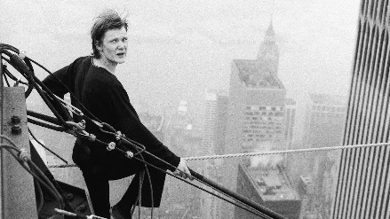 | Create a 3D model of an amazing structure/building.
Maths – Perimeter.  We ran out of time to cover this in class! If you log on to Education City and do a search for ‘perimeter’, there are lots of activities to work through. I suggest you start with the ones for the youngest children (Y3/4) and then build up to the Y5/6 ones.  On Mathletics, I will also set tasks to revise the work we have covered. Let’s see how many points you can achieve! | PE – It’s really important that we all stay fit and active. Try to do at least an hour of playing in the garden or walking out with a parent every day. Fresh air makes us all feel better! If you’re stuck inside, try a Joe Wicks workout:  https://www.youtube.com/watch?v=-TGEdzRzSbw  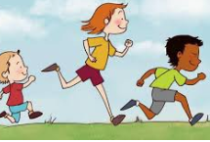 | Remember to read for pleasure daily.  Also remember your photography competition – for those of you who did not get a paper pack – please see the next page.

You could also go online and use Education City, Mathletics, Timestable Rockstars, etc.

Photography Competition

We are going to be hosting a photography competition within our class.

The categories are:
- A landscape
- A portrait
- Childhood
- Action
- Caring for our world
- Celebration and sport
- Pattern, shape and colour
- The unusual

You may enter up to one photograph in each category but you can just choose to enter only one or two categories. You can either print off your photographs (at whatever size you choose) or you can email me your photograph(s) and I will print them.

