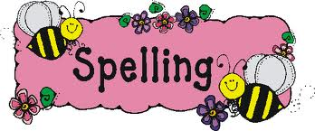
23rd March 2020- Easter break
Extras
If you do anything else over the break such as play board games, bake, go on a bike ride, walk or visit a national trust site, draw me a picture, write a recount, tell me a story about it or take some fabulous pictures. Not all learning can be done in the classroom!

Writing
In class we have been learning all about fairytales, focusing on The Princess and the Pea in particular. We have recently read The Pea and the Princess which is the same story, however told through the eyes of the Pea. We consequently call this a twisted fairytale as it is through the eyes of one of the characters. Can you write your own ‘twisted’ fairytale? For example, The Beanstalk and Jack, told through the eyes of the beanstalk.
Spellings

Please spend time learning the Year 3 and 4 National Curriculum spelling list which you will find in the front of your reading planners. Can you find these words in a dictionary and write a sentence for each word?

Maths
Our current maths topics are fractions and decimals. See the maths page below for some websites to help you.
Times Tables
It is important you keep practising your times tables. Have a look on the times tables page for websites to help you.

Reading
We read in class every day, so it would be really nice if you could spend some time every day reading a book. This can be a home book, a newspaper, magazine or anything alike. Do not forget to record this in your reading record.
It would also be good practise to complete some book reviews in the back of you reading record.

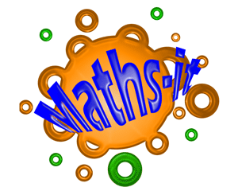
Topic
Our History topic this term is ‘Looking at the British Monarchy over time’
See the grid below for some project based ideas for you to complete.

Times Table Activities

https://play.ttrockstars.com/auth/school - Times Table Rock Stars is a great way to practise your times tables
https://play.edshed.com/ - Practise your times tables
https://www.timestables.co.uk/ - learn and practise
https://www.topmarks.co.uk/maths-games/7-11-years/times-tables
https://www.oxfordowl.co.uk/for-home/maths/help-with-times-tables/ -
https://www.themathsfactor.com/times-tables-check/#/- A Times Tables Check in the same format the Multiplication Test will be.

Maths Activities
Read and watch the class clips https://www.bbc.co.uk/bitesize/topics/zhdwxnb/resources/1 to help you complete activities set over the next 2 weeks.
Fraction and decimal activities will be set for Week 1 on Mathletics.
Please log onto you mathletics account and complete the activities set. If you get stuck during one of the questions remember to click on the ? and it will explain what you need to do in more detail. https://login.mathletics.com/#/student
Fraction and decimal activities will be set for Week 2 on Education City.
Please log onto your education city account and in classwork, complete the activities in order. “The Learn Screen” program will help you understand the lesson and “Activity” program will let me know if you have understood it. “Activity Sheet” is a worksheet available to print if you have that option. https://www.educationcity.com/

Extra Maths Games
https://play.prodigygame.com/ - Pokemon style game with maths questions!
https://play.edshed.com/ - practise your number bonds, power of 10 and addition and subtraction
www.topmarks.co.uk –interactive games
https://www.oxfordowl.co.uk/for-home/kids-activities/fun-maths-games-and-activities/#maths-7-9 – games and activities
https://www.mathswithparents.com/KWeb?startTime=1584558592239#menu584883 – Free access to parents – videos and activities across the maths curriculum.

The Victoria sponge cake was named after Queen Victoria, who ate a slice of sponge cake with her afternoon tea. Can you bake a Victoria Sponge Cake with the help of an adult?  Topic Activities  https://www.bbcgoodfood.com/recipes/classic-victoria-sandwich-recipe |  | Can you research and complete your family tree? How far back can you go? Click on the link to see an example of the Modern Day ‘Royal Family’ family tree.  https://www.britroyals.com/royalfamily.asp
Think about the personalities and qualities a King or Queen must have to rule over a country. Can you write a job advert for a new Queen or King? Think about including a job description, the qualities and responsibilities the job would involve. | During the Victorian and Elizabethean era, people took pride in what they wore. Can you design an outfit, for either era, for a man or woman. | 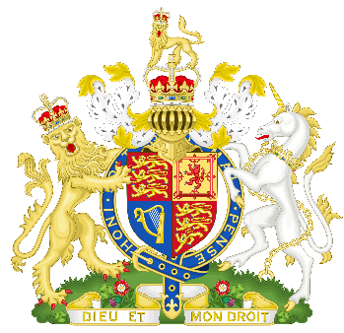  Below is a picture of The Royal Coat of Arms of the United Kingdom. This is the official coat of arms of the British monarch, currently Queen Elizabeth II. The British Government also uses the Royal Arms as a national symbol of the United Kingdom.  Can you design your own royal coat of arms?
Henry VIII was a famous ruler for various reasons………Can you find out why?
This song might give you a clue! Can you learn the song?!
https://www.bbc.co.uk/cbbc/watch/horrible-histories-song-wives-of-henry-viii-song
Do you feel strongly towards a current topic that you would like to address the Queen about? Do you believe a new law should be introduced? Why don’t you write a letter to the Queen at Buckingham Palace? | When Queen Victoria came to the throne in 1837, Britain already governed several countries around the world. These formed the British Empire. Can you find out which countries were in the British Empire at the time? I have provided a map, with the red areas indicating those countries that were in the British Empire in 1837. You might like to label these countries. Has this changed since?

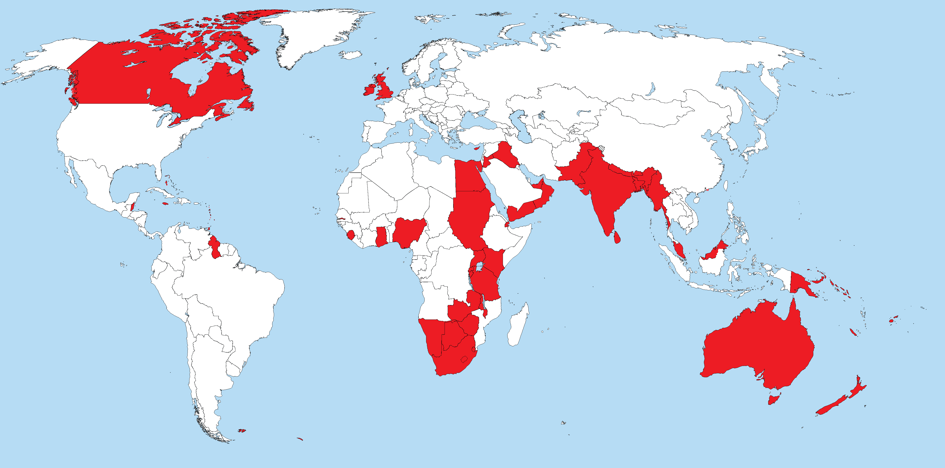

PE Activities

https://www.cosmickids.com/category/watch/- Cosmic Kids Yoga. These activities vary from under 10 minutes to over 15 minutes.
https://www.youtube.com/results?search_query=body+coach+kids- Tune in with Joe Wicks for some HITT sessions!
https://www.youtube.com/user/thebodycoach1 - Joe Wicks is also providing live workout, every morning at 9am, called "PE with Joe" on his YouTube channel The Body Coach TV.

Additional Websites

These websites are offering free, fun and interactive resources to help learning at home.

Twinkl- https://www.twinkl.co.uk/resources/parents
Mrs Mactivity- You can claim a free resource pack by signing up with your email- https://www.mrsmactivity.co.uk/
White Rose Maths- This is the Maths scheme we follow in school. They have provided free, really helpful lessons online that include a short video showing you clearly and simply how to help your child to complete the activity-.https://whiterosemaths.com/homelearning/
Classroom Secrets- They have created fun, interactive and practical home learning packs to ensure all children can continue to learn- https://classroomsecrets.co.uk/
Teach Starter- They are offering a 1 month free membership and a collection of free home learning packs-https://www.teachstarter.com/
Newsround- Watch Newsround live at 9:15am, 12:10pm and 4:00pm for the latest news- https://www.bbc.co.uk/newsround

