WEEK COMMENCING: 1st June |  | HOME ACTIVITIES |  | CLASS 1MS/ 1H
Numeracy  - Practise counting forwards and backwards in 1s. Please ensure your child is forming the numbers correctly.  - Find one more/less than a given number.  - Count forwards and backwards in 2s, 5s and 10s.  - Add and subtract one-digit and two-digit numbers to 20.  - Using knowledge of numbers bonds to 10 to write addition and subtraction facts.  Home learning lessons are still available on www.whiterosemaths.com |  | Dear Parents and Children  It was lovely to talk to you again the other week. We have enjoyed hearing about your adventures at home – I know quite a few of you have enjoyed playing in the garden and some of you were in the paddling pool when we called. It certainly sounds like you are spending quality time with your family.  We are so pleased to hear that you have enjoyed your home schooling. Please find enclosed the work for this week next week.  Keep working hard and enjoy your time at home.  Mrs Mulhall, Mrs Hall and Mrs Smith |  | PSHE  https://campaignresources.phe.gov.uk/schools  e-bug resources support children's understanding of how germs and viruses spread. Select KS1 Horrid hands and Super Sneezes. Watch the video clips and try the quiz. Make a poster or fact sheet about hand washing, respiratory hygiene or social distancing.  3 Houses: House of good / House of worries / House of dreams- Draw a picture for each house. Focus on the house of good first and discuss positives such as an achievement during the period at home e.g. learning to catch a ball.  Watch the video https://www.literacyshed.com/bubbles.html  How does the little girl feel when she finds the bubble? What colours can you see? How does the music make you feel? How did she feel when the second little girl found the bubbles?  Where would you like to go on a bubble?  Make a bubble or fantasy land picture using paint or chalks.  Draw you, your family and favourite things inside a bubble.
History
Look around your home for modern day appliances that make everyday life easier (washing machine, dishwasher and cooker). Talk to your Grandparents or neighbour about what life was like when they were young.
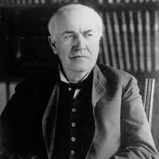
Choose two appliances and find out how that job was done 100 years ago.
Scientists and inventors
Find out about Thomas Edison. Who was he? How did he change how we live our lives today? Make a fact file or PowerPoint.

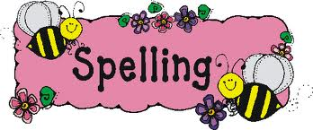
Please try to learn spellings from the Statutory spelling list provided, and remember to highlight any you get correct on the sheet. A list of the common exception words can also be found here  onhttps://home.oxfordowl.co.uk/  Spell the days of the week  Practice spelling your surname  Add er/ est to a root word https://www.twinkl.co.uk/resource/t2-e-4950-year-1-adjectives-suffixes-er-and-est-activity | Practice forming all your letters correctly. Think carefully about which letters should be tall and which letters should come below the line.  Practice writing capital letters. Ensure that they taller than lower case letters. | Mathletics activities will be set in addition to White Rose tasks for children at home. It has been fantastic to see so many children login on!
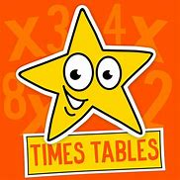 |  | 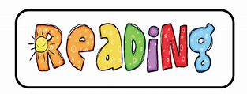
Please practice counting in sets of 2s, 5 and ten. Use coins and objects to help you.  Can you pair up socks and count them into you draw?  Count 10 pence coins into your money box. | We have set you some phonics and spelling activities to try. | Please continue to read every day. Use the online books onhttps://home.oxfordowl.co.uk/  Read the phonics comic strips at https://phonicsplaycomics.co.uk/comics.html

I can count forwards and backwards in 1s
You can use a number square to help you.

1 | 2 | 3 | 4 |  |  |  | 8 | 9

10 | 11 |  |  | 14 |  | 16

20 | 19 |  |  | 16 |  | 14 | 13

15 | 16 |  |  |  | 20 |  | 22

12 |  | 10 | 9 |  |  |  | 5

21 | 22 |  | 24 |  |  | 27 |  |  | 30

26 | 25 |  |  | 22 |  |  | 19

Now write your own number sequences!

One More and One Less
1 less | Number | 1 more
 | 2
 | 7
 | 11
 | 16
 | 25
 | 32
 | 10
 | 47
 | 19
 | 41
 | 24
 | 49
 | 30

I can count forwards and backwards in 10s
You can use a number square to help you.

10 | 20 | 30 | 40 |  |  |  | 80 | 90

20 | 30 | 40 |  |  | 70 |  |  | 100 | 110

100 | 90 |  |  | 60 | 50 |  |  |  | 10

120 | 110 | 100 |  |  |  | 60

30 |  | 50 |  | 70 | 80

110 |  |  | 80 | 70 |  |  |  |  | 20

30 | 40 |  |  |  | 80

Now write your own number sequences! If you have found this task easy, why not try starting from a number that is not a multiple of 10. Perhaps 12?

Counting in 2s
How many wheels?

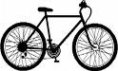

How many shoes?
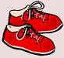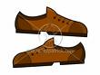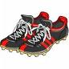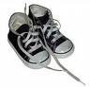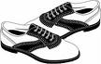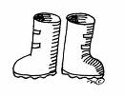

How many footprints?
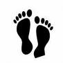

How many gloves?

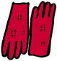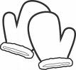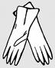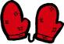

How much money?

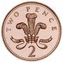

How many socks?

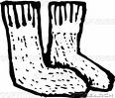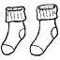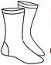

Counting in 2s
Carry on the number sequences. Look carefully to see if they are counting forwards or backwards.
2 | 4 | 6 | 8

8 | 10 |  |  | 16 | 18

20 | 18 | 16

24 | 22 | 20 |  |  |  | 12

6 |  | 10 |  |  | 16

24 |  | 20 | 18 |  |  |  |  |  | 6

2 |  |  | 8 |  |  |  |  |  | 20

24

6 | 8 |  |  |  | 16

20 |  |  |  |  |  |  |  |  | 2

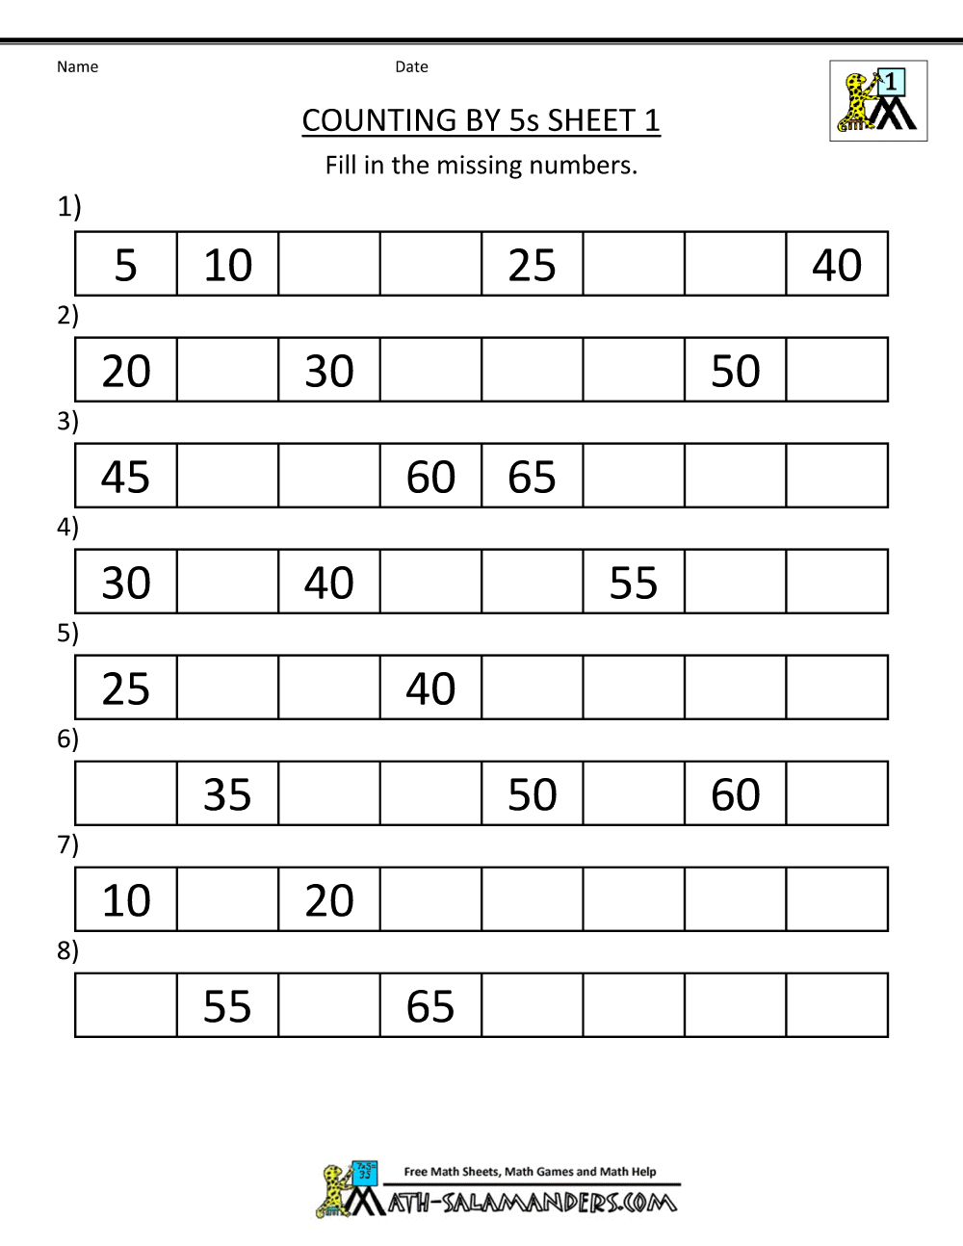

Addition
Use the number lines to help you answer the following

9 + 7 = | 8 + 12 = | 7 + 7 = | 19 + 1 =
14 + 3 = | 13 + 3 = | 3 + 13 = | 6 + 9 =
17 + 2 = | 2 + 17 = | 15 + 2 = | 17 + 1 =
5 + 11 = | 12 + 5 = | 10 + 4 = | 5 + 7 =
6 + 6 = | 9 + 8 = | 4 + 16 = | 8 + 3 =

Subtraction
Use the number lines to help you answer the following

9 - 6 = | 19 - 7 = | 18 - 2 = | 13 - 2 =
10 - 6 = | 11 - 6 = | 20 - 8 = | 19 - 9 =
8 - 5 = | 20 - 4 = | 17 - 2 = | 14 - 5 =
9 - 3 = | 15 - 8 = | 12 - 6 = | 17 - 6 =
7 - 6 = | 14 - 7 = | 18 - 4 = | 19 - 3 =

Number bonds to 10
Use the part–whole model to complete the addition and subtraction facts.
10
7

3

3 + 7 = 10

7 + 3 = 10

10 – 7 = 3

10 – 3 = 7

10
6

_____ + _____ = 10

_____ + _____ = 10

_____ - ____ = 6

_____ - _____ = 4

_____ + _____ = _____
10
1

_____ + _____ = _____

_____ - _____ = _____

_____ - _____ = _____

