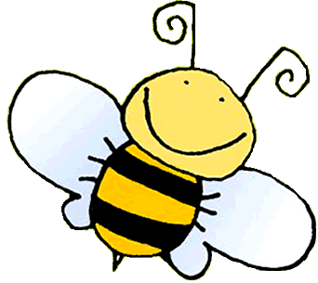Good Morning Year 6!!

Myself and Miss Hill have been busy as bees working together to plan work in school for all those Year 6 children who have returned to school today (1st June). Now, not all of you will have returned to school just yet; and that is absolutely fine. This is a decision made by you and your parents and we support you in your choices. School is not school as you know it so please do not think that you are missing out. Our plan is to teach work in school that you can also do at home as much as we possibly can. We encourage you to send in pictures of the work that you have done so that we can see how wonderful your work is. You can use the email address for the office and the lovely Mrs Bonfield and Mrs Linfitt will forward anything you send to Miss Hill and myself. Lots of you have been doing that already and it really does make us smile – yes, we are missing every single one of you and it is great to know what you are all up to! Here is the email address as a reminder: [enquiries@cranwell.lincs.sch.uk](mailto:enquiries@cranwell.lincs.sch.uk)

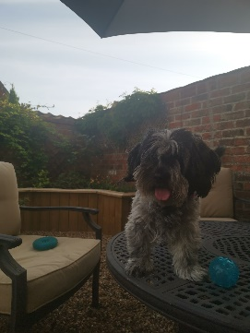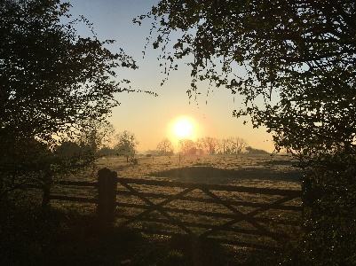We are asking what you have been up to, so here are a few things that we have been getting up to. Miss Hill has been busy in her garden planting some strawberries and she is delighted that the first few flowers have already arrived which means that she will have some strawberries in the coming weeks. Delicious! She has also been for a really lovely early morning walk and managed to capture the sunrise beautifully with her phone camera.

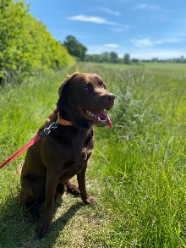Mrs Mulhall has been busy preparing resources for German lessons next year and has done lots of running and been out with her dog, Harley, on some lovely walks near her home. I have been busy decorating my house on chillier days and enjoying some gardening when the sun is out. I have also been enjoying the lovely countryside surrounding my village and have discovered lots of new walks with my dog. Today, whilst I have been on my laptop in the garden planning all of this work for you, Bailey, my dog, was dropping some rather subtle hints that she wanted me to stop and to play fetch with her. She jumped on the garden table!! Cheeky dog. I have also loved trying out the new ice cream parlour in the village where I live – delicious and perfect for the end of my dog walk on a hot day!

We are so lucky to have so much countryside around us so we are really spoilt for choice for walks and bike rides.

Here is your next two weeks of work. Remember to try your best. If you need further help, then you can always ring the office and leave a message or email your problem to the email address above. We are all still here to help, even though you are at home ☺ If you look at the heading of each box it will say the subject and also which week we would like you to complete it in. If you follow the dates, then it will match what we are doing in school.

|  |  |
| --- | --- |
| **Maths – Week beginning 1/6/20**  Please continue to complete your daily maths lesson, using the White Rose resources from the website. Have a go at the questions on the video, on a piece of paper. Remember to also follow the links to BBC Bitesize for even more practise.  You can find your lessons here: https://whiterosemaths.com/homelearning/year-6/ Please move onto the section labelled ‘Summer Term Week 6 w/c 1st June’. The videos are also available on Facebook, if the website is overloaded.  Of course, I’ll continue to set tasks on Mathletics, but only do these if you have spare time!  Want an extra challenge? Complete the sheet below. | **Maths – Week beginning 8/6/20**  Please continue to complete your daily maths lesson, using the White Rose resources from the website. Have a go at the questions on the video, on a piece of paper. Remember to also follow the links to BBC Bitesize for even more practise.  You can find your lessons here: https://whiterosemaths.com/homelearning/year-6/ Please move onto the section labelled ‘Summer Term Week 6 w/c 8th June’. The videos are also available on Facebook, if the website is overloaded.  Of course, I’ll continue to set tasks on Mathletics, but only do these if you have spare time!  Want an extra challenge? Complete the sheet below. |
| **Literacy – Week beginning 1/6/20**  Attached below is a booklet from Talk for Writing called The Gadgets Workbook. If you like spy stories like we do, then you will enjoy this writing unit of work; if you like gadgets you will like it even more!  Monday: complete the tasks on p1-6; this will involve **cracking a code** (the answer…shhhhh top secret…. Is at the end of the booklet). Next, create a **spy name!** Have fun seeing what spy names your families would have using the grid on p3. Follow the instructions in the booklet and read the text; if you need to, you can listen to it by following the link in the booklet. Finally, complete **Activity 1: Vocabulary** and **Activity 2: Persuasive Games**.  Tuesday: complete **Activity 3: Underlying Pattern of Adverts**. When you are ready, complete **Activity 4: Making a Toolkit for Persuasion**. Then it is time for some practice at using speech punctuation with **Activity 5: Quotation Practice**.  Wednesday: try out **Activity 6: New Ideas** and then for some fun completing **Activity 7: Draw Your Gadget**. Time to get some work done with **Activity 8: Planning.** All the best authors ask someone else to check through their work, you can try this too with **Activity 9: Talk Your Plan Through**.  Thursday: Find somewhere quiet so that you can concentrate to complete **Activity 10: Time to Write your Advert/Persuasion.**  Friday: After sharing your work so far with another human being then it is time to complete your final task which is **Activity 11: Re-read, polish and improve**.  **Just for Fun:** If you have enjoyed this unit of work, then there are two more activities for you to try! | **Literacy – Week beginning 8/6/20**  NEWSFLASH – you have reached the grand old age of 99! Happy Birthday!! You have decided it is time to write your autobiography (auto=self; bio=life; graphy=to write).  We are giving you the chance to look back on your life to reflect on the wonderful things you have done, the places you have been, and the inspirational people you have met.  You will need to ensure that you are mentioning any major events (Coronavirus pandemic would probably be one of these as it is a global event and you can record what it was like to have been a child during this unprecedented time – you could also include being invited back to your school when you were 58-60 (depending on your age now) to open a Covid-19 timecapsule buried by Mr Wilson in 2020 – use your imagination). What other major or memorable events might happen in your lifetime? Could anything happen in space travel? Will all vehicles be electric? Will something have been invented to replace aeroplanes? Will we still be a country dog and cat lovers or are we all now bee keepers?  Will you have had children? Grandchildren? Great-grandchildren? Perhaps you could include an imaginary family tree within your autobiography to make it seem authentic?  Who will be on the throne when you are 99? Who will have been on the throne between now and then? Thinking about how music has changed throughout the decades, what will you be listening to now or will have enjoyed throughout your life? (This all links to our History last term).  What career did you choose? Did you have more than one career choice? Try to keep it realistic – most people don’t tend to be famous footballers, famous popstars or famous youtubers. What experiences did you enjoy in your working life? If you became a vet, did you manage to go overseas to work with big cats in a Kenyan wildlife reserve for instance? If you became a volcanologist, which volcanoes have you visited in your research? Maybe your love of dancing led to you creating your own dance school after a career in a ballet company?  What exciting lives did you lead? |
| **Reading/Art task – Week beginning 1/6/20**  This week we would like you to create a new book cover for the book that you are **currently reading**. Have a good look at the existing book cover. Why did the illustrator choose that image for the book’s front cover? Does the picture on the front cover give anything important away or just enough to get you interested? What image do you think would represent the book well in your opinion?  Don’t forget the title, author, illustrator and publisher information. You will need to write a blurb for the back cover too.  Remember to allow yourself some time to continue reading your book – 30 minutes a day. Remember 5/6B, I suggested moving your reading den outside to enjoy this marvellous weather we are having at the moment. There is nothing better than reading in the garden, listening to the sounds of the birds; very relaxing! 6H why not try it too? Create a den/space in the garden to relax in with a lovely book, and allow the author to transport you somewhere else! You don’t always need to leave your home to have an adventure. ☺ | **Reading/Art task – Week beginning 8/6/20**  This week we would like you to think about **your favourite book** that you have ever read. I remember, when I was a child, I loved Enid Blyton and also enjoyed all the Pippa Longstocking books written by Astrid Lindgren. I know that Harry Potter would have been a firm favourite of mine too. Miss Hill also loved Enid Blyton and Pippa Longstocking as a child as well as the Chalet School series by Elinor M. Brent-Dyer, Babysitters Club by Ann Martin and Saddle Club by Bonnie Bryant.  There are lots of interesting and wonderful books out there whether you crave adventure or sci-fi; animals or gangsta grannies. Give yourself time to think about which you feel would be your favourite still when you are 99 years old.  Once you have decided, then design and create a new book cover for it. Remember the book cover should give a hint of the story within without giving anything away; it needs the title, author and publisher information. You will also need to include the blurb for the back cover and perhaps the price.  Remember time to read undisturbed! Hopefully the weather is still really lovely by the time you are reading this; if not, enjoy your reading den you created in Week 1 5/6B. 6H why not create one inside too? ☺ |
| **Geography – Week beginning 1/6/20**  **WHAT ARE NATURAL RESOURCES?**  Jot down what you think natural resources are before watching the following clip from BBC Bitesize and see if you were right: <https://www.bbc.co.uk/bitesize/topics/zshp34j/articles/z62qy9q> the end made me chuckle! Watch the clip again and this time make notes – you could just use a spider diagram like we do on the board at school.  Next have a look at the nine pictures included below. What is happening in each of the pictures? Ask older siblings or your parents if you are stuck – or even share them with other relatives when you video call them.  Some other countries also have valuable natural resources. For example: South Africa has a precious metal called gold; New Zealand grow sheep which suits their landscape perfectly; Venezuela has lots of oil; and Iceland have plenty of ocean to fish.  **Your task** this week is to find out as much as you can about the countries in the example above (South Africa, New Zealand, Venezuela and Iceland) and their amazing natural resources. You could make a min-fact file for each or a powerpoint if you have the chance to use the computer. I will leave the presentation and format up to you! | **Geography – Week beginning 8/6/20**  **RENEWABLE AND NON-RENEWABLE RESOURCES – WHICH IS WHICH?**  Jot down as many different energy sources you can think of. Ask siblings, parents and relatives to help you.  Now watch the short video clip on BBC Bitesize: <https://www.bbc.co.uk/bitesize/topics/zshp34j/articles/zntxgwx>  Have a look at the list you created before the video clip. Have you been able to add any more to it?  There are some ENERGY CARDS attached below. Sort the cards into two groups: renewable energy sources and non-renewable energy sources. Don’t worry if you can’t print them off (my printer is always out of ink when I need it!) you could look at them on the screen and write them in two columns. Next explain to another human being why you chose them to be in each group – how good are you at explaining?  Draw an annotated (labelled) poster for each of the two groups to show which energy sources belong in which. Make sure you label them clearly!  Ask a sibling, parent or relative (via the phone) what they think the advantages of renewable energy might be. Do they all agree? What do you think? Now ask what they think the disadvantages might be. Do they all agree? What do you think? You could use the activity sheet attached below ADVANTAGES AND DISADVANTAGES SHEET if you are finding it hard – you need to sort them into advantages and disadvantages.  **Your task** this week is to choose one of the following energy sources and to research it and create a factfile/powerpoint about it. Here is the list to choose from (the ones in green are trickier if you want a challenge!):  Renewable – wind, geo-thermal, biomass, hydro-electricity.  Non-renewable – coal, natural gas, oil, nuclear. |
| **Spelling Task – Week beginning 1/6/20**  Can you use a dictionary to find out what these words mean and then learn how to spell them? Don’t worry if you don’t have a dictionary at home, you can, with your parents’ permission, google it or use these online ones: <https://www.wordsmyth.net/> or <https://kids.britannica.com/kids/browse/dictionary>.  Here are this week’s topical words:   1. Natural resources 2. Agricultural resources 3. Geological resources 4. Crops 5. Oil 6. Wind 7. Rivers 8. Tides 9. Minerals 10. Fossils fuels 11. Renewable energy 12. Non-renewable energy | **Spelling Task – Week beginning 8/6/20**  Just like last week, can you use a dictionary to find out what these words mean and then learn how to spell them? Try to use the words in your work in Geography this term. It might be wise to make a note of them perhaps?  Remember, if you don’t have a dictionary at home, with your parents’ permission, try one of the online ones: <https://www.wordsmyth.net/> or <https://kids.britannica.com/kids/browse/dictionary>.  Here are this week’s topical words:   1. Geothermal 2. Biomass 3. Hydroelectricity 4. Nuclear 5. Natural gas 6. Coal 7. Oil 8. Distribution 9. Imbalance 10. Starvation 11. Conservation |
| **German**  We hope you have been enjoying practising your German using Duo Lingo. We must say, both Miss Hill and myself have been enjoying practising our German and when we chatted to you all, lots of you said you were enjoying it too. ☺  Keep practising – it’s quite fun: <https://www.duolingo.com/> | **PSHE**  At times like this people can often experience a wide range of emotions. You are missing those you love like family and friends; missing normal routines and school; missing your clubs and activities; missing going shopping for toys and games; missing birthday parties and celebrations outside the home; missing being free to move around the country and to travel on a plane; missing eating out in restaurants and going to the cinema.  There are lots of things that I am sure you all miss that I haven’t mentioned. It’s ok to feel like this. It’s ok to miss people, things and opportunities. It is all perfectly natural.  What can we do about it? Well we can’t change how things are, that’s for certain; but we can think of ways to tell people how much we miss them. Why not try one of these ways below:   * You could create a “hug” out of paper for someone you miss, make sure the arms are long enough! Then write all the things you love about them along each of the paper arms and put it in an envelope to send to the person you miss, perhaps it is your grandparents or another relative. * You could write a letter, thanking someone for being them, or just to say “hi” – it’s nice to receive a letter through the post that someone has taken the time to write; maybe you will be lucky and receive one back? * You could write a gratitude diary listing all of the things you are grateful to have in your life and all the things that you are looking forward to doing one day soon. They will be worth the wait! |
| **Art/Relaxation**  If you would like to colour in some mindfulness pictures, then there are some attached below. Colouring in is great food for your soul. It helps relax your brain and gives you space to just “be”.  Here is a link to a bumper pack of free colouring pages from Twinkl: <https://www.twinkl.co.uk/resource/t-c-1551-mindfulness-colouring-sheets-bumper-pack>  Or…  Like Andy Goldsworthy, <https://www.kidzworld.com/article/29663-andy-goldsworthy-the-art-of-nature> can you try a pebble balance challenge? <https://www.youtube.com/watch?v=HBvgaOlR9J4> or this <https://www.youtube.com/watch?v=hdjPYsPZaks> have lots of fun but be careful and remember to ask permission from your parents/carers before deciding where to create your challenge. |
| **PE**  Keep up with Joe Wicks every day or if you prefer to move around to music try Just Dance. Perhaps yoga is your thing? <https://www.youtube.com/user/CosmicKidsYoga>  Mrs Owen has sent lots of ideas via Parent Mail which I hope you are enjoying completing. | **PE**  Keep up with Joe Wicks every day – it is important to keep moving around and to be active.  If you fancy a change, why not try skipping? Here is a link for an explanation of how to begin to skip if you can’t already do so <https://www.youtube.com/watch?v=OKu5s-2RyiQ> and then once you have mastered the skill, there are many more challenges to complete: <https://www.youtube.com/results?sp=mAEB&search_query=dan+skipping+man> |

Maths Extra Challenge – Week beginning 1st June

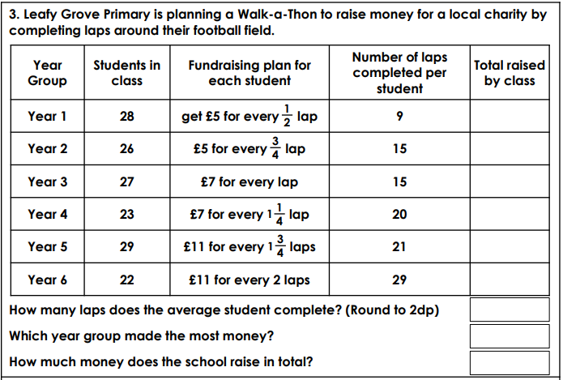

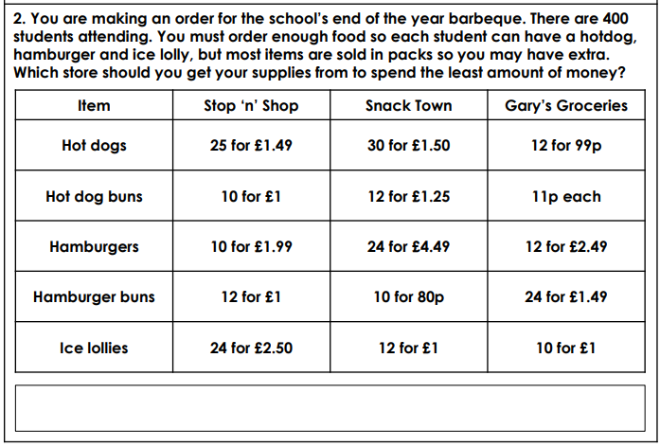Maths Extra Challenge – Week beginning 8th June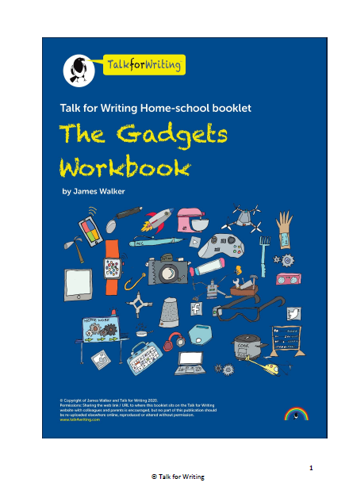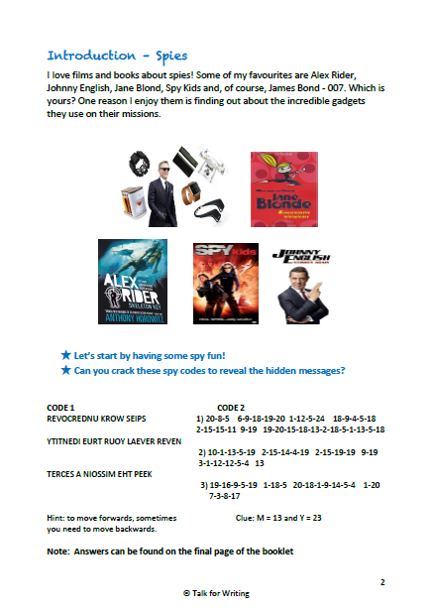

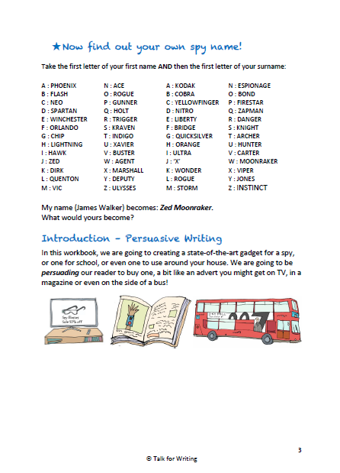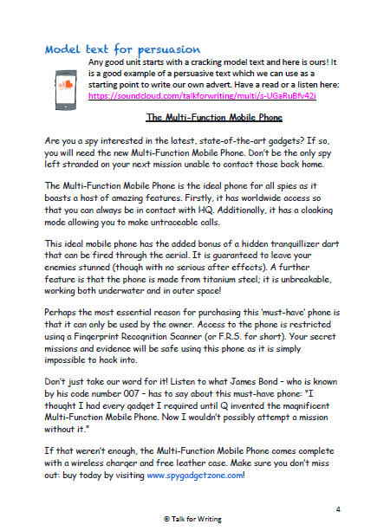

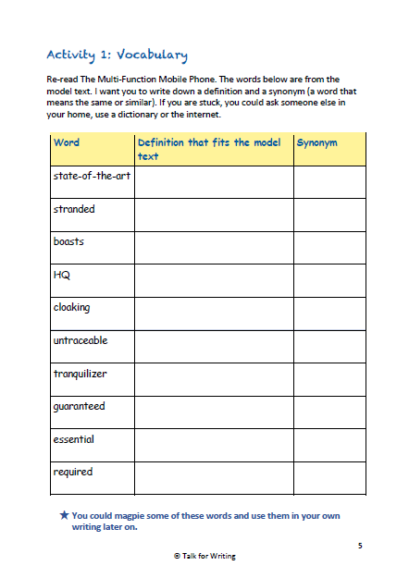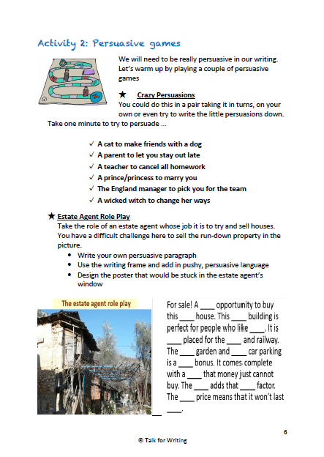

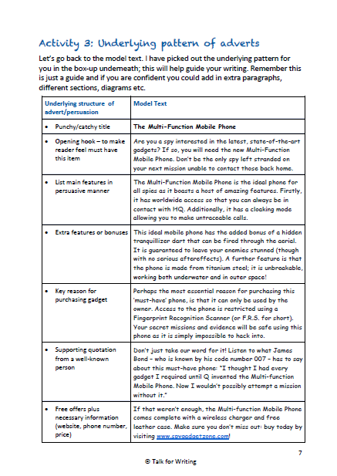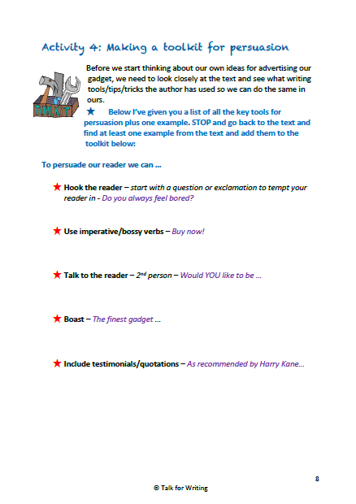

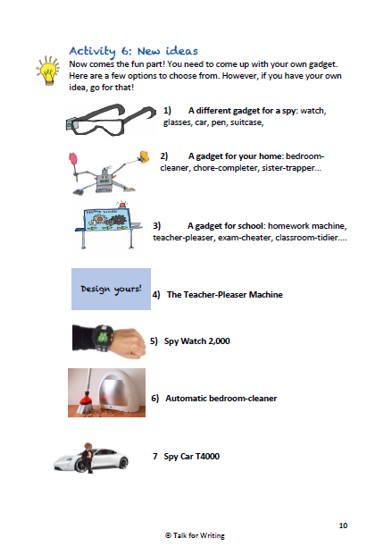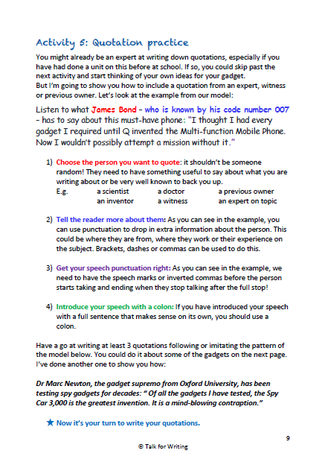

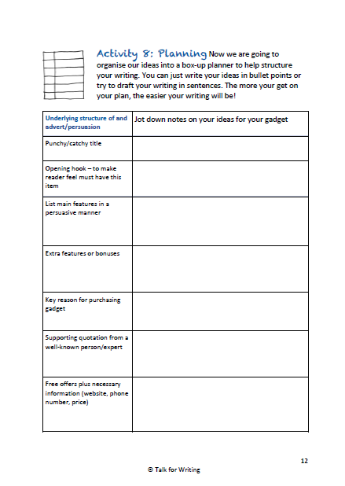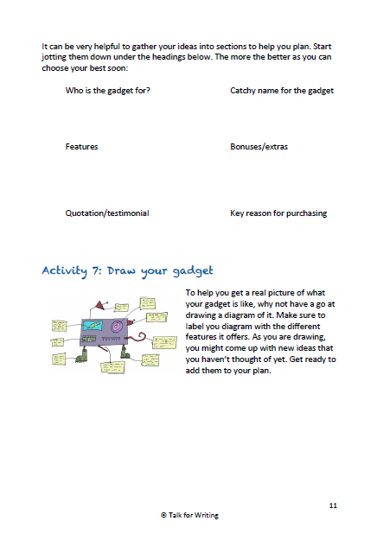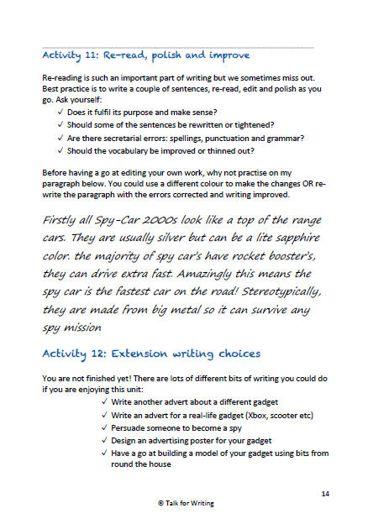

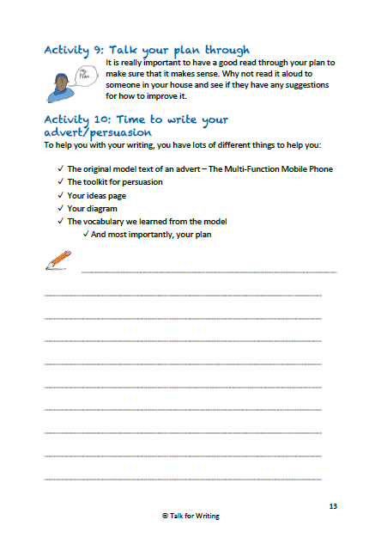

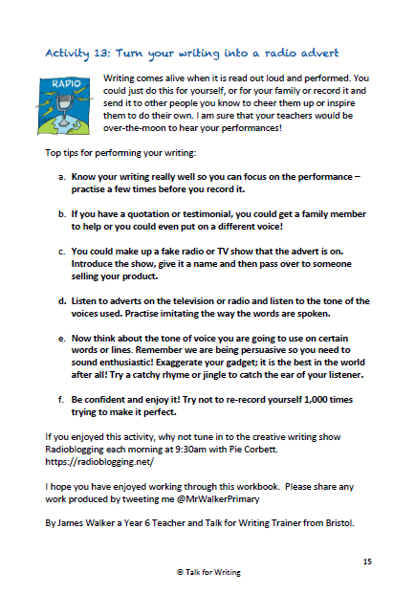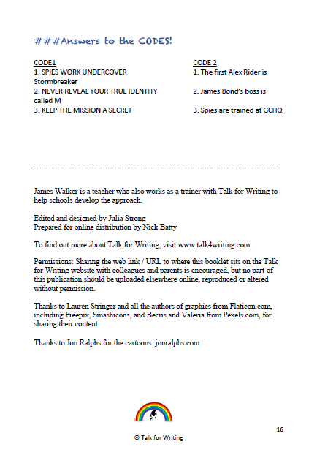

|  |  |  |
| --- | --- | --- |
|  |  |  |
|  |  |  |
|  |  | W |

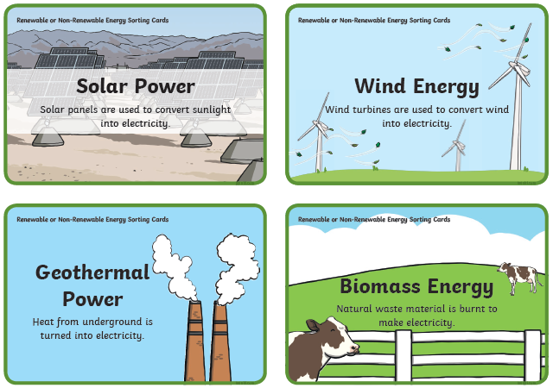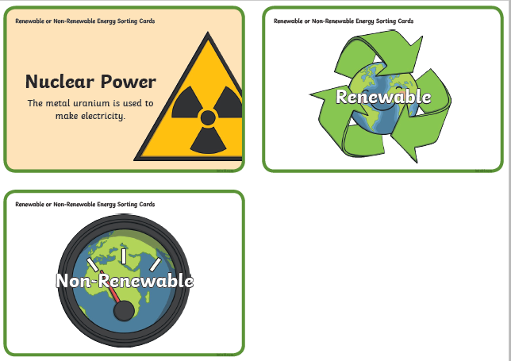

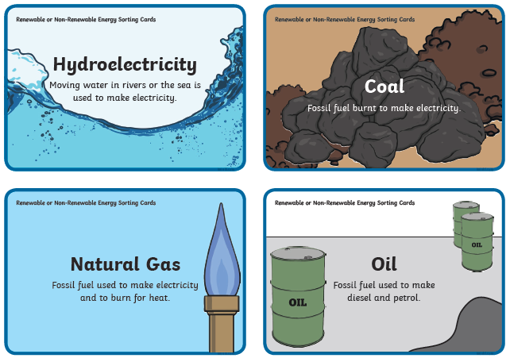

Geog for Week beginning 8/6/20 – Advantages and disadvantages of renewable and non-renewable energy sources

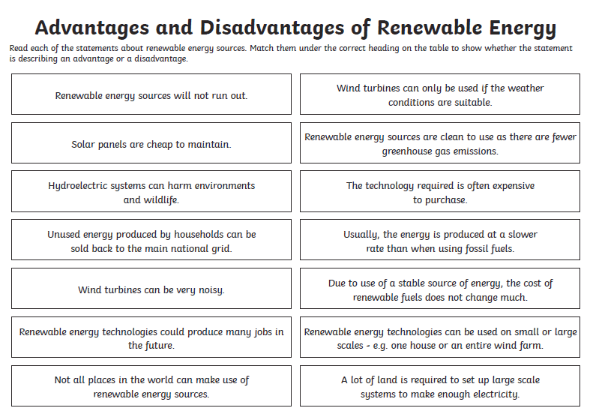

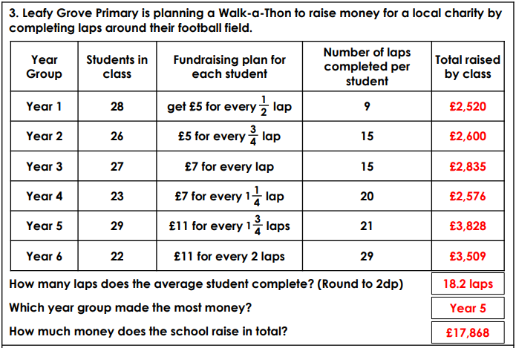ANSWER SECTION – TOP SECRET – ANSWER SECTION – TOP SECRET – ANSWER SECTION – TOP SECRET – ANSWER SECTION – TOP SECRET – ANSWER SECTION – TOP SECRET

