EYFS Home Learning Challenges Week beginning 1st June 2020
 | Challenge 36 | Challenge 37 | Challenge 38 | Challenge 39 | Challenge 40
Challenge | 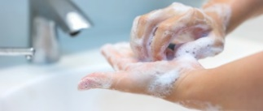  Discuss with your parents what germs are and how we can stay healthy e.g. washing hands – you could also make a poster to share what you know! | 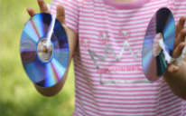  What objects could you use in your house as instruments? Can you play your instrument on your doorstep during clap for carers? | 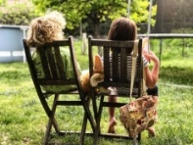  Senses … can you sit in your garden and listen. What can you hear? Try this in the morning and later before bedtime. Can you draw or write down what you hear? | 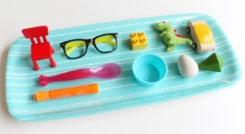  Play a memory game – what is under the blanket? Take an object away; can you remember what is left? | Can you make an obstacle course outside using chalk? Or equipment?  Can you add a hop scotch? Spins? Hops? Jumps?  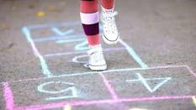
Maths Focus | Write down a number line 0-10/20. | Use your number line from yesterday. Cover up some numbers.  What numbers are missing? | How many spoons to you have in your house?  How many doors do you have in your house?  How many toilets do you have in your house? | Think of a number.  What is one more?  What is one less? | Children to practice writing digits 0-9. Make sure they all start in the same place. Use chalk or a paintbrush and water? (See challenge above)
Phonics Focus | Draw a picture of what you did at the weekend and either label what you have drawn or write some sentences. | Play a game of ‘I spy’ What can you see around you? | Write a list of all the things you can see around you.  You can even put them into a sentence. | Write down all the names of people in your family. Make sure all the letters start in the right places. | Go through your envelope of phonics and ‘tricky’ words. Do you now know more than you did before?

EYFS Home Challenges Week beginning 8th June 2020
 | Challenge 41 | Challenge 42 | Challenge 43 | Challenge 44 | Challenge 45
Challenge | 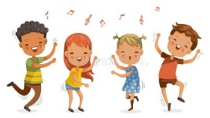  Can you make a dance pattern using 5 different movements e.g. jump, clap, turn, roll, stamp? | 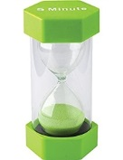  Count how many things you can do in 30 seconds e.g. how many jumps can you do? How many times can you clap your hands? | Catch a large ball and throw it to someone 5 times without dropping it. Count how many times can you throw it without dropping it.  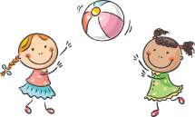 | 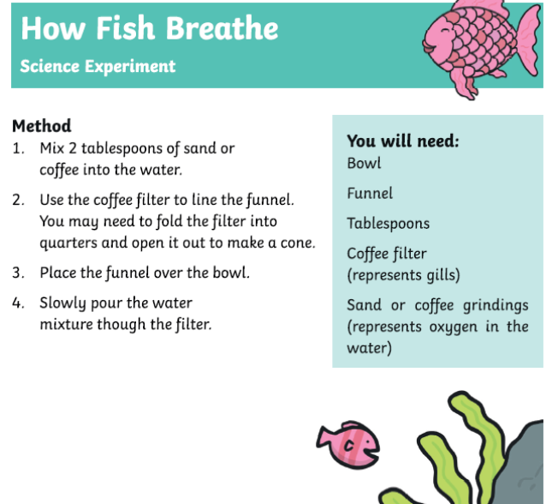 | This weekend would usually see the celebration of the Queens’ Birthday and ‘Trooping the Colour’.  Find out about what usually happens during ‘Trooping the Colour’ and practice your marching skills.  You may also want to make and colour in your own union flag to wave.
Maths Focus | Look around the house and see how many circles and semi-circles you can find. | Cut up or collect as many 2d shapes as you can. What under the sea picture can you make? | Listen/Watch the story  Can you make a repeating pattern? The Rainbow Fish is made up of a pattern. If you were a fish, what pattern would you like to be? | Look around the house and see how many triangles you can find.  What makes it a triangle? Why is it not a square? | What shapes do you need to make a Union Flag? Can you see any circles? Can you see any triangles? What shape is a flag?
Phonics Focus | Watch or read the story of ‘The Rainbow Fish’. Talk about what you like about the story. Draw a picture of the rainbow fish and label it. | Being kind- What can you do for a friend?  How can you show a friend you care? Make a list | Write a sentence about The Rainbow Fish. What does he look like? How does he feel at the beginning of the story? What does he feel like at the end of the story? | Who else is in the story of The Rainbow Fish?  What do they look like? Draw a picture or make the other characters. | Act out the story of The Rainbow Fish. Use the characters you have made or dress up or use construction. Upload a video onto Tapestry.
Link to the Rainbow Fish story: https://www.youtube.com/watch?v=QFORvXhub28

