4A Distant Learning: 1st June to 12th June

Hello 4A!
Welcome to your next 2 weeks’ worth of home learning! I hope you all enjoyed your half term and had a lovely little break from all that hard work you are doing at home! Last time I spoke to you, a lot of you said you were thoroughly enjoying the plant activities from the previous distant learning pack, which is lovely to hear. I have been busy myself in the garden at the weekends; it’s amazing how quickly weeds can grow back isn’t it! I can see a lot of you have been very busy on Mathletics and some GIGANTIC scores have been achieved!! Big congratulations to Keira-Rose and Thomas who have scored thousands of points for the last couple of weeks.
If you would like to further your learning, I highly recommend online BBC Bitesize daily lessons. This is a wonderful resource which may teach new concepts but also revisits previously learned material and is a great way to refresh our knowledge whilst on lockdown. Find your year group on https://www.bbc.co.uk/bitesize/dailylessons
If you have any questions about the work that I have set, then you can ring the school office on 01400 659001 or email enquiries@cranwell.lincs.sch.uk and I will do what I can to help you!
Speak to you all soon and remember to keep smiling!
Mrs Allen

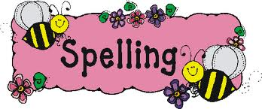

Literacy
This term we would have been learning how to write an explanation text. An explanation text describes how something works or why something happens. Explanation texts include a lot of specific detail and logically describe the stages in a process, for example; ‘How do seeds grow?’ and ‘The Development of a Frog’. Your task for the next 2 weeks is to write your own explanation text, on a topic of your choice! See below for more information, including the features of an explanation text, an example and a few ideas to help you out.

Spellings

Alongside learning the Year 3 and 4 National Curriculum spelling can you mark Mr Woops’ work and find his mistakes?! Why not use coloured pens like Mrs Allen does in your books when marking your work!

Reading
We read in class every day, so it would be really nice if you could spend some time every day reading a book. This can be a home book, a newspaper, magazine or anything alike. Do not forget to record this in your reading record.
It would also be good practise to complete some book reviews in the back of you reading record.

Extras
Food safety week begins on 4th June. Can you make a poster which draws attention to food safety rules that are important to follow in the kitchen when preparing food? I have also included a fun healthy eating, living and nutrition pack under the 4A section on downloads if you wish to complete these.

Maths
Please see ‘Maths’ information page, which explains your daily tasks.
Times Tables
I have provided you with the times tables test you complete weekly in school. Once you have completed and scored full marks on the multiplication sheet in 5 minutes then you can move onto the division sheet. You have 5 minutes to complete as many as you can, column by column. You could also have a look on the times tables page for websites to help you.
French
You were all trying really hard in class and enjoying our French lessons. Use this fun website, www.duolingo.com, to further your French vocabulary! Follow the instructions below to access the fun learning!

Spelling Activities

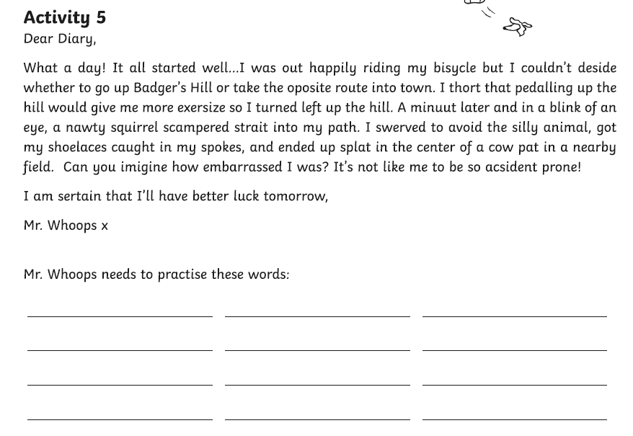

Literacy
Features of an explanation text

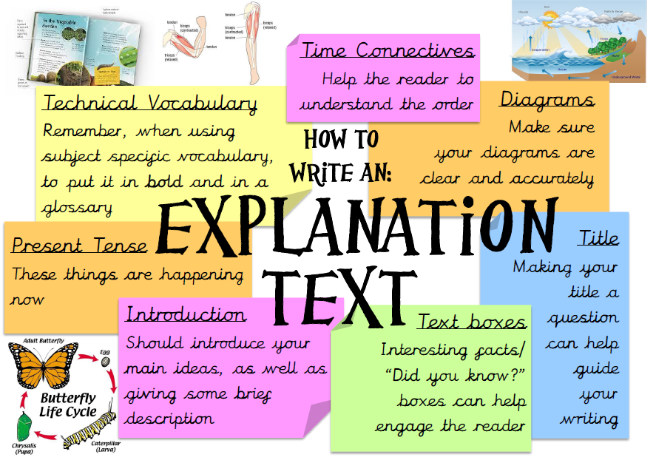
Example

What could I write my explanation text on?

I thought it would be a nice idea to let you choose what topic you would like to write your explanation text on. Maybe over dinner, with your family, you could discuss what process would be a good topic to write about. Depending upon what topic you chose to write your explanation text on, you may need to do a little bit of research online for specific details. You may even like to get really creative and design your own machine to use around the house and write an explanation text on how it works. If you are struggling for ideas, I have listed a few below.
The lifecycle of a frog

How do volcanoes erupt?

How does a chicken hatch?

How does a spider spin a web?

How do seeds grow?

Times Table Activities

https://play.ttrockstars.com/auth/school - Times Table Rock Stars is a great way to practise your times tables
https://play.edshed.com/ - Practise your times tables
https://www.timestables.co.uk/ - learn and practise
https://www.topmarks.co.uk/maths-games/7-11-years/times-tables
https://www.oxfordowl.co.uk/for-home/maths/help-with-times-tables/ -
https://www.themathsfactor.com/times-tables-check/#/- A Times Tables Check in the same format the Multiplication Test will be.

Maths Activities

Please continue to complete your daily maths lesson, on the White Rose website. You should now be ready to move onto ‘Summer term- Week 6 (w/c 1st June)’ and ‘Summer term-Week 7 (w/c 8th June)’.
Each day, there will be a short video of a lesson to watch, which will contain questions for you to answer on paper. The lesson videos will also be linked to the BBC Bitesize website, where you will find further explanations and activities.
Follow this link to find your daily lessons and follow the instructions on the website: https://whiterosemaths.com/homelearning/year-4/
In addition to this, Mathletics activities will be set and don’t forget you always have access to Times Tables Rockstars and Education city.
Extra Maths Games
https://play.prodigygame.com/ - Pokemon style game with maths questions!
https://play.edshed.com/ - practise your number bonds, power of 10 and addition and subtraction
www.topmarks.co.uk –interactive games
https://www.oxfordowl.co.uk/for-home/kids-activities/fun-maths-games-and-activities/#maths-7-9 – games and activities
https://www.mathswithparents.com/KWeb?startTime=1584558592239#menu584883 – Free access to parents – videos and activities across the maths curriculum.

2x table |  | 5x table |  | 10x table |  | 3x table |  | 4x table |  | 8x table
1 x 2 = |  | 3 x 5 = |  | 2 x 10 = |  | 4 x 3 = |  | 3 x 4 = |  | 2 x 8 =
6 x 2 = |  | 8 x 5 = |  | 6 x 10 = |  | 10 x 3 = |  | 1 x 4 = |  | 10 x 8 =
10 x 2 = |  | 11 x 5 = |  | 8 x 10 = |  | 1 x 3 = |  | 9 x 4 = |  | 8 x 8 =
2 x 2 = |  | 2 x 5 = |  | 3 x 10 = |  | 5 x 3 = |  | 7 x 4 = |  | 1 x 8 =
4 x 2 = |  | 4 x 5 = |  | 7 x 10 = |  | 9 x 3 = |  | 2 x 4 = |  | 5 x 8 =
5 x 2 = |  | 6 x 5 = |  | 10 x 10 = |  | 6 x 3 = |  | 12 x 4 = |  | 7 x 8 =
7 x 2 = |  | 10 x 5 = |  | 4 x 10 = |  | 2 x 3 = |  | 8 x 4 = |  | 9 x 8 =
12 x 2 = |  | 1 x 5 = |  | 11 x 10 = |  | 11 x 3 = |  | 11 x 4 = |  | 3 x 8 =
3 x 2 = |  | 5 x 5 = |  | 9 x 10 = |  | 8 x 3 = |  | 5 x 4 = |  | 6 x 8 =
8 x 2 = |  | 9 x 5 = |  | 1 x 10 = |  | 12 x 3 = |  | 10 x 4 = |  | 11 x 8 =
11 x 2 = |  | 12 x 5 = |  | 12 x 10 = |  | 3 x 3 = |  | 6 x 4 = |  | 4 x 8 =
9 x 2 = |  | 7 x 5 = |  | 5 x 10 = |  | 7 x 3 = |  | 4 x 4 = |  | 12 x 8 =
Total: |  | Total: |  | Total: |  | Total: |  | Total: |  | Total:
6 x table |  | 7 x table |  | 9 x table |  | 11 x table |  | 12 x table
2 x 6 = |  | 2 x 7 = |  | 1 x 9 = |  | 4 x 11 = |  | 3 x 12 =
6 x 6 = |  | 10 x 7 = |  | 6 x 9 = |  | 10 x 11 = |  | 1 x 12 =
8 x 6 = |  | 8 x 7 = |  | 10 x 9 = |  | 1 x 11 = |  | 9 x 12 =
3 x 6 = |  | 1 x 7 = |  | 2 x 9 = |  | 5 x 11 = |  | 7 x 12 =
7 x 6 = |  | 5 x 7 = |  | 4 x 9 = |  | 9 x 11 = |  | 2 x 12 =
10 x 6 = |  | 7 x 7 = |  | 5 x 9 = |  | 6 x 11 = |  | 4 x 12 =
4 x 6 = |  | 9 x 7 = |  | 7 x 9 = |  | 2 x 11 = |  | 8 x 12 =
11 x 6 = |  | 3 x 7 = |  | 12 x 9 = |  | 3 x 11 = |  | 11 x 12 =
9 x 6 = |  | 6 x 7 = |  | 3 x 9 = |  | 8 x 11 = |  | 5 x 12 =
1 x 6 = |  | 11 x 7 = |  | 8 x 9 = |  | 12 x 11 = |  | 10 x 12 =
12 x 6 = |  | 4 x 7 = |  | 11 x 9 = |  | 11 x 11 = |  | 6 x 12 =
5 x 6 = |  | 12 x 7 = |  | 9 x 9 = |  | 7 x 11 = |  | 12 x 12 =
Total: |  | Total: |  | Total: |  | Total: |  | Total:

2÷ table |  |  | 5÷ table |  |  | 10÷ table |  |  | 3÷ table |  | 4÷ table |  |  | 8÷ table
2÷2 = |  |  | 15 ÷ 5 = |  |  | 20 ÷ 10 = |  |  | 12 ÷ 3 = |  | 12 ÷ 4 = |  |  | 16 ÷ 8 =
12÷ 2 = |  |  | 40 ÷ 5 = |  |  | 60 ÷ 10 = |  |  | 30 ÷ 3 = |  | 4 ÷ 4 = |  |  | 80 ÷ 8 =
20 ÷ 2 = |  |  | 55 ÷ 5 = |  |  | 80 ÷ 10 = |  |  | 3 ÷ 3 = |  | 36 ÷ 4 = |  |  | 64 ÷ 8 =
2 ÷ 2 = |  |  | 10 ÷ 5 = |  |  | 30 ÷ 10 = |  |  | 15 ÷ 3 = |  | 28 ÷ 4 = |  |  | 8 ÷ 8 =
8 ÷ 2 = |  |  | 20 ÷ 5 = |  |  | 70 ÷ 10 = |  |  | 27 ÷ 3 = |  | 8 ÷ 4 = |  |  | 40 ÷ 8 =
10 ÷ 2 = |  |  | 30 ÷ 5 = |  |  | 10 ÷ 10 = |  |  | 18 ÷ 3 = |  | 48 ÷ 4 = |  |  | 56 ÷ 8 =
14 ÷ 2 = |  |  | 50 ÷ 5 = |  |  | 40 ÷ 10 = |  |  | 6 ÷ 3 = |  | 32 ÷ 4 = |  |  | 72 ÷ 8 =
24 ÷ 2 = |  |  | 5 ÷ 5 = |  |  | 110 ÷ 10 = |  |  | 33 ÷ 3 = |  | 44 ÷ 4 = |  |  | 24 ÷ 8 =
6 ÷ 2 = |  |  | 25 ÷ 5 = |  |  | 90 ÷ 10 = |  |  | 24 ÷ 3 = |  | 20 ÷ 4 = |  |  | 48 ÷ 8 =
16 ÷ 2 = |  |  | 45 ÷ 5 = |  |  | 10 ÷ 10 = |  |  | 36 ÷ 3 = |  | 40 ÷ 4 = |  |  | 88 ÷ 8 =
22 ÷ 2 = |  |  | 60 ÷ 5 = |  |  | 120 ÷ 10 = |  |  | 9 ÷ 3 = |  | 24 ÷ 4 = |  |  | 32 ÷ 8 =
18 ÷ 2 = |  |  | 35 ÷ 5 = |  |  | 50 ÷ 10 = |  |  | 21 ÷ 3 = |  | 16 ÷ 4 = |  |  | 96 ÷ 8 =
Total: |  |  | Total: |  |  | Total: |  |  | Total: |  | Total: |  |  | Total:
6 ÷ table |  | 7 ÷ table |  |  | 9 ÷ table |  |  | 11 ÷ table |  |  |  | 12 ÷ table
12 ÷ 6 = |  | 14 ÷ 7 = |  |  | 9 ÷ 9 = |  |  | 44 ÷ 11 = |  |  |  | 36 ÷ 12 =
36 ÷ 6 = |  | 70 ÷ 7 = |  |  | 54 ÷ 9 = |  |  | 110 ÷ 11 = |  |  |  | 12 ÷ 12 =
48 ÷ 6 = |  | 56 ÷ 7 = |  |  | 90 ÷ 9 = |  |  | 11 ÷ 11 = |  |  |  | 108 ÷ 12 =
18 ÷ 6 = |  | 7 ÷ 7 = |  |  | 18 ÷ 9 = |  |  | 55 ÷ 11 = |  |  |  | 84 ÷ 12 =
42 ÷ 6 = |  | 35 ÷ 7 = |  |  | 36 ÷ 9 = |  |  | 99 ÷ 11 = |  |  |  | 24 ÷ 12 =
60 ÷ 6 = |  | 49 ÷ 7 = |  |  | 45 ÷ 9 = |  |  | 66 ÷ 11 = |  |  |  | 48 ÷ 12 =
24 ÷ 6 = |  | 63 ÷ 7 = |  |  | 63 ÷ 9 = |  |  | 22 ÷ 11 = |  |  |  | 96 ÷ 12 =
66 ÷ 6 = |  | 21 ÷ 7 = |  |  | 108 ÷ 9 = |  |  | 33 ÷ 11 = |  |  |  | 132 ÷ 12 =
54 ÷ 6 = |  | 42 ÷ 7 = |  |  | 27 ÷ 9 = |  |  | 88 ÷ 11 = |  |  |  | 60 ÷ 12 =
6 ÷ 6 = |  | 77 ÷ 7 = |  |  | 72 ÷ 9 = |  |  | 132 ÷ 11 = |  |  |  | 120 ÷ 12 =
72 ÷ 6 = |  | 28 ÷ 7 = |  |  | 99 ÷ 9 = |  |  | 121 ÷ 11 = |  |  |  | 72 ÷ 12 =
30 ÷ 6 = |  | 84 ÷ 7 = |  |  | 81 ÷ 9 = |  |  | 77 ÷ 11 = |  |  |  | 144 ÷ 12 =
Total: |  | Total: |  |  | Total: |  |  | Total: |  |  |  | Total:

French

To access the fun learning on DuoLingo follow the instructions below
1. Enter www.duolingo.com into your search bar or follow the hyperlink in blue.
2. Click the ‘Get Started’ icon.
3. Choose the language ‘French’.
4. When it asks why you are learning a language, click the ‘School’ icon.
5. It will then ask you to choose a daily goal. This is entirely your choice, depending on how long you would like to spend on it a day. Just bear in mind, you can keep track of your daily points and achieve ‘streaks’ if you manage to complete your daily goal on consecutive days. I chose ‘Regular-10 minutes a day’.
6. The next question will ask you if you want your daily goal logging. I would suggest you chose ‘not now’ unless you wish to do otherwise. It does keep track of your daily activity without having to create an account.
7. Lastly, when it asks you to choose your path, select ‘New to French’
8. You are now ready to go! Follow the instructions on the page and remember to have your volume turned up so you can hear the pronunciation of the French vocabulary.
You will only have to follow these instructions the first time you access the website. If you use the same laptop/computer daily, it should have saved your settings so you will be ready to go the next day! Enjoy! I am excited to see if any of you can achieve a 7-day streak!

PE Activities

https://www.cosmickids.com/category/watch/- Cosmic Kids Yoga. These activities vary from under 10 minutes to over 15 minutes.
https://www.youtube.com/results?search_query=body+coach+kids- Tune in with Joe Wicks for some HITT sessions!
https://www.youtube.com/user/thebodycoach1 - Joe Wicks is also providing live workout, every morning at 9am, called "PE with Joe" on his YouTube channel The Body Coach TV.
https://www.cranwell.lincs.sch.uk/ Follow our school twitter feed on the school website or visit our twitter page, or Carre’s Grammar School Outreach support https://twitter.com/CranwellSchool, https://twitter.com/CGSOutreach for fun daily challenges and virtual competitions you can enter.

Additional Websites

These websites are offering free, fun and interactive resources to help learning at home.

Twinkl- https://www.twinkl.co.uk/resources/parents
Mrs Mactivity- You can claim a free resource pack by signing up with your email- https://www.mrsmactivity.co.uk/
White Rose Maths- This is the Maths scheme we follow in school. They have provided free, really helpful lessons online that include a short video showing you clearly and simply how to help your child to complete the activity-.https://whiterosemaths.com/homelearning/
Classroom Secrets- They have created fun, interactive and practical home learning packs to ensure all children can continue to learn- https://classroomsecrets.co.uk/
Teach Starter- They are offering a 1 month free membership and a collection of free home learning packs-https://www.teachstarter.com/
Newsround- Watch Newsround live at 9:15am, 12:10pm and 4:00pm for the latest news- https://www.bbc.co.uk/newsround

