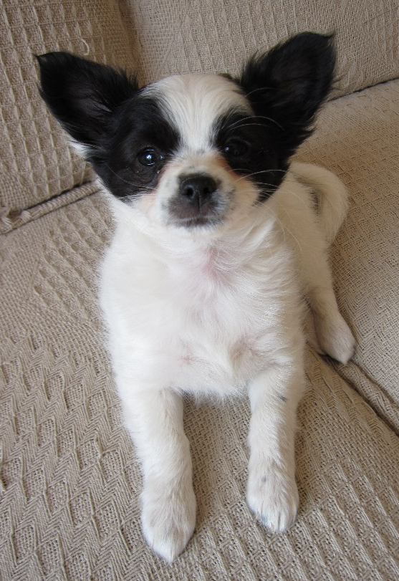
Hello 4/5N,
Wecome to Term 6!
Firstly, well done to all of you for coping so well with not being at school or seeing your friends. I know you have all been keeping busy with your work, exercising and helping out at home. Where possible, try to allocate some time towards maths and literacy learning on week days. Practising ‘little and often’ will help you retain, and hopefully build upon, what you’ve learnt at school and will help ease your transition back to school.
Thank you for the work and lovely photos some of you have been able to share with me, it’s comforting to see your smiling faces. I am very impressed with the standard of work you have produced despite not being in school; you have shown maturity beyond your years.
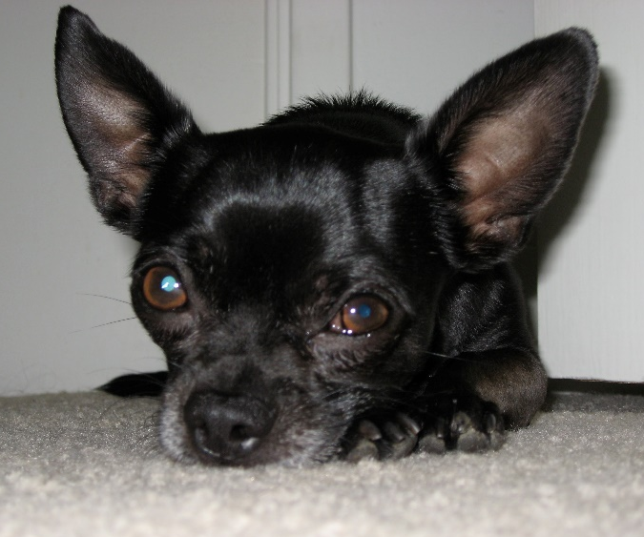
You should be able to complete these independently, but ask Mum or Dad if you need help. If you have any problems with log-ins etc., you can ask an adult to ring school, as we are still there to help you.
Parents and children, if you would like to supplement your learning further, I highly recommend online BBC Bitesize daily lessons. This is a wonderful resource which may teach new concepts but also revisits previously learned material and is a great way to refresh our knowledge whilst on lockdown. Find your year group on https://www.bbc.co.uk/bitesize/dailylessons
Take care and hope to see you all soon, Mrs New

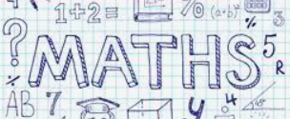
Please continue to complete your daily maths lesson, using the White Rose resources from the website.  Each day, watch a short video of a lesson. If there is a worksheet use it, otherwise write your answers in your exercise book.  You can find your lessons on this website: https://whiterosemaths.com/homelearning/year-4/ Please move onto the section labelled ‘Summer Term Week 4-5’. The videos are also available on Facebook, if the website is overloaded.  In addition, Mathletics tasks will be set.  Extension challenge: You can extend your maths knowledge through the following site which is free to all users at the moment (charges may apply in the future): https://kids.classroomsecrets.co.uk/ | Please follow the link below to access a home learning booklet called ‘Mission Possible’ (this can either be printed or you can write your answers and ideas in your exercise books):  https://www.talk4writing.co.uk/wp-content/uploads/2020/05/Y4-Mission.pdf  This booklet is designed for you to work at your own pace, taking you through a series of literacy tasks related to the story including: reading comprehension, grammar, vocabulary and planning tasks. The booklet culminates in you producing your own adventure story!  Please don’t try to complete this in one sitting. Try to complete a couple of pages per session as you work towards creating a fantastic story – good luck!  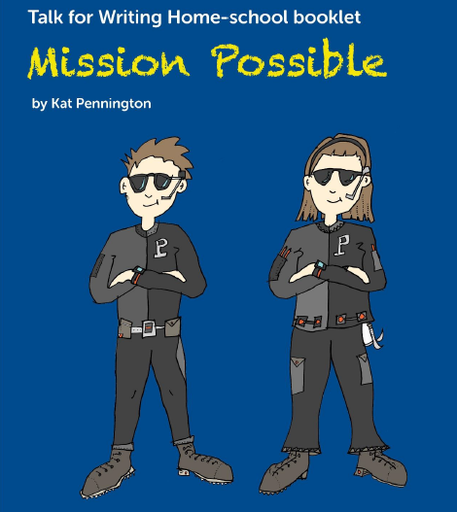
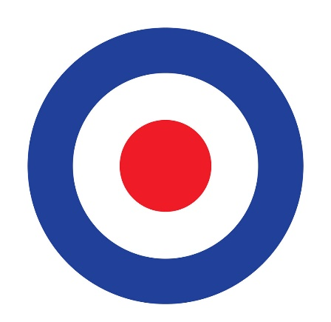

History – RAF Cranwell

On 1st April 2016, RAF Cranwell, the first military academy in the world, celebrated 100 years of aviation. 2016 marked the 100th year since aircraft flying training started at the airbase in Cranwell.

Can you design a poster to commemorate this important milestone?

What facts or illustrations do you think would be worthy of featuring on your poster?

It could feature:  - Your favourite RAF plane  - The Red Arrows (who were temporarily based at Cranwell)  - The grand RAF College building  - You could advertise the renowned Band of the RAF College  - You might include the instantly recognisable RAF target symbol | It should include:  - Short, snappy sentences  - A catchy slogan  - An eye catching layout  - Attention grabbing pictures or photographs
Have fun and be creative!

Science – Forces and Magnets  Find out about magnets. The following clip is a good starting point:  https://www.bbc.co.uk/bitesize/topics/zyttyrd/articles/zpvcrdm  In your books, write a brief explanation of the following principles:  - When two magnets are close, they create pushing or pulling forces on one another.  - Same poles repel.  - Different poles attract.  Challenge yourself with this quiz on magnets:  https://www.bbc.co.uk/bitesize/topics/zyttyrd/articles/zpvcrdm  Investigate:  Which objects are magnetic around your house? Use the worksheet below with the heading, ‘Is it magnetic?’ to predict and test different materials. |  |  | Science – Forces and Magnets  When the famous scientist Albert Einstein was five years old, he loved to play with a magnetic compass. In this activity, you can explore the same magnetic force that fascinated Albert Einstein.  Can you create your own magnet maze? Here is a video to demonstrate how:  https://www.youtube.com/watch?v=6JHCDo-fHKY  You will need a magnet, paperclip and a paper plate or piece of light cardboard to create your maze design. If you don’t have a magnet, you can still create a maze and we can test it when you are back in school. You can be as elaborate as you like – you could try creating a LEGO maze!  If you would like a template, there are some available from Twinkl (free access code is CVDTWINKLHELPS) via the following link:  https://www.twinkl.co.uk/resource/nz-t-2547836-magnet-tracking-maze-activity-pack  I hope you enjoy this task!
Reading/Art  Can you create a new book cover for the book that you are currently reading?  Have a good look at the existing book cover. Why did the illustrator choose that image for the book’s front cover? Does the picture on the front cover give anything important away or just enough to get you interested? What image do you think would represent the book well in your opinion?  Don’t forget the title, author, illustrator and publisher information. You will need to write a blurb for the back cover too. |  | In addition to your weekly spelling activity, can you use a dictionary to find out what these words mean and then learn how to spell them?  Don’t worry if you don’t have a dictionary at home, you can, with your parents’ permission, google it or use these online ones:  https://www.wordsmyth.net/  https://kids.britannica.com/kids/browse/dictionary.  - Magnet  - Magnetic  - Magnetic field  - Poles  - Repel  - Attract

D&T

‘Make it Fly’

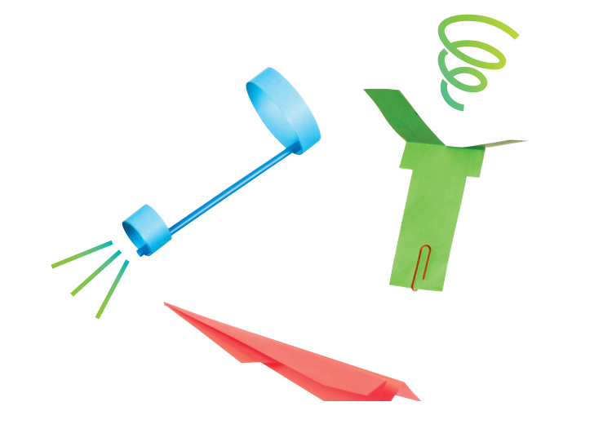
Have a go at creating different types of aircraft, using the link below:

https://learning.sciencemuseumgroup.org.uk/wp-content/uploads/2019/02/SMG-Learning-Activities-Make-It-Fly.pdf

Think scientifically by answering the following questions:

• Which design travels fastest and why do you think this is?
• Why do these designs behave differently to a scrunched-up piece of paper?
• How do your paper planes compare with the shapes of real planes you’ve seen?
• Which way does the helicopter spin? Can you make it spin the other way?
• What do you notice if you make the front of the plane heavier?
• Make your own plane design and see if you can make it travel further than the others.

Extension task: Linking back to our Plants topic – can you find out about how Sycamore seeds ‘fly’ and describe which method of seed dispersal they use?

Physical Education

I’m happy to hear that many of you are doing lots of exercise during this period at home – well done!

I would like all of you to aim to do at least 60 minutes exercise a day. This includes playing sports as a family, riding your bikes or going for walks/jogs with the dogs.

Can you think of other ways to get your heart rate up?

If you need some inspiration, the following link has some ideas for getting active whilst at home:

https://www.cambslearntogether.co.uk/home-learning/pe

If possible, I would like you to send me a picture of you doing exercise at home. You can send them FAO: Mrs New to enquiries@cranwell.lincs.sch.uk.

I may include a selection of photos in your next set of home learning, therefore can parents please indicate whether they are happy for your image to be shared in this way in the body of the email. Also be mindful not to include other people in the picture as I need consent to include their images.

 |  | 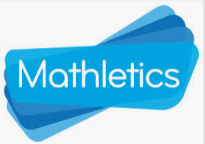
Please try to learn spellings from the Statutory spelling list provided, and remember to highlight any you get correct on the sheet. | SPAG (spelling, punctuation and grammar) activities will be set online. | Mathletics activities will be set in addition to White Rose tasks.
Please complete your weekly times table test, giving yourself 5 minutes to write answers in your book, then self-mark and keep a record of your total along with the date.  For further challenge, you can choose to complete the division test. | Please read for at least 20 minutes every day this week.  Try to read aloud with an adult, at least once, and discuss what you’ve read with them.  Once you have read a book, please complete a book review in your exercise books. | Please see ‘Birds of Prey’ data collection instructions below, which requires you to gather data that we can later input into Excel to create tables, graphs and charts.

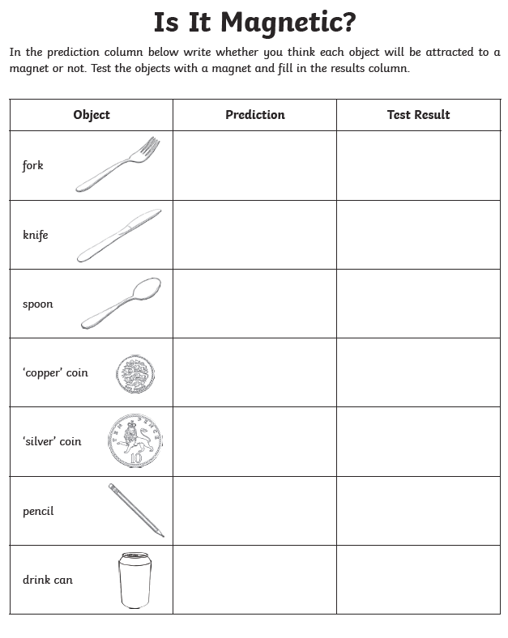

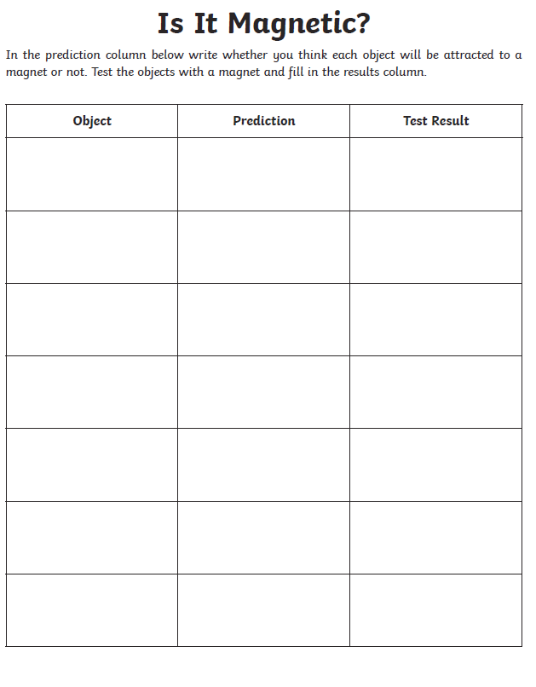

Data Collection
Red Kite
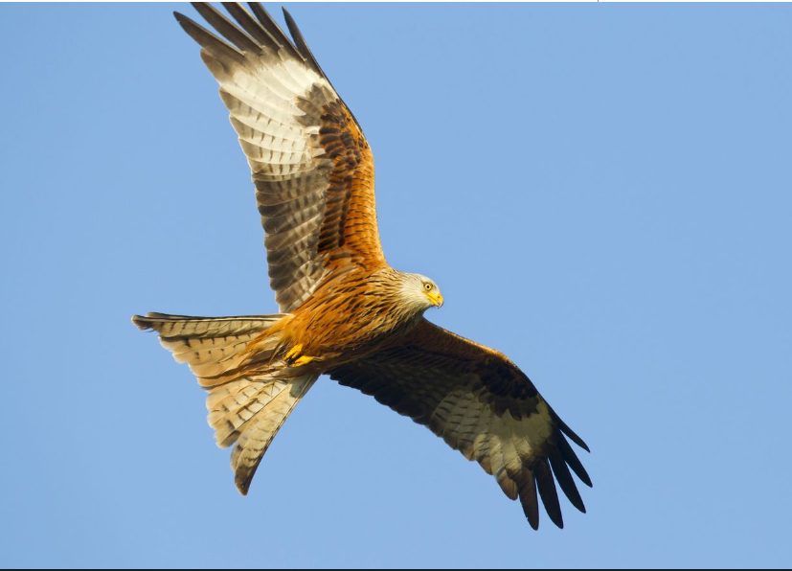
We have such a variety of birds here in the UK, including the Red Kite. As you can see, they have a distinctive forked (v-shape) tail. These birds of prey nearly wiped out in the UK – killed because they were thought to be killing game birds and livestock, but have been successfully introduced thanks to a conservation project. While at home, I have frequently spotted a Red Kite soaring in the sky. It is then quickly pursued by a couple of crows who attack it mid-air, presumably to protect their own fledglings from its hunt.
These sightings helped inspire your homework task below.

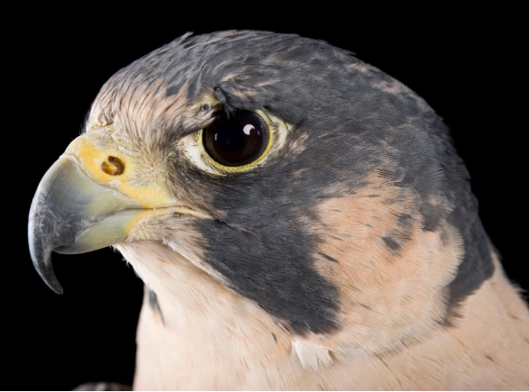
Peregrine Falcon
Did you know the Peregrine Falcon is the fastest animal on earth? These beautiful birds are capable of reaching speeds of more than 200 miles per hour when diving after their prey and are one of the few bird of prey species that can be found in urban areas. There are many webcams available online to observe wild birds feeding their chicks - here is one that I have enjoyed viewing:
https://www.warwickshirewildlifetrust.org.uk/peregrine
But please, as always, remember ask for permission from your parents before accessing any online content.
White tailed Eagle
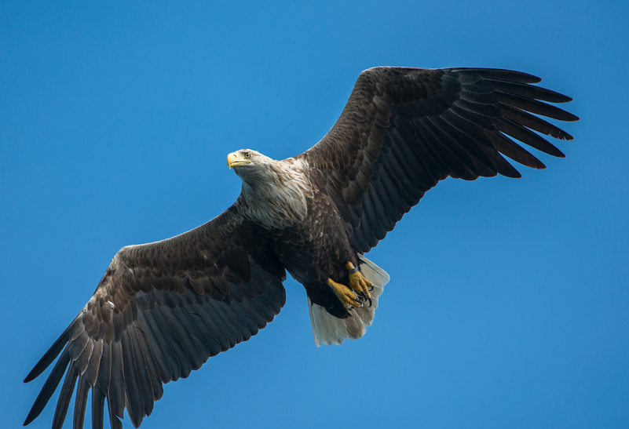
White tailed Eagles have recently been reintroduced in the UK, after being driven to extinction. They are the largest birds of prey in the UK. They are fantastic hunters and this short clip demonstrates their fishing skills:
https://www.youtube.com/watch?v=8RR-__fK9Vs

Data collection homework task
U.K. Birds of Prey
Name | Peregrine Falcon | White tailed Eagle | Red Kite | Osprey | Sparrow Hawk
Family | Falconidae
Habitat | Coasts & tall urban structures
Wing Span (cm) | 120
Main Diet | Birds and bats
Top Speed (mph) | 220
Conservation Status | Stable
Top Fact | Fastest animal on earth

- Create a table either on paper or on a computer. You can use the example above or you can think of your own ideas of information to collect (e.g., mass, life span, etc.).

- At least two rows of your data must include numerical data which can then be easily translated to chart/graph form (you must record using the same units to be able to compare – e.g., record all top speeds in mph).

- I find these UK birds of prey fascinating, but I know you will learn more when you are interested in the subject, therefore I am giving you the option to gather data about UK birds of prey or another species of your choice (pterosaurs, dogs, minibeasts, dinosaurs, etc.). You may even want to compare objects, e.g., planes.
I hope we can reconvene soon as a class and, when we do, plan to teach you how to use Excel software to compile, manipulate and present data. Excel is a wonderful tool and I suspect you will enjoy learning about all the different ways it can present given data.
If you would like to extend this task perhaps you could include images or hyperlinks within your table. You might even have a parent and/or sibling who are able to show you how to turn your data into chart/graph format – just be aware, if you reach this stage you may be designated as an ‘Excel Expert’ and asked to be a ‘helper’ to your classmates if and when we return to school.
If you’re interested, here are some short clips to find out more about our birds of prey:
https://www.bbc.co.uk/bitesize/clips/zwd4d2p
https://www.bbc.co.uk/bitesize/clips/zh89wmn I hope you enjoy this task!
Birds of Prey Sudoku
Can you fill in the gaps so that every bird of prey appears only once in each row and column? Write the first letter of their name in each of the squares to complete the challenge (see key provided below, e.g., write R for Red Kite in the right square)!

 |  |  | 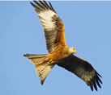 | 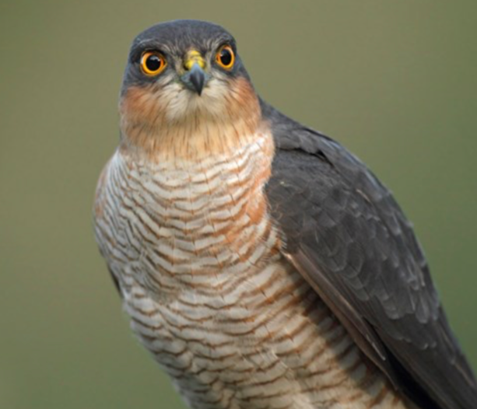 | 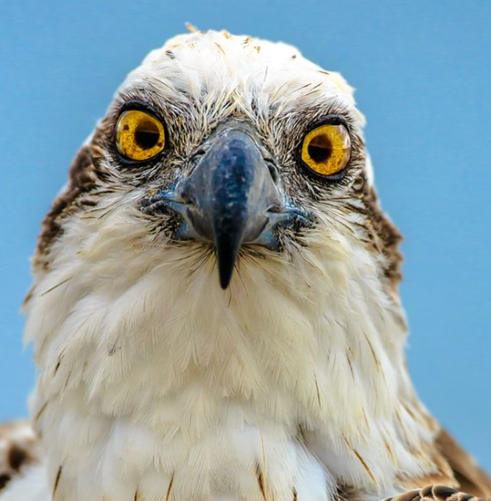
 |  |  | 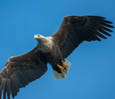 |  | 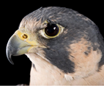
 | 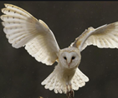

Key: |  | R | Red Kite |  | W | White Tailed Eagle
 |  | S | Sparrow Hawk |  | P |  | Peregrine Falcon
 |  | O | Osprey |  | B |  | Barn Owl

Answers to Sudoku puzzle:
W | P | B
O |  | S |  | B
B | O | R | S
 |  | P | B | O | R
 | S |  | P |  | B
 |  |  | O | R | S

