Numeracy  Remember you need to know 2x, 5x, 10x, 3x, 4x and 8x table and division facts out of order. Use them to try short division.  First watch this for division of 2 digit numbers. https://www.twinkl.co.uk/resource/t2-m-1336-new-formal-division-bus-stop-method-powerpoint-pack  Keep doing the home learning lesson each day on the White Rose website for year 3 if you can.  Remember to do Mathletics activities too.  Try Education City or Prodigy and Times Table Rockstars. For fun reasoning activities try-  https://nrich.maths.org/ | Literacy  Practise spelling another ten key words each week and keep reading.  Can you improve your grammar with the activities below?  Also try to write your own riddles and jokes like the ones on the sheets.  If you want to do more writing, try to write your own stories, letters or fact leaflets. | PE  Keep doing your regular exercise/sport.  If you want to try new things, have a look at these on Youtube.  Light sabre training-Glenn Higgins fitness  Pop sugar family fun cardio workout  Go noodle  BBC supermovers  Kidz bop daily dance break  Debbie Doo dance and movement  Little sports
Science  Try and have some fun with science now using ideas from these websites or playing any of the Education City games for Year 3.  http://www.sciencefun.org/kidszone  https://mommypoppins.com/kids/50-easy-science-experiments-for-kids-fun-educational-activities-using-household-stuff  https://sciencebob.com/category/experiments/ | 3CO  We would love to see your photos and work.  tamasin.craven@cranwell.lincs.sch.uk  jill.owen@cranwell.lincs.sch.uk  This is for the weeks  1st to 12th June. | History  To finish off our History topic, research and create fact files for the famous pilots Amy Johnson and Douglas Bader.  Can you find out where and when they were born, what they are famous for and why we have them as leaders of our school houses?  https://www.funkidslive.com/learn/amys-aviation  https://primaryfacts.com/4806/douglas-bader-facts-and-information/
RE  Look at the Aboriginal Creation story from Australia. Summarise the story by writing sentences and drawing pictures. Use the PowerPoint on twinkl to help you. What other ideas have people had about how the world might have been created?  https://www.twinkl.co.uk/resource/au-h-36-the-rainbow-serpent-powerpoint  Can you do some more aboriginal style painting we enjoyed? Use felt tip pen dots or the bottom of a paintbrush to create animals and patterns on your picture. | Home learning for 3CO  Keep trying to do an hour’s exercise, some numeracy and some literacy or another subject.  However, imaginative play, baking, art work, playing card and board games and chatting to friends and family is just as important to keep happy and healthy.  Just do the best you can!  https://www.twinkl.co.uk/resource/t2-a-143-pointillism-powerpoint-powerpoint will tell you more about this art technique. | French  Use Education City to practise your French by repeating phrases out loud.  Try to learn more vocabulary by playing “Ma famille”, “Mes jeux preferes”, “Mon agenda”, “Mon passeport”, “Photos de famille” and “Stylo dore”.  You will probably enjoy the songs too!  (French Year 3)  You could make an illustrated French/ English  Dictionary.

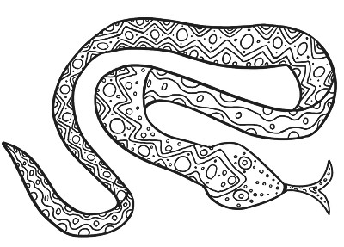

L.O. Homophone jokes. (Words that sound the same but mean different things)

Match each question to its answer then underline the homophones.

Questions

How does a rabbit keep its fur neat and clean?

How do mountains hear?

What did the beach say when the tide came in?

What does a woolly mammoth do when he stubs his toe?
What do you call spending the afternoon with a cranky rabbit?
What do you call a pony with a sore throat?
What's the most popular wine at Christmas?
How does a dog stop the DVD player?
What animal do you look like when you get in the bath?
Answers.
A bad hare day (hair).
A little bear (bare).
Long time, no sea (see).

A little hoarse (horse).
"But, Mum, I don't like sprouts..." (whine).

He calls a tow-truck (toe).
It uses a hare brush (hair).

He presses the paws button (pause).
With mountaineers (ears).

Now write some of your own homophone jokes.
Remember to use VCOP. You could add pictures too!

L.O. Animal riddles.

Finish the riddles, underline the adjectives and circle the rhymes. Which are spelt differently?

- It has four hooves, a tail of course.
Who wants to ride this lovely _ _ _ _ _ .

- It’s dressed in feathers, rhymes with carrot,
Sharp curved beak, must be a _ _ _ _ _ _ .

- It’s long and skinny as a rake,
Don’t let it bite, must be a _ _ _ _ _ .

- It’s small and scuttles round the house.
A long, thin tail, must be a _ _ _ _ _ .

- Long ears, bright eyes, a hopping habit,
Round white tail, must be a _ _ _ _ _ _ .

- You count them when you’re trying to sleep.
Those woolly jumpers must be _ _ _ _ _ .

Now make up some animal riddles of your own.
Remember to use VCOP. You could draw pictures too.

Mental arithmetic A Name Date

1. 4 + 9 = | 14. 10 x 6 =
2. 17 – 10 = | 15. ½ 0f 40 =
3. 8 + 6 + 6 = | 16. 15 divided by 3 =
4. 37 + 10 = | 17. 38 + 54 =
5. 25 – 6 = | 18. 5 x 5 =
6. 34 + 7 = | 19. ¾ of 8 =
7. 20 – 19 = | 20. 64 – 26 =
8. 7 + ____= 11 | 21. 50 – 28 =
9. 63 – 30 = | 22. ¼ of 16 =
10. 26 + 16 = | 23. 40 + 50 + 5 =
11. 0 x 2 = | 24. 57 + ____ = 85
12. 17 + 10 + 2 = | 25. 2/3 of 15 =
13. 70 - ____= 50 | 26. 24 divided by 2 =

Now carry on these counting patterns.

100, 98, 96, 94

99, 97, 95,

100, 95, 90,

99, 96, 93,

100, 96, 92,

100, 92, 84,

Challenge.
Just using some of the digits 1 to 9 only once, can you make a 3 digit add 3-digit sum that is closest to 1000?
You will have to try lots of combinations and think about place value.

Mental arithmetic B Name Date

1. 5 + 8 = | 14. 10 x 7 =
2. 23 – 10 = | 15. ½ 0f 60 =
3. 9 + 7 + 7 = | 16. 18 divided by 3 =
4. 56 + 10 = | 17. 36 + 44 =
5. 34 – 6 = | 18. 7 x 5 =
6. 55 + 7 = | 19. ¾ of 12 =
7. 20 – 17 = | 20. 54 – 26 =
8. 6 + ____= 13 | 21. 60 – 28 =
9. 84 – 30 = | 22. ¼ of 12 =
10. 35 + 15 = | 23. 30 + 40 + 5 =
11. 0 x 5 = | 24. 47 + ____ = 65
12. 14 + 10 + 5 = | 25. 2/3 of 12 =
13. 80 - ____= 60 | 26. 30 divided by 2 =

Now carry on these counting patterns.

80, 78, 76, 74

79, 77, 75,

80, 75, 70,

69, 66, 63,

80, 76, 72,

80, 72, 64,

Challenge.
Just using some of the digits 1 to 5 only once can you make a 2-digit times 1 digit sum that is closest to 90?
You will have to try lots of combinations and think about place value.

L.O: To be able to divide using a written method.

Answer these questions. Change how they are written to use the short bus-stop method.
57 ÷ 3 = 19

How many times does 3 go into 5?
It goes into 5 once and has a remainder of 2.
How many times does 3 go into 27?

It goes into 27 nine times and has no remainder.

1 9

2
3
5 7

The 2 left over is really 2 tens so 20 add 7 is 27. |  | no remainder.
39 ÷ 3 = | 88 ÷ 8 = | 48 ÷ 4 =
24 ÷ 2= | 15 ÷ 5 = | 52 ÷ 4 =
50 ÷ 2 = | 60 ÷ 5 = | 56 ÷ 4 =
54 ÷ 3 = | 96 ÷ 8 = | 36 ÷ 2 =
72 ÷ 3 = | 84 ÷ 4 = | 90 ÷ 5 =
320 ÷ 8 = | 92 ÷ 4 = | 97 ÷ 3 =

Challenge.
If you are feeling confident, make up some 3-digit numbers to divide by 2, 3,4,5 and 8.
If you need more practice, make up some more 2-digit numbers for division.
How many division sums can you make with the answer less than 25?

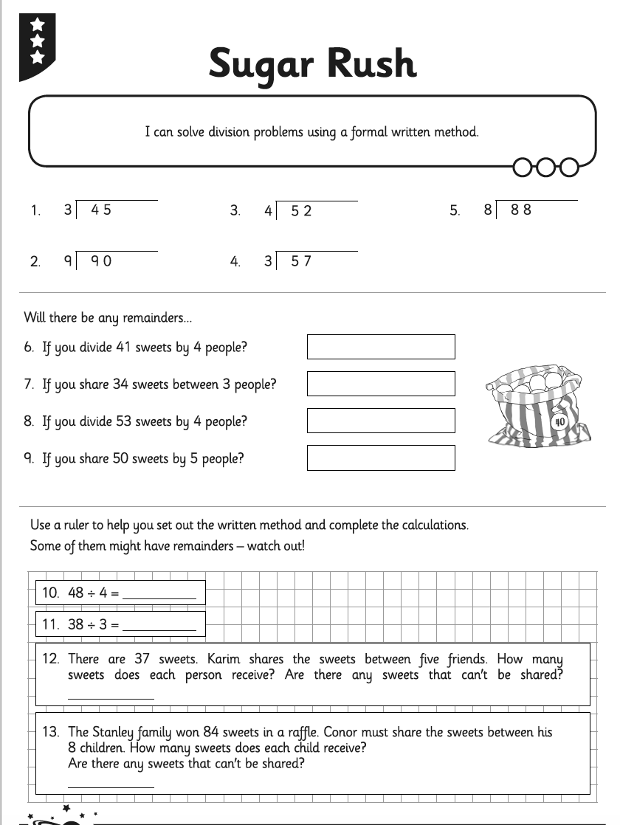

Challenge.

Now make up your own division word problems for someone else to solve.
