**Year 6 Home Learning**

Hello everyone at home! I hope you are all continuing to work hard – and enjoy the opportunity to be outside a bit more! All the school adults are busy in school working with our new smaller classes – but I am definitely missing those of you who are at home and those who are not in my ‘bubble’! It was really lovely to speak to you all again this last week.

Below is the work for the next two weeks – split into two blocks – one for each week. Remember, it is up to you how much you do. Any problems, don’t forget that you can always email or telephone school:

[enquiries@cranwell.lincs.sch.uk](mailto:enquiries@cranwell.lincs.sch.uk)

01400 659001

**Year 6 – w/c 15th June 202**

|  |  |  |
| --- | --- | --- |
| Please continue to complete your daily maths lesson, using the White Rose resources from the website. Remember to also follow the links to BBC Bitesize for even more practise.  You can find your lessons here:  <https://whiterosemaths.com/homelearning/year-6/>  Please move onto the section labelled ‘Summer Term Week 8 w/c 15th June. The videos are also available on Facebook, if the website is overloaded.  Of course, I’ll continue to set tasks on Mathletics, but only do these if you have spare time | Idioms: An idiom is a saying that doesn’t mean exactly what is written. They have hidden meanings.  Complete the worksheet below, matching the idiom to its meaning.  You may need to ask an adult to help you! | Please see the Talk for Writing Booklet below.  Monday – complete activity 1 & 2  Tuesday – complete activity 4 & 5  Wednesday – complete activity 6 & 7  Thursday – complete activity 8  Friday – complete activity 9 |
| Getting ready for secondary school… WEEK ONE  Please use the booklet below – Be Awesome, Go Big workbook.  It has nine sessions and so I suggest that you complete one session per day over the next two weeks – with one day to spare! There are some really excellent activities in this.  If you wish, on the penultimate page of the booklet, there is a grid of extra ideas and activities that you could do in order to prepare for secondary school. | <https://www.e-bug.eu/junior_pack.aspx?cc=eng&ss=2&t=e-Bug%20Lesson%20Pack>  Access the E-Bug website using the link above.  Explore the sections:  Microorganisms – An Introduction  Spread of Infection – Respiratory Hygiene  Prevention of infection – Immunity  Prevention of Infection – Vaccinations  There are Powerpoints to watch and activities to have a go at. Make sure that an adult at home gives you permission to have a go at any of the practical activities. In school, we will not be able to do the practical activities obviously due to the current circumstances but some you may wish to do with your family at home.  If you wish, feel free to explore the rest of the website – but remember to check with an adult before doing any practical activities | Geography – this week we will be focusing on the distribution of food resources in the world.  Look at the map on the sheets below – Who is hungry?  Write a paragraph summarising which are the main areas of the world that do not have enough food.  You might like to explore the Action Against Hunger website. <https://www.actionagainsthunger.org.uk/>  Complete one of the Food shortages sheets below – researching either Bolivia, Haiti & Peru. |
|  | **German**  We hope you have been enjoying practising your German using Duo Lingo.  Keep practising:  <https://www.duolingo.com/> | Remember to read for pleasure daily. You might like to read - **The Book of Hopes: Words and Pictures to Comfort, Inspire and Entertain Children in Lockdown.**  You can read it all online at:  <https://literacytrust.org.uk/family-zone/9-12/book-hopes-for-children-during-lockdown/> |

**Year 6 – w/c 22nd June 2020**

|  |  |  |
| --- | --- | --- |
| Please continue to complete your daily maths lesson, using the White Rose resources from the website. There may or may not be a sheet available each day this week (they keep changing their minds!), but if not, just have a go at the questions on the video, on a piece of paper. Remember to also follow the links to BBC Bitesize for even more practise.  You can find your lessons here:  <https://whiterosemaths.com/homelearning/year-6/>  Please move onto the section labelled ‘Summer Term Week 8 w/c 22nd June. The videos are also available on Facebook, if the website is overloaded.  Of course, I’ll continue to set tasks on Mathletics, but only do these if you have spare time! | Idioms: An idiom is a saying that doesn’t mean exactly what is written. They have hidden meanings.  Jot down some more idioms. For help, you could ask an adult or use the internet,  For an extra challenge – can you write a short story or a conversation using as many idioms as you can – BUT.. it has to make sense! | Please see the Talk for Writing Booklet below.  Monday – complete activity 10  Tuesday – edit your portal story  Wednesday – produce a final, neat copy of your portal story.  Mini writing challenge – Thursday & Friday:  TASK – Write a letter to the reception/Foundation Stage children starting at our school in September. Tell them the best things about our school and what they have to look forward to during their time with us.  Plan your letter – you might like to use a spider diagram to help.  Write your letter.  Edit your letter.  Produce a final neat copy of your letter. |
| Getting ready for secondary school… WEEK TWO  Please use the booklet below – Be Awesome, Go Big workbook.  It has nine sessions and so I suggest that you complete one session per day over the next two weeks – with one day to spare! There are some really excellent activities in this.  If you wish, on the penultimate page of the booklet, there is a grid of extra ideas and activities that you could do in order to prepare for secondary school. | **German**  We hope you have been enjoying practising your German using Duo Lingo.  Keep practising:  <https://www.duolingo.com/> | Geography – This week we are thinking about conserving natural resources and in particular conserving food.  Have a look at the pie chart below called ‘Reducing Food waste’. What kinds of foods are most wasted? Why do you think people throw food away?  Create an information leaflet for families about how they can conserve (save) food. |
| <https://www.bbc.co.uk/teach/ten-pieces/ten-pieces-at-home/zjy3382> Access this film clip - Week Six: Create your own 3D sculpture... Get arty with Amy Leung as she shows you how to create your own 3D sculpture inspired by Anna Clyne’s *Night Ferry*!  Complete the ‘first’ & ‘then’ activities. | Make a poster about Health & Hygiene Rules. You might like to display this at home as a reminder for your family.  Remember – you can always use the E-Bug website from last week for reminders! | Remember to read for pleasure daily.  If you are running out of books at home, you can use the book on: <https://www.twinkl.co.uk/home-learning-hub> (Guided Reading) or try Oxford Owl’s free online library <https://www.oxfordowl.co.uk/for-home/find-a-book/library-page> which has lots of your favourites from school! |



Doors

-the world of possibility

# Year 6 Workbook

by Jamie Thomas

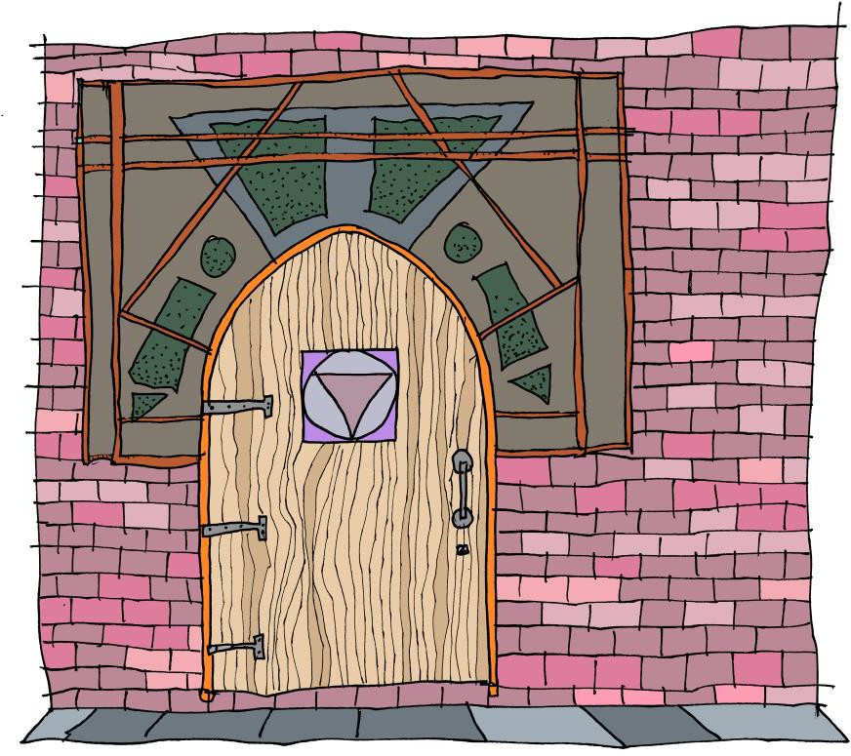

## Introduction

Have you ever looked at a door and wondered what might be on the other side? Where may it lead? What may be hiding within? At first glance, a door is just a piece of wood, glass or metal that is opened and closed so that people can get in and out of a room, a vehicle or a space. But in the hands of a writer, a door represents a world of possibility, a world where things are not only hidden but often closed off and restricted. Together, through poetry, text games and narrative, we shall explore the potential that a door offers to you, the writer.



## Activity 1: The world we live in

As I write this, the world is in lockdown, shut behind doors for our own safety and the safety of everyone else. Covid-19 has closed schools, closed shops and temporarily closed some of the things we take for granted, like playing in the park with our friends.

### ★ Make a list of all the things that you miss doing. You may like to think about some of the following categories:

|  |  |
| --- | --- |
| * seeing family * seeing friends * day to day things | * playing sports * exploring your interests * places you love to visit |

Throughout these sessions, you may like to use these personal reflections to inspire and influence your writing.

Activity 2: I opened the magical door and saw …

This is an idea inspired by Kit Wright’s poem ‘The Magic Box’ (you could search for this on the internet to read his poem). In the poem, Kit imagines what may be contained inside a magical box. We can use this idea to connect to what could be behind the magical door.

### ★ Before you begin, brainstorm a list of ideas for what might be behind the door. Let your imagination run wild as there is no wrong answer. Once

**you have your list, have a go at writing a poem, using the repeating opener: I opened the magical door and saw …**

Here’s an example to help you get going:

I opened the magical door and saw shadows dancing.

I opened the magical door and saw a rainbow leading to another world.

I opened the magical door and saw people crying.

I opened the magical door and saw a magical fairground flooded in lights.

### Once you have got your ideas, go back and see if you can add to them. You could add more description or bring the thing to life through action, e.g.

I opened the magical door and saw a shoal of hungry shadows, tangoing through busy streets.

### Have fun adding to your ideas and let your imagination run wild. Have a read of this poem I created with some Y6 children to help you get ideas:

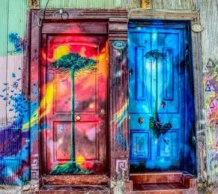**The Magical Door**

I opened the magical door and saw …

a world turned upside down:

the sea, now a floating ceiling, the clouds, an inviting carpet.

I opened the magical door and saw …

the reflection of myself:

standing, searching, staring, questioning how this was possible.

I opened the magical door and saw …

a sweet-treat paradise:

clouds of candy floss,

drifting across a bubble gum sky.

I opened the magical door and saw …

a field of waves:

blue potatoes were leaping, playing in white foam,

as puzzled farmers watched from sunny shores

I opened the magical door and saw … The image of a street I used to know, But as I entered, everything changed; As I reached out, everything had gone.

continued … I opened the magical door and saw …

A forest of mirrors,

surrounding me in dazzling white light, leading me into a world of mystery.

I opened the magical door and saw… A feast of my favourite foods Guarded by monster chips

Waiting to fight off all invaders.

I opened the magical door and saw …

Monstrous mobile phones Herding people into little houses And laughing, laughing, laughing.

I opened the magical door and saw…

The future.

### ★ Reread what you have written and change some of the words so that it says exactly what you want it to say. You may want to look at the writing

**challenge below and add in some of these ideas.**

**Writing Challenge:**

★ **Can you explore more of the senses? You may like to try the following pattern:**

I opened the magical door and saw …

I opened the magical door and heard …

I opened the magical door and smelt …

I opened the magical door and touched …

I opened the magical door and found …

Activity 3: Artistic challenge

Doors are not only exciting for what may lie behind them, they can be designed to invite you into their world. A few years ago, a derelict area of Funchal in Madeira was transformed by local artists who decided to bring the dead doors to life. The beauty of the art opened new doors, and soon homes, shops and restaurants flourished there. Here are a few of those doors.

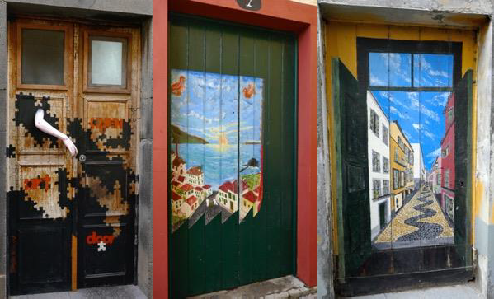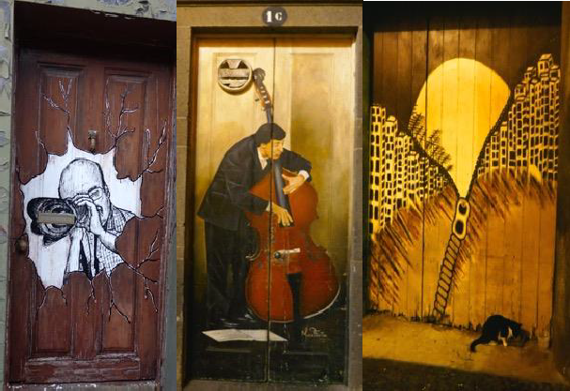

### ★ Have a go at drawing, painting or creating your own door. What design would you choose? What would it represent?

## Activity 4: Idioms

An idiom is a common word or phrase which means something different from its literal meaning but can be understood because of its popular use, e.g.

|  |  |
| --- | --- |
| **Idiom** | **Meaning** |
| Beat around the bush | Avoid saying what you mean, usually because it is uncomfortable |
| Bite the bullet | To get something over with because it is inevitable |

### ★ Below is a list of idioms about doors. Can you work out what they mean?

|  |  |
| --- | --- |
| **Idiom** | **Meaning** |
| as one door closes, another opens |  |
| at death’s door |  |
| behind closed doors |  |
| through the back door |  |
| dead as a doornail |  |
| foot in the door |  |
| keep the wolf from the door |  |
| knocking on heaven’s door |  |
| leave the door open |  |
| show somebody the door |  |
| slam the door in somebody’s  face |  |

Activity 5: ‘The Door’

In this session, we are going to consider the importance of fluency and expression when we read. Begin by reading Miroslav Holub’s poem *The Door*. You may like to listen to these two contrasting performances:

**The Door**

by Miroslav Holub

Go and open the door. Maybe outside there’s a tree, or a wood,

a garden,

or a magic city.

Go and open the door. Maybe a dog’s rummaging. Maybe you’ll see a face, or an eye,

or the picture of a picture.

<https://www.youtube.com/watch?v=bazJvnuOLMM> <https://www.bbc.co.uk/programmes/p011kx3r>

### ★ Decide which reading you prefer and why and jot down your response.

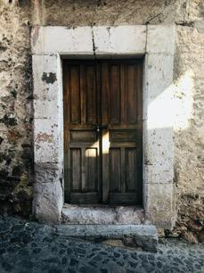

Go and open the door.

If there’s a fog it will clear.

**Now make some notes on the poem:**

Go and open the door. Even if there’s only the darkness ticking, even if there’s only the hollow wind,

even if nothing is there,

go and open the door.

1. What did you like about the poem? What was your favourite line and why?
2. How did the poem make you feel?

At least there’ll be a draught.

1. Which line in the poem did you find the most interesting and why?
2. Are there any parts of the poem that leave you with unanswered questions?

Miroslav Holub, ‘The door’ trans. Ian Milner, Poems Before & After: Collected English Translations (Bloodaxe Books, 2006)

[www.bloodaxebooks.com](http://www.bloodaxebooks.com/)

1. What questions would you like to ask the poet, Miroslav Holub?

### ★ Decide how you would perform this out loud and have a go at performing at home.

★ Activity 6: Comprehension

**Read this extract from *The Snow-Walker's Son* by Catherine Fisher. You can listen to the extract here:** [**https://soundcloud.com/talkforwriting/doors/s-ItAy0hpt715**](https://soundcloud.com/talkforwriting/doors/s-ItAy0hpt715)

*© Catherine Fisher 2011 from The Snow Walker's Son, published by Red Fox, by permission of the author.*

**The door was the last one in the corridor.**

**As the flames flickered over it, they showed it was barred; a hefty iron chain hung across it, and the mud floor beneath was red with rust that had flaked off in the long years of locking and unlocking.**

The keeper hung his lantern on a nail, took the key from a dirty string around his neck, and fitted it into the keyhole. Then he looked behind him.

'Get on with it!' the big man growled. 'Let me see what she keeps in there!' The keeper grinned; he knew fear when he heard it. With both hands he turned the key, then tugged out the red chain in a shower of rust and pushed the door. It opened, just a fraction. Darkness and a damp smell oozed through the black slit.

He stepped well back, handed the stranger the lantern, and jerked his head. He had no tongue to speak with; she'd made sure he kept her secrets.

The stranger hesitated; a draught moved his hair and he gazed back up the stone passageway as if he longed suddenly for warmth and light. And from what I've heard, the keeper thought, you won't be seeing much of those ever again.

Then the man held up the lantern and pushed the door. The keeper watched his face intently in the red glow, and his great hand, as it clutched a luck-stone that swung at his neck. The man went in, slowly. The door closed.

#### The door was the last one in the corridor.

What is the significance of the word *last*? Can you think of another context where the word *last* has a significant meaning? e.g. *the last chance*.

* 1. How do the opening lines (highlighted above) set the mood of the story? What are your immediate impressions?
  2. Having spent a great deal of time reflecting on the significance of doors and their appearance, what does this description suggest to you?
  3. Why has Fisher described the iron chain as being ‘hefty’? What could the significance of this word be in the context of the story?

#### Darkness and a damp smell oozed through the black slit.

How does this make you feel as a reader? What is the relevance of both darkness and a damp smell? Do either of these surprise you; if so, why?

## Activity 7: Grammar & Sentence Work

1. **Pattern of three:**

Fisher uses the **pattern of three** actions in a sentence to advance the action and inject a sense of pace into her writing. This helps to balance description, action and dialogue. e.g.

* + The keeper **hung** his lantern on a nail, **took** the key from a dirty string around his neck, and **fitted** it into the keyhole.
  + With both hands he **turned** the key, then **tugged** out the red chain in a shower of rust and **pushed** the door.
  + He **stepped** well back, **handed** the stranger the lantern, and

**jerked** his head.

### ★ Can you come up with three of your own sentences using this skill?

1. **Semicolon for independent clauses**

A semicolon can be used between independent clauses that are closely related in theme. In the following sentences, Catherine Fisher chooses to use semicolons in both of these sentences rather than using a joining word (conjunction) like *because*.

* + The keeper grinned**;** he knew fear when he heard it.
  + He had no tongue to speak with**;** she'd made sure he kept her secrets.

### ★ In your opinion, why has she made this choice and what impact does it have on you as the reader?

★ **Can you write two or three sentences of your own that illustrate the power of the semicolon over the use of a conjunction?**

1. **Adverbs – roving reporters**

In the sentences below, the adverb ‘slowly’ is used to describe how the man enters the room. Adverbs are like roving reporters – they can be moved around the sentence, e.g.

1. 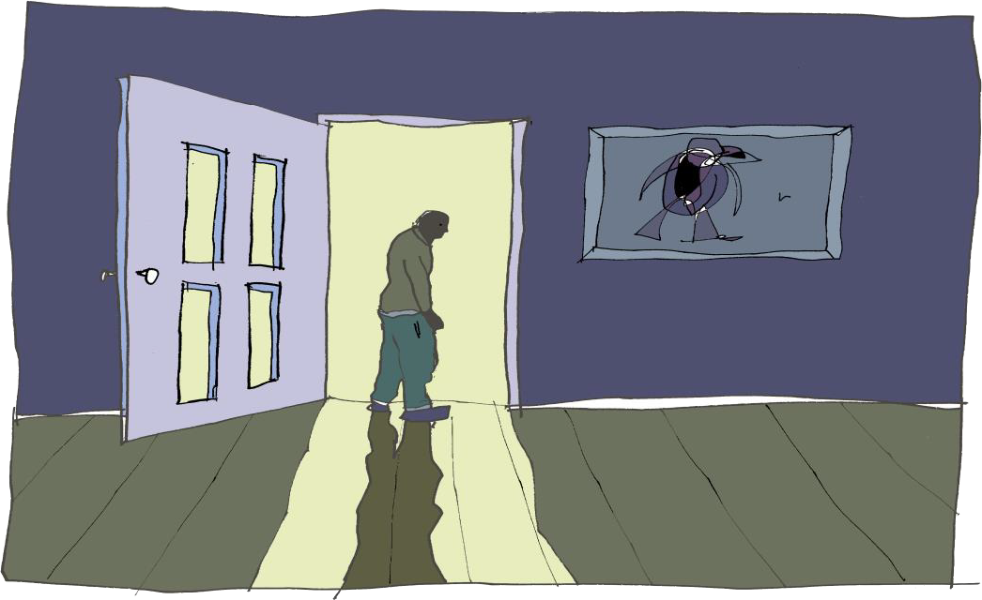The man went in, slowly
2. Slowly, the man went in.
3. The man went slowly in.
4. The man slowly went in.

By changing the position of the adverb, we can often either alter the meaning or add emphasis to a sentence. In this instance, by placing the *slowly* at the end, we infer that the character has a heightened awareness of the situation they are in and therefore deliberately enters with caution.

### ★ Try playing around with the adverb position in the following sentences.

**Consider how it alters the meaning and where the emphasis is best**

**placed.**

1. Cautiously, Samantha crept towards the door that stood before her.
2. Sadly, the boy stared out of the window.

### ★ Now try this out with a sentence of your own.

## Activity 8: Through the eyes of a character



One of the things I love exploring when I’m writing is what must be going on in a character’s mind. Whenever I read great portal stories, I always try to put myself into the shoes of the character, to try to imagine how they must be feeling as they discover this passageway to a new world. How must Alice have been feeling as she fell through the never-ending tunnel into Wonderland?

**First, think of your character** – it’s easier if you base this on someone you know.

* + What are they called?
  + What do they look like?
  + What sort of a person are they (miserable/friendly/kind/aggressive)?
  + What do they say?
  + What do they do?
  + How do they treat other people?
  + How do other people treat them?

Now compose a short piece of descriptive writing based on seeing a mysterious door through the eyes of your character. To do this, we will use a simple opener to drop the reader straight into the action:

Samantha stared. …

Ali hesitated. …

We will also try to use some of the tools we explored in *The Snow Walker’s Son.* Look at this example*:*

**Samantha stared.** There, rising out of the cliff, was an unfamiliar door; its metallic panels were tarnished in rust. Paint flaked off the brittle walls that made up its frame and the door handle rattled in the bitter breeze. Slowly, Samantha gazed all around her, took a deep breath and stepped forward.

### Here are the tools I used:

|  |  |
| --- | --- |
| * Show the setting through the eyes of the main character (MC) | Samantha stared. |
| * Describe the door/portal. (You may like to use two sentences that are closely linked in meaning and connect them with a semicolon.) | There, rising out of the cliff, was an unfamiliar door; its metallic panels were tarnished in rust. |
| * Add some more detail. | Paint flaked off the brittle walls that made up its frame and the door handle rattled in the bitter breeze. |
| * Include an adverb to hint at how the MC feels. Remember, you can move the position within the sentence. | Slowly, |
| * Use the pattern of three to advance the action and inject a sense of pace into your writing. | Samantha gazed all around her, took a deep breath and stepped forward. |

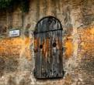★ **Now Imagine your main character is walking along the road when they come across a mysterious**

**doorway. Describe this through their eyes. Use my model above to help you.**

Session 9: Planning a portal story

Nearly all portal stories follow a similar pattern:

|  |
| --- |
| * Main character (MC) finds magical portal & enters new world |
| * Describe new world |
| * MC explores this new world & encounters a problem |
| * MC has to escape & return through the portal |
| * MC cannot find portal again   (sometimes brings back a memento of new world) |

Once you have identified the pattern of the story, the possibilities are endless. Let your imagination run free. Brainstorm lots of ideas and then decide which captures your interest as a writer. Before you start, take a look at my top tips.

### Top tips for story writing:

* **Start in a world/a setting that you know well** – it is far easier to describe something familiar to you, e.g. a garden, your school, your local town, etc.
* **Use a stimulus (e.g. picture) for the new world** – an image will help you focus in on the detail and describe what is there.
* **Let your ideas flow** – don’t worry about spelling, handwriting or presentation … you can go back and edit this later.

### Here are a couple of ideas to open your mind to the world of possibility:

|  |  |  |
| --- | --- | --- |
| **Underlying Pattern** | **Story idea 1** | **Story idea 2** |
| Main character (MC) finds magical portal and enters new world | Elif is playing in her  Grandmother’s garden and notices a small fairy door. Touches door and shrinks/ enters. | Josh and Archie playing hide and seek in their house. Archie opens hatch in the roof and discovers new world. |

|  |  |  |
| --- | --- | --- |
| Describe new world | Arrives in an underground world full of caves, giant toadstools and magical creatures. | Transported to life onboard an enormous sailing ship in Tudor England. |
| MC explores new world and encounters a problem | Elif explores new world and enters an area strictly forbidden. Picks magical flower. | Ship is thrown into battle. |
| MC has to escape and return through the portal | Alarms sound and Elif runs. She is chased through the magical world by unknown threat and escapes. | Archie desperately searches for portal and way back to own world. |
| MC cannot find portal again (sometimes has brought back a memento of new world) | Elif cannot find fairy door again, but the cut flower lives on forever reminding her of her journey. | Archie escapes with small pouch of gunpowder in his pocket. |

★ **Using this underlying pattern, plan a few portal stories of your own. You may like to draw upon your own personal experience as well as your**

**wider reading and imagination. I have also included two pictures in case they help you.**

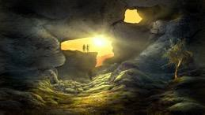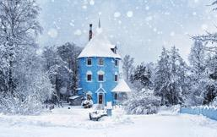

Session 10: Writing your own story

You now have all of the tools required to write your own portal story. You may like to write about a more traditional portal that leads you to a magical world, or you may prefer to draw upon your personal experiences, as we have explored throughout this unit.

To recap on all the key points we’ve been learning:

1. **Describe the portal in detail**. You may want to show the portal through the eyes of the main character.
2. **Think about what lies on the other side of the door.** Allow yourself the opportunity to write about what interests you and what is important to you.
3. **Great writers steal ideas (‘magpie’) from other great writers.** Reflect upon the portal stories that you have loved reading and consider what made these so engaging. Try to bring in some of these skills and techniques into your own work.
4. **Enjoy it.** Writing is all about sharing a passion for words, stories and the world of possibility. If you love the story you are writing – so too will your reader.

### ★ Now write your portal story, drawing on all that you have learned. Don’t

**forget to share or publish your work – great writing deserves an audience!**





This workbook has helped me learn …

Happy reading and writing!

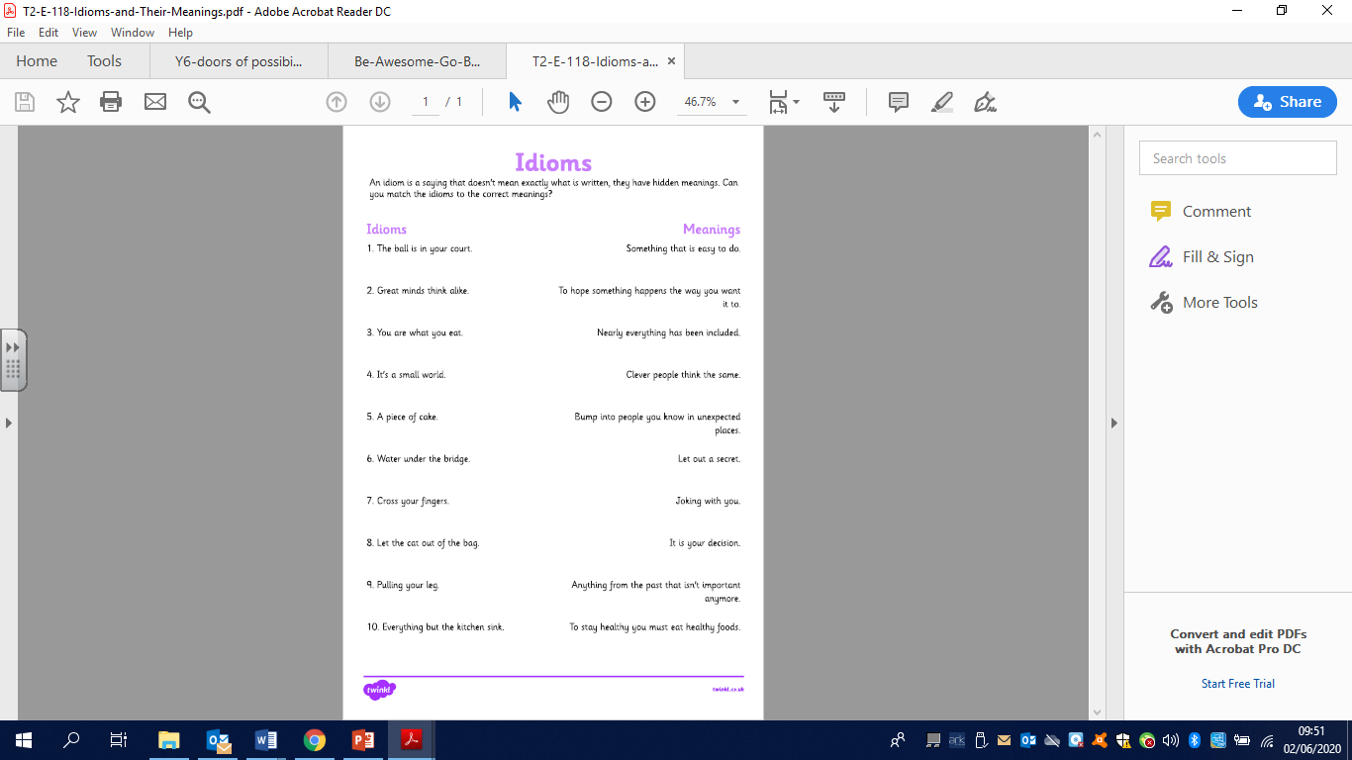

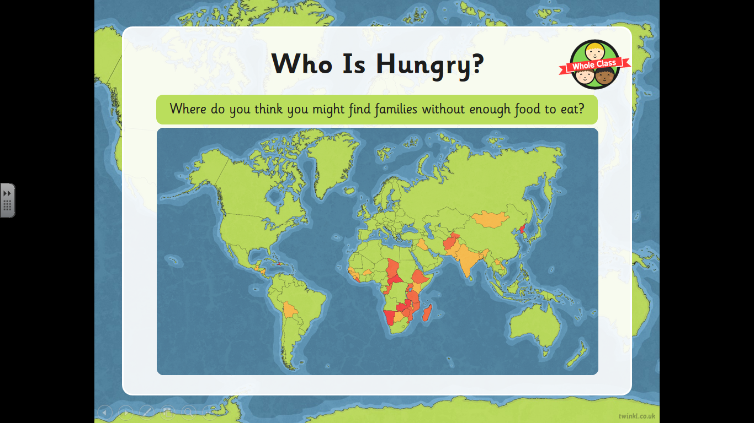

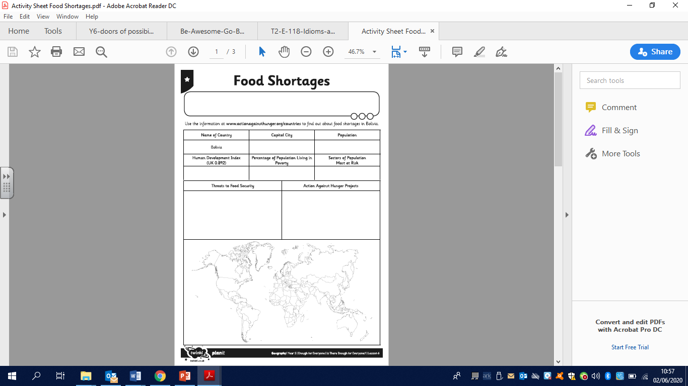

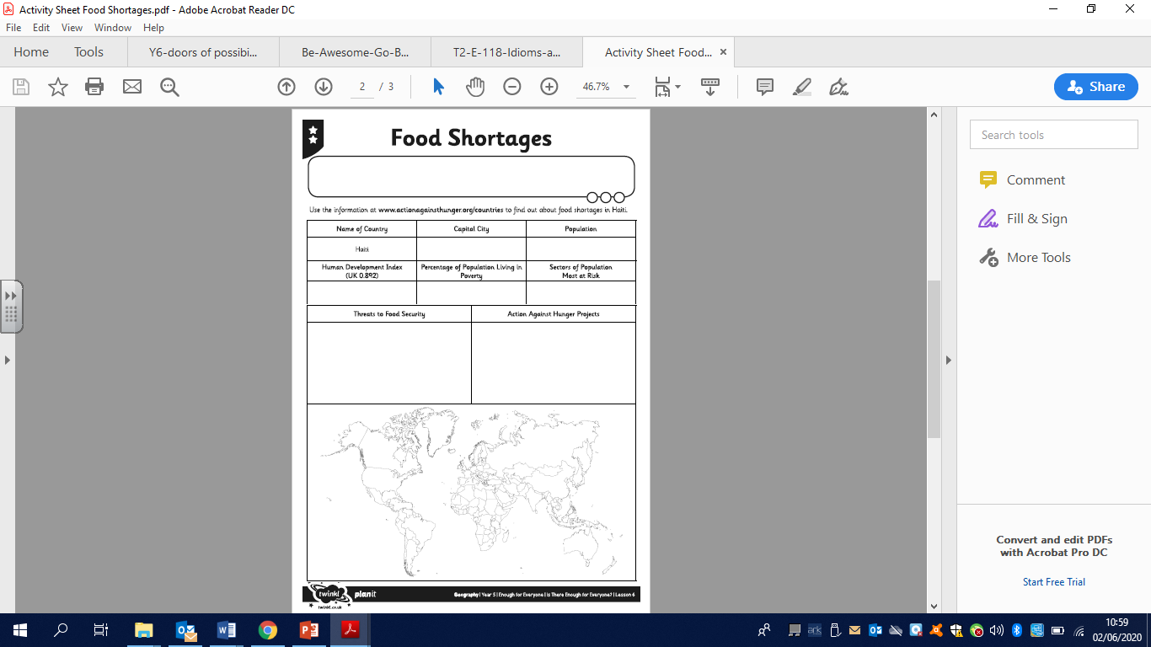

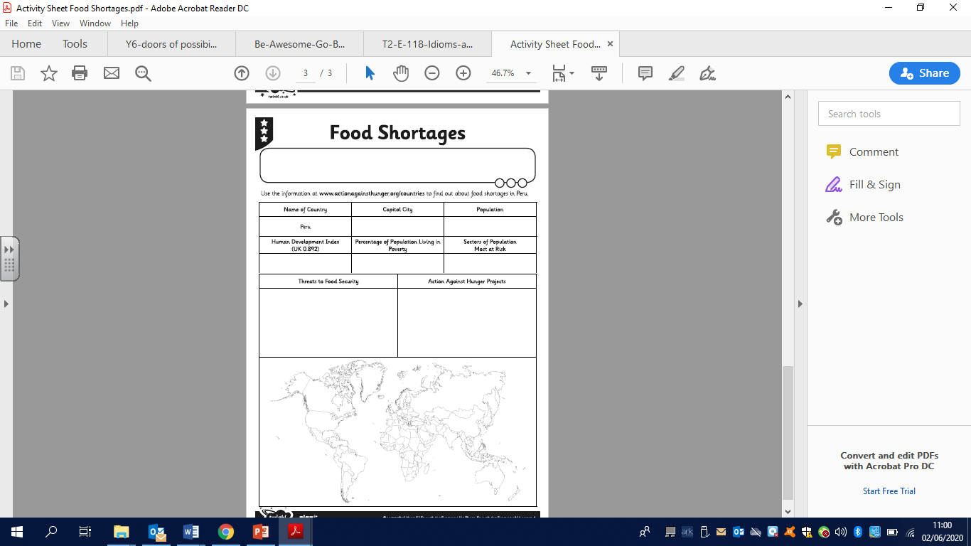







**Workbook**

**© 2020 The PiXL Club Ltd and Hachette UK**

This resource may be shared with any primary school Year 6 student in its current form, and parts thereof, to enhance your transition work with students. All opinions and contributions are those of the authors. The contents of this resource are not connected with, or endorsed by, any other company, organisation or institution.

If there are any inadvertent omissions or errors in the acknowledgements or usage, this is unintended and we will remedy these on written notification.

Hachette UK own 'You Are Awesome' by Matthew Syed and 'Go Big' by Matthew Burton, which may be purchased by individuals and schools, should they wish to do so to enhance these resources for students. 'You Are Awesome' illustrations copyright © Toby Triumph. 'Go

Big' illustrations copyright © Chris Madden.

# Session 1

**Being awesome**

**TASK:** Is there anything holding you back?

Worried you can’t do things

Feeling embarrassed

You find it hard to focus

Scared of hard work

Feeling stressed or anxious

Fear of looking foolish

Scared of taking risks

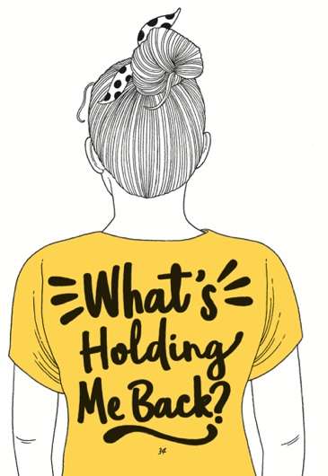

**TASK:** Write down what you can learn from your primary school experience ahead of going to secondary school.

* How did you handle things when they went wrong?
* How did you react when you got stuck?
* Think about a time when you showed a ‘kid awesome’ attitude. Write about it here:
* Write down the kind of person you want to be at secondary school.

# Session 2

**Unlocking your mind**

#### TASK:

* 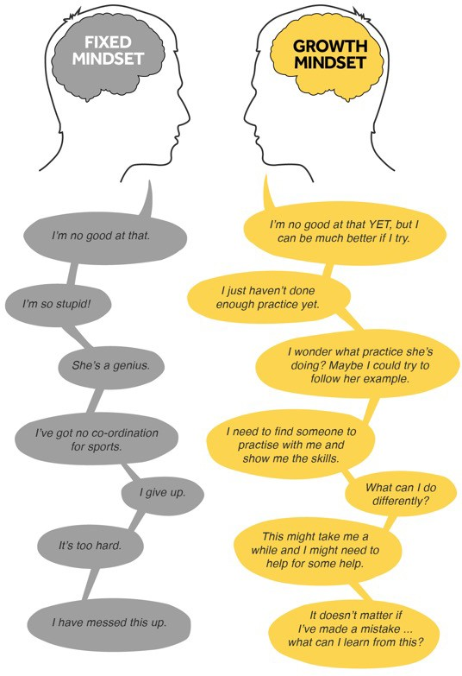Look at these two people, each with a different mindset.
* Which mindset are you and why?
* Does it change depending on different situations in your life?
* Are you someone who thinks that you are just born intelligent?

# The Worry Jar

* + What are the things you tend to worry about which might stop you from trying something new or hard?
  + Write them down on strips of paper (or you can write them down in your booklet).
  + Put those strips of paper in a worry jar – any jam jar or a pot will do.
  + In a week’s time, look at the strips of paper again (maybe with a

parent or sibling) and see if the worries still apply.

* + Throw away the ones that don’t.
  + Take a look at the ones that are still worrying you. Is there someone you can talk to about these?



# Use this time before Year 7 to have a go at things.

#### TASK:

* + Identify three things that you say you ‘can’t do’. Write them down.

1.

2.

3.

* + Now write each thing down using a growth mindset approach. For example, ‘I can’t do maths’ turns into, ‘I am going to practise the things in maths that I can’t do yet’.

1.

2.

3.

* + Think of something you’ve always wanted to get better at. Write it down. How could you practise that thing now?

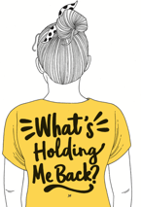

# Session 3

**Dare to take risks**

#### What are your hopes and dreams for secondary school?

You will be there from when you’re 11 to maybe 16 or 18 years old. A lot will change in that time.

Write down your thoughts about the following:

* What do you hope you will achieve?
* What kind of person do you hope you will become?
* Write down three words that you hope people will say about you.

1.

2.

3.

# Are you scared of failure?

Everyone will be scared of failure at some point in our lives, BUT sometimes fear stops us from doing things.

It can stop you from achieving your goals and dreams.

What are you worried about ‘failing’ in secondary school?

Some Year 6 students say that they are worried about some of the following:

* + not making friends
  + not being able to do the work
  + that they won’t know where to go.

Think again about failure. That is how we learn.

It is how we become determined.

Think of something that didn’t go quite as you had expected. What did it teach you?

Jot that down now.

# Session 4

**Making the change**

Before you make a change, it is good to look back as well as look forward. Doing this can help you to see how far you have come! You started primary school when you were just 5 years old – you couldn’t read or write back then!

# School memories

Name three things that have changed the most about you since you started primary school.

1.

2.

3.

What will you miss most about your old school?

What are you most concerned about in your new school?

# New school

Write down three things that you are really excited about doing in secondary school.

Write down three worries you have about secondary school. Speak to someone you trust about your worries to help you feel better.

# Life is a journey…

Build on who are and what you have done in primary school…

Use it as a stepping stone to help you achieve, and enjoy a new school and environment.

What are the things that you have already done at primary school that you would like to build on?

# Session 5

**Lost but not lost**

#### Remember when Matthew Syed talked about a ‘growth mindset’? Now is the time to remind yourself of that!

Change the statements on the left so that they are positive and hopeful. Your brain sometimes tells you negative things that are not based on fact. Your job is to tell your brain that there is another way to think and that it is wrong sometimes!

|  |  |
| --- | --- |
| **Statement** | **Transform it!** |
| I won’t ever fit in. | This is not true – I will find people who are like me; I just need to find them! |
| I will always be lost. |  |
| I can’t do these subjects. |  |
| I won’t make friends like I had in Year 6. |  |
| I miss my primary school. |  |
| One of your own: |  |

# This is the Triangle of Trust

Write down who is in your Triangle of Trust. Put their names on the triangle.

Who can you talk to about different things?

What three things makes you feel happy and good? 1.

2.

3.

Where is your safe place to just relax?

## Mr Burton’s Triangle of Trust:

Home/Parents

YOU!!

### School/Teachers

**Session 6 ‘Bouncebackability’**

#### How do you handle bouncing back?

Answer the following questions/finish the sentences:

1. I have shown ‘grit’ when…
2. I need to show more determination when…
3. How do you handle making a mistake? What is your reaction?
4. Think of a time when you made a mistake. Were you kind to yourself?

#### What does ‘work hard’ and ‘be kind’ mean?

Fill in the person outline with all the things that you can do to show you are working hard.

Now think about what you can do to be kind. How many of these things do you do already?

Highlight the ones that you would like to do more of!

# Session 7

**What is normal anyway?**

#### What is the uniform you will have at your new school? Do some research, go onto the school website and have a look at what they say.

1. Write down a list of things that you have to wear.
2. What are you NOT allowed to wear?
3. Your equipment is also part of your uniform. What do you have to take with you?

# Find out who you are and do it deliberately.

* Write down all of the ways in which you are different and unique.
* How may these help you in your new school or in life?

# Session 8

**Friendships and fallouts**

## What kind of friends do you want to have in secondary school? Make a list.

**What kind of friend do you want to be to other people? Make a list.**

**Your friendships**

* + Who makes you laugh?
  + Who is a good listener?
  + Who can you trust?
  + Who will give you an honest opinion?
  + Who will help you get through the transition to secondary school?

# Session 9 Living well

**Keeping yourself well**

Write down three things that you are going to do when starting your new school to help you stay well.

1.

2.

3.

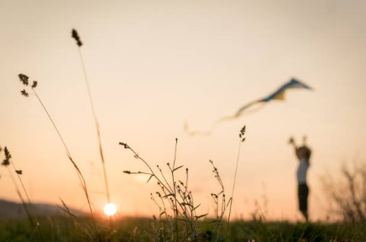

#### Here are some activities that will help you get ready for secondary school. Why don’t you try some of them?

Getting Ready to Go Big

While you are working from home, try and complete AS MANY of these as possible. As you complete the activities, write the date or colour in the box to help you keep track. You can paste any photos/links to your work into a PowerPoint document.

If you or your parents use social media, please share photos of you doing any of the challenges and tag #BeAwesomeGoBig

GOOD LUCK!

|  |  |  |  |  |
| --- | --- | --- | --- | --- |
| Write a letter to your future self. You could put it somewhere safe to open in a year’s time.  What is happening right now? How do you feel about it all?  What are your biggest hopes and fears about moving school? | Write a letter to a teacher who has had a positive impact on your life so far.  What do you want to thank them for? How have they impacted on your life? | Write your own autobiography. You might include:   * When and where you were born * Important events in your life and how they made you into the person you are now * Things you would have done   differently, if you had the chance   * What your hopes are for the future. | Write down three ways you can be kind to someone this week. | ‘I am’ poem: you will be meeting a lot of new people and friends when starting secondary school. Write an ‘I am’ poem to introduce yourself. It should be a minimum of 5 lines and a maximum of 10. e.g.  I am excited to see my friends  I am nervous about the different lessons I am worried about finding my way around I am looking forward to new subjects  I am going to take part in sport |
| Take your first name, or that of a family member/friend and write it vertically on different lines. Complete each line with something positive which starts with the letter given (for example strengths and skills they/you have).  This could be one word or ten! | Write a Haiku – a 3-line poem (1st line 5 syllables, 2nd line 7 syllables, 3rd line 5 syllables) on what it means to be kind in school. | Create your own musical instrument using household objects. You could use items from your recycling, dried beans, elastic bands etc. Experiment with different ways you could use the items to create sounds. | Have a conversation with the oldest person you know about their life. This could be a grandparent, friend, aunt or uncle. Before you do, think about the questions you would like to ask, such as:   * Tell me about the food you ate. What were your meals like? What were your favourite sweets? * What games did you play? * What was it like being at school? Who was your favourite teacher? Was it strict? Did you have a favourite lesson? Was there a lesson you hated? * What was your favourite book or comic when you were my age? | Make your interview into a radio or television programme. Or, if you prefer, turn it into a magazine article with photos. Send it to the person you interviewed as a memento. |
| Write down three things you would do if a friend of yours was anxious about starting a new school. | Come up with three questions about the world around you that you would like to ask your new science teacher. For  example, why does my cat have stripes? | Watch your favourite film or read your favourite book again. Write a letter to a friend explaining why you think that they should read it. | You will be studying maths at secondary school. Can you identify five times you have used maths in your daily life? | Make your own map of the neighbourhood. Identify key buildings, parks, statues, schools and anything else you can think of/that you notice. Perhaps use contour lines to show the height of different areas. |
| You’ll study science at secondary school and you will need to understand about managing risk. Make a list of hazards involved when cooking dinner. | Create a powerful speech on something you feel passionate about. It might be a local issue, something global or a topic relevant to only you. | Find a recipe and work out the ingredients needed for 30 people. | Write a letter to the reception children starting at your old primary school. Tell them the best things about the school and what they have to look forward to during their time there. | Learn to tie three different types of knots. |
| Design a flying car of the future, imagining you are living in the year 2300. | Design a new logo for your secondary school. | Turn a favourite song or story into a picture that summarises it. | Write a newspaper article persuading people why it is important to study maths. | Write down three things you would do if you saw someone being unkind. |

© 2020 The PiXL Club Ltd and Hachette UK

#### Why don’t you write to your new tutor at secondary school and introduce yourself?

**Tell them what you have learned from doing the ‘Be Awesome Go Big’ sessions.**

**You could also enter our competition - visit**

[www.beawesomegobig.co.uk.](http://www.beawesomegobig.co.uk/)



You’ve come to the end of Be Awesome, Go Big so why not enter our

**AWESOME competition** to win all of the books from the booklist?

All you have to do is write either:

1. a book review of *You are Awesome* or *Go Big*
2. a letter to the authors to tell them what you’ve learned from the sessions.

Take a picture of your work and get your adult to send it in.

*Deadline date 1st July 2020, winner revealed on 15th July 2020.*

Type your answer here.