EYFS Home Learning Challenges Week beginning 15th June 2020
 | Challenge 41 | Challenge 42 | Challenge 43 | Challenge 44 | Challenge 45
Challenge | My Network Hand  Can you think of five people in your ‘network’ that you could talk to if something was worrying you?  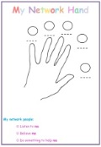  Parents: You may like to look at www.mefirst.org.uk to support your discussion with your child | 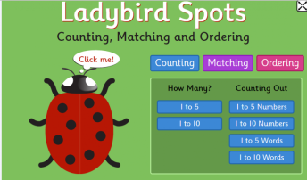  On your tablet, computer or phone use www.topmarks.co.uk to complete an Early Years activity. | 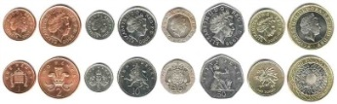  Look at some coins. Can you draw round them? Which is the largest coin and which is the smallest? What numbers can you see? Extra challenge can you order them in value? | Draw a picture of your dream house.  Think about what it would look like and what it would have inside. Would it have a secret door, a swimming pool or a zoo in the garden? | Pick a creature that lives in the sea.  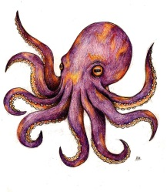  Can you find out three facts about it?
Maths Focus | Can you find half?  Half of a cupcake?  Halve your toys  Halve your sandwich  What else can you halve? | How many items in your house have a number on them? TV remote control, clock, etc  Which object has the most numbers? | Can you write the value of the coins next to the coins you have drawn around? | Look at your dream house picture. How many windows have you drawn? How many doors? | An Octopus has 8 legs if you double 8 what do you have? Can you double other numbers?
Phonics Focus | There are lots of fish under the sea. Can you think of three other words that end with sh? | Spread your letters out  Your grown up will give you a word. Can you build it with the letters? | Your grown up will shout out one of your sounds from your envelope.  Can you write it down? | Can you label the house you have drawn? | If one of your toys came alive what would it say? What would it do? Get your grown up to write the story of your toy or write your own.

 | Challenge 46 | Challenge 47 | Challenge 48 | Challenge 49 | Challenge 50
Challenge | 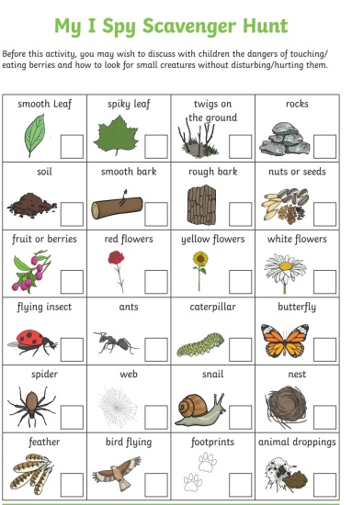 | 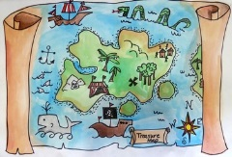  Draw a map of your garden or outside space. Draw/label all the things you can see. Now hide some ‘treasure’ and make an x on your map. Now give the map to your grown up and see if they can find your treasure. | Design an outfit to wear to the beach.  Explain to your grown up why you have picked what you have. | Collect some different sized leaves.  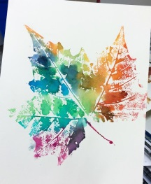  Can you create a picture printing the leaves onto a blank piece of paper? | Get your grown up to hold open an empty pillow case or cushion cover. Throw a soft ball at it and see if you can get the ball in the case. Take a step back to make it trickier. Is it easier the higher or lower the case is held?
Maths Focus | Draw around both of your hands. Can you write a number above each thumb/finger? If that is easy draw around your hands again and carry on writing numbers! | Count how many strides it is between the various things in your garden. Can you record them on your map? | Make some balls out of screwed up paper. Write numbers on pieces of paper for targets. What is your highest score? | Before you print with them can you order your leaves? Biggest to smallest? | How many times do you get the ball into the case? Can your grown up beat your score?
Phonics Focus | Can you find something that begins with a s how many more things can you find? Can you write them down? | Use sticks or stones to make the first letter of your name. | Create a list of things you would need to take to the beach | Play phonic hopscotch. Draw a hopscotch with chalk outside and then write sounds/digraphs/words instead of numbers. Hop and say! | Talk to your grown up about what you do at bedtime? Can you put them in sequence? Can you write down your sequence?
EYFS Home Learning Challenges Week beginning 22nd June 2020

