Hello again 5B!

As I write, I have just completed my first full week back at school since the lockdown. I am teaching a small group of Year 6s and three Year 5 (key workers’) children – 12 children in all. This is definitely the smallest and quietest class I have ever had! We are all slowly getting used to living in our little ‘bubble’, staying apart and doing lots of handwashing! School is very different from how it was before and Mrs Barrett and I both miss seeing your smiling faces each day.

I am very grateful for Mrs New’s help in designing your next two weeks of home learning, to make sure that all our Year 5 children are covering roughly the same work, across all classes. If there seems like a lot of work, don’t worry - just complete as much as you can. If you need any help, remember that you can contact me through school on 01400 659001, or by email: [enquiries@cranwell.lincs.sch.uk](mailto:enquiries@cranwell.lincs.sch.uk) .

Take care and I hope to see you soon!

Mrs Bullement

|  |  |
| --- | --- |
| **Maths – Week beginning 15/6/20**  Please continue to complete your daily maths lesson, using the White Rose resources from the website. Have a go at the questions on the video, on a piece of paper. Remember to also follow the links to BBC Bitesize for even more practise.  You can find your lessons here: <https://whiterosemaths.com/homelearning/year-5/> Please move onto the section labelled ‘Summer Term Week 8 w/c 15th June’. The videos are also available on Facebook, if the website is overloaded.  Of course, I’ll continue to set tasks on Mathletics, but only do these if you have spare time!  Want an extra challenge? Try the area and perimeter activity below. If you have a printer, you could print off some squared paper and draw some shapes if your own!    Bored? Have a look at this website: it’s a weekly FREE maths ‘newspaper’ which is full of interesting challenges <https://www.cdmasterworks.co.uk/the-daily-rigour/> | **Maths – Week beginning 22/6/20**  Please continue to complete your daily maths lesson, using the White Rose resources from the website. Have a go at the questions on the video, on a piece of paper. Remember to also follow the links to BBC Bitesize for even more practise.  You can find your lessons here: <https://whiterosemaths.com/homelearning/year-5/> Please move onto the section labelled ‘Summer Term Week 9 w/c 22nd June’. The videos are also available on Facebook, if the website is overloaded.  Of course, I’ll continue to set tasks on Mathletics, but only do these if you have spare time!  Want an extra challenge? There’s a great trick with percentages to investigate…  Bored? Have a go at this week’s maths challenges in the Daily Rigour! <https://www.cdmasterworks.co.uk/the-daily-rigour/> |
| **Literacy – 2 Weeks (w/c 15th and 22nd June)**  Please follow the link below to access a home learning booklet called ‘Meet the Rhi-swano-zeb-tah’ (this can either be printed or you can write your answers and ideas on paper or in a notebook):  <https://www.talk4writing.com/wp-content/uploads/2020/05/Y5-Maria-Rhizeb.pdf>  This booklet is designed for you to work on at your own pace: it takes you through a series of literacy tasks related to the story including: reading comprehension, grammar, vocabulary and planning tasks. The booklet culminates in you producing your own information text based on a creature you create!  Please don’t try to complete this in one sitting; we have used these booklets in class and have found they take more than a week to complete properly. Try to complete a page or two each day and enjoy creating a fantastic leaflet. If you’d like to show me your finished work, you could take a picture of it and ask Mum or Dad to email it to me at school! | |
| **Reading / Art (2 weeks) – The Ickabog by J.K.Rowling**  J.K. Rowling, author of the Harry Potter series, has recently released a new book which is available online, in instalments, for free!  Please follow this link to read the chapters online: <https://www.theickabog.com/read-the-story/>  J.K.Rowling is inviting children to create illustrations for each chapter - she will suggest themes for these: (<https://theickabogcompetition.com/illustration-themes>)  In addition, the publishers (Hachette) are running a competition for 7-12 year olds. You could enter your drawing or painting (<https://theickabogcompetition.com/>) for a chance to be featured in the print version of the book. If you win, you would receive a signed copy of the printed book, and a school or public library of your choice would also receive £500 worth of Hachette children’s books! What a fantastic set of prizes!  If you choose to enter the competition, please be mindful of the illustration instructions, which are quite specific and can be found here: <https://theickabogcompetition.com/illustration-instructions>  J.K. Rowling has also written the following advice on The Ickabog site:  *I won’t be judging the competition. Each publisher will decide what works best for their editions. However, if you, your parent or your guardian would like to share your artwork on Twitter using the hashtag #TheIckabog, I’ll be able to see it and maybe share and comment on it!*  I hope you enjoy creating your own illustrations, and perhaps entering the competition, but most of all I hope you enjoy the story! | |
| **Geography – Week beginning 15/6/20**  Global Distribution of Food  I would like you to find out about the distribution of food resources in the world.   * Look at the map on the sheets below – Who is Hungry? * Write a paragraph summarising which are the main areas of the world that do not have enough food. Can you think why or pick out any aspects they all have in common?   You might like to explore the Action Against Hunger website. <https://www.actionagainsthunger.org.uk/>  Choose one of the Food Shortages sheets below – researching either Bolivia, Haiti & Peru – and complete. | **Geography – Week beginning 22/6/20**  Conserving Food  I would like you to think about conserving natural resources and, in particular, conserving food.   * Have a look at the pie chart below called ‘Reducing Food waste’. * What kinds of foods are most wasted? * Why do you think people throw food away?   Create an information leaflet for families about how they can conserve (save) food. |
| **Spelling Task – Week beginning 15/6/20**  Please access the following links which will take you to spelling games, which use words from the statutory spelling list for Year 5:  <http://www.ictgames.com/mobilePage/lcwc/index.html>  You’ll need to click on the purple circle next to ‘Years 5&6’, then choose either a spelling pattern or ‘tricky words’, then ‘go’. The game shows you a word, then hides it and you have to type it into the space. It will then tell you whether you are right or not when you click on the green eyes! | **Spelling Task – Week beginning 22/6/20**  Can you use a dictionary to find out what these words mean and then learn how to spell them? Don’t worry if you don’t have a dictionary at home: you can, with your parents’ permission, use Google or these online ones:  <https://www.wordsmyth.net/>  <https://kids.britannica.com/kids/browse/dictionary>.   |  |  | | --- | --- | | 1. Bacteria 2. Bug 3. Cell 4. Disease 5. Fungi 6. Germ | 1. Microbe 2. Micro-organism 3. Microscope 4. Pathogen 5. Probiotic 6. Viruses | |
| **French**  We hope you have been enjoying practising your French, using Duo Lingo. Keep having a quick go each day (5 minutes is fine) – it’s fun and you’ll learn so many new words! <https://www.duolingo.com/> | **PSHE – 2 weeks**  School Wellbeing - PSHE  **PSHE – ‘Pay it Forward’**  I remember watching the movie ‘Pay it Forward’ and I enjoyed it because of the message it conveyed: to ‘pass on’ acts of goodwill. The main character in the movie devises a plan whereby if you receive an act of kindness, you then perform three acts of kindness to others. What a brilliant idea!  With this film in mind, I have a special task for you. I would like you, over the next 2 weeks, to record 10 acts of kindness. I have included a form below that you are welcome to use for this purpose. Once you have completed 10 acts of kindness, please can you ask your parents to email this to school – I will let Mr Wilson know about what you have done and hope he will see fit to issue Headteacher stickers to acknowledge your efforts (though I will have to keep these safe for you until your return to school).  Here are some suggestions for ‘acts of kindness’:   * I completed my Home Learning work this morning, which meant my parents were able to attend to their jobs rather than chase me to do my work. * I made a ‘thank you’ card for my parents/siblings to show them how much I appreciate the time they have spent to try and help me with my learning. * I helped my little brother/sister to do their homework (or get dressed/fed) so my mum/dad could have a well-deserved break. * With permission from my mum/dad, I made a video call to (someone I care about) to let them know I am thinking of them. * I set/cleared the dining table to help my parents. * I tidied my bedroom, without being asked. * I asked my mum/dad/brother/sister how they are feeling and asked what I could do to make things easier for them.   I have full faith that all of you will be able to complete this exercise and I look forward to finding out about all the inventive ways you have been able to ‘pay it forward’. |
| **ICT**    Lightbot – Hour of code  This is a computer coding activity that can be accessed for free online, using the following link:  <https://lightbot.com/flash.html>  In Lightbot, students must program a robot with commands to solve puzzles. Mrs New used Lightbot with some children at school as part of her Computing Club and it was well received. This starts off at a fairly basic level but soon increases in complexity. A nice introduction to coding - enjoy! |
| **Science – Understanding the spread of germs**  <https://www.e-bug.eu/junior_pack.aspx?cc=eng&ss=2&t=e-Bug%20Lesson%20Pack>  Access the E-Bug website using the link above.  Explore the sections:   * Microorganisms – An Introduction * Spread of Infection – Respiratory Hygiene * Prevention of infection – Immunity * Prevention of Infection – Vaccinations   There are PowerPoints to watch and activities to have a go at. Make sure that an adult at home gives you permission to have a go at any of the practical activities. In school, we will not be able to do the practical activities, due to the current circumstances but some you may wish to do so with your family at home. |
| **PE – w/c 15th June**  This week, why not set yourself a challenge? Perhaps you could learn how to do a cartwheel, perform a handstand for 5 seconds or see if you can do 100 skips in a minute? Measure your performance on Monday, practise hard and see if you’ve improved by the end of the week. | **PE – w/c 22nd June**  How far can you throw a ball? There’s a real knack to throwing well and this video clip breaks the throw down really clearly into 5 parts: <https://www.youtube.com/watch?v=C0sI_YYBxuo>  Take your ball and perhaps Mum, Dad or a sibling, out into the garden or park and have a go. Perhaps you could measure your throw in paces at the start and the end of your practise and see how much progress you’ve made! |

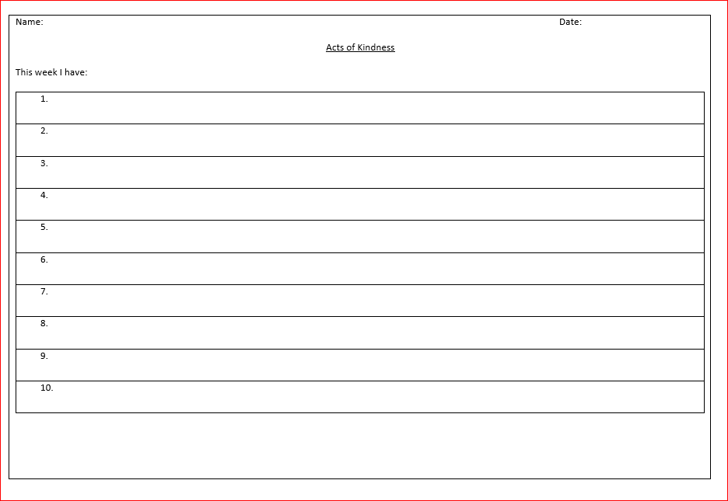

**PSHE – w/c 15th and 22nd June**

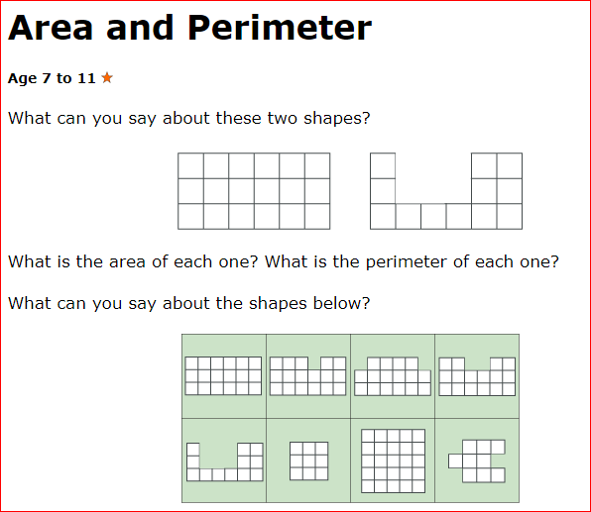Maths Extra Challenge – Week beginning 15th June

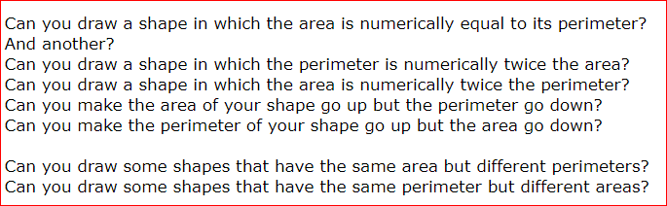

Maths Extra Challenge – Week beginning 22nd June

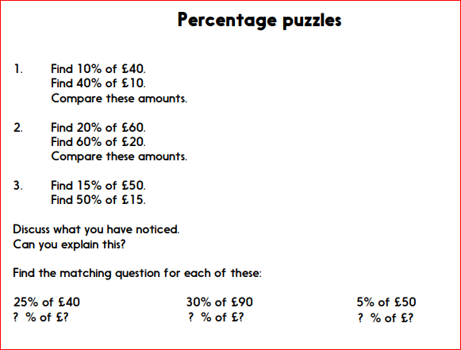 **Geography – w/c 15th June**

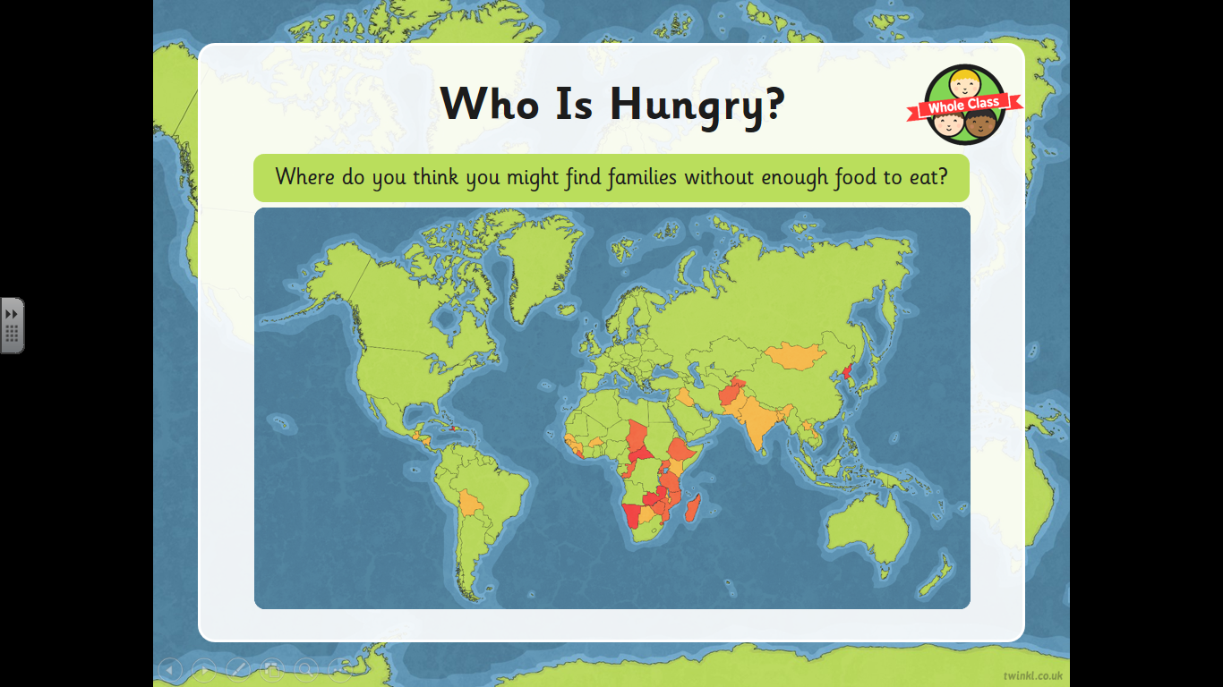

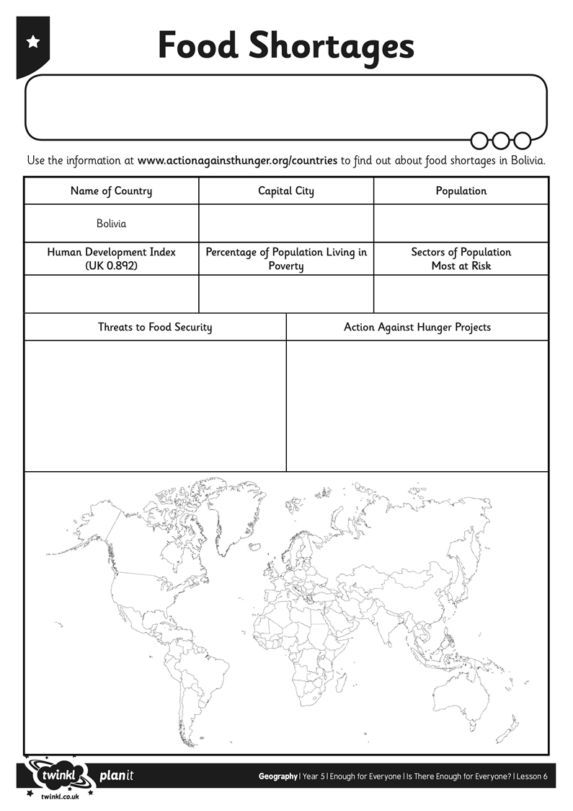

**Geography w/c 15th June**

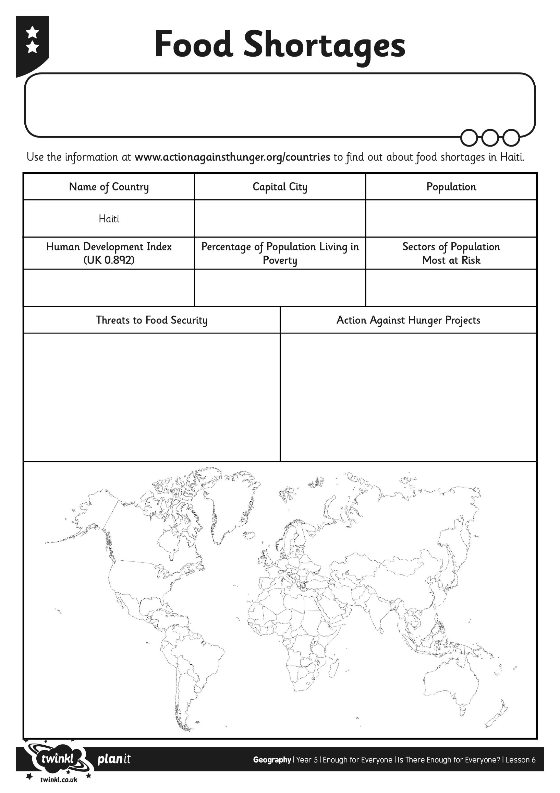

**Geography w/c 15th June**

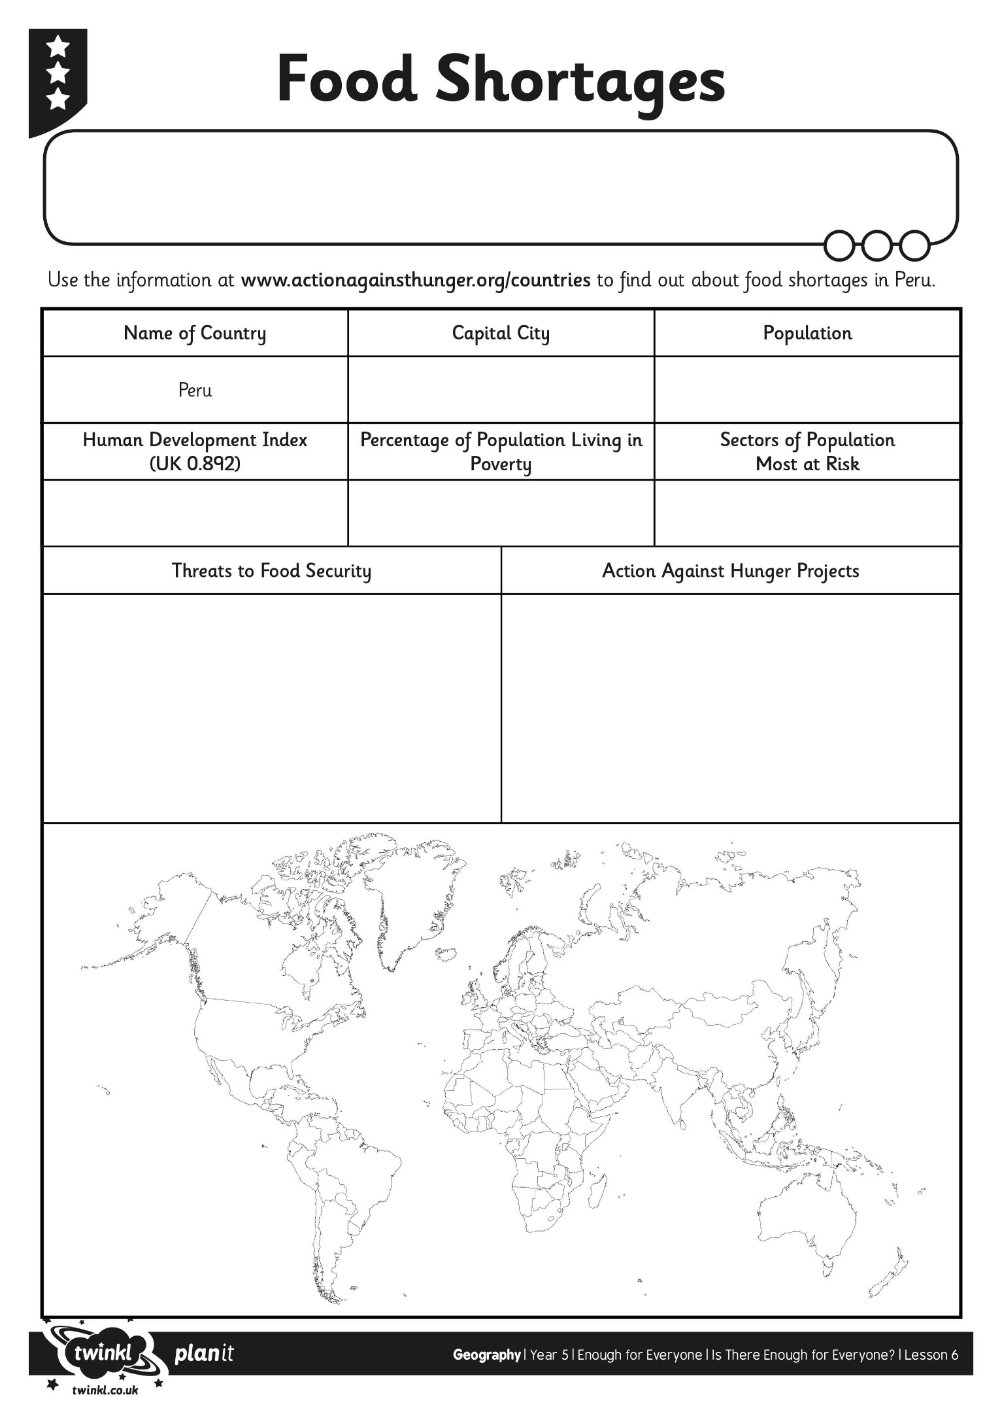

**Geography w/c 15th June**



**Geography w/c 22nd June**