4A Distant Learning: 15th June to 26th June

Hello 4A!
Welcome to your next 2 weeks’ worth of home learning. It has been a busy couple of weeks in school, as you may know Foundation Stage, Year 1 and Year 6 have been invited back into school. I am teaching one of the Foundation bubbles which feels very funny as they are a lot smaller than you guys! We have been working hard on our numbers, phonics and writing, however the school environment is a very different one to what you are used to. Please don’t worry, we haven’t forgotten about you all at home, I will still be setting work for you to do on here and hopefully I will get a chance to speak to you again over the next couple of weeks. I really enjoy catching up with you all on the phone and hearing what you have been up to!
Keep working hard for me and I am keeping an eye on those amazing Mathletics scores of yours!
If you would like to further your learning, I highly recommend online BBC Bitesize daily lessons. This is a wonderful resource which may teach new concepts but also revisits previously learned material and is a great way to refresh our knowledge whilst on lockdown. Find your year group on https://www.bbc.co.uk/bitesize/dailylessons
If you have any questions about the work that I have set, then you can ring the school office on 01400 659001 or email enquiries@cranwell.lincs.sch.uk and I will do what I can to help you!
Speak to you all soon and remember to keep smiling!
Mrs Allen

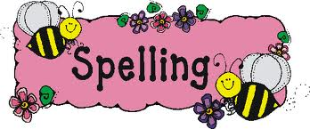

Literacy-Writing
Climate Change –melting ice caps
Have you ever dreamt of owning a Blue Peter badge?! I certainly did when I was your age! Well, now is your chance! Can you write a story on an environmental topic and send it to Blue Peter to earn the chance of a Green Badge? See the further information below. What an exciting opportunity!

Spellings

Alongside learning the Year 3 and 4 National Curriculum spelling can you mark Mr Woops’ work and find his mistakes?! Why not use coloured pens like Mrs Allen does in your books when marking your work!

Reading
We read in class every day, so it would be really nice if you could spend some time every day reading a book. This can be a home book, a newspaper, magazine or anything alike. Do not forget to record this in your reading record.
It would also be good practise to complete some book reviews in the back of you reading record.

Extras
On Sunday 21st June it is Father’s Day. It would be a really lovely surprise if you could make a card for your Dad, Grandad or someone special. I have attached some templates you may like to use, as well as some fun arts and crafts. You will find these under the ‘Extra Resources’ in the 4A Downloads section.

Maths
Please see ‘Maths’ information page, which explains your daily tasks.
Times Tables
I have provided you with the times tables test you complete weekly in school. Once you have completed and scored full marks on the multiplication sheet in 5 minutes then you can move onto the division sheet. You have 5 minutes to complete as many as you can, column by column. You could also have a look on the times tables page for websites to help you.
Topic activities

Linked to your writing topic, climate change, I have enclosed some fun activities which you may like to do.

Spelling Activities
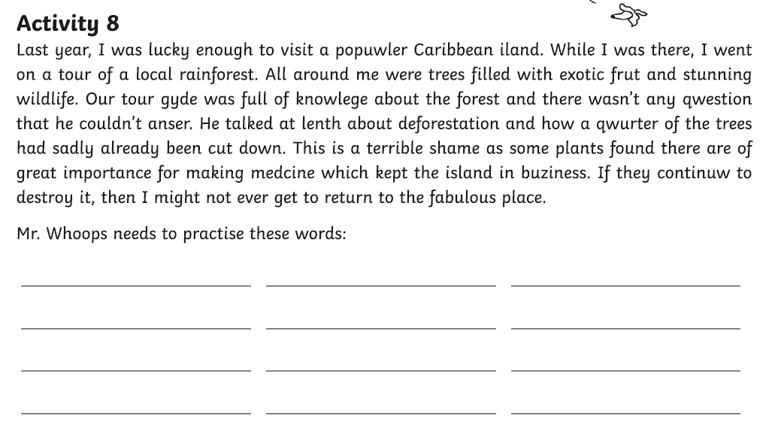

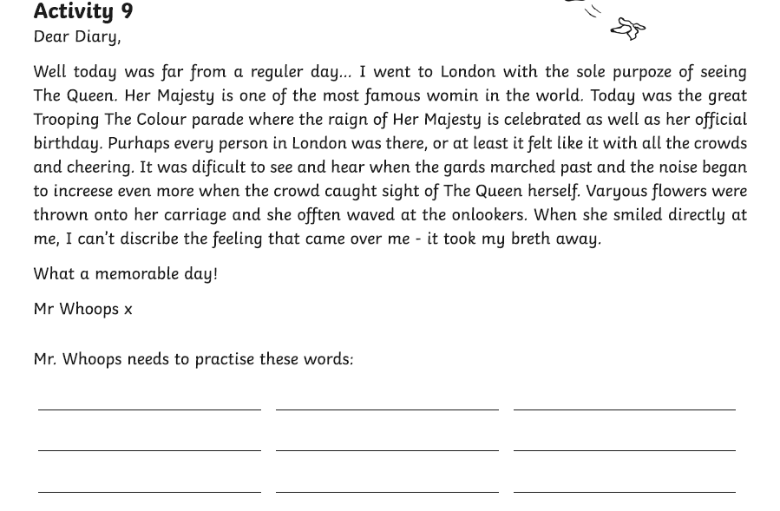
Literacy
For this next set of home learning we are focusing on story writing. I would like you to plan and write a story with an environmental theme. I have chosen the theme of climate change and the melting ice caps. See the topic activities for some research ideas on the melting ice caps, which will help you with your story writing.
I have included this picture and a story starter in the ‘Extra Resources’ pack under the 4A section in Downloads. When planning and writing you could think about the following questions;
When is this story set? Where is it set? Why are you there? How did you get there? Will the mammoth defrost? What happens after? How does your story end?

See extra resources for a planning sheet.
https://www.bbc.co.uk/cbbc/findoutmore/blue-peter-apply-for-a-green-badge
Once you have written your story you can email it into school for me to read or send it off to Blue Peter to potentially earn a Green Badge.
There will be a prize for the best Y3 & Y4 story sent into school.
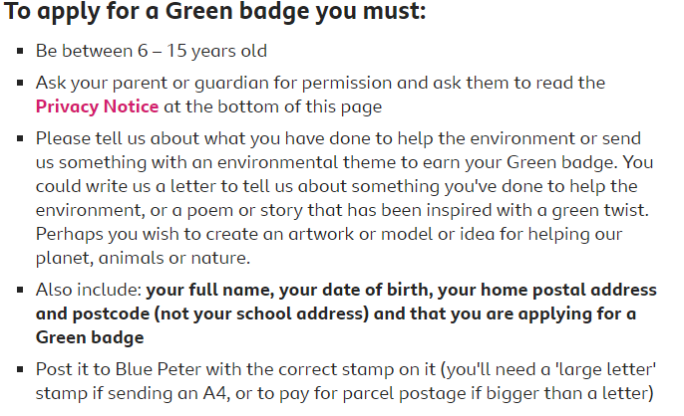

Times Table Activities

https://play.ttrockstars.com/auth/school - Times Table Rock Stars is a great way to practise your times tables
https://play.edshed.com/ - Practise your times tables
https://www.timestables.co.uk/ - learn and practise
https://www.topmarks.co.uk/maths-games/7-11-years/times-tables
https://www.oxfordowl.co.uk/for-home/maths/help-with-times-tables/ -
https://www.themathsfactor.com/times-tables-check/#/- A Times Tables Check

Maths Activities

Please continue to complete your daily maths lesson, on the White Rose website. You should now be ready to move onto ‘Summer term- Week 8 (w/c 15th June)’ and ‘Summer term-Week 9 (w/c 22nd June)’.
Each day, there will be a short video of a lesson to watch, which will contain questions for you to answer on paper. The lesson videos will also be linked to the BBC Bitesize website, where you will find further explanations and activities.
Follow this link to find your daily lessons and follow the instructions on the website: https://whiterosemaths.com/homelearning/year-4/. If you have been following the White Rose scheme throughout lockdown, you will have already covered the planned content for the next 2 weeks. Follow the link that says ‘Already covered this content?’ for an alternative plan.
In addition to this, Mathletics activities will be set and don’t forget you always have access to Times Tables Rockstars and Education city.
Extra Maths Games
https://play.prodigygame.com/ - Pokemon style game with maths questions!
https://play.edshed.com/ - practise your number bonds, power of 10 and addition and subtraction
www.topmarks.co.uk –interactive games
https://www.oxfordowl.co.uk/for-home/kids-activities/fun-maths-games-and-activities/#maths-7-9 – games and activities
https://www.mathswithparents.com/KWeb?startTime=1584558592239#menu584883 – Free access to parents – videos and activities across the maths curriculum.

2x table |  | 5x table |  | 10x table |  | 3x table |  | 4x table |  | 8x table
1 x 2 = |  | 3 x 5 = |  | 2 x 10 = |  | 4 x 3 = |  | 3 x 4 = |  | 2 x 8 =
6 x 2 = |  | 8 x 5 = |  | 6 x 10 = |  | 10 x 3 = |  | 1 x 4 = |  | 10 x 8 =
10 x 2 = |  | 11 x 5 = |  | 8 x 10 = |  | 1 x 3 = |  | 9 x 4 = |  | 8 x 8 =
2 x 2 = |  | 2 x 5 = |  | 3 x 10 = |  | 5 x 3 = |  | 7 x 4 = |  | 1 x 8 =
4 x 2 = |  | 4 x 5 = |  | 7 x 10 = |  | 9 x 3 = |  | 2 x 4 = |  | 5 x 8 =
5 x 2 = |  | 6 x 5 = |  | 10 x 10 = |  | 6 x 3 = |  | 12 x 4 = |  | 7 x 8 =
7 x 2 = |  | 10 x 5 = |  | 4 x 10 = |  | 2 x 3 = |  | 8 x 4 = |  | 9 x 8 =
12 x 2 = |  | 1 x 5 = |  | 11 x 10 = |  | 11 x 3 = |  | 11 x 4 = |  | 3 x 8 =
3 x 2 = |  | 5 x 5 = |  | 9 x 10 = |  | 8 x 3 = |  | 5 x 4 = |  | 6 x 8 =
8 x 2 = |  | 9 x 5 = |  | 1 x 10 = |  | 12 x 3 = |  | 10 x 4 = |  | 11 x 8 =
11 x 2 = |  | 12 x 5 = |  | 12 x 10 = |  | 3 x 3 = |  | 6 x 4 = |  | 4 x 8 =
9 x 2 = |  | 7 x 5 = |  | 5 x 10 = |  | 7 x 3 = |  | 4 x 4 = |  | 12 x 8 =
Total: |  | Total: |  | Total: |  | Total: |  | Total: |  | Total:
6 x table |  | 7 x table |  | 9 x table |  | 11 x table |  | 12 x table
2 x 6 = |  | 2 x 7 = |  | 1 x 9 = |  | 4 x 11 = |  | 3 x 12 =
6 x 6 = |  | 10 x 7 = |  | 6 x 9 = |  | 10 x 11 = |  | 1 x 12 =
8 x 6 = |  | 8 x 7 = |  | 10 x 9 = |  | 1 x 11 = |  | 9 x 12 =
3 x 6 = |  | 1 x 7 = |  | 2 x 9 = |  | 5 x 11 = |  | 7 x 12 =
7 x 6 = |  | 5 x 7 = |  | 4 x 9 = |  | 9 x 11 = |  | 2 x 12 =
10 x 6 = |  | 7 x 7 = |  | 5 x 9 = |  | 6 x 11 = |  | 4 x 12 =
4 x 6 = |  | 9 x 7 = |  | 7 x 9 = |  | 2 x 11 = |  | 8 x 12 =
11 x 6 = |  | 3 x 7 = |  | 12 x 9 = |  | 3 x 11 = |  | 11 x 12 =
9 x 6 = |  | 6 x 7 = |  | 3 x 9 = |  | 8 x 11 = |  | 5 x 12 =
1 x 6 = |  | 11 x 7 = |  | 8 x 9 = |  | 12 x 11 = |  | 10 x 12 =
12 x 6 = |  | 4 x 7 = |  | 11 x 9 = |  | 11 x 11 = |  | 6 x 12 =
5 x 6 = |  | 12 x 7 = |  | 9 x 9 = |  | 7 x 11 = |  | 12 x 12 =
Total: |  | Total: |  | Total: |  | Total: |  | Total:

2÷ table |  |  | 5÷ table |  |  | 10÷ table |  |  | 3÷ table |  | 4÷ table |  |  | 8÷ table
2÷2 = |  |  | 15 ÷ 5 = |  |  | 20 ÷ 10 = |  |  | 12 ÷ 3 = |  | 12 ÷ 4 = |  |  | 16 ÷ 8 =
12÷ 2 = |  |  | 40 ÷ 5 = |  |  | 60 ÷ 10 = |  |  | 30 ÷ 3 = |  | 4 ÷ 4 = |  |  | 80 ÷ 8 =
20 ÷ 2 = |  |  | 55 ÷ 5 = |  |  | 80 ÷ 10 = |  |  | 3 ÷ 3 = |  | 36 ÷ 4 = |  |  | 64 ÷ 8 =
2 ÷ 2 = |  |  | 10 ÷ 5 = |  |  | 30 ÷ 10 = |  |  | 15 ÷ 3 = |  | 28 ÷ 4 = |  |  | 8 ÷ 8 =
8 ÷ 2 = |  |  | 20 ÷ 5 = |  |  | 70 ÷ 10 = |  |  | 27 ÷ 3 = |  | 8 ÷ 4 = |  |  | 40 ÷ 8 =
10 ÷ 2 = |  |  | 30 ÷ 5 = |  |  | 10 ÷ 10 = |  |  | 18 ÷ 3 = |  | 48 ÷ 4 = |  |  | 56 ÷ 8 =
14 ÷ 2 = |  |  | 50 ÷ 5 = |  |  | 40 ÷ 10 = |  |  | 6 ÷ 3 = |  | 32 ÷ 4 = |  |  | 72 ÷ 8 =
24 ÷ 2 = |  |  | 5 ÷ 5 = |  |  | 110 ÷ 10 = |  |  | 33 ÷ 3 = |  | 44 ÷ 4 = |  |  | 24 ÷ 8 =
6 ÷ 2 = |  |  | 25 ÷ 5 = |  |  | 90 ÷ 10 = |  |  | 24 ÷ 3 = |  | 20 ÷ 4 = |  |  | 48 ÷ 8 =
16 ÷ 2 = |  |  | 45 ÷ 5 = |  |  | 10 ÷ 10 = |  |  | 36 ÷ 3 = |  | 40 ÷ 4 = |  |  | 88 ÷ 8 =
22 ÷ 2 = |  |  | 60 ÷ 5 = |  |  | 120 ÷ 10 = |  |  | 9 ÷ 3 = |  | 24 ÷ 4 = |  |  | 32 ÷ 8 =
18 ÷ 2 = |  |  | 35 ÷ 5 = |  |  | 50 ÷ 10 = |  |  | 21 ÷ 3 = |  | 16 ÷ 4 = |  |  | 96 ÷ 8 =
Total: |  |  | Total: |  |  | Total: |  |  | Total: |  | Total: |  |  | Total:
6 ÷ table |  | 7 ÷ table |  |  | 9 ÷ table |  |  | 11 ÷ table |  |  |  | 12 ÷ table
12 ÷ 6 = |  | 14 ÷ 7 = |  |  | 9 ÷ 9 = |  |  | 44 ÷ 11 = |  |  |  | 36 ÷ 12 =
36 ÷ 6 = |  | 70 ÷ 7 = |  |  | 54 ÷ 9 = |  |  | 110 ÷ 11 = |  |  |  | 12 ÷ 12 =
48 ÷ 6 = |  | 56 ÷ 7 = |  |  | 90 ÷ 9 = |  |  | 11 ÷ 11 = |  |  |  | 108 ÷ 12 =
18 ÷ 6 = |  | 7 ÷ 7 = |  |  | 18 ÷ 9 = |  |  | 55 ÷ 11 = |  |  |  | 84 ÷ 12 =
42 ÷ 6 = |  | 35 ÷ 7 = |  |  | 36 ÷ 9 = |  |  | 99 ÷ 11 = |  |  |  | 24 ÷ 12 =
60 ÷ 6 = |  | 49 ÷ 7 = |  |  | 45 ÷ 9 = |  |  | 66 ÷ 11 = |  |  |  | 48 ÷ 12 =
24 ÷ 6 = |  | 63 ÷ 7 = |  |  | 63 ÷ 9 = |  |  | 22 ÷ 11 = |  |  |  | 96 ÷ 12 =
66 ÷ 6 = |  | 21 ÷ 7 = |  |  | 108 ÷ 9 = |  |  | 33 ÷ 11 = |  |  |  | 132 ÷ 12 =
54 ÷ 6 = |  | 42 ÷ 7 = |  |  | 27 ÷ 9 = |  |  | 88 ÷ 11 = |  |  |  | 60 ÷ 12 =
6 ÷ 6 = |  | 77 ÷ 7 = |  |  | 72 ÷ 9 = |  |  | 132 ÷ 11 = |  |  |  | 120 ÷ 12 =
72 ÷ 6 = |  | 28 ÷ 7 = |  |  | 99 ÷ 9 = |  |  | 121 ÷ 11 = |  |  |  | 72 ÷ 12 =
30 ÷ 6 = |  | 84 ÷ 7 = |  |  | 81 ÷ 9 = |  |  | 77 ÷ 11 = |  |  |  | 144 ÷ 12 =
Total: |  | Total: |  |  | Total: |  |  | Total: |  |  |  | Total:

Climate Change –melting ice caps
Watch WWF presentation on climate change.  https://www.wwf.org.uk/sites/default/files/2016-11/WWF_KS2_Lesson1_Presentation_v3.pdf | 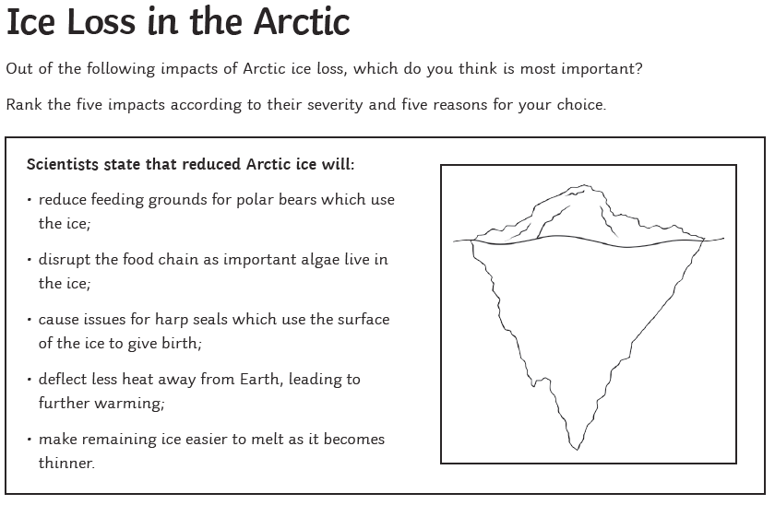 | Artic animal word search  See extra resources
The Tantrum that Saved the World – Megan Herbert & Michael E Mann  Story ends at 12min 30Sec – the rest of the book is information.  https://www.youtube.com/watch?v=eIK1HZZtsw8 |  | Art – Make some art that links to climate change or the melting of the ice caps. Find some examples in the extra resources.
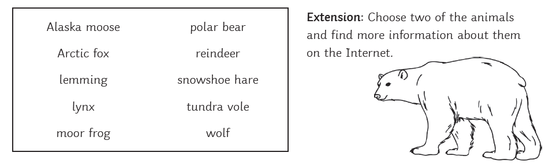
Can you make a PowerPoint or fact file to present your information?

PE Activities

https://www.cosmickids.com/category/watch/- Cosmic Kids Yoga. These activities vary from under 10 minutes to over 15 minutes.
https://www.youtube.com/results?search_query=body+coach+kids- Tune in with Joe Wicks for some HITT sessions!
https://www.youtube.com/user/thebodycoach1 - Joe Wicks is also providing live workout, every morning at 9am, called "PE with Joe" on his YouTube channel The Body Coach TV.
https://www.cranwell.lincs.sch.uk/ Follow our school twitter feed on the school website or visit our twitter page, or Carre’s Grammar School Outreach support https://twitter.com/CranwellSchool, https://twitter.com/CGSOutreach for fun daily challenges and virtual competitions you can enter.

Additional Websites

These websites are offering free, fun and interactive resources to help learning at home.

Twinkl- https://www.twinkl.co.uk/resources/parents
Mrs Mactivity- You can claim a free resource pack by signing up with your email- https://www.mrsmactivity.co.uk/
White Rose Maths- This is the Maths scheme we follow in school. They have provided free, really helpful lessons online that include a short video showing you clearly and simply how to help your child to complete the activity-.https://whiterosemaths.com/homelearning/
Classroom Secrets- They have created fun, interactive and practical home learning packs to ensure all children can continue to learn- https://classroomsecrets.co.uk/
Teach Starter- They are offering a collection of free resources-https://www.teachstarter.com/
Newsround- Watch Newsround live at 9:15am, 12:10pm and 4:00pm for the latest news- https://www.bbc.co.uk/newsround

