Maths
For the next two weeks we are using the White Rose alternative plan for summer Week 7 and 8.
The topic is measurement.
Times tables
You need to keep practising your times tables. Have a look on the times table page for websites to help you.
Writing/Topic
Climate Change –melting ice caps
Write a story on an environmental topic and send it to Blue Peter to earn a Green Badge.

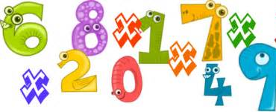

Extras – MFL
It is Father’s Day on Sunday 21st June. I have included some card templates and colouring for you to do for your Dad.

Reading
We would normally read every day in class – try to read every day and record this in your reading record. If you have finished your reading record could you make your own or just write down your page number on paper.

Spelling Punctuation and Grammar
Use this time to learn the words from the 3/ 4 Word list you can find in the front of your planner.
Using a wider range of conjunctions.
Maths Activities
It was great to hear that you all have been working hard on your maths whether that is through the White Rose videos, BBC Bitesize or Mathletics! This work is to last you two weeks.
These topics are from the White Rose alternative plan as we have already completed their fractions work.
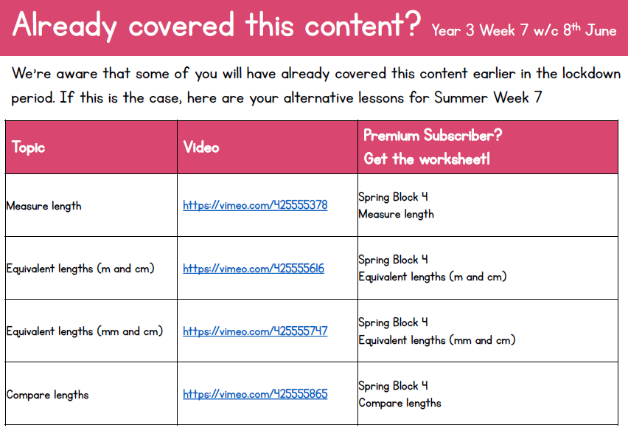
Week beg 15th June: Click the purple box to download the alternative plan or click this link. https://wrm-13b48.kxcdn.com/wp-content/uploads/2020/06/Y3-Week-7-Alternative-Plan.pdf

Click on the links provided on your online version to watch the videos and I have included the corresponding worksheets in the extra resources.
Week beg 22nd June:
You still have the option to go on Mathletics and Education City and these will match up to the measurement topics.
https://login.mathletics.com/ https://www.educationcity.com/
Extra Maths Games
https://play.prodigygame.com/ - Pokemon style game with maths questions!
https://play.edshed.com/ - practise your number bonds, power of 10 and addition and subtraction
www.topmarks.co.uk –interactive games
https://www.oxfordowl.co.uk/for-home/kids-activities/fun-maths-games-and-activities/#maths-7-9 – games and activities
https://www.mathswithparents.com/KWeb?startTime=1584558592239#menu584883 – Free access to parents – videos and activities across the maths curriculum.

Times Table Activities
I have had a few questions about the expectations of times tables in Year 3 so to make you all aware by the end of Year 3 children should be able to know (off by heart and in any order) the 2,3,10,3,4 & 8 times tables. Year 4’s are expected to know all of their times tables by the end of the year ready for the National Multiplication Check.

https://play.ttrockstars.com/auth/school - Times Table Rock Stars is a great way to practise your times tables
https://www.timestables.co.uk/ - Learn and practise
https://www.topmarks.co.uk/maths-games/7-11-years/times-tables
https://www.oxfordowl.co.uk/for-home/maths/help-with-times-tables/
Literacy Activities
For this next set of Home Learning we are focusing on story writing. I would like you to plan and write a story with an environmental theme. I have chosen the theme of climate change and the melting icecaps. See the topic activities for some research ideas on the melting ice caps.
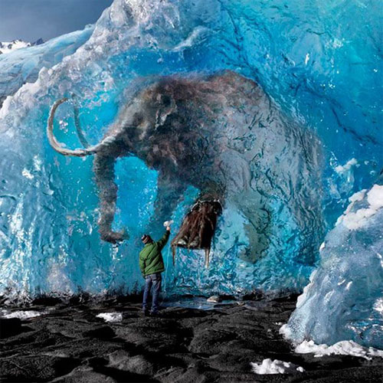
Here is a picture to give you ideas about what you could write.
When is this story set? Where is it set? Why are you there? How did you get there? Will the mammoth defrost? What happens after? How does your story end?

See extra resources for a planning sheet. Can you add conjunctions to your story?

https://www.bbc.co.uk/cbbc/findoutmore/blue-peter-apply-for-a-green-badge
Once you have written your story you can email it into school for me to read or send it off to Blue Peter to potentially earn the Green Badge.
There will be a prize for the best Y3 & Y4 story send into school.
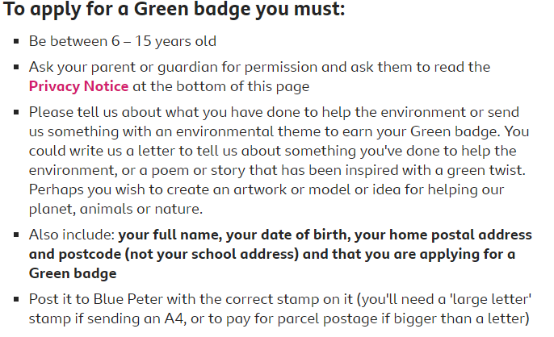
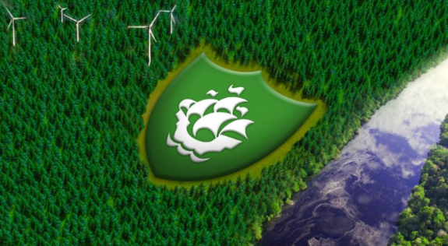

Spelling Punctuation and Grammar Activities
In the Extra resources find some worksheets on conjunctions. Fairy Tale sentences and Cameron’s Conjunction Challenge. Try to add some of these into your story writing.

You have a list of words in your planner than you need to know by the end of Year 4. Learn some of these that you did not know before. Find them in a dictionary and write them in a sentence.
https://go.educationcity.com/ - Log in and select classwork to find a selection of SPaG activities to complete.
https://www.topmarks.co.uk/english-games/7-11-years/spelling-and-grammar - A selection of different games and activities to help you learn and practise SPaG topics.
https://www.bbc.co.uk/bitesize/dailylessons - If you want to extend your learning this is a great resource which may teach new concepts but also revisits previously learned material and is a great way to refresh your knowledge whilst on lockdown.

Topic activities – Climate change
Watch WWF presentation on climate change.  https://www.wwf.org.uk/sites/default/files/2016-11/WWF_KS2_Lesson1_Presentation_v3.pdf | 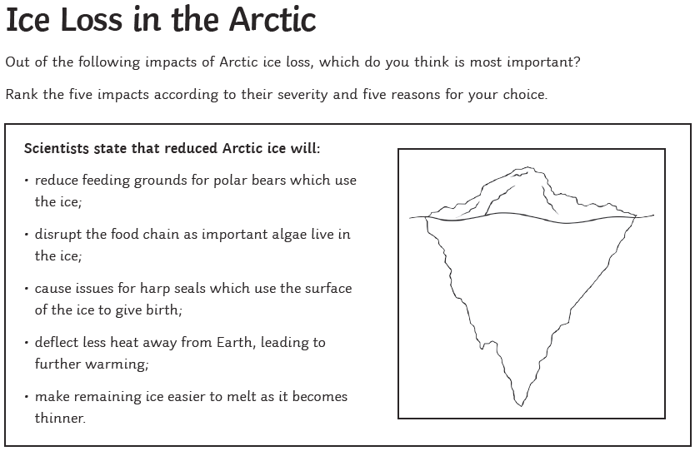 | Artic animal word search  - See extra resources
The Tantrum that Saved the World – Megan Herbert & Michael E Mann  Story ends at 12min 30Sec – the rest of the book is information.  https://www.youtube.com/watch?v=eIK1HZZtsw8 |  | Art – Make some art that links to climate change or the melting of the ice caps. Find some examples in the extra resources.
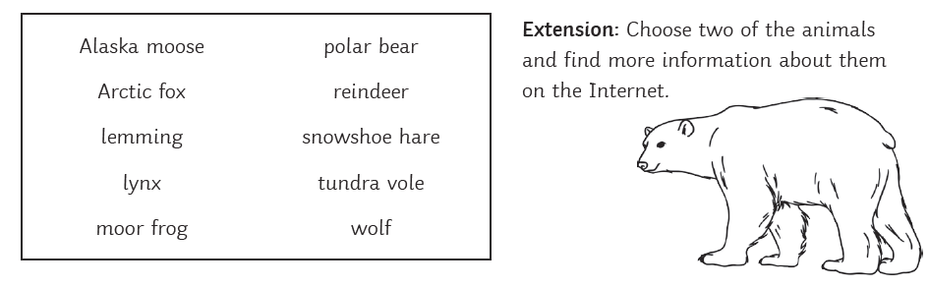
Can you make a PowerPoint or fact file to present your information?

Extras!
Father’s Day Activities – See Father’s Day resources

If you want some extra PE resources these are things we use in class;
https://www.cosmickids.com/ - Yoga
https://www.youtube.com/watch?v=gCzgc_RelBA – Just Dance
https://www.youtube.com/watch?v=mhHY8mOQ5eo – Joe Wicks Fitness video

