EYFS Home Learning Challenges Week beginning 11th May 2020
Here are the next set of challenges that will be uploaded daily onto Tapestry. We hope that you are enjoying them and we love looking at the photos and videos that you share with us each day. Please keep reading and looking through your phonics envelope as well as challenging yourself on Mathletics and playing the fun games on Education City. If you have read all your school books you can always help mum/dad to read your bedtime story or look on www.oxfordowl.co.uk for some free ebooks like your school books.
Sending love and best wishes to you all.
Mrs Lawson, Mrs Case, Donna, Chloe J, Drew, Katie, Emma and Chloe B
Challenge 26 | Challenge 27 | Challenge 28 | Challenge 29 | Challenge 30
During spring, lots of animals have their babies.  Find out the names of these baby animals: duck, pig, sheep, cow and horse.  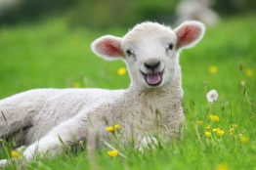 | Explore evaporation. Place a small amount of water on a plate and place in a sunny window. Leave it for a while and see what happens to the water. Where did it go? | Find a fun place to read a book.  Where will you go? The bath? Under a table? | Captain Hook wants a new pirate ship and would like you to build it!  What could you use? A construction toy/ junk materials?  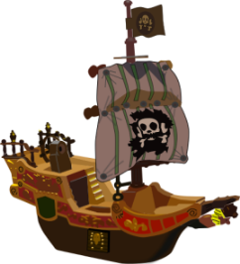 | How main lights can you find in your home?  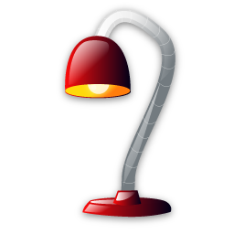  What else gives us light?
EYFS Home Learning Challenges Week beginning 18th May 2020
This would usually have been the last week of the term in school where we would have joined together for Grandparent day. We are very sad that we are not in school to enjoy this. We hope that you are enjoying time at home though and keeping in touch with your wider family. We are missing you lots in school and will give you another call this week for a catch up. Thank you for the learning that you have uploaded onto Tapestry, it really does brighten our day.
Take care and enjoy the lovely sunshine!
Mrs Lawson, Mrs Case, Donna, Chloe J, Drew, Katie, Emma and Chloe B
Challenge 31 | Challenge 32 | Challenge 33 | Challenge 34 | Challenge 35
Pick five favourite toys. Estimate and order them from heaviest to lightest. How can you find out if you are correct?  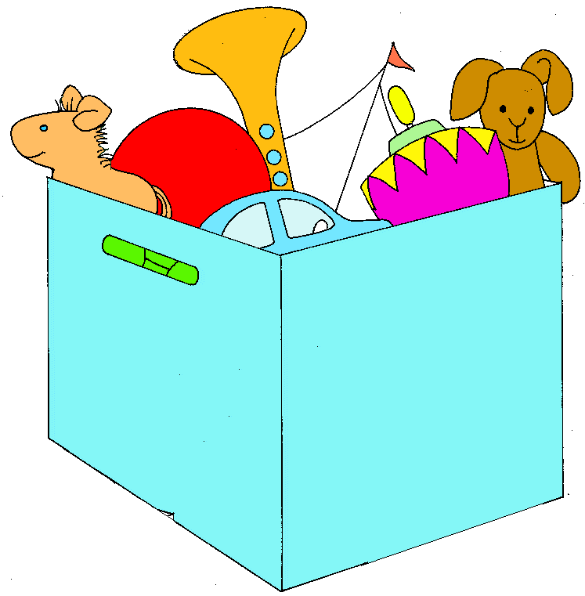 | Listen to some classic music The Great Escape- Elmer Bernstein or The Flight of the Bumblebee – Rimsky-Korsakov (or one of your own favourites) Dance or draw/paint to the music. | 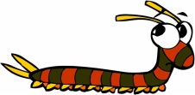  Explore your garden or go for a walk. Look under pots, logs and stones. Ask your grown up to help you when lifting. What mini-beasts can you find? | Make some labels for things around your house. | We would have been enjoying Grandparent Day in school today.  Why don’t you give your grandparent or another relative in your family and call or send them a letter or picture in the post.

