Dear children and parents

Goodness, it’s nearly half term! What a strange few weeks this has been! So, only one more week of school work, then a lovely week off .

This week, we should have had Grandparents’ Day, but sadly that can’t happen this year. So this week, as an extra activity, I’d really like you to make contact with your Grandparents, if you can. Have a chat with Mum and Dad about how to do this: you could phone them, use Skype, Zoom or an app on a phone perhaps. If they aren’t technologically-minded, they might really appreciate a letter or a picture through the post. You’ll probably have lots to talk about, but you might like to ask them about your family tree – who were their grandparents? If you don’t have grandparents to talk to, don’t worry – perhaps you could get in touch with other relatives, who I’m sure will also be really delighted to hear from you.

Keep up the great work and remember that you can contact me, through school reception (01400 659001), if you have any questions about the work I’ve set or if you need help with anything else.

Mrs Bullement

Maths  Please continue to complete your daily maths lesson, using the White Rose resources from the website. There may or may not be a sheet available each day this week (they keep changing their minds!), but if not, just have a go at the questions on the video, on a piece of paper. Remember to also follow the links to BBC Bitesize for even more practise.  You can find your lessons here: https://whiterosemaths.com/homelearning/year-5/ Please move onto the section labelled ‘Summer Term Week 5 w/c 18th May’. The videos are also available on Facebook, if the website is overloaded.  Of course, I’ll continue to set tasks on Mathletics, but only do these if you have spare time!  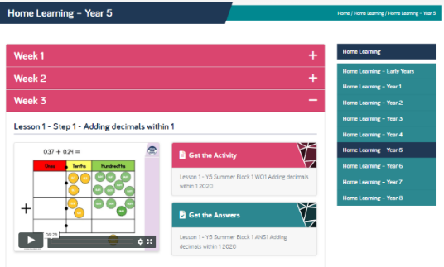  Want an extra challenge? Try the ‘Reach 100’ problem below. It’s taken from the NRICH website, which has lots of other activities to keep you busy, if you’d like to stretch yourself further: https://nrich.maths.org/14600 | English  Write and Perform a Poem  Can you write a rhyming poem and perform to other people?  Lots of poems have rhymes within them. Sometimes the rhyme is internal (middle) where the rhyme occurs within one single line of a verse. On other occasions, the rhyme occurs at the end of a line. Commonly, the ends of the first and third-line rhyme and the ends of the second- and fourth-line rhyme. An example of an ABAB Rhyming Poem:  At the top of a large, bushy tree  Sat a bird with a broken wing  He was trapped and could not break free  And so all day, he did nothing but sing.  Mon: read some poems and decide which features you like. You might like to use books or these websites for ideas: https://www.poetryfoundation.org/poems/browse#page=1&sort_by=recently_added&filter_poetry_children=1  https://www.familyfriendpoems.com/poems/children/  Tues: Use your planning sheet to help you organise your ideas. Challenge – can you write 2 verses?  Wed: draft your poem and share it with Mum or Dad. Ask how you could improve it.  Thurs: edit and improve your poem, using the comments from yesterday to guide you.  Fri: write up your poem in best. You might like to illustrate it or draw a colourful border around it. Now perform it to your audience!
SPAG  This week, we’ll be revising commas, dashes and brackets for parenthesis. Have a look at: https://www.youtube.com/watch?v=YZJbRaA3LUI and then have a go at the sheet below. There’s a BBC Bitesize lesson too, if you need extra practise: https://www.bbc.co.uk/bitesize/articles/zrdyvk7 | PE  It’s really important that we all stay fit and active. Try to do at least an hour of playing in the garden or walking out with a parent every day. Fresh air makes us all feel better! If you’re stuck inside, try a Joe Wicks (or Rosie Wicks!) workout:  https://www.youtube.com/watch?v=-TGEdzRzSbw  For a challenge, can you design a circuit in your garden? Try to remember those great circuit training activities Mrs Barrett taught you. Can you set up a circuit of 5-6 different exercises for your whole family to do? Remember that you’ll have to try them out first, then perhaps you could be the one holding the stopwatch!
Reading
Please make sure you read for at least 20 mins every day this week. If you don’t have a book at home, you can use the book on: https://www.twinkl.co.uk/home-learning-hub (Guided Reading) or try Oxford Owl’s free online library https://www.oxfordowl.co.uk/for-home/find-a-book/library-page which has lots of your favourites from school!
French
I’m really enjoying practising my French each day on Duolingo and I hope you are too! Keep that streak going!
https://www.duolingo.com/
Science – Earth and Space  This week, we’re learning more about day and night by investigating time zones around the world. Have a look at https://www.bbc.co.uk/bitesize/topics/zvsfr82/articles/zjk46v4 ; there’s even a little game to play!  If you enjoy a challenge, you might like to have a go at the questions on the cards below – perhaps you could print them, share them with Mum or Dad and see who gets the most right! I’ve included a time zone map, but it’s not quite as clear as I’d like. I suggest you either use one from an atlas or try this interactive website, where you can search for the countries and see them pinpointed: https://24timezones.com/timezone-map  Perhaps you have friends in other countries – what time is it with them? | History  The innovation we’re learning about this week is an important one for many of our families – flight! I’d like you to research the history of flight and see if you can find out about a very important invention which took place in Cranwell! There are many interesting websites, but here are some suggestions:  https://www.theschoolrun.com/homework-help/history-of-flight  https://www.bbc.co.uk/bitesize/topics/zvb76v4/articles/zdcskmn  https://www.dkfindout.com/uk/transport/history-aircraft/ (super website – click on the images to find out more).  https://www.historylearningsite.co.uk/inventions-and-discoveries-of-the-twentieth-century/the-jet-engine/  Can you make a timeline of all the different ‘aircraft’?
Other ideas for outside
What plants and mini beasts can you find in your garden? I bet it’s been ages since you went on a mini-beast hunt! Have a good rummage around, under leaves and logs in particular and see what you can find. Remember to put your wee beasties carefully back where you find them though! For help with identification, try the iNaturalist app (ask an adult first!) or https://www.wildlifetrusts.org/wildlife/how-identify.

Reach 100

Age 7 to 14
Here is a grid of four "boxes":
You must choose four different digits from 1−9 and put one in each box. For example:
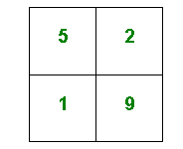
This gives four two-digit numbers:
52 | (reading along the 1st row)
19 | (reading along the 2nd row)
51 | (reading down the left hand column)
29 | (reading down the right hand column)
In this case their sum is 151.
Try a few examples of your own.
Is there a quick way to tell if the total is going to be even or odd?
Your challenge is to find four different digits that give four two-digit numbers which add to a total of 100.
How many ways can you find of doing it?

This problem is adapted from Make 200 from 'Mathematical Challenges for Able Pupils Key Stages 1 and 2', published by DfES, features on the NRICH website.

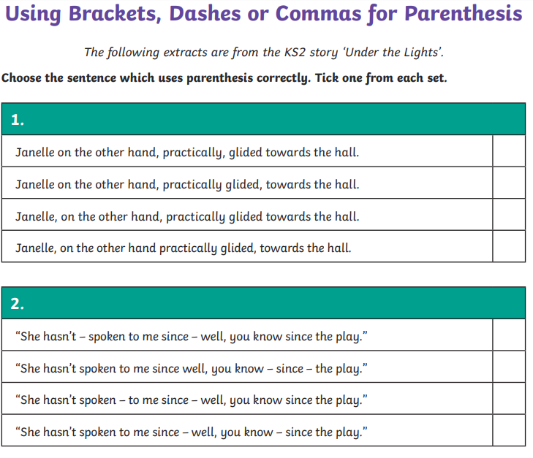

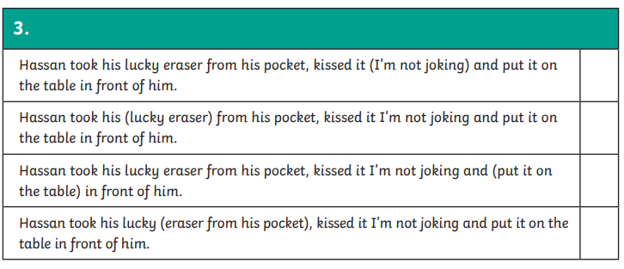
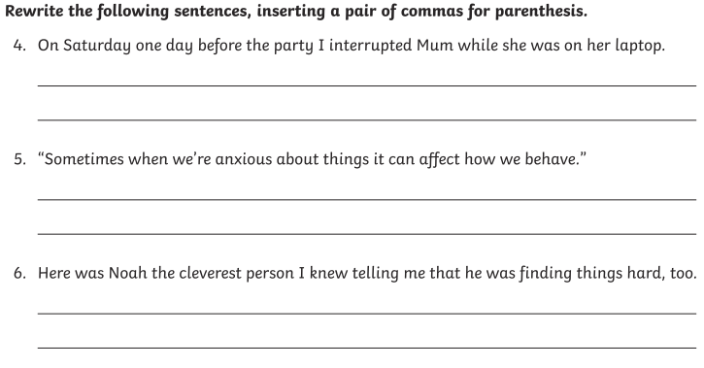
Resource from Twinkl: Under the Lights Using Parenthesis Differentiated Worksheets. Please see Twinkl website for answer sheet.
