Hello 4/5N!
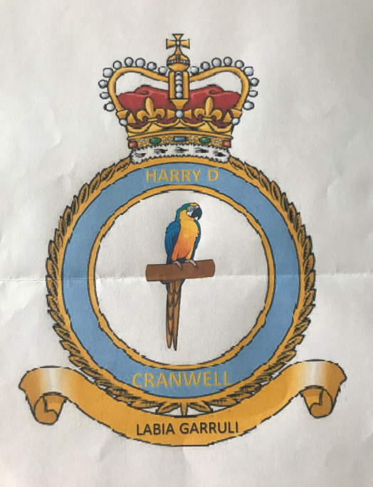
It was lovely to speak to you on the phone recently; I’m glad you are staying busy with both work and quality family time, although I know you are all missing your friends.
You have all been working hard on your Home Learning tasks and several of you mentioned completion of your ‘family crest’ as well as your PowerPoints outlining the history of RAF Cranwell. A couple of students sent me their work and, I must say, I am very impressed at the care and attention to detail taken to complete these tasks – a huge well done from me! My hope is that we come back together as a class and share your wonderful work but, until then, I wanted to celebrate our work by showcasing a crest designed by our very own Harry D – the parrot and Latin motto (which translates to chatterbox) all point to his passion for talking! I hope you won’t mind me sharing your work Harry … it’s definitely a WAGOLL!
As I mentioned to many of your parents on the phone, the most important focus during this lockdown should be your happiness and wellbeing. We are all in the same boat and we will all work together to fill gaps when we get back to school.
If you are finding your schoolwork a struggle, please take a break and try a different activity - some of you have been baking, gardening, or even doing algebra! I hope you can create some lasting memories alongside all the work you and your parents are doing. Remember, you are not expected to complete every task set, but, if possible, try to find time to do some daily maths and literacy work. I am aware that you will all have differing levels of support at home as well as time to devote to study, therefore just try to complete what you can - that’s all any of us can ask for during this challenging time.
The following sheet gives instructions on home learning activities. The format of this is as follows:
- One maths and one English/History lesson for every day
- 20 min daily reading session
- Science, SPAG, ICT and Art/DT activities for you to have a go at, whenever you can fit them in.
- I will also be setting some Education City SPAG tasks as well as Mathletics, and there are some challenge tasks attached below.
- I have also set a ‘for fun’ task about dogs – hope you enjoy this is you have spare time.
You should be able to complete these independently, but ask Mum or Dad if you need help. If you have any problems with log-ins etc., you can ask an adult to ring school, as we are still there to help you.
Parents and children, if you would like to supplement your learning further, I highly recommend online BBC Bitesize daily lessons. This is a wonderful resource which may teach new concepts but also revisits previously learned material and is a great way to refresh our knowledge whilst on lockdown. Find your year group on https://www.bbc.co.uk/bitesize/dailylessons
Take care and hope to see you all soon, Mrs New

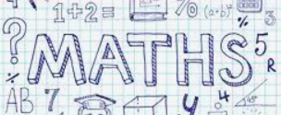
Please continue to complete your daily maths lesson, using the White Rose resources from the website.  Each day, watch a short video of a lesson. If there is a worksheet use it, otherwise write your answers in your exercise book.  You can find your lessons on this website: https://whiterosemaths.com/homelearning/year-4/ Please move onto the section labelled ‘Summer Term Week 2-3’. The videos are also available on Facebook, if the website is overloaded.  In addition, Mathletics tasks will be set. | The Battle of Britain was a military campaign during the Second World War that lasted over 3 months, in which the RAF defended the UK against attacks from the Luftwaffe (Nazi Germany air force).  I would like you to find out more about the Battle of Britain by reading the information piece attached titled ‘Battle of Britain’ and then answering the questions – You can choose which answer sheet you feel most confident with (the number of stars indicates level of difficulty).  Following this, have a go at writing a diary entry as yourself during the Battle of Britain campaign. I have attached a sheet providing an outline of what a diary entry might include below. The following site will help you discover some more about what life was like during this time: http://www.primaryhomeworkhelp.co.uk/war/children.htm  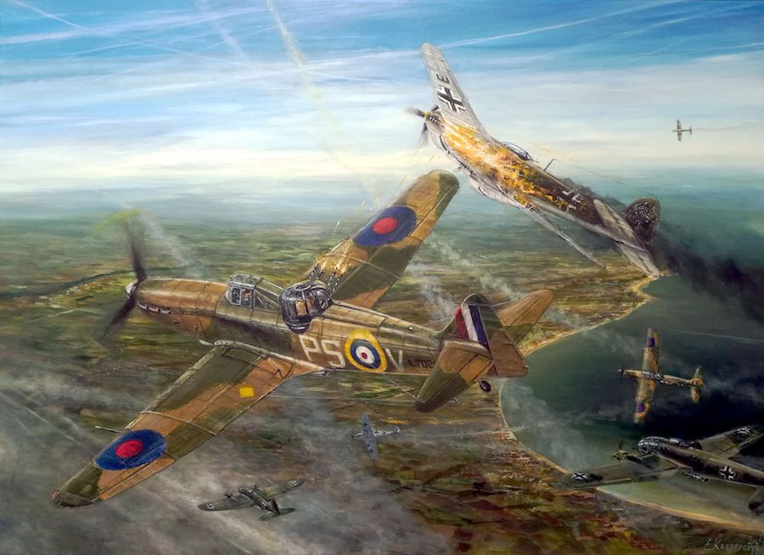  Here are some ideas to think about:  - Sounds – aeroplanes, shouting, sirens, your family summoning you to safety.  - Sights – how could you describe an exchange of fire between RAF and Luftwaffe planes – a kaleidoscope of colour … like fireworks in the sky … swooping, diving like … (try to use similes and powerful adjectives to describe what you might see).  - Smells – cooking, plane fuel, gunfire, etc.  - Touch – do you have to feel your way through familiar objects in the dark to get to safety during blackouts?  - Taste – find out about what children during WWII Britain may have eaten – might you still be hungry? You may be yearning for certain food you haven’t been able to eat for a long time.  - Activities – what did children do for fun during the war? Perhaps you started to grow vegetables in your own garden to become self-sufficient?  - Feelings – pride at the protection offered by RAF pilots? Worried about your safety?
History

Can you research the history of flight and find out about a very important invention which took place in Cranwell! There are many interesting websites, but here are some suggestions:

https://www.theschoolrun.com/homework-help/history-of-flight

https://www.bbc.co.uk/bitesize/topics/zvb76v4/articles/zdcskmn

https://www.dkfindout.com/uk/transport/history-aircraft/ (super website – click on the images to find out more).

https://www.historylearningsite.co.uk/inventions-and-discoveries-of-the-twentieth-century/the-jet-engine/

Can you make a timeline of all the different ‘aircraft’?

Science – Plants  Can you find out about photosynthesis? Animals have to move and search for their food, but green plants must stay in one place and make their food. They make food using sunlight, a process called photosynthesis.  The following websites give a brief overview of this process:  https://www.bbc.co.uk/bitesize/clips/z2k4d2p  https://kids.britannica.com/kids/article/photosynthesis/353624  Please research and then create a diagram to show the process of photosynthesis, including the following labels:  - Sunlight  - Carbon dioxide  - Water  - Food  - Oxygen  - Chlorophyll  Be sure to include arrows, where necessary, to indicate the direction of the above labels. You could add further description of the process underneath your diagram, if you wish. |  | Science – Plants  Can you find out about seed dispersal? Fruits and seeds must be carried away from the parent plant to stop overcrowding – this is called dispersal.  The following websites give a brief overview of this process:  https://www.bbc.co.uk/bitesize/clips/znvfb9q  https://www.dkfindout.com/uk/animals-and-nature/plants/how-seeds-are-spread/  Please research the following three ways to disperse seeds:  - By wind  - By animals  - By explosion  Please provide a description of each method of dispersal and include at least one example of each (with an illustration).
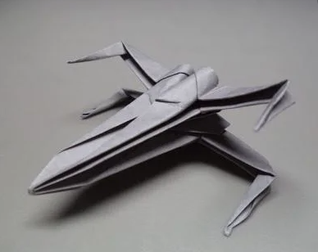

D&T

This week, I would like you to design and build a paper aeroplane.

The links below may give you some ideas – can you create a plane that can travel a long distance? Perhaps you could build more than one and evaluate why one design travelled further than another?

https://www.bbc.co.uk/newsround/26050831
https://www.foldnfly.com/#/1-1-1-1-1-1-1-1-2
https://redwhiteblueday.co.uk/wp-content/uploads/2019/01/RWB-2017-Spitfire-Instructions.pdf

If you have access to a printer, this site lets you personalise your plane online:

https://howthingsfly.si.edu/activities/paper-airplane

Perhaps you could challenge your siblings/parents to a paper aeroplane contest – whose aeroplane can travel the greatest distance? Remember to record your greatest distance.

If you have grandparents or other family and loved ones who you would like to keep in touch with, perhaps you could share some of the fabulous work you have created at home. I’m sure they would enjoy hearing about it!

There are many ways to showcase you work: you could show them your work online; tell them about it on the phone; send them a letter or card.

I hope you enjoy sharing your work as much as your loved ones will enjoy hearing about it.
Art

Can you draw your very own plane?

This is your design so think of features you want (a marshmallow shooter, stealth invisibility mode).

Or, you may rather a different mode of air transport – what about a fantastical creature like a dragon? How about a swan like Billy flew on in The Minpins?

Perhaps your favourite plane already exists? Have a go at drawing it!

You could use any medium you like to create your masterpiece (pencil, paint, collage, etc).

I look forward to seeing your creations in due course.

Please try to learn spellings from the Statutory spelling list provided, and remember to highlight any you get correct on the sheet. | SPAG (spelling, punctuation and grammar) activities will be set online. | Mathletics activities will be set in addition to White Rose tasks.
Please complete your weekly times table test, giving yourself 5 minutes to write answers in your book, then self-mark and keep a record of your total along with the date.  For further challenge, you can choose to complete the division test. | Please read for at least 20 minutes every day this week.  Try to read aloud with an adult, at least once, and discuss what you’ve read with them.  Once you have read a book, please complete a book review in your exercise books. | Look at the following link and see if you can use writing and sequencing skills and directional words or ordered pairs to guide Buzz Lightyear through a grid.  https://www.nasa.gov/pdf/227839main_Connect_It.pdf

Chihuahua fact of the week: Chihuahuas have a natural instinct to burrow.
Whether it’s bed linens, blankets or pillows, Chihuahuas will burrow their way in. Scientists believe this instinctual behaviour derives from their ancestors who likely burrowed in the sand and vegetation for warmth and protection from predators.

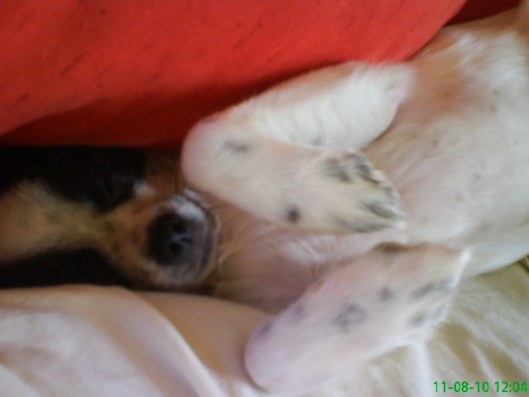
Can you find out about an indigenous (Google it) species/breed that has a natural instinct to burrow?
Can you find out why they burrow?
Perhaps you could create a mini fact file about the creature you research and include an illustration of it.

