WEEK COMMENCING: 11/05/20 |  | HOME ACTIVITIES |  |  | CLASS 2C
Please continue with the Africa activities too.  Do you fancy a trip to a safari park? You might see lots of animals that you would see in Kenya. Follow this link. |  |  |  | For some art and creative activities click here. You can investigate colours, go on a texture treasure hunt or make a self-portrait using natural or recycled material.
Height  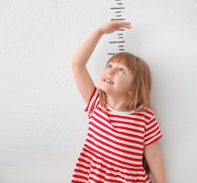  Create a chart or table about the height of all the people in your home. Measure them in centimetres or metres. How many others ways could you measure someone? What might be the best way?  Write some sentences to describe what you have found out using the vocabulary below. |  | Comparing your toys  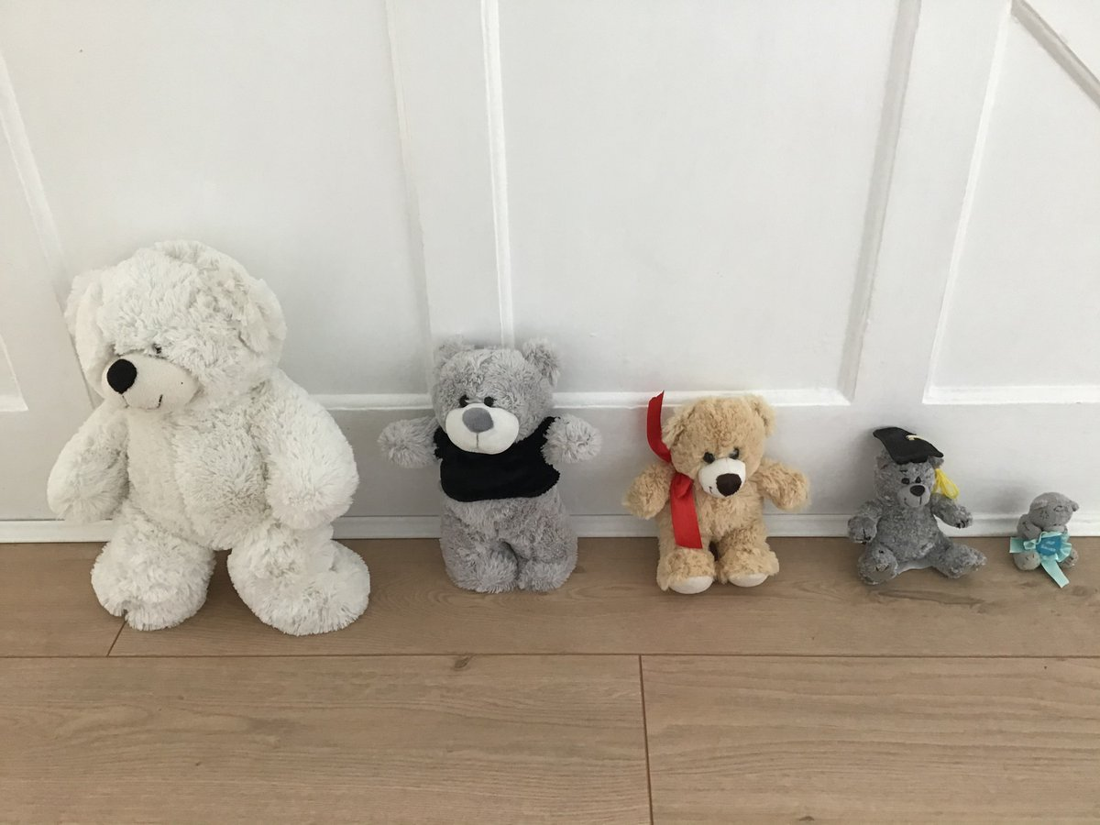  Can you order your toys thinking about their length and their weight?  Can you order them by weight?  Can you order them by length using a ruler or tape measure?  Does the order change? |  |  | Weighing scales  For this activity you can use weighing scales, or you can hold the objects.  Find different objects or foods around your home and compare their weight.  Record what you find using greater (>) or less than (<) symbols.  e.g. The remote weighs < the saucepan  OR  Draw your objects and label them.  Could you help an adult bake or cook something and measure the ingredients?
Vocabulary  Taller, tallest, smaller, smallest, heavier, heaviest, lighter, lightest. |  |  |  |  | Continue to read every day!  You can find some of the books we have in school as e-books here.
 |  | Measurement
ICT  You all have your log-ins; they are in the front of your Reading Record.  Mathletics – Measures Length & temperature  Complete the activities set on Mathletics that focus on measures length and temperature.  Education City - Measures  I have selected a variety of SPaG related activities to carry out on Education City. |  | 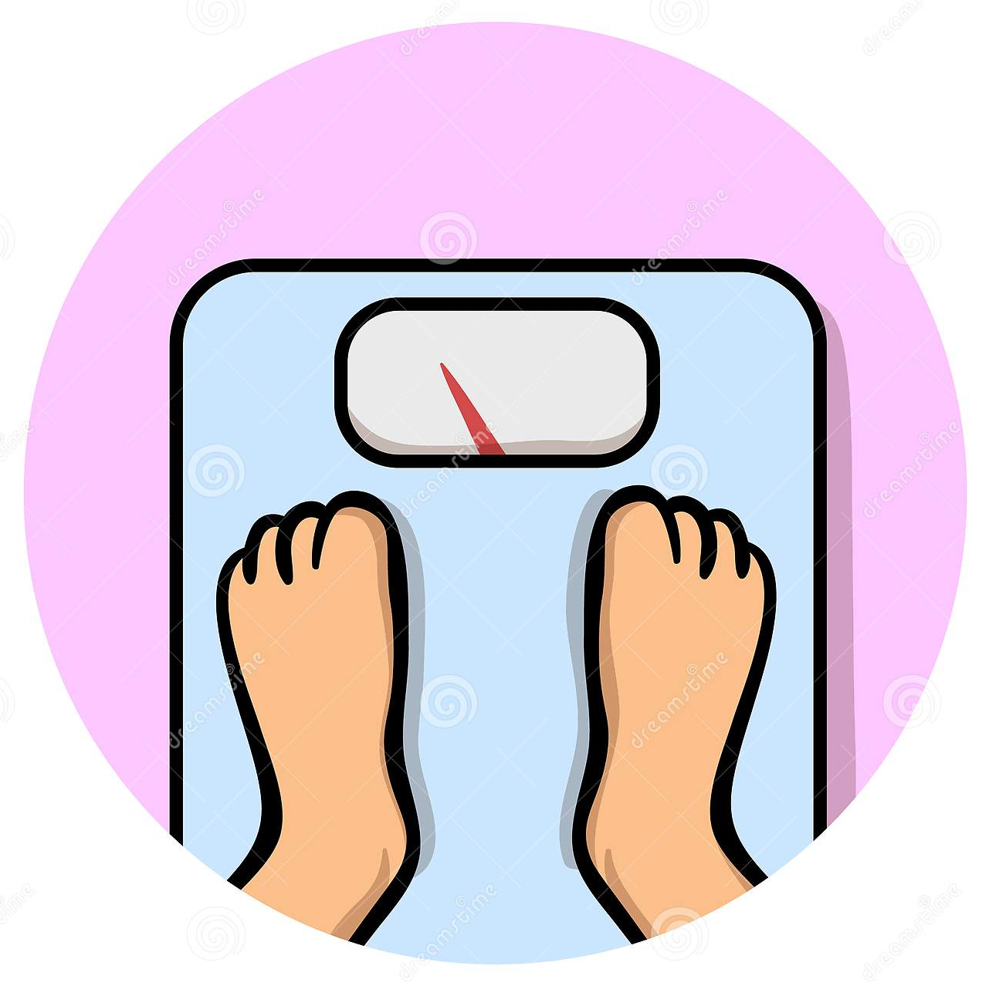  Weight  Create a chart or table about the weight of all the people in your home.  Think about the units you are recording the results in.  Do you notice any patterns with the height and weight of people?  Write some sentences to describe what you have found out using the vocabulary above. |  |  | Investigation time!  True or false  Big things are always heavy.  Small things are always light.  Find things around your home and investigate the statements.  Record what you find and explain whether the statements are true or false.  Find a resource below to help.
On the attached pages are some worded maths problems to try and an activity about estimating and measuring the capacity of containers.
Person | Height (Centimetres or metres)
Person | Weight (Kilograms)

What have you found out about the height of people at home?

What have you found out about the weight of people at home?

Big things are always heavy. Small things are always light.

Draw or write something in each box
Big and heavy | Big and light
Small and heavy | Small and light
What have I found out?

