**(Revised and Adopted Spring 2020)**

Cranwell Primary School



Progression in calculation for

Multiplication and

Division

**Vocabulary**

Counting, steps, each, doubling, scaling, times, twice, count in ones, count in intervals of…, lots of, groups of, times, multiply, multiple of, repeated addition, array, row, column, double, group, multiplication, product, inverse, multiplier, multiplicand.

***Note:*** *Use the term ‘calculation’ not ‘sum’, which means ‘plus’ or ‘total’. Use ‘digit’ not ‘number’ (a number consists of digits and ‘number’ is the quantity of an item or amount).*

**Stage 1**

Doubling

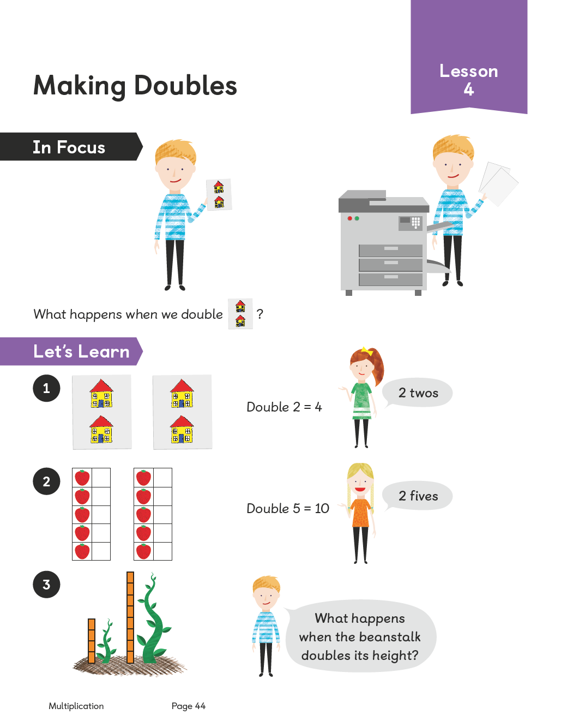Using equipment, children understand that doubling is creating an identical number to the one that you started with. Using a variety of equipment they can make two equal groups and know this as doubling.

Children will experience practical opportunities involving equal sets or groups, using a wide range of equipment. Practical resources will support children’s development of mental representations and images.

Counting in multiples

Children will begin to count in different multiples including twos, fives and tens, making links to natural groupings (e.g. legs on animals and pairs of items). They will begin to use the language and associated representation of doubling.

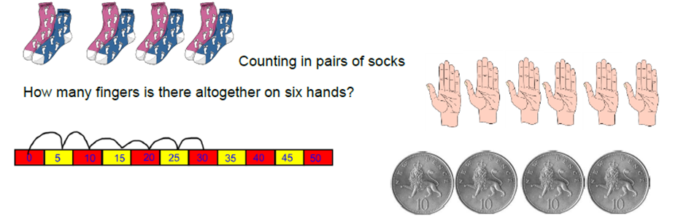

**Stage 2**

Multiplication as repeated addition

Children will begin to arrange objects into equal groups to aid counting. They will continue to count in multiples and begin to relate this to multiplication through finger counting. Children will be introduced to a variety of representations of repeating addition.

Children use a variety of objects to make equal group and know that they need to add together these equal groups to find the total. Children are able to use a number line or draw their own pictorial representations to support them to count in multiples, still understanding the need for equal groups.

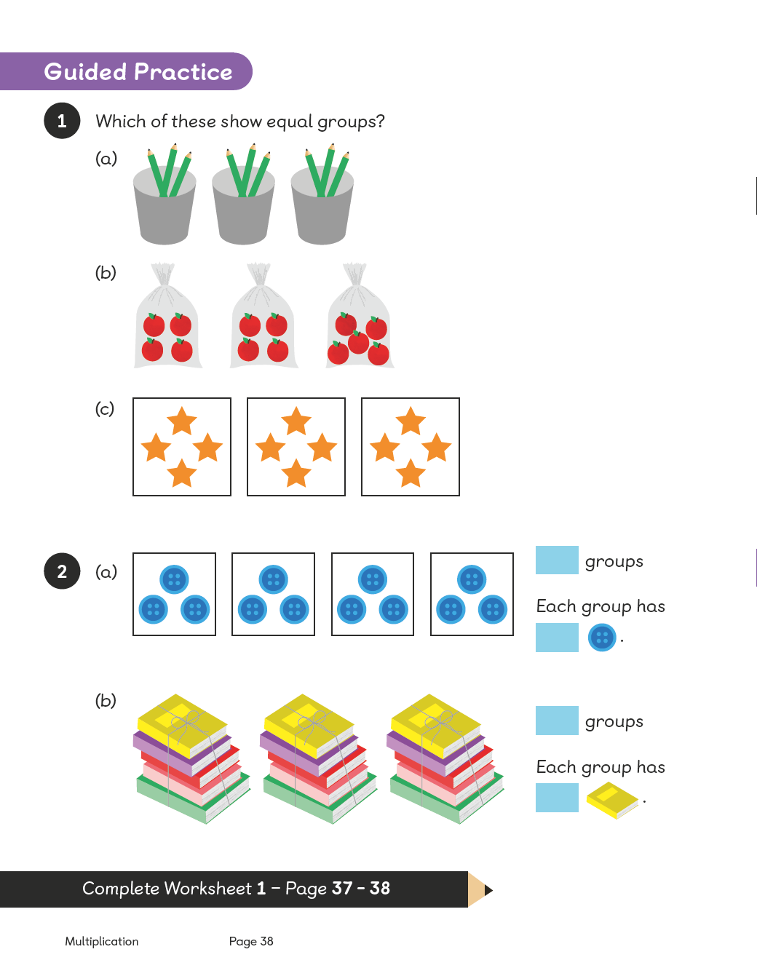

**Stage 3**

Children will continue to count in multiples and relate this to multiplication through finger counting.

They will be able to spot missing numbers in a pattern.

**3, 6, 9 ____ 15, 18, ____, 24**

**Developing arrays**

Children should be able to model a multiplication calculation using an array (either using apparatus, such as counters, or pictorially by using dots). This is an effective method of counting and making the link to repeated addition. Children need to explore related multiplication facts of a given number by making a variety of arrays and explain what they show. This understanding will support the development of more formal strategies. Arrays are also useful in developing an understanding of commutativity (that 3 x 5 = 5 x 3).

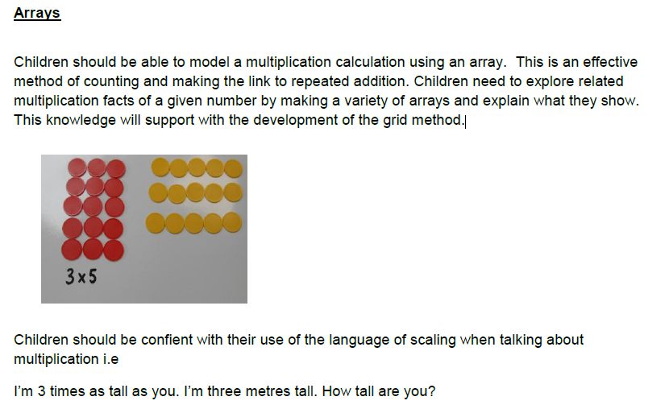

**Understanding Scaling**

Children develop an understanding of scaling (relating the size / number / dimensions of one item or group to another). Examples might include, ‘Jenny is twice as old as Ben’ or ‘I have three times as many sweets as you’.

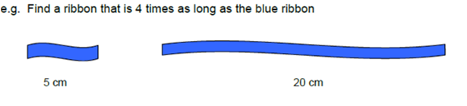

They also begin to understand that symbols can stand for unknown numbers; they then use these to solve inverse operation problems: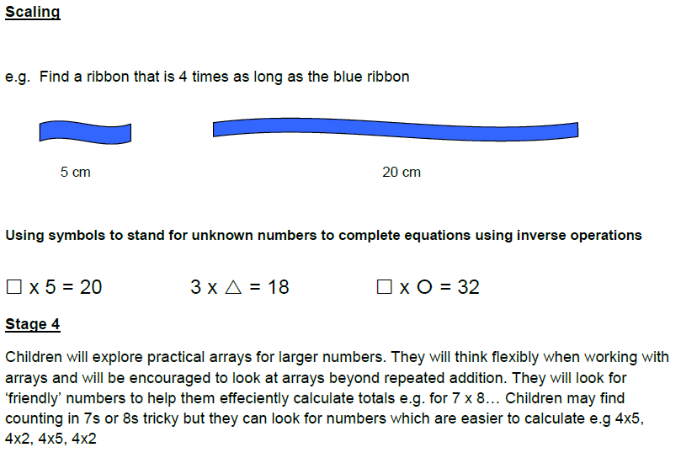

**Stage 4**

Children will explore arrays for larger numbers. They will think flexibly when working with arrays and will be encouraged to look at arrays beyond repeated addition. They will looks for ‘friendly’ numbers to help them effectively calculate products for e.g. 7x8: Children may find counting in 7s or 8s tricky, but they can use numbers which are easier to work with, e.g. (5 x 8) + (2 x 8).

**Stage 5**

Children will continue to explore arrays, exploring larger numbers, leading to the grid method of multiplication. To begin with, children should see the array with grid lines. When appropriate, they should move to using the grid method with numerals only. Example: 6 x 14 = (6 x 10) + (6 x 4)

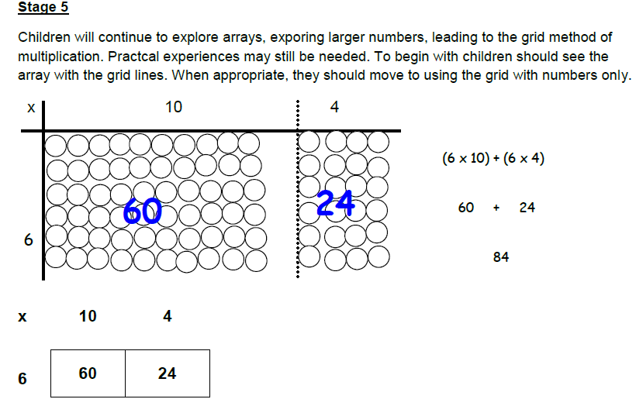

**Stage 6**

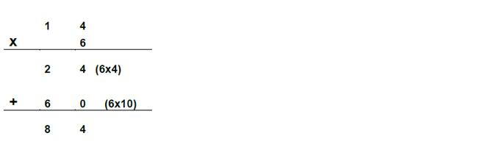Children will now be secure in using the grid method for multiplying 2-digit by 1-digit numbers. They then start to explore the link between the grid method and the expanded method of short multiplication.

**Stage 7**

Children will have a good understanding of the expanded short multiplication method and will begin to represent this as compact short multiplication for 2-digit numbers x single-digit numbers:

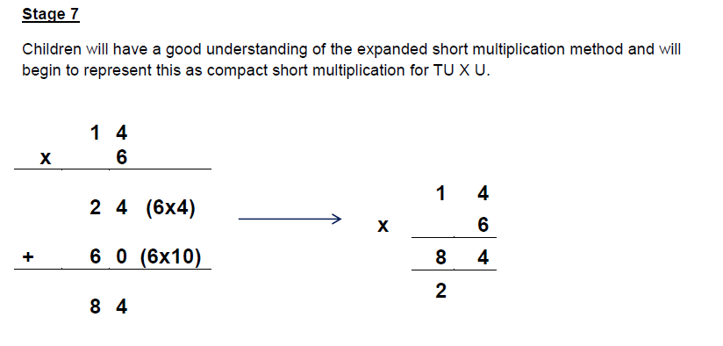

**Stage 8**

Children will now have a good understanding of short multiplication method *and* be progressing to the expanded method for long multiplication:

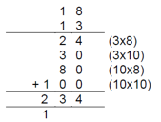

They will explore the grid method of multiplying two 2-digit numbers and connect this with the expanded method:

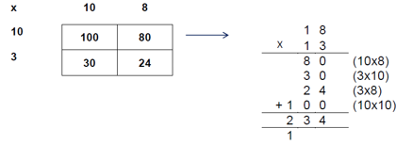

Once secure in this, they will progress to represent this as compact long multiplication:

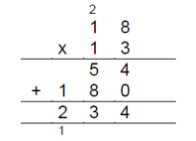

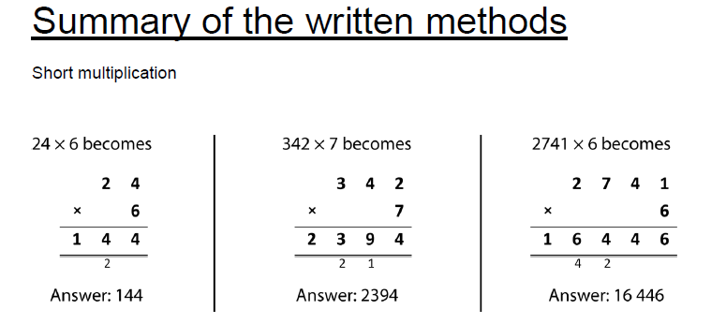

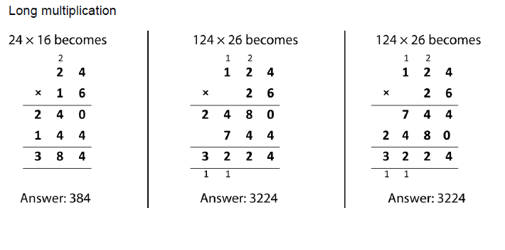

**Division**

**Vocabulary**

Halve, share, equally, divide, division, divided by, divided into, left over, remainder, quotient, dividend, divisor, divisible by, inverse, exchange, repartition, partition, scaling, repeated subtraction, groups of, array, row, column.

**Stage 1**

Children will explore the language of sharing. They will experience practical activities in sharing objects between groups and people. There will be an emphasis on sharing equally.

Children will be introduced to ‘grouping’ objects, e.g. each person will get 2 biscuits.

Children begin to use the language and images of halving. They use pictures to show their findings.

**Stage 2**

Children will relate the grouping of objects to repeated subtraction and begin to represent this using a number line whilst also using equipment.

E.g. *How many twos are there in 10?*

*How many twos can we take away from 8?*

Children will use their knowledge of counting in multiples to solve division calculations. They will recognise that this is the inverse of multiplication.

Children will begin to group objects into arrays, rather than scattered groups:

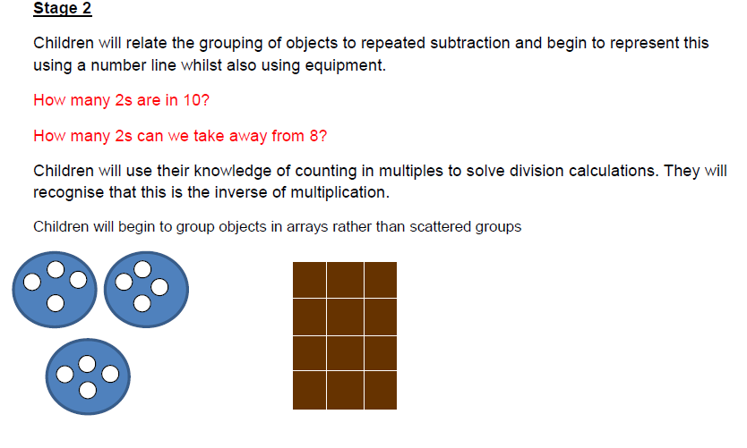

Children make simple links between division and fractions, e.g. halving means sharing into two groups.

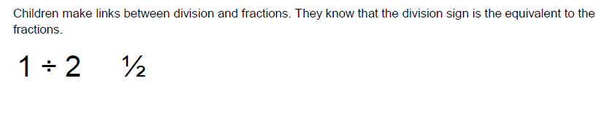

**Stage 3**

Children continue to use knowledge of counting on multiples to support the inverse of multiplication and repeated addition. They build on their use of arrays for division, recognising the links to repeated subtraction and the inverse of multiplication in order to derive the associated division facts. Children need to explore related division facts of a given number by making a variety of arrays and explaining with they show.

**Stage 4**

Children continue to organise groups into arrays using larger numbers. They should continue to experience the laguage of scaling, e.g. they can scale down a picture by powers of 10.

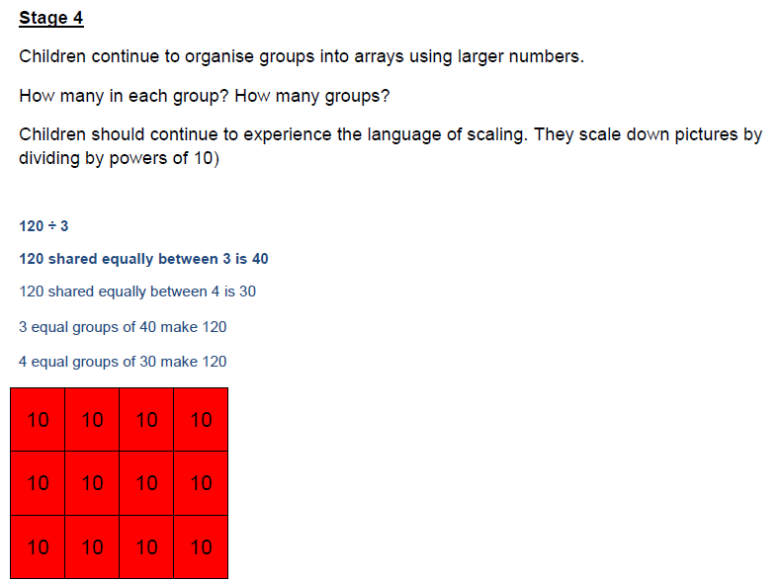

**Stage 5**

Children will continue to work with concrete arrays, exploring known multiplication and division facts, with the use of grid lines to make the link to short division of easily divisible numbers. The children understand that the arrays within short division can be interpreted as both sharing and as ‘equal groups of’.

E.g. 56: How many equal groups of 8 can I make? If I put these into 7 equal groups, how many would be in each group?

**Stage 6**

Children will work with equipment to divide any integer by a single digit divisor, using their knowledge of exchange (supported by place value counters and place value grids).

Children are then intoiduced to the notation of short division.

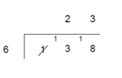

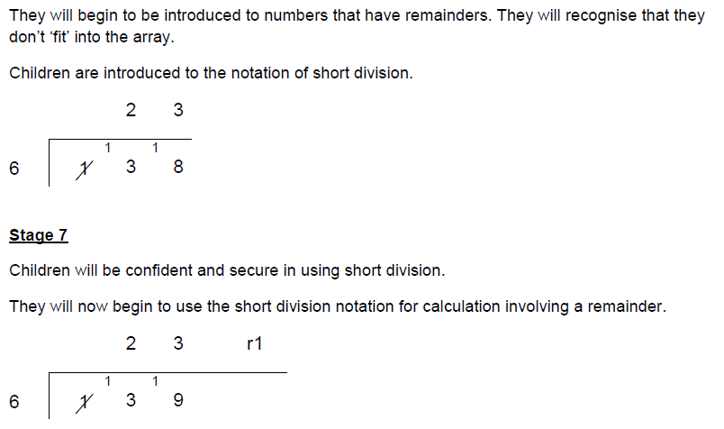**Stage 7**

Children will be confident and secure in short division. They begin to be introduced to numbers that have remainders, which won’t ‘fit’ into an array. They will docuss strategies for dealing with remainders (rounding up or down, or ignoring), in the ‘real life’ contexts.

**Stage 8**

Children use jottings of ‘friendly’ numbers to support short division using 2-digit divisors. Children explore ‘chunking’ of numbers (partitioning large numbers into easier, smaller numbers).

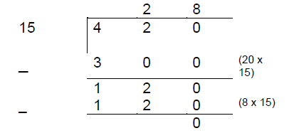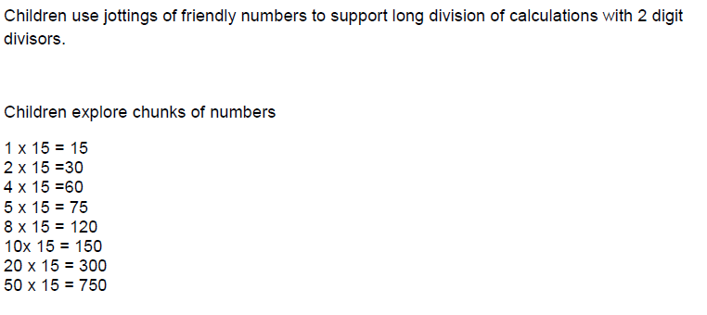

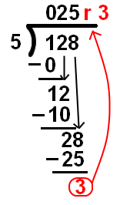**Stage 9**

Children will now be secure using short division for one-digit and two-digit divisors. They continue to use jottings (as above) to support their development of formal long division methods, using the ‘Divide, Multiply, Subtract and Bring It Down’ method.

They will explore short and long division with remainders, interpretting these as integer remainders, fractions or decimal fractions, rounding as appropriate to the context.

