Armed Forces Day 2020 Competition
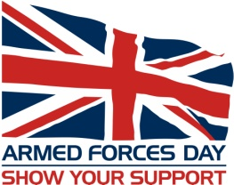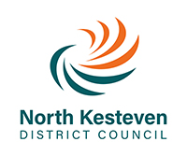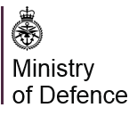

We’re looking back this year as we commemorate the 75th Anniversary of Victory in Europe
(VE) Day, so entries should reflect this theme, please. Using any medium, please draw your original design in the box below, complete the details and return the form to:
Partnership Team, Armed Forces Day 2020 Design Competition, North Kesteven District Council. Kesteven Street, Sleaford NG34 7EF by the closing date of Thursday 2nd April 2020. The winning designs will be used to promote Armed Forces Day 2020 in North Kesteven.

Name |  | Age
School/Contact details: |  | School Year

