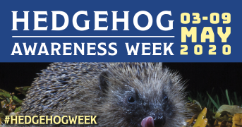  This week is Hedgehog Awareness Week. Can you find out three facts about hedgehogs? For example; What do they like to eat? What are their babies called? What does the word nocturnal mean? Can you draw/paint a picture of a hedgehog and post it n Tapestry? | Look around the house. How many rectangles can you find? Where did you find them? | Swap a dandelion for a paintbrush. Dip the dandelion flower into the paint instead of using a brush.  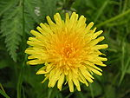  We would love to see you pictures on Tapestry. | Tomorrow is V.E Day. Hold a favourite toy picnic. Make invites, place mats. How many do you need?  What food will you eat? Can you make a list? Enjoy your role-play picnic. | V.E Day Bank Holiday  Enjoy celebrating V.E Day with your family

Cranwell Primary Foundation Stage Home Challenges Week beginning: 4th May 2020

