Class 6H – w/b 4th May 2020

Hello, everyone! I hope you and your family are all well and are keeping busy. It’s great to see that lots of you have been doing amazingly well on Mathletics!

For those of you who were in school in the final days that we were open, a reminder – and for those that weren’t – a top tip! Please use this time at home to really take ownership over your own learning – fill in the gaps for topics/aspects that you know you find tricky, especially in Maths and SPAG! Then, you will be extra well-prepared for secondary school.

https://www.thenational.academy/online-classroom/year-6/#subjects You may have heard about the Government’s Oak National Academy, which is publishing lessons online. The topics covered at present for Year 6 are topics that we have already covered in maths and literacy or are not directly linked to our topic work, however, if you would like to explore them, as revision or for some extra topic work (mainly linked to WW1), please feel free.

I’m missing you all! Take care and I hope to see you all very soon.

Miss Hill xx

If you were in school and received a pack of work, you will have been given activities and the mark schemes. Please do not rush to do all of these straight away! Instead, use these to supplement the activities that will be published on the School website for our class.

For the activities sent home as paper copies, I suggest that on one day, you do a test/activity. Then, ideally, the next day mark the test/activity (perhaps with an adult’s help) and try to do your corrections. If there are topics that you are struggling with, try to go online and find out more – you could just do a google search, use BBC Bitesize, Twinkle, Education City, etc.

MATHS:
You have two maths booklets compiled by Mrs. Bennett & I over the years – revision booklets with key facts to help.
- Maths Easter revision booklet;
- Arithmetic Paper 7
- Arithmetic Paper 8
- Maths Reasoning 1a
- Maths Reasoning 1b
- Maths Reasoning 2a
- Maths Reasoning 2b
- Maths Revision booklet – Multiplication & Division
- Maths Revision booklet – Fractions, Decimals & Percentages
- Maths Revision booklet – Position & Direction
- Maths Revision booklet – Statistics
- Maths Revision booklet – Algebra
- Maths Revision booklet – Addition & Subtraction
- Maths Revision booklet – Properties of Shape

LITERACY:
Reading Activity Booklet – Fiction, Non-Fiction & Poetry
SPAG Test Paper 1
Ninja SPAG test
SPAG Revision Booklet – Grammatical Terms and Word Classes
SPAG Revision Booklet – Sentences, Phrases and Clauses
SPAG Revision Booklet – Verb Forms & Tenses
SPAG Revision Booklet – Punctuation
SPAG Revision Booklet – Vocabulary & Standard English
SPAG Revision Booklet – Spelling

For each week day, I would much prefer you to only do a bit every day and do it really well, rather than 6 hours of not very good work! Try to structure your day so that you have a good mix of activities – rest, food, exercise, play/fun, school work, reading for pleasure, electronics/TV time, sleep, etc.

I suggest each day that you spend:
One hour on literacy based activities
One hour on numeracy
One hour on topic work

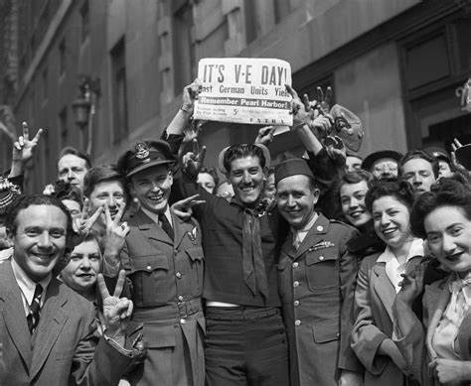
Friday 8th May is our Early May Bank Holiday. It coincides with Victory in Europe Daye – VE Day. This marks the 75th anniversary of the formal end of World War Two. See how much you can find out about VE Day. Could you make some special plans for celebrating VE Day with your own household in your own home? Could you decorate your house? Could you arrange a virtual family celebration via FaceTime? I would love to see any photographs of your celebrations!
https://rnli.org/youth-education/education-resources  Explore the RNLI resources – create a poster about how to stay safe at the beach/around water – ready for when the Lockdown finishes and hopefully we will be able to travel to the seaside and enjoy the countryside a bit further away from our homes!  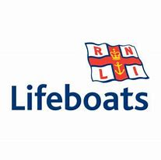 | Research the different moving toys available for sale at the moment, especially see if you can spot any toys with a CAM MECHANISM.  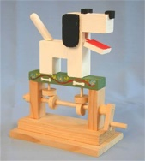  You could look at your toys at home (and those of your siblings), in magazines, on the internet, in catalogues (e.g. Argos), etc.  Create a montage of the different toys that you like.  Then, either draw the toy or cut out a picture of it and label what you like about it.  Find out as much as you can about cam mechanisms – you could write a short explanation, including a labelled diagram to show how they work.  At school you will be using this research to help you design your own toy with a cam mechanism. | How many planets are there in our Solar System? What are their names and what are they like?  Create an information leaflet about the planets. Remember to make it look attractive!  BBC Bitesize has some interesting short clips about the Solar System: https://www.bbc.co.uk/bitesize/topics/zdrrd2p. National Geographic also has some interesting clips: https://www.youtube.com/watch?v=libKVRa01L8 , but there is a host of information on the internet or you might have some useful books of your own!  Did you know that on a cloudless night, you can see some of the planets quite clearly from your own back garden? Have a look at this website for clues about where to look: https://www.timeanddate.com/astronomy/night/uk/london
This term, we’re learning about inventions through the ages, so I’d like you to choose one of these ancient inventions and research it:  - Fire  - Wheel  - Paper  Next, write a fact file about what you have learnt.  Lessons: these are just suggestions about how to divide up your time!  1 – research  2 – draft your fact file  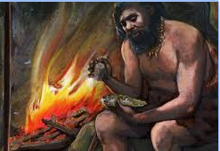  3 – edit your fact file  4 – present your fact file as a final polished piece. | You might like to take your history research further and make your own recycled paper! Have a look at: https://natashalh.com/how-to-make-your-own-recycled-paper-without-a-mold-or-deckle/ | Have a go at learning some more German using Duolingo – make sure that you ask the adults at home for permission to access this.  https://www.duolingo.com/
https://whiterosemaths.com/homelearning/year-6/  Using the link above, access Week 3, which is revision linked to fractions. There is a short film clip to watch, which teaches you the key points. Then there is an activity sheet to download to work from or to print if you can. The answers are then available as a separate download. There is one lesson per day, if you wish to use it. The activities also link to the BBC Bitesize website.  On Mathletics, I will also set tasks to revise the work we have covered. Let’s see how many points you can achieve! | It’s really important that we all stay fit and active. Try to do at least an hour of playing in the garden or walking out with a parent every day. Fresh air makes us all feel better! If you’re stuck inside, try a Joe Wicks workout:  https://www.youtube.com/watch?v=-TGEdzRzSbw  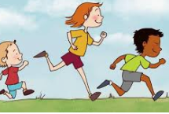  Fancy a change from Joe Wicks? Every weekday morning at 11am, Ollie from The Beat Goes On is running live body percussion workshops on YouTube.  https://www.youtube.com/user/OllieTunmer/videos | https://giftshop.redcross.org.uk/pages/downloadable-limited-edition-prints To continue our kindness work from the last block – if you have a printer, you might like to download and print – the black and white option – for one or two of the posters on the link. You could then colour them in and then display them in your windows, to make people smile when they walk by your house.
- Remember to read for pleasure daily.
- Work towards completing your reading passport.
- You could also go online and use Education City, Mathletics, Timestable Rockstars, etc.
- Also, remember your photography competition!
- You might be interested….on weekday mornings, Pie Corbett presents a free, creative and interactive literacy show called RadioBlogging at 9.30am. The hour-long show teaches writing and children can post their own writing online and receive feedback. https://radioblogging.net/

