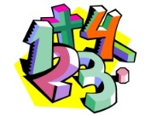
Maths
Our current maths topic is fractions. See the maths page below for some websites to help you.
Times tables
You need to keep practising your times tables. Have a look on the times table page for websites to help you.
Writing/Topic
Our new RE topic this term is ‘Beautiful world, wonderful God’. We will be exploring the meanings in the creation stories of the Bible, the impact of believing in God and showing appreciation for the natural world. See the grid below for some project based ideas.

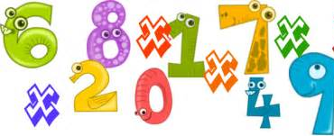

Spelling Punctuation and Grammar
Use this time to learn the words from the 3/ 4 Word list you can find in the front of your planner.
Check out the SPaG page below for some more ideas.
eight
eighth
eighty
weight
neighbour
vein
veil
beige
sleigh
freight

Extras
May is National Walking Month. Can you keep a diary of when you go for a walk and how far you think you have walked? It will be really fun when we get back to school to share how far you think you have walked during lockdown!

Reading
We would normally read every day in class – can you try to read every day and record this in your reading record. Why don’t you check out the poems on bitesize and complete the activities https://www.bbc.co.uk/bitesize/articles/zb2k8xs

Maths Activities
Well done for working through your recent maths activities. This work is to last you a week and follows the same structure as before. There is a video for you to watch that goes through the learning objective for the day. Then there is an activity (pink button) for you to work through. You can either print these sheets out or do your working out in your homework book.
https://whiterosemaths.com/homelearning/year-3/

Week beg 4th : Please complete Summer term Week 2

For the end of the week or after each video/ activity I will include matching activities on Mathletics and Education City so that I can monitor who is completing the work and how much you are understanding it.
https://login.mathletics.com/ https://www.educationcity.com/

Please remember to log in to find the work I have set. If you have not completed the previous activities (I know who you are! ) please complete to keep you up to date with our maths topics.
Extra Maths Games
https://play.prodigygame.com/ - Pokemon style game with maths questions!
https://play.edshed.com/ - practise your number bonds, power of 10 and addition and subtraction
www.topmarks.co.uk –interactive games
https://www.oxfordowl.co.uk/for-home/kids-activities/fun-maths-games-and-activities/#maths-7-9 – games and activities
https://www.mathswithparents.com/KWeb?startTime=1584558592239#menu584883 – Free access to parents – videos and activities across the maths curriculum.

Times Table Activities

https://play.ttrockstars.com/auth/school - Times Table Rock Stars is a great way to practise your times tables
https://play.edshed.com/ - Practise your times tables
https://www.timestables.co.uk/ - Learn and practise
https://www.topmarks.co.uk/maths-games/7-11-years/times-tables
https://www.oxfordowl.co.uk/for-home/maths/help-with-times-tables/ -

The world we live in is a very special place, for which we all have responsibility. Can you create a symbol to show how the world should be treated and respected? | A story board or comic includes a number of pictures and captions with speech bubbles which summarise a story. Can you create a storyboard or comic for either the Christian Creation Story or Hindu Creation Story? See extra activities for an outline of these Creation Stories.
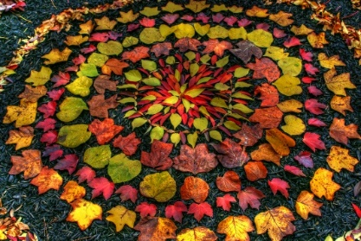  Andy Goldsworthy is a fabulous artist who is inspired by using natural items to represent the Earth. Can you create your own piece of art using natural resources? Find some information in the extra resources or conduct your own research. Take a photo of your creation so you can share it with 4A when we return to school! | Can you write a poem about either the Christian or Hindu Creation Story? See extra activities for an outline of these Creation Stories. | It is everyone’s responsibility to look after the Earth. Unfortunately, not all human impacts are positive. One way we can protect our environment is to recycle our waste. Can you make a campaign to encourage recycling in your local area?
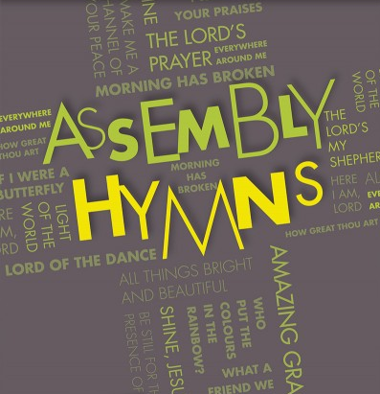
In assembly and hymn practice we always sing a number of hymns, even with actions when you are lucky! I am sure you have a favourite! Two of my favourites are; ‘Colours of Day (Light up the fire) and ‘He’s got the whole world in his hands’. Can you find your favourite hymn on YouTube and teach your family the words and maybe actions to go with it?
R.E. Topic Activities
Spelling Punctuation and Grammar Activities
R.E. Topic Work
https://play.edshed.com/ - I have assigned you all the spelling activities based on the spelling patterns we have already looked at this year as revision.
You have a list of words in your planner than you need to know by the end of Year 4. Learn some of these that you did not know before. Find them in a dictionary and write them in a sentence.

https://go.educationcity.com/ - Log in and select classwork to find a selection of SPaG activities to complete.

https://www.topmarks.co.uk/english-games/7-11-years/spelling-and-grammar - A selection of different games and activities to help you learn and practise SPaG topics.

https://www.bbc.co.uk/bitesize/dailylessons - If you want to extend your learning this is a great resource which may teach new concepts but also revisits previously learned material and is a great way to refresh your knowledge whilst on lockdown.

Extras!
Don’t forget you can play sports in your garden and have fun!
If you want some extra PE resources these are things we use in class;
https://www.cosmickids.com/ - Yoga
https://www.youtube.com/watch?v=gCzgc_RelBA – Just Dance
https://www.youtube.com/watch?v=mhHY8mOQ5eo – Joe Wicks Fitness video

