WEEK COMMENCING: 04/05/20 |  | HOME ACTIVITIES |  | CLASS 2C
 |  | Continue to read every day!
THE WEATHER & TEMPERATURE  Track the weather in Kenya over the next two weeks. Use the internet to do this. Keep a note of the temperatures recorded and write a summary of the weather each day. You could use symbols instead of word! How does the weather in Kenya compare to the weather in your local area. Why do you think the weather in Kenya is so different to the UK? |  | AFRICAN FACTS  Create your own fact file all about Africa.  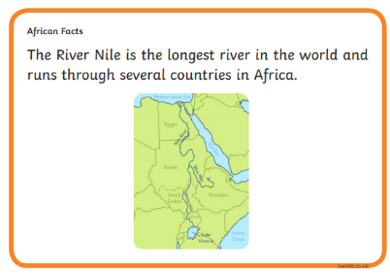  You can present these facts in any way you please, you might like to produce your very own fact cards.  One of my facts would be…. |  | ART & DT  Create your own African Animal Sunset Art work. You could practise your colour mixing skills, produce your own animal silhouette or use pastels or chalks.  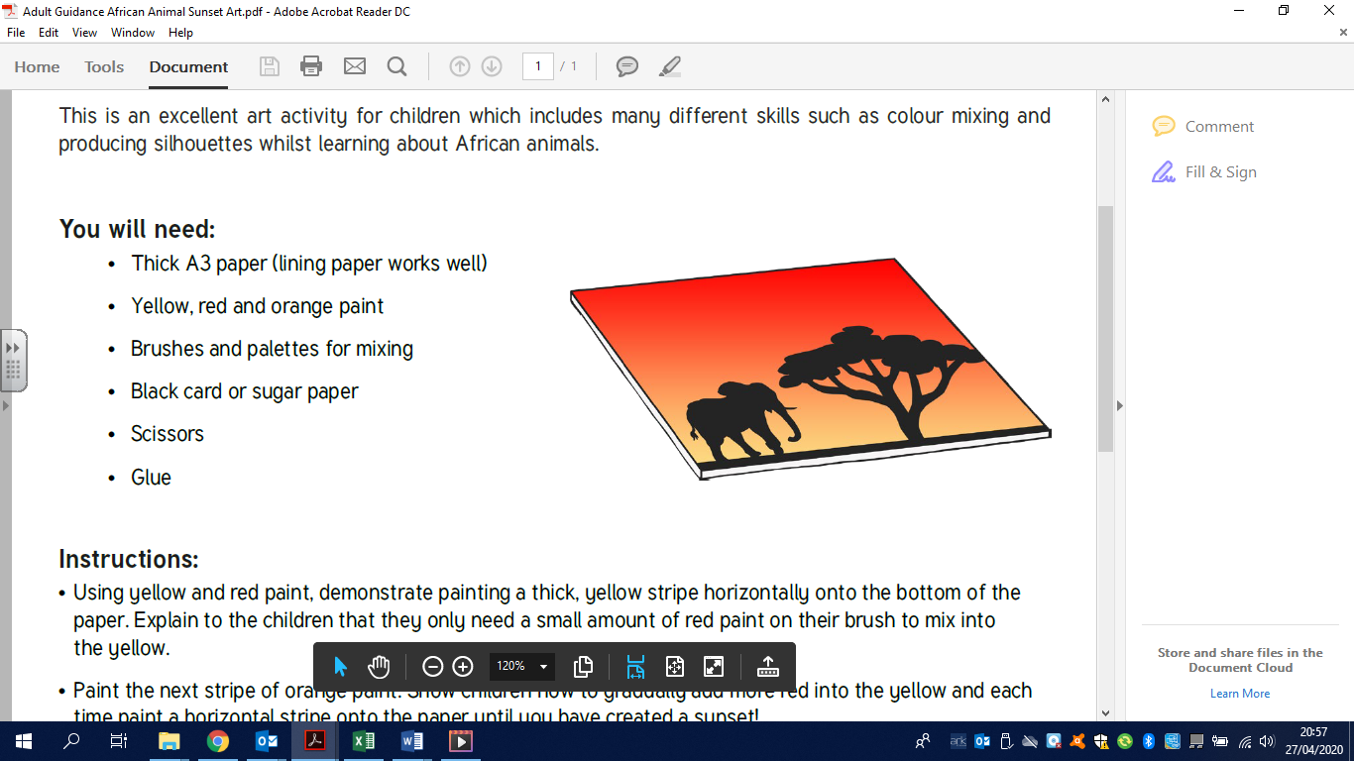
Practise adding 2, 2 digit numbers. |  |  |  | Practise subtracting a 2 digit number from another 2 digit number.
Practise adding 2, 2 digit numbers. |  | AFRICA
ICT  You all have your log-ins; they are in the front of your Reading Record.  Mathletics – Measures Length & temperature  There are lots of measuring length related activities for you to complete over the next week on Mathletics.  Education City - Measures  I have selected a variety of measure related activities to carry out on Education City. |  | GEOGRAPHY  Using the given outline of the map of Africa. How many different African countries can you name?  Can you draw on the Equator?  Look at the collection of African flags. How many African flags can you name? |  | ENGLISH  Research folk tales from Africa. you might want to choose a couple from … https://fairytalez.com/region/african/  Read a few folk tales from Africa.  Talk about the story with your parents. What do all folk tales have in common?  Write your own story in the style of an African folk tale. What lesson will your story teach the reader?

Can you create your own unique pieces of African artwork? Explore… there are lots of very interesting African artists.

A Map of Africa. How many different African Countries can you name?
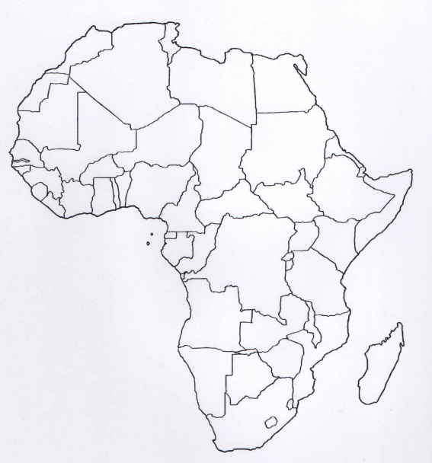

African Flags – Do you recognise any of the flags? Can you name the countries these flags represent?
