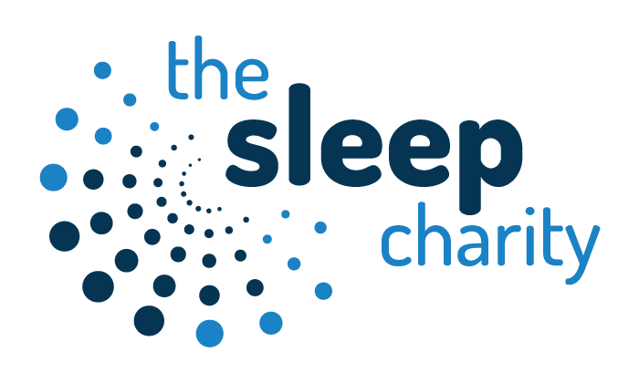

Are you the parent of a child aged 1 year or over with sleep issues?

Would you like to speak with an experienced Sleep
Practitioner about those issues?
The Sleep Charity are pleased to announce
FREE
1-2-1 Sleep Clinic Appointments

Due to the COVID-19 Our Face to face clinics are on hold, however we are keen to support families however we can, we are offering appointments over the telephone mostly but are happy to use video calls too.

To find out more or to book an appointment please contact: -
Claire 07568 052300 or preferably email
claire@thesleepcharity.org.uk
Families must reside within the Lincolnshire boundary
Follow us on Facebook The Sleep Charity-Lincolnshire project

