Dear children and parents

Welcome to your next week of home learning! I hope you enjoyed exploring some to the activities last week and are ready for some new challenges. Again, I’d like you to try to do a short maths lesson, an English/History task and 20 mins of reading every day. Additionally, I’ve included some science, SPAG and other activities for you to have a go at, if you have time. You should be able to get on with these independently, but if you need help, please ask an adult (provided they’re not busy working, that is!). Remember that you can contact me, through school reception, if you have any questions.

For those of you planning to take the 11+ exam in September: remember to keep doing a bit of practice, using the YouTube videos (for example, https://www.youtube.com/watch?v=FZkBpIAy62k ) and any workbooks you have at home. You should be working on resources written for ‘GL assessment’ exams; VR, NVR and Spatial Reasoning. Little and often is the best way to practise.

Mums and Dads: if you need extra ideas for work, or support in structuring a ‘learning day’ there are lots of great ideas on https://www.twinkl.co.uk/home-learning-hub . Please don’t hesitate to contact me, through school, if you need any help.

Mrs Bullement
Maths  Please continue to complete your daily maths lesson, using the White Rose resources from the website. Each day, you can watch a short video of a lesson, then complete the worksheet. You’ll also have an answer sheet to check your work – you might like to ask Mum or Dad to do that for you (but only if they’re not busy working).  You can find your lessons on this website: https://whiterosemaths.com/homelearning/year-5/ Please move onto Week 4 this week. Again, we whizzed through parts of this topic at the end of the term, but this will be useful practise and extension work for you.  Of course, I’ll continue to set tasks on Mathletics, but only do these if you have spare time!  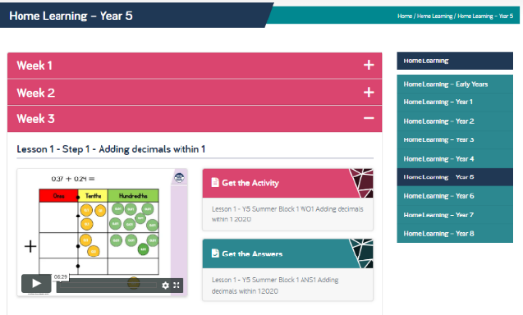  Want an extra challenge? Is it possible to predict the total of a chain of numbers in a sequence of alternating positive and negative numbers? Explore this question, using the instructions on the ‘Alternating Chains’ sheet below! | English / History  We’ll will continue to explore the history of inventions and innovations this week, moving forward on our timeline to the period between 1066 to just before the reign of Queen Victoria.  This week, I’d like you choose one of the following topics to research and write about:  - Charles Babbage’s computer  - Edward Jenner and the first vaccine  - George Stephenson and the railways  Our text type this week will be biography, so you’ll need to research the inventor or scientist and find out about their life and work, aiming for at least a side of A4 of writing. I suggest you organise your sessions as follows:  Monday: research your chosen inventor, engineer or scientist, making notes.  Tuesday / Wednesday: Draft your biography, thinking about beginning with where/when they were born, their family, early life / education. You’ll then need to write about their great discoveries or inventions. Finally, include information about their later life and any awards, and finish with a summary about their impact on the way people lived.  Thursday: edit and improve your draft, perhaps asking Mum or Dad to support you.  Friday: write up your biography in best and share it with Mum or Dad.
SPAG  Let’s revise main and subordinate clauses this week, using the activities on Education City. Log on using the details in your reading record, or let me know, through school, if you don’t have them. | PE  It’s really important that we all stay fit and active. Try to do at least an hour of playing in the garden or walking out with a parent every day. Fresh air makes us all feel better! If you’re stuck inside, try a Joe Wicks workout:  https://www.youtube.com/watch?v=-TGEdzRzSbw
Reading
Please make sure you read for at least 20 mins every day this week. If you don’t have a book at home, the nice people at Twinkl are offering free access to their home learning resources: https://www.twinkl.co.uk/home-learning-hub . Scroll down to ‘Guided Reading’ and you’ll find an e-book. There are lots of other activities you can have a go at too!
Parents – for additional home learning resources and support across the curriculum, try https://www.twinkl.co.uk/resources/parents
Science – Earth and Space  How many planets are there in our Solar System? What are their names and what are they like? These are the questions we’ll be working on this week.  BBC Bitesize has some interesting short clips about the Solar System: https://www.bbc.co.uk/bitesize/topics/zdrrd2p. National Geographic also has some interesting clips: https://www.youtube.com/watch?v=libKVRa01L8 , but there is a host of information on the internet or you might have some useful books of your own!  I’ve included a worksheet below for you to print and complete afterwards. If you don’t have a printer, don’t worry – perhaps you could draw your own picture and label the planets in the correct order.  Did you know that on a cloudless night, you can see some of the planets quite clearly from your own back garden? Have a look at this website for clues about where to look: https://www.timeanddate.com/astronomy/night/uk/london | Art  Let’s take our art outside this week and explore the work of Andy Goldsworthy. You might like to watch this video about him: https://www.bbc.co.uk/bitesize/clips/zh4wmp3  Here are some more images of his work: https://www.pinterest.co.uk/jnmadani/andy-goldsworthy-for-kids/  When it’s a nice day, perhaps go out into the garden and have a go at creating some art, using the natural materials you find there. It would be lovely if you could take a photo of your creation too!
French
I’m really enjoying practising my French each day on Duolingo and I hope you are too! Keep that streak going!
https://www.duolingo.com/

