Dear children and parents

I hope that you’ve all had a lovely Easter and are full of chocolate eggs! I also hope that you enjoyed having a nice break from school work – I certainly did! So here we are, starting the Summer Term, with lots of exciting new topics to explore.

To help you plan your days, I’ve set one maths and one English/History lesson for every day, along with a 20 min reading session. Also, I’ve added some Science, SPAG, French and Art/DT activities for you to have a go at, whenever you can fit them in. You should be able to complete these independently, but ask Mum or Dad if you need help. If you have any problems with log-ins etc., you can ask an adult to ring school, as we are still there to help you. Please also remember to get out in the garden for a run around or to kick your football for a while. Fresh air and sunlight are so important in keeping us happy!

Have a great week!
Mrs Bullement
Maths  As we seem likely to be at home for a while, from now on there will be a daily maths lesson for you to complete, using the White Rose resources we have used in class. Each day, you can watch a short video of a lesson, then complete the worksheet. Don’t worry of you can’t print out the worksheet, just write your answers on a piece of paper or in a notebook. You’ll also have an answer sheet to check your work – you might like to ask Mum or Dad to do that for you (but only if they’re not busy working).  You can find your lessons on this website: https://whiterosemaths.com/homelearning/year-5/ We start with Week 3, which is work we whizzed through, but will be good revision for you.  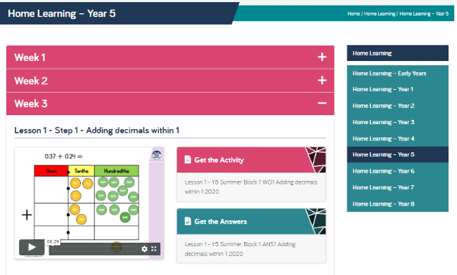  Of course, I’ll continue to set tasks on Mathletics, but only do these if you have spare time!  Extra challenge: see the ‘Four of the Best’ investigation below! | English / History  This term, we’re learning about inventions through the ages, so I’d like you to choose one of these ancient inventions and research it:  - Fire  - Wheel  - Paper  Next, write a fact file about what you have learnt. Please share this with a parent and ask them to check your spelling and punctuation!  Lessons: these are just suggestions about how to divide up your time!  1 – research  2 – draft your fact file (ask someone else to give you feedback and suggest one way you could improve it).  3 – write your fact file up in your best writing.  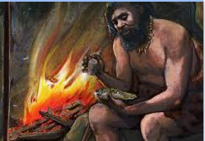  4 – add some lovely, colourful illustrations.  5 – share your work with someone else. This could be an adult or older sibling, who could give you feedback on your work, or a younger brother or sister who would just enjoy finding out about your ancient invention.
SPAG  Let’s revise speech marks this week, using the ‘Learn Screen’ and activities on Education City. Log on using the details in your reading record, or let me know, through school, if you don’t have them. | 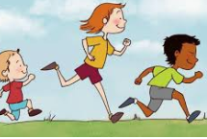  PE  It’s really important that we all stay fit and active. Try to do at least an hour of playing in the garden or walking out with a parent every day. Fresh air makes us all feel better! If you’re stuck inside, try a Joe Wicks workout:  https://www.youtube.com/watch?v=-TGEdzRzSbw
Reading
Please make sure you read for at least 20 mins every day this week. If you don’t have a book at home, the nice people at Twinkl are offering free access to their home learning resources:
https://www.twinkl.co.uk/home-learning-hub
Scroll down to ‘Guided Reading’ and you’ll find an e-book, ‘Firebird’. There are lots of other activities you can have a go at too!
Parents – for additional home learning resources and support across the curriculum, try https://www.twinkl.co.uk/resources/parents
Science – Earth and Space  Today, most people believe that the Earth is a sphere, but some people believe that it is flat. I’d like you to do some research to find some good evidence that the Earth is a sphere and not flat. Here are some useful websites:  https://www.bbc.co.uk/bitesize/clips/zd3fb9q  https://www.livescience.com/60544-ways-to-prove-earth-is-round.html  Why some believe it’s flat: https://www.livescience.com/24310-flat-earth-belief.html  You might like to take this further and think about why it’s a sphere! Have a look at the Nasa Website: https://spaceplace.nasa.gov/planets-round/en/  Also, we have a really exciting event due to happen soon! A massive comet, which is about half the size of the sun, will be visible in the skies above England this month. Comet Atlas will be visible from Earth throughout April. By the end of the month, it should appear in the sky brighter than Venus. It may look greenish and will hopefully have a magnificent tail. You’ll need to look close to the Plough constellation to find it. Here are more details: https://www.thetimes.co.uk/article/comet-of-a-generation-set-to-light-up-the-night-sky-8bwblcfgs | Art / DT  You might like to take your history research further and make your own recycled paper! Have a look at: https://natashalh.com/how-to-make-your-own-recycled-paper-without-a-mold-or-deckle/  Or…try a paper collage, using any old newspapers of magazines you might have at home. If you’ve been inspired by your space research, why not collage the Earth, using blues for the oceans and greens/yellows/white for the continents?
French
I’m really enjoying practising my French each day on Duolingo and I hope you are too! Keep that streak going!
https://www.duolingo.com/

