Year 6 Home Learning

Hello everyone at home! Our final block of home learning for this academic year! I am sorry that we are not all together as a class for these last three full weeks of term but I am looking forward to telephoning you before the end of term to say a final farewell – and even then, I hope that you will still keep in touch and let me know how you are getting on at secondary school.

Below is the final block of work for the last three complete weeks of term – split into blocks – one for each week. Remember, it is up to you how much you do. Any problems, don’t forget that you can always email or telephone school:
enquiries@cranwell.lincs.sch.uk
01400 659001

I hope that you enjoyed the ‘Awesome’ transition work in our last block. I have treated myself to two books linked to this:

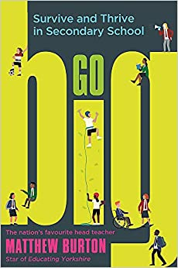
If you are wanting to know a bit more about strategies for meeting the challenges of secondary school, you might like to purchase:

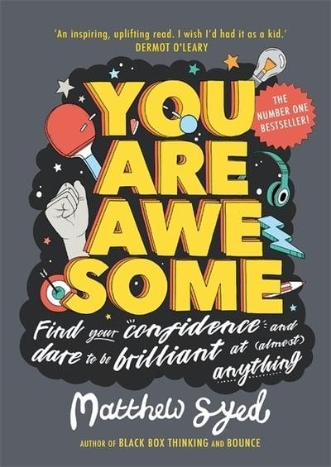

If you are interested in becoming more confident and how to be the best possible version of yourself, you might like:

Mrs. Birchenall and Miss Pettitt will be sending out a separate ParentMail just for you Year 6 children with resources linked to puberty, growing up and Sex Education. Please do make sure you cover this topic with an adult at home.

I will eagerly await your farewell letters (see the first week of this block!)

Take care.
Miss Hill xx
Mrs. Birchenall xx

Year 6 – w/c 29th June 2020
Please continue to complete your daily maths lesson, using the White Rose resources from the website. Remember to also follow the links to BBC Bitesize for even more practice.  You can find your lessons here:  https://whiterosemaths.com/homelearning/year-6/  Please move onto the section labelled ‘Summer Term Week 10 w/c 29th June. The videos are also available on Facebook, if the website is overloaded.  Of course, I’ll continue to set tasks on Mathletics, but only do these if you have spare time | Start to work through the booklet ‘Have you got the grasp for writing?’  This is SPAG revision. There are six weeks of work and so I suggest you cover two topics per week. | Monday  Listen and look at the story retelling of ‘The Day the Crayons Quit’ by Drew Daywalt.  https://www.youtube.com/watch?v=489micE6eHU  Choose one of the coloured crayons and make notes about what they are unhappy about!  How has each crayon tried to persuade Duncan to change his colouring habits?  Brainstorm ideas for which items in our life might be fed up with us! For example, socks, glue sticks, washing machines, etc.  Tuesday  Choose some of the items that you brainstormed yesterday – what might they complain about?  Choose one of these items and start to plan a letter to yourself, explaining why your item is fed up.  Wednesday  Complete the draft of the letter to yourself, explaining why your item is fed up with you.  Thursday  Edit the draft of the letter to yourself, explaining why your item is fed up with you.  Friday  Present your piece of writing in an IMAGINATIVE way!
Check that you can spell these words – and that you know what they mean! For any words that you cannot spell correctly, focus on learning these this week. Remember – you could make your own spelling flash cards to use daily if you wish.  accommodate  appreciate  deviate  disproportionate  disastrous  dissociate  individual  interfere  interrupt  infrequent  misplace  misbehaviour  mispronounce  ancient  patient  conscious  delicious  ferocious  immune  committee  telecommunication  correspond  extracurricular  extraordinary  secretary  stationary | Now that the lockdown is slowly starting to ease a little, we are all, perhaps, starting to think a bit about the future and life returning to normal or at least the ‘new normal’. Although lockdown has presented us all with huge challenges and worries, hopefully, we will also have some happy memories and experiences to look back upon. As Mr. Wilson said at the very start of lockdown, this is a time in history that future generations will be learning about and you might one day get to share your experiences with your own children, grandchildren and even great grandchildren!  My suggestion is that over these next three weeks, you start to think about how to collect together some of these memories and experiences – by making a memory box. In some ways this is similar to a time capsule, but you are not going to bury it!! Some of you may already have a memory box recording your life so far or for a special event or person. You might like to make a new one especially for recording this time. I know lots of you have been keeping a diary – this would make a perfect addition to your memory box!  So… creating our memory box!  Choose the right box  In order to preserve your memories properly, you’ll want to choose a box that’s going to keep them safe for years to come. It can be tempting to use any old shoe or cardboard box that you have lying around, but these will start to look tired after a while. Instead, I would recommend using a box made from a sturdy material like wood or plastic. If you don’t have anything suitable, you can always collect everything and put it into a temporary box for now. Then, when we’re all able to return to normal life, you can buy something that’s perfect.  You’ll always want to think carefully about the size of your memory box. While you’ll need it to be big enough to hold plenty of bits and bobs, you’ll also want to be able to store it quite easily for years to come. So, try to get the balance right.  Decorate the box.  Make the outside of your memory box personal to you. You could add your names to the box, or cover it in handprints. It’s also a good idea to add the date somewhere, so you’ll always remember when and why you put the box together. | Write a letter to your class teacher or TA to say farewell – and send it into us via post or email.
PE – It’s really important that we all stay fit and active. Try to do at least an hour of playing in the garden or walking out with a parent every day. Fresh air makes us all feel better! If you’re stuck inside, try a Joe Wicks workout:  https://www.youtube.com/watch?v=-TGEdzRzSbw | German  We hope you have been enjoying practising your German using Duo Lingo.  Keep practising:  https://www.duolingo.com/ | Remember to read for pleasure daily.  In our last block, I recommended the book below – it has got lots of short stories to dip in and out of.  You might like to read - The Book of Hopes: Words and Pictures to Comfort, Inspire and Entertain Children in Lockdown.  You can read it all online at:  https://literacytrust.org.uk/family-zone/9-12/book-hopes-for-children-during-lockdown/

Year 6 – w/c 6th July 2020
Please continue to complete your daily maths lesson, using the White Rose resources from the website. Remember to also follow the links to BBC Bitesize for even more practice.  You can find your lessons here:  https://whiterosemaths.com/homelearning/year-6/  Please move onto the section labelled ‘Summer Term Week 11 w/c 6th July The videos are also available on Facebook, if the website is overloaded.  Of course, I’ll continue to set tasks on Mathletics, but only do these if you have spare time | Start to work through the booklet ‘Have you got the grasp for writing?’  This is SPAG revision. There are six weeks of work and so I suggest you cover two topics per week. | Please see the Talk for Writing Booklet below. MONSTERS  Monday – complete introduction, activity 1 & 2  Tuesday – complete activity 3, 4 & 5  Wednesday – complete activity 6 & 7  Thursday – complete activity 8 & 9  Friday – complete activity 10 – just the first draft of your monster report.
Check that you can spell these words – and that you know what they mean! For any words that you cannot spell correctly, focus on learning these this week. Remember – you could make your own spelling flash cards to use daily if you wish.  explanation  examination  vacation  information  embarrassment  environment  amusement  nourishment  smoulder  boulder  marvellous  oblivious  anonymous  college  privilege  allege  astern  govern  cavern  orifice  suffice  sacrifice  sufficient  efficient  inefficient | Pick your keepsakes carefully  Your memory box is personal to you but here are some ideas of items you might like to include:  - Labelled photographs – of activities you have completed, whether that might be school tasks, garden projects, photos of your family on walks  - Letters and emails from family & friends.  - An email from Mr. Wilson to the children of our school.  - Something you have made.  - A favourite recipe you have discovered.  - A painted pebble like those many of you have placed on your walks around Cranwell. | Geography – complete the World Water Day comprehension activity.  Choose the level of difficulty of questions that you feel is most appropriate.  *=easiest  **  *** = hardest
PE – It’s really important that we all stay fit and active. Try to do at least an hour of playing in the garden or walking out with a parent every day. Fresh air makes us all feel better! If you’re stuck inside, try a Joe Wicks workout:  https://www.youtube.com/watch?v=-TGEdzRzSbw | German  We hope you have been enjoying practising your German using Duo Lingo.  Keep practising:  https://www.duolingo.com/ | Reading – The Summer Reading Challenge  Hopefully, you’ve had time to explore the wonderful world of books over the past few weeks, so are you ready for the Summer Reading Challenge? Have a look at this website for details about how to get involved, including helpful tips on how to access new books if you’re stuck in the house: https://summerreadingchallenge.org.uk/  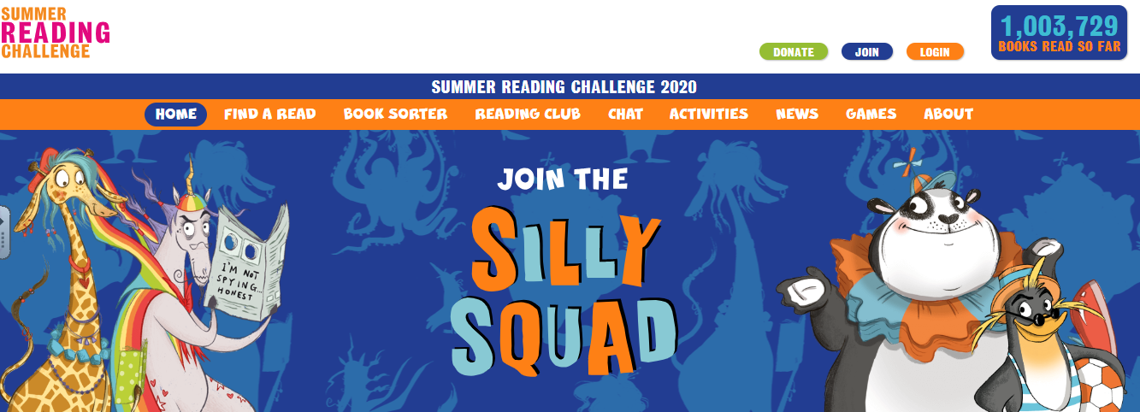

Year 6 – w/c 13th July 2020
Please continue to complete your daily maths lesson, using the White Rose resources from the website. Remember to also follow the links to BBC Bitesize for even more practice.  You can find your lessons here:  https://whiterosemaths.com/homelearning/year-6/  Please move onto the section labelled ‘Summer Term Week 12 w/c 13th July The videos are also available on Facebook, if the website is overloaded.  Of course, I’ll continue to set tasks on Mathletics, but only do these if you have spare time | Start to work through the booklet ‘Have you got the grasp for writing?’  This is SPAG revision. There are six weeks of work and so I suggest you cover two topics per week. | Please see the Talk for Writing Booklet below - MONSTERS  Monday – edit your Monster report.  Tuesday – present your Monster report in neat.  Wednesday – complete activity 14 – a wanted poster.  For the last two days of this week – and the final two days of term next week, choose one of the story starters from Pobble 365 (find this in the resources below this grid) – they all focus on a different type of monster. Use the image as a prompt to writing your own story about a monster – you could even base your story on the monster that you created in our Talk for Writing task.  The prompt cards also have some useful supporting writing tasks, if you want to have a go.  Remember to plan, draft and edit your story. Hopefully you will have time to produce a final, neat version of your story too!
Check that you can spell these words – and that you know what they mean! For any words that you cannot spell correctly, focus on learning these this week. Remember – you could make your own spelling flash cards to use daily if you wish.  Literature  conjecture  culture  unnecessary  unprofessional  overconfident  overproduction  overflow  outrageous  outperform  autobiography  automobile  difference  innocence  reference  silence  conference  accusingly  accidentally automatically  reign  foreign  discourage  discuss | You needn’t finish the box in one go, and can take your time to hand pick and collate special items. You can even create a digital version of the memory box by saving your photos and writing your memories on a word document. | Geography – research ways to conserve water.  Plan, design and produce a poster encouraging people to save water.  Your poster needs to emphasise why it is so important to save water & also give helpful strategies for saving water.
Complete activity 11 from the Monsters – Talk for Writing Pack - Draw a map of your monster’s land. | PE – It’s really important that we all stay fit and active. Try to do at least an hour of playing in the garden or walking out with a parent every day. Fresh air makes us all feel better! If you’re stuck inside, try a Joe Wicks workout:  https://www.youtube.com/watch?v=-TGEdzRzSbw | Reading – The Summer Reading Challenge  Hopefully, you’ve had time to explore the wonderful world of books over the past few weeks, so are you ready for the Summer Reading Challenge? Have a look at this website for details about how to get involved, including helpful tips on how to access new books if you’re stuck in the house: https://summerreadingchallenge.org.uk/

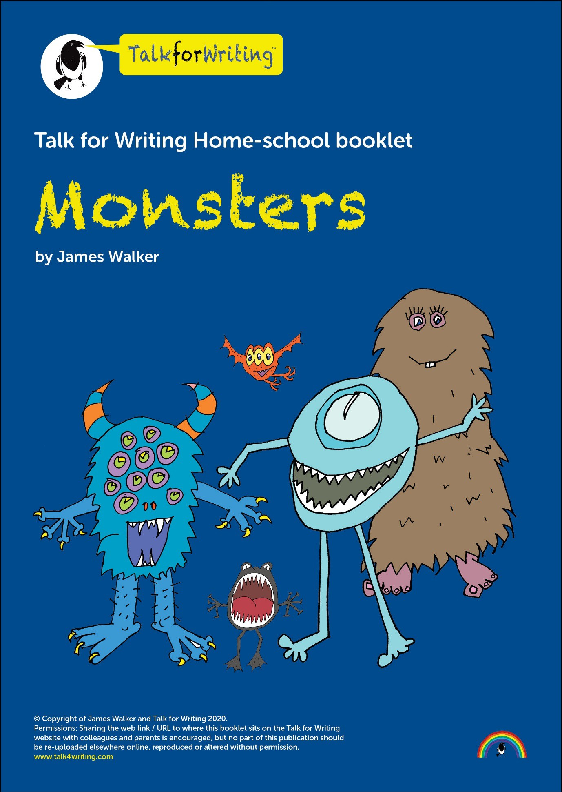

Monsters

A workbook by James Walker

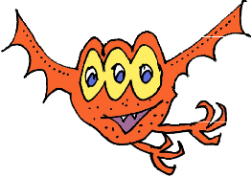
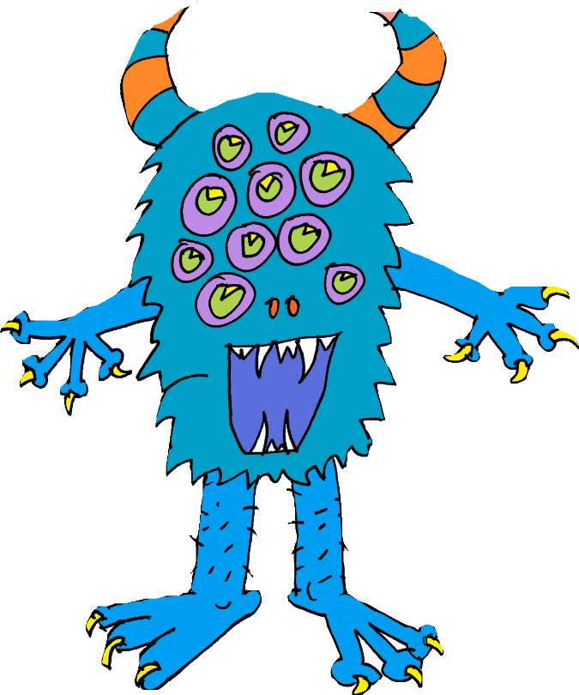
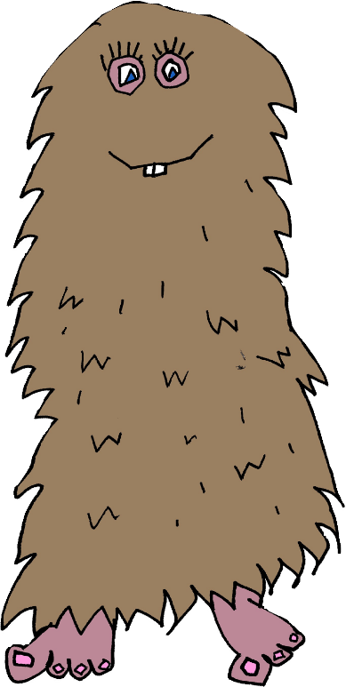
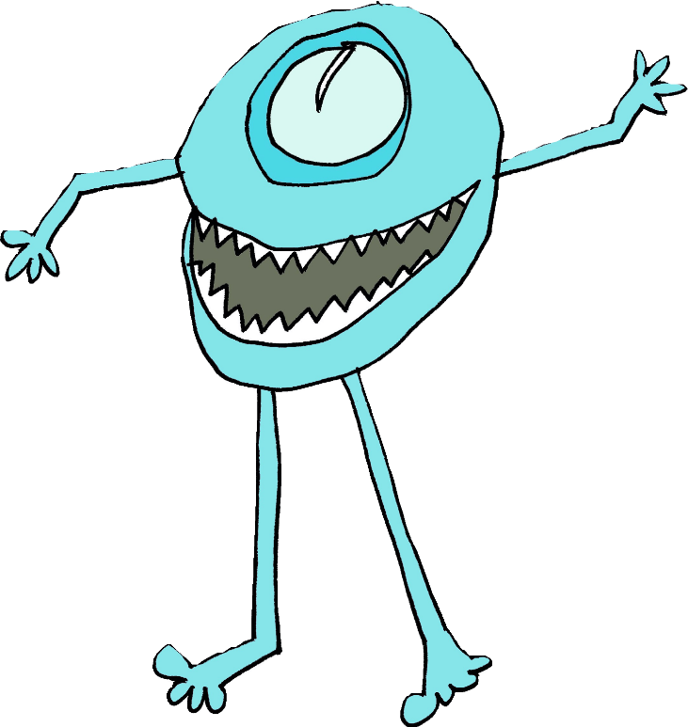
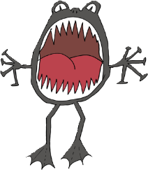

Professor Behemoth’s Monsterology

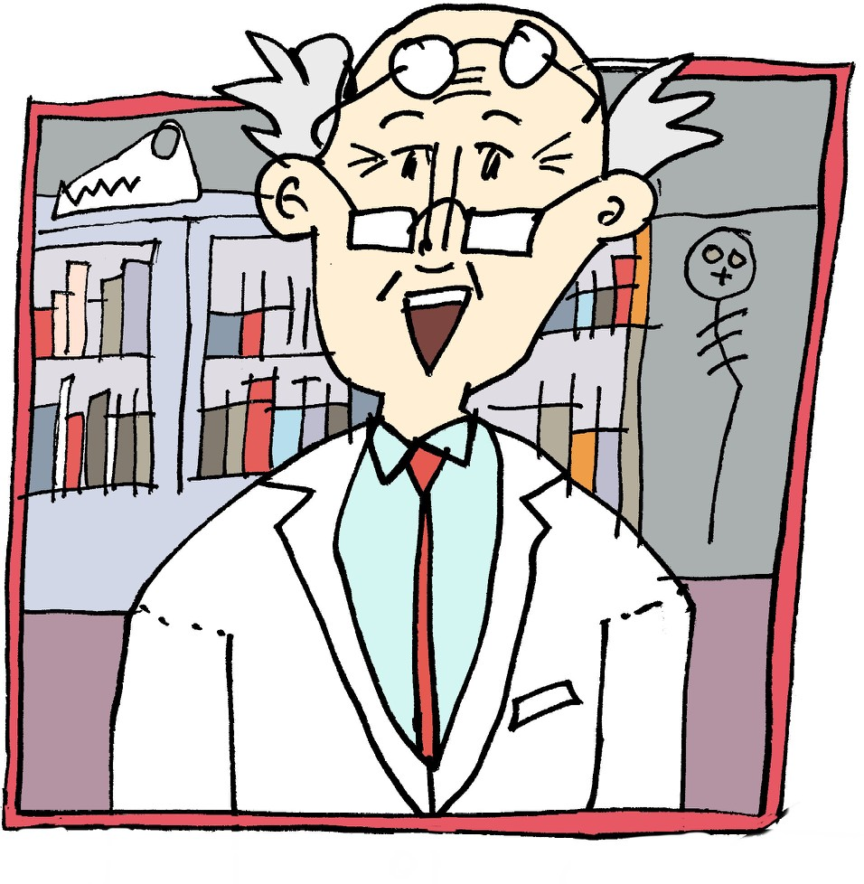
World famous monster expert Professor Behemoth is putting together a Monsterology of different types of monsters and beasts. He has spent years researching all sorts of weird and wonderful monsters and has a wide variety for his encyclopedia. Your job, in this booklet, is to provide the professor with another entry for his book; you’ll have to use your imagination unless you have actually seen a monster!

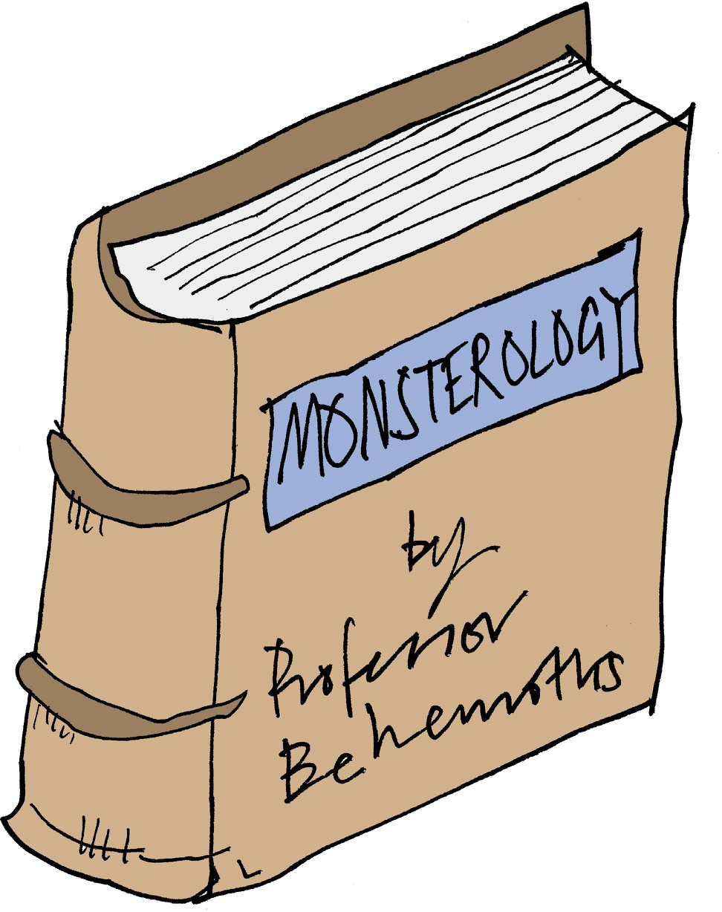
Information with a touch of ‘faction’
In this workbook, we are going to be writing an information text about a made-up monster or beast. Even though this is a non-fiction genre of writing, we can still be inventive and creative. I like calling it FACTION when teaching it (the form fits information about facts but the content is fiction).

To get us started, here is a model of a fictional information text about swamp monsters. As you are listening, you might want to think about which type of monster you will write about. Have a read below and then listen to me read it aloud here: https://soundcloud.com/talkforwriting/swamp/s-28ED2KJCK6n

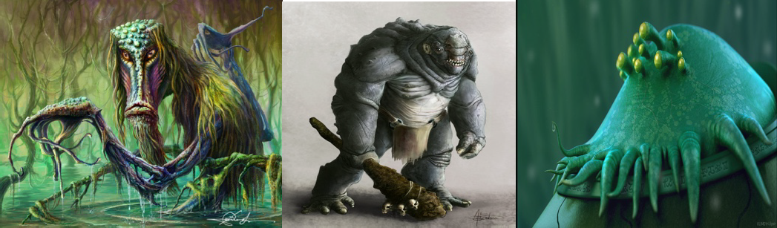
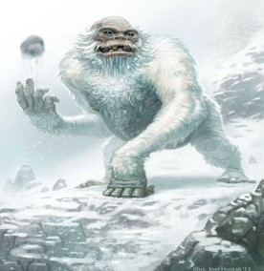

Swamp Monsters
Do you ever wonder what might be lurking in the murky swamps of our world? Rumour has it that the fabled swamp monster is not just a creature mentioned in myth and legend but it actually exists! Now is your chance to find out all that has been discovered about this unique being.
Swamp monsters are rumoured to inhabit the most remote and humid swamps of the Amazon rainforest. Living in total solitude, it is believed that there is, perhaps, only one swamp monster on our planet, making it a mystery how they reproduce. Dr Patrick Thurston
- world renowned monsterologist from Bristol University - could perhaps be the only living person ever to see this magnificent creature: “You cannot believe the pure majesty of the swamp monster. They seem as if they are ‘one with the swamp’ living in pure harmony with their habitat.”
Swamp monsters don’t just live in swamps they resemble them. Being experts in camouflage, they are indistinguishable from their environment. Their bodies are made from this environment: limbs of gnarled branches, incredibly long fingers and glowing, iridescent hair which changes colour to match their mood. The most incredible thing about a swamp monster is that they have translucent breathing tubes meaning they can stay underwater indefinitely but continue to breathe.
Have you ever wondered what a swamp monster eats? Their diet consists of herons, rats and even alligators which they hypnotise with their ever-staring, haunting eyes. Transfixed, any animal is helpless to the swamp monster who squeezes the life from them with its lean, powerful limbs. The swamp monster’s tongue has the ability to taste the air; this allows it to identify when its prey is close by.

If you are now tempted to try and spot a swamp monster, we advise extreme caution! This beautiful but deadly creature should be left in solitude to be studied only by experts trained in monsterology.

Activity 1: Match the vocabulary to its definition
You might not know all of the vocabulary that is in our model text. Don’t worry as this activity will help! Match the word to the correct definition and then check at the end of the booklet to see if you have them all right.

Word Definition

myth not distinguishable

translucent the state of living alone in seclusion

indistinguishable agreement or harmonious relations

resemble displaying lustrous colours like those of a rainbow

renowned a traditional or legendary story

majesty rugged, bent, twisted or weather-beaten

iridescent to be like or similar to

harmony permitting light to pass through but any objects on the other side are not clearly visible

gnarled to hold motionless with amazement

solitude supreme greatness

transfixed to be celebrated or famous

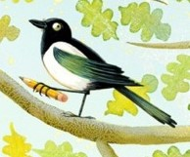
You could magpie some of these words and use them in your own writing later on.

Activity 2: Underlying pattern of information texts Let’s go back to the model text. I have picked out the underlying pattern for you by boxing up the structure for you; this will help guide your writing.
Remember this is just a guide and, if you are confident, you could add in extra paragraphs, different sections, diagrams etc.

Title | Swamp Monsters
Opening hook – to | Do you ever wonder what might be lurking in the murky
make the reader | swamps of our world? Rumour has it that the fabled swamp
interested in finding | monster is not just a creature mentioned in myth and legend
out more. Fascinating | but it actually exists! Now is your chance to find out all that has
fact for interest | been discovered about this unique being.
Habitat | Swamp monsters are rumoured to inhabit the most remote and
Information about the | humid swamps of the Amazon rainforest. Living in total
area the creature lives | solitude, it is believed that there is, perhaps, only one swamp
in | monster on our planet, making it a mystery how they
 | reproduce. Dr Patrick Thurston - world renowned
 | monsterologist from Bristol University - could perhaps be the
 | only living person ever to see this magnificent creature: “You
 | cannot believe the pure majesty of the swamp monster. They
 | seem as if they are ‘one with the swamp’ living in pure harmony
 | with their habitat.”
Appearance | Swamp monsters don’t just live in swamps they resemble them.
Information about | Being experts in camouflage, they are indistinguishable from
what the creature | their environment. Their bodies are made from this
looks like including | environment: limbs of gnarled branches, incredibly long fingers
evidence | and glowing, iridescent hair which changes colour to match
 | their mood. The most incredible thing about a swamp monster
 | is that they have translucent breathing tubes meaning they can
 | stay underwater indefinitely but continue to breathe.
Diet  Information about what the creature eats | Have you ever wondered what a swamp monster eats? Their diet consists of herons, rats and even alligators which they hypnotise with their ever-staring, haunting eyes. Transfixed, any animal is helpless to  the swamp monster who squeezes the life from them with its lean,
 | powerful limbs. The swamp monster’s tongue has the ability to taste
 | the air; this allows it to identify when its prey is close by.
Warnings and advice  to the reader | If you are now tempted to try and spot a swamp monster, we advise extreme caution! This beautiful but deadly creature should be left in solitude to be studied only by experts trained in monsterology.

Activity 3: Let’s look at the toolkit
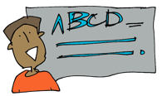
Before we start thinking about our own ideas for our monster, we need to look closely at the text and see what writing tools/tips/tricks the author has used so we can do the same in ours. Here is a toolkit I have made for writing information texts.

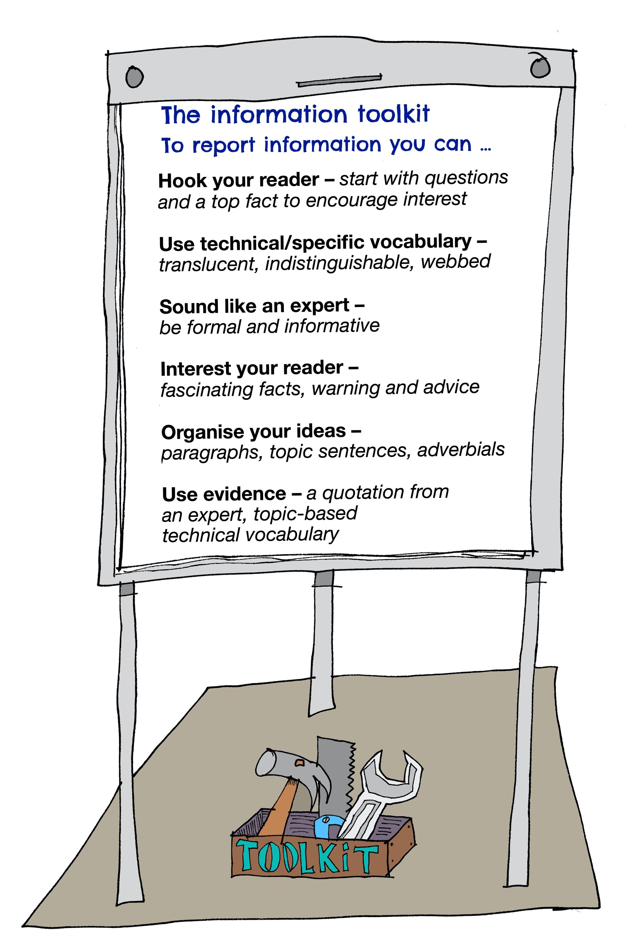

Activity 4: Formality
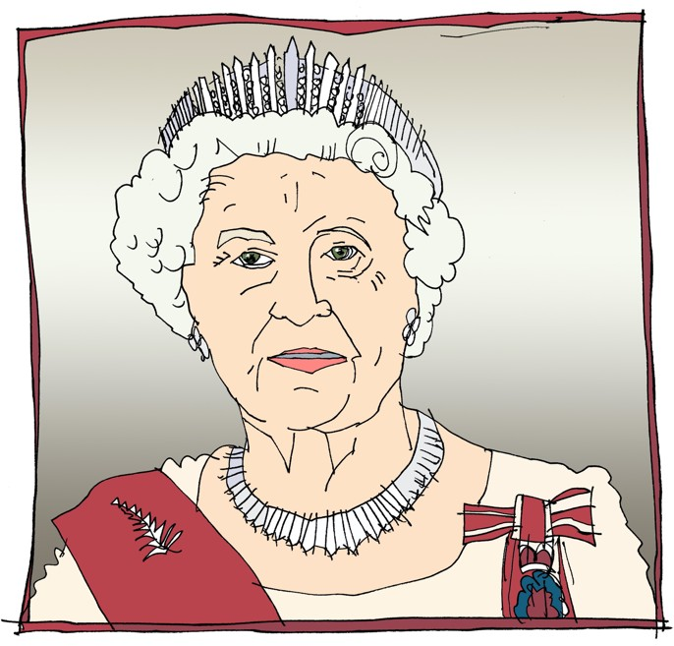
You might have heard your teachers talking about ‘being formal’. The best way to explain it in this type of writing is to: SOUND LIKE AN EXPERT.
Imagine you are David Attenborough narrating a TV show or your writing will feature in a non-fiction book from the library. We don’t need to make our reader laugh, persuade them or in fact give any opinion at all. Our main job is to give information as precisely as possible.
Here are two texts. Spot which is formal and which is informal!
  - Swamp monsters have a proper rancid diet. They love to eat all sorts of weird and unusual stuff like slugs – uuurrrggghhh! Also, they glug down the dirty swamp water by the gallon!
  - It has been discovered that swamp monsters have an unusual diet. In the main, these creatures are known to consume only gastropods. In addition, they have a preference for water from their swamps as it contains essential minerals.
Which one is informal and why? Which one is formal and why?
Now decide whether these are formal or informal sentences?
★ I really want you to come to my party – please come! formal/informal
★ Henry VII didn’t like his wife – he chopped off her head! formal/informal
★ The teacher-pleaser machine is a state-of-the-art contraption. formal/informal
★ Your presence is requested at the Queen’s celebration. formal/informal
★ At 6:00pm on the 24th December Mr Jones was arrested by the police and detained at the local police station.
formal/informal
Challenge: can you re-write each sentence the other way round so the formal ones become informal and the informal ones become formal!

Activity 5: Topic sentences
You might have noticed that the model text does not have sub-headings. Instead, in Year 6, we can use TOPIC SENTENCES. These are like little introductions to the paragraph allowing you to add more detail than you would in a simple heading.

Examples from our model:
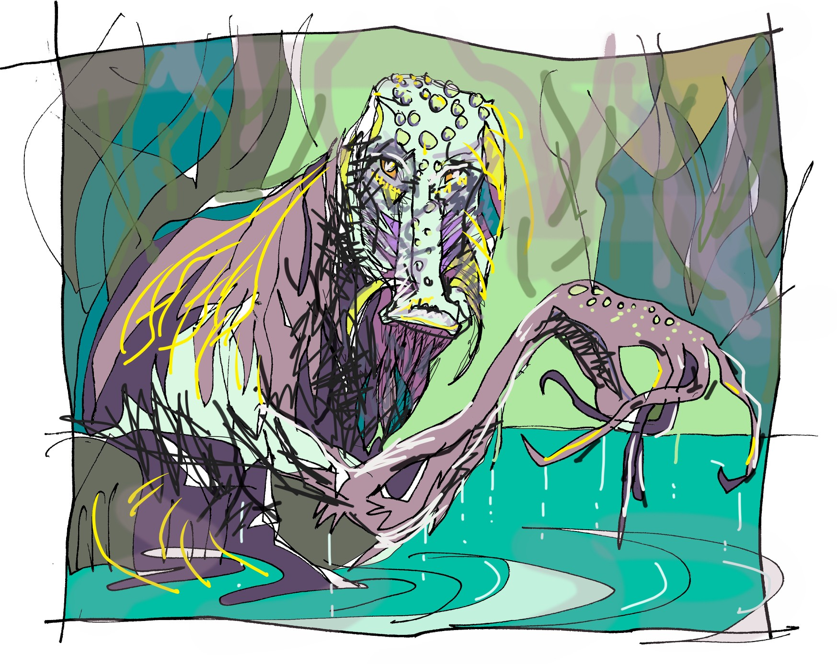
Swamp monsters don’t just live in swamps they resemble them.
This topic sentence introduces our APPEARANCE paragraph

Have you ever wondered what a swamp monster eats? This topic sentence introduces our DIET paragraph and uses another question to interest the reader.

Swamp monsters are rumoured to inhabit the most remote and humid swamps of the Amazon rainforest.
This topic sentence introduces the paragraph which is about DIFFERENT SPECIES and HABITAT.

★ Use these examples to have a go at writing some topic sentences of your own for the topics below

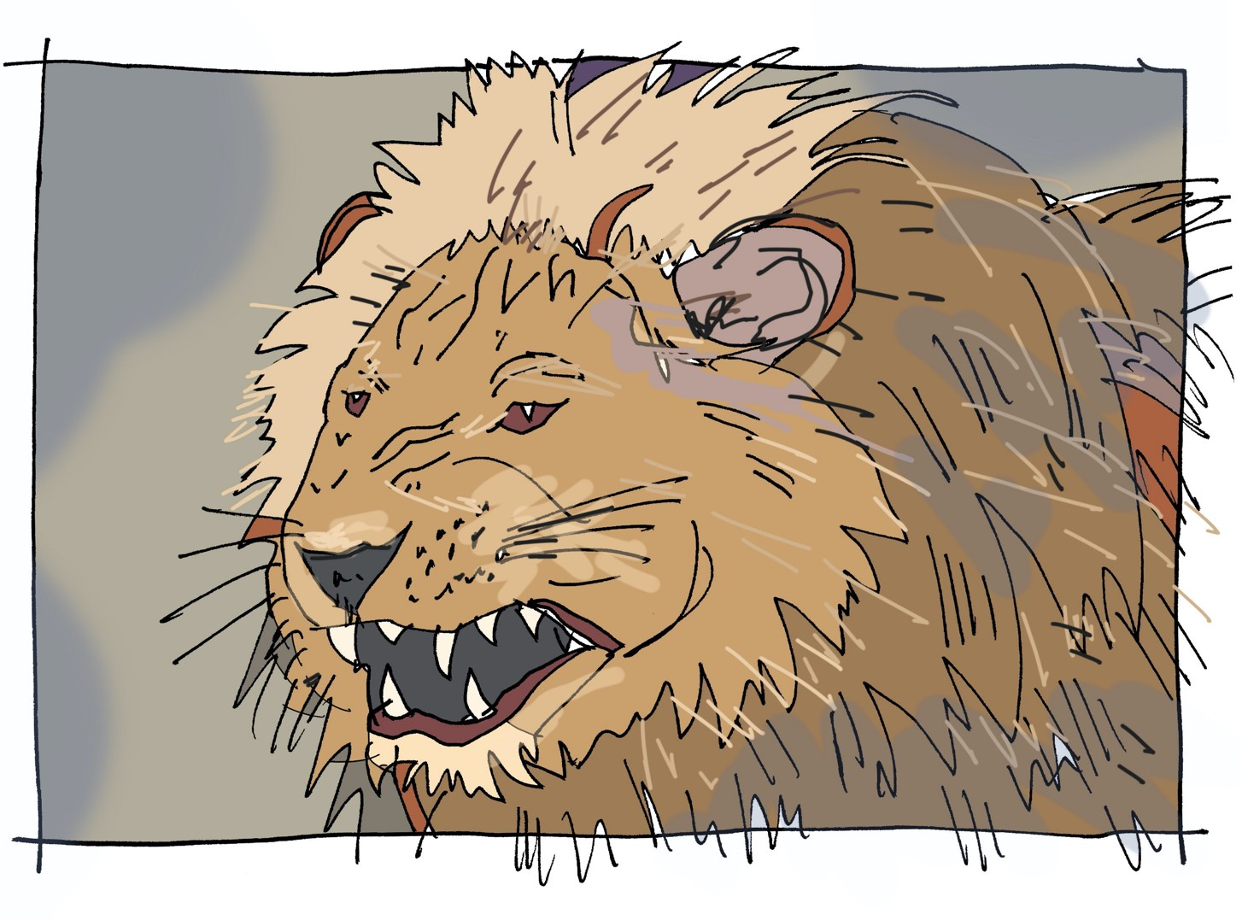
Topic sentences for the appearance, diet and habitat of a lion:

Topic sentences for the habitat, diet, and appearance of a swamp monster:

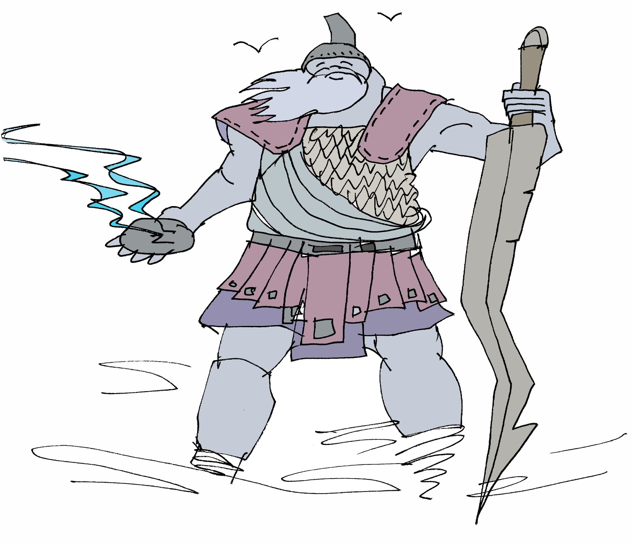
Topic sentences for the appearance, powers, enemies or abilities of a storm giant:

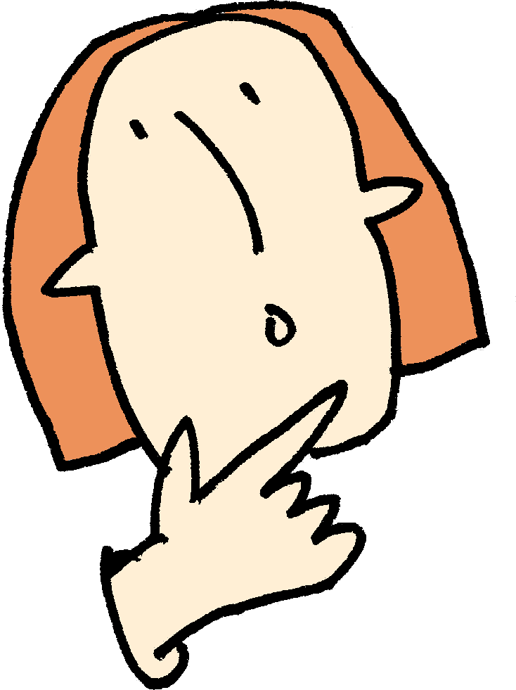
Activity 6: New ideas
Now comes the fun part! You need to write an information text about a monster beast for Professor Behemoth’s Monsterology. The choices are endless and I am sure that you already have an idea about what you might do but here are some pictures that might inspire you.

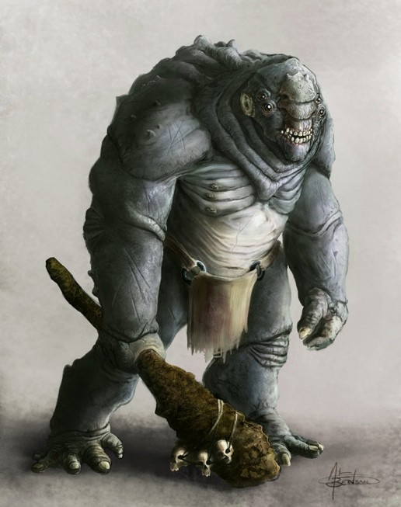
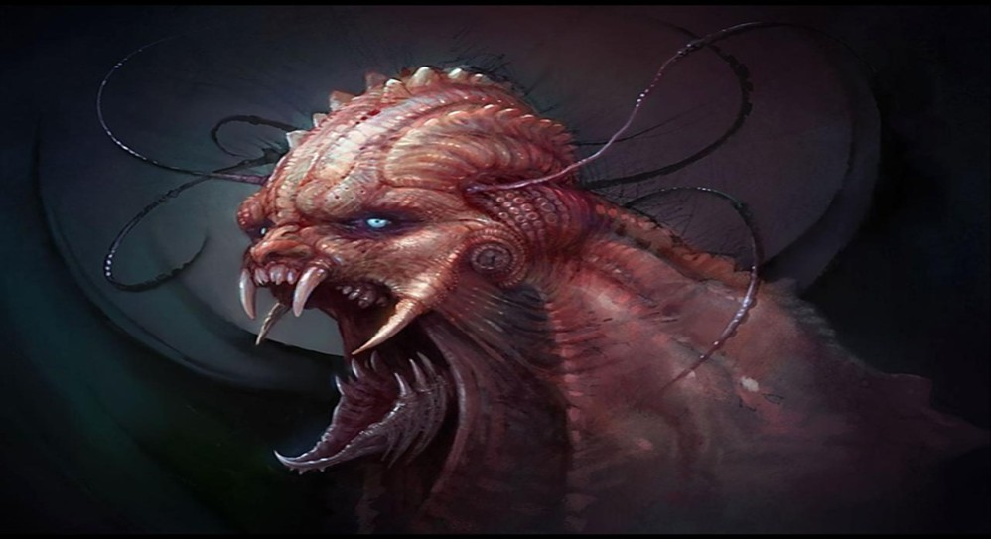
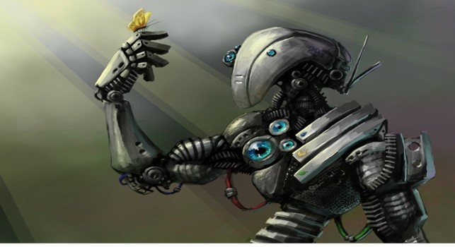

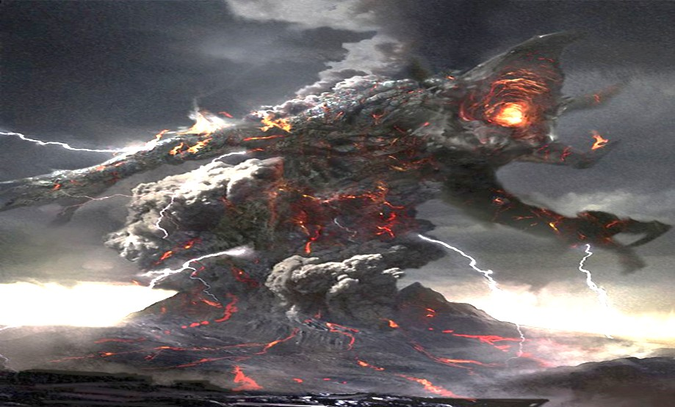
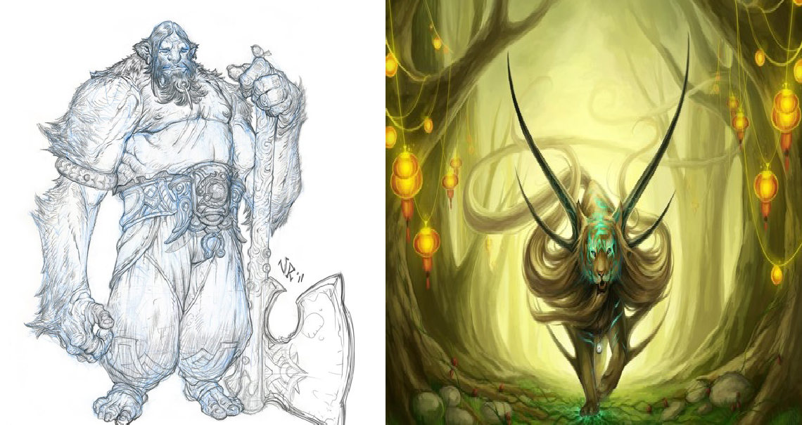

★ Coming up with ideas! I have given you a few ideas for what your different paragraphs could be about below and I am sure that you can think of others. Use the space to get as many ideas down as you can or
use separate paper

Appearance | Diet
-  - |  | -  -
-  - |  | -  -
Habitat |  | Abilities
-  -  -  - |  | -  -  -  -
Friends/Enemies |  | Weapons/Powers
-  - |  | -  -
-  - |  | -  -

Quotations from an expert ??????????

- -
- -
- -
- -

Activity 7: Draw your monster

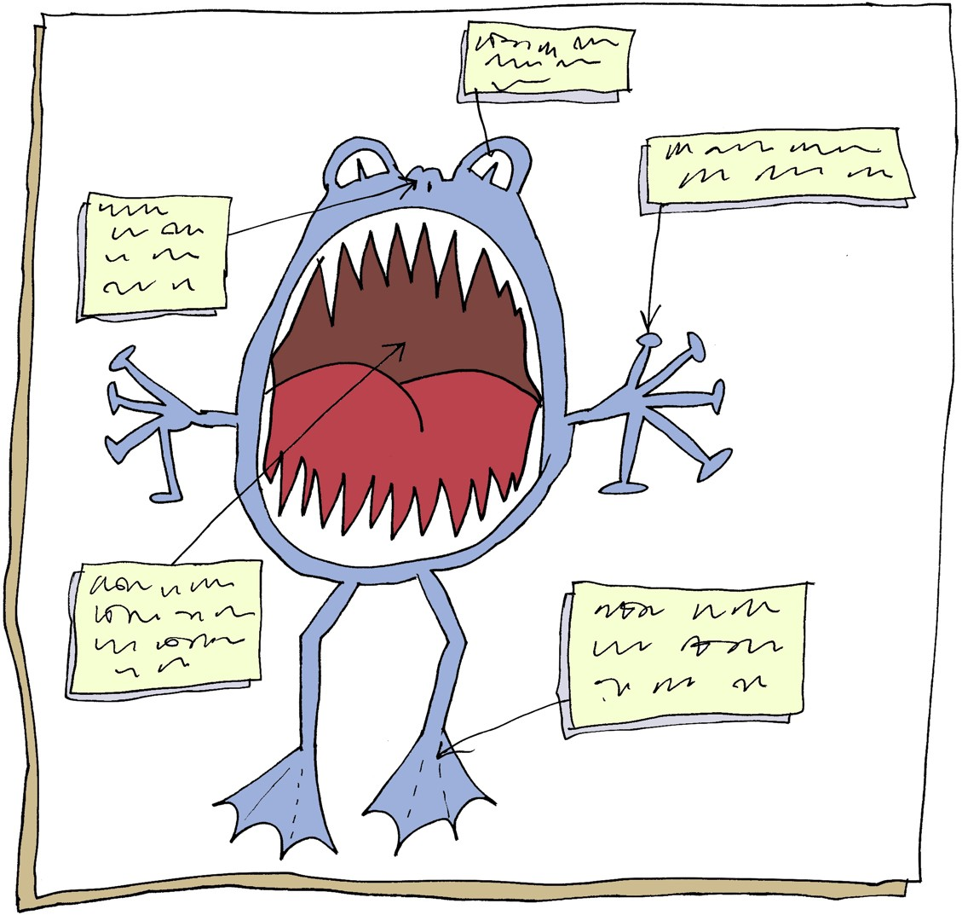

To help you get a real picture of what your monster is like, have a go at sketching them.

Activity 8: Planning
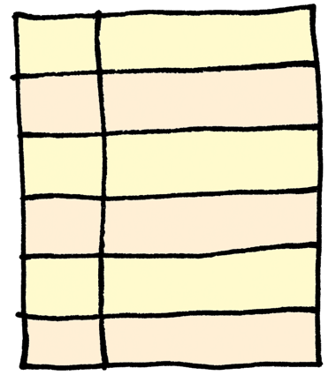
Now we are going to organise our ideas into a box-up planner to help structure your writing. Remember you can pick different topics than appearance, habitat and diet and also you can have your quotation in a different section. I have left the right-hand column blank as you might want to have 2, 3, 4, 5 or 6 different sections so draw your own lines!

Structure of monster information text | Your ideas
Title of monster
Opening hook – to make the reader interested in finding out more.
Fascinating fact for interest
Habitat
Information about the area the creature lives in
Appearance
Information about what the creature looks like including evidence
Diet
Information about what the creature eats
Warnings and advice to the reader

Activity 9: Talk your plan through

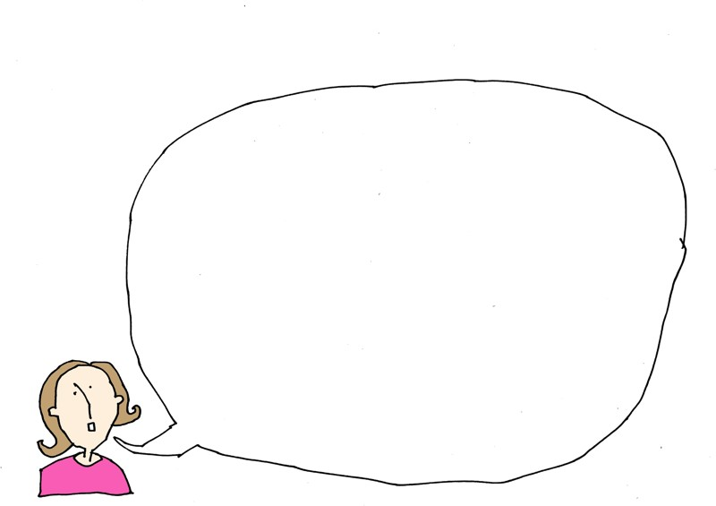
It is really important to have a good read through your plan to make sure that it makes sense. Why not read it aloud to someone in your house and see if they have any suggestions for how to improve it.

Activity 10: It’s time to write your monster report

To help you with your writing, you have lots of different things to help you:

    - The original text about monsters
    - The toolkit for reporting information
    - Your ideas page
    - Your diagram
    - The vocabulary we learned from the model
    - And most importantly, your plan
Draft your ideas on one piece of paper and edit it so you really like the words you have chosen. Read it through again to check spelling and punctuation and then write your final draft.

Activity 11: Draw a map of your monster’s land
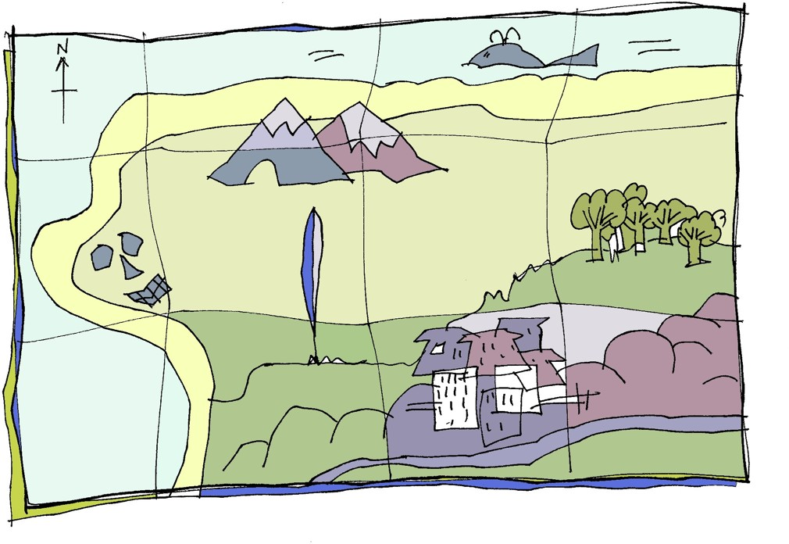
One of my favourite things about reading children’s books is when you find a map right at the beginning of the land in the story. I keep referring to the map as they talk about the different locations and settings in the story. I am sure that you have done the same. I thought it would be a great idea for you to design and draw your own map of where your giant lives.

★ Step 1: draw the outline of your map
★ Step 2: fill in the landmarks: trees, rivers, boulders, mountains, volcano, cities, sea, swamps
★ Step 3: make up names for the different areas of your map
★ Step 4: stain the map to make it look old by using a used (and cool) tea bag to turn the paper brown. You don’t need to get it that wet for it to change colour
★ Step 5: When it is dry, cut or rip the edges of the paper to make it look old and worn. A small hole in the middle of the map can look great
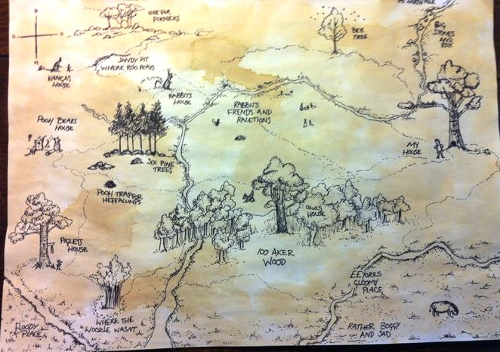

Activity 12: Giving feedback

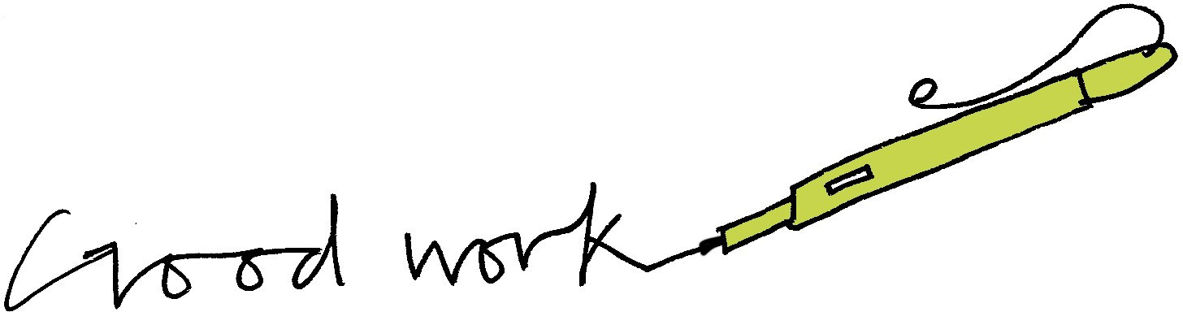
An important part of writing is giving feedback to the writer. Normally, in school, this is probably done by your teacher and sometimes by other children in your class. Read my paragraph of information writing underneath.
Correct up any errors and then leave me some feedback based on the toolkit from earlier in the booklet. Is it formal enough? Is there a topic sentence? Is it interesting? Does it engage the reader?

Diet:

Ogres clubs there pray to death and then feast on the carcasses. Many ogres keep the bones and use them to festoon their caves; skulls being their main bone of choice! Disgusting isn’t it. Their favourite thing to eat are definitely otter or beaver cub’s which they cruelly take from their mothers.

Feedback:

Activity 13: Extension writing choices
★ You are not finished yet! There are lots of different bits of writing you could do if you are enjoying this unit:
★ Write another report about a real animal (lion, great white shark)
★ Write another report about a different beast (vampire, ogre)
★ Write a fact-file for your monster
★ Write a newspaper report about a monster on the loose
★ Write a set of Instructions for How to Trap a Monster
★ Write a discussion text like Should Monsters be Allowed to Live on Earth?

Activity 14: WANTED Poster
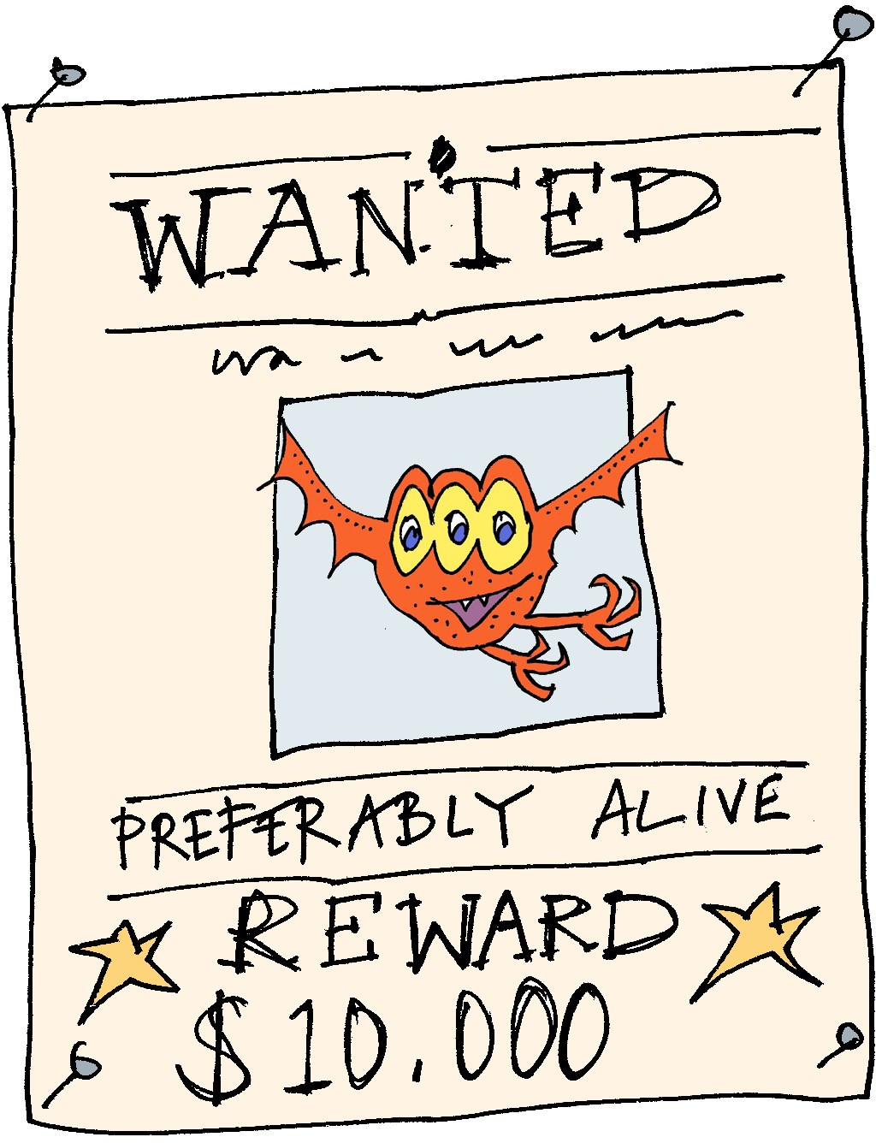
Imagine the monster or beast you have written about is on the loose! Design a WANTED poster calling on the public to help hunt down and capture them before it is too late. You might want to include:
★ A reward
★ Who to contact if they see the monster
★ What the monster has done – why they are dangerous
★ Where they were last spotted

Book recommendations
Below are books that I would recommend for Year 6 that feature a monster or a beast. If you have read some of them, why not do a book review?
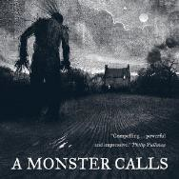  A Monster Calls by Patrick Ness | 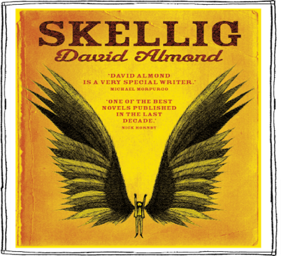  Skellig  by David Almond | 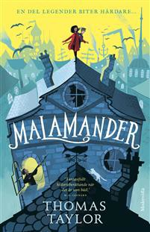  Malamander by Thomas Taylor
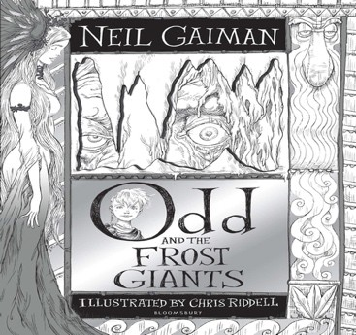  Odd & the Frost Giants by Neil Gaiman | 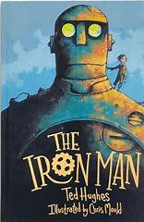  The Iron Man by Ted Hughes | 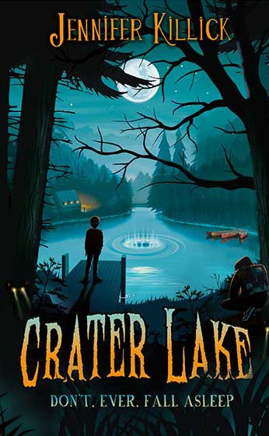  Crater Lake by Jennifer Killick
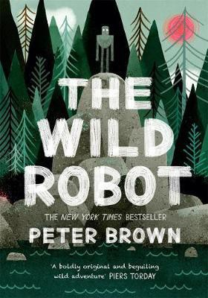  The Wild Robot by Peter Brown | 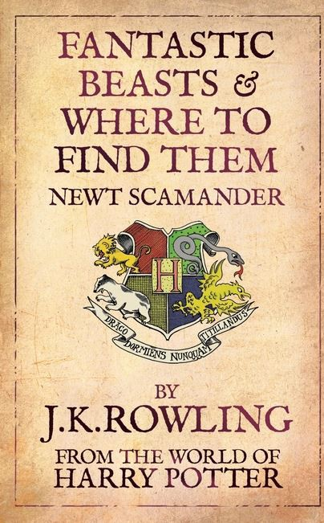  Fantastic Beasts by JK Rowling | 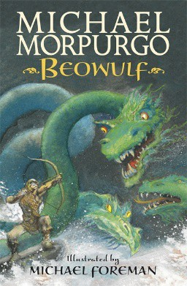  Beowulf  by Michael Morpurgo
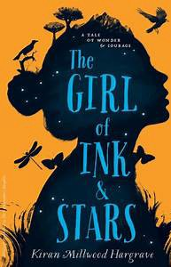  The Girl of Ink and Stars by Kiran Milwood  Hargrave | 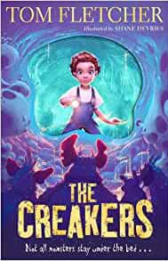  The Creakers by Tom Fletcher | 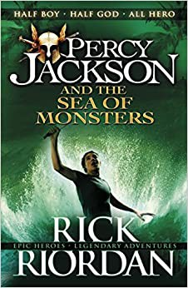  Percy Jackson and the Sea of Monster by Rick Riordan

If you enjoyed this activity, why not tune in to the creative writing show Radioblogging each morning at 9:30am with Pie Corbett. Visit RadioBlogging.net

I hope you have enjoyed working through this workbook. Please share any work produced by tweeting me @MrWalkerPrimary

James Walker a Year 6 Teacher and TalkForWriting Trainer from Bristol.

Answers to vocabulary

myth – a traditional or legendary story
translucent – permitting light to pass through but objects on the other side are not clearly visible
indistinguishable – not distinguishable resemble – to be like or similar to renowned – to be celebrated or famous majesty – supreme greatness
iridescent – displaying lustrous colours like those of a rainbow harmony – agreement or harmonious relations
gnarled – rugged, bent, twisted or weather-beaten solitude – the state of living alone in seclusion transfixed – to hold motionless with amazement

Answers to formality
★ I really want you to come to my party - please come! formal/informal
★ Henry VII didn’t like his wife – he chopped off her head! formal/informal
★ The teacher-pleaser machine is a state-of-the-art contraption.
formal/informal
★ Your presence is requested at the Queen’s celebration.
formal/informal
★ At 6:00pm on the 24th December Mr Jones was arrested by the police and detained at the local police station.
formal/informal

James Walker is a teacher who also works as a trainer with Talk for Writing to help schools develop the approach.

Edited and designed by Julia Strong
Prepared for online distribution by Nick Batty

To find out more about Talk for Writing, visit www.talk4writing.com.

This resource is copyright. All materials herein, texts and supporting resources are copyright to James Walker & Talk for Writing. They are to be used to support children/staff/parents in home-learning ONLY and not for commercial gain or for training or sharing widely, in their original form or any variations. They must also not be shared online or on any social media platforms.

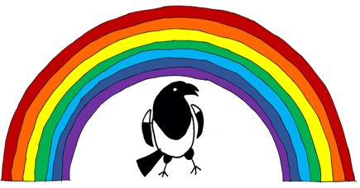
Thanks to Lauren Stringer and all the authors of graphics from Flaticon.com, including Freepix, Smashicons, and Becris and Valeria from Pexels.com, for sharing their content.

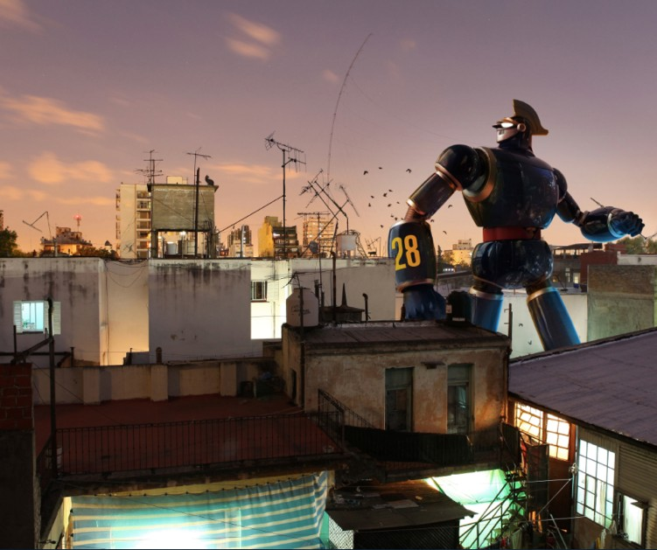
Story starter!

Thump…Thump…Thump…His footsteps thundered down the road, causing passers-by to stare in amazement, dogs to howl in back yards and alarmed old ladies to peer out of their bedroom windows wearing petrified looks on their faces.
His legs were as long as oak trees, his torso was as wide as a house and his fists were as heavy as tractors: this metallic monster meant business.
“Number 28 checking in. Over.” He spoke into the radio set, built in to his helmet.
His instructions crackled back through the earpiece. He knew what he had to do…

Question time!

- Who/what is Number 28? What is his mission? Where has he come from? Who is he speaking to?
- Do robots have feelings? Will there be robots around in the future?
- If we all had a personal robot that belonged to us, would this be a good thing or a bad thing?

Sentence challenge!

- Can you write a sentence that uses an apostrophe for omission?
- E.g. cannot =can’t
- I have = I’ve
- he will= he’ll
- Can you write a sentence that uses an apostrophe for possession?
- E..g. The robot’s suit
- Number 28’s head

Sick sentences!

- These sentences are ‘sick’ and need help to get better. Can you help?
- He was really big. People were scared. His big body walked down the street.

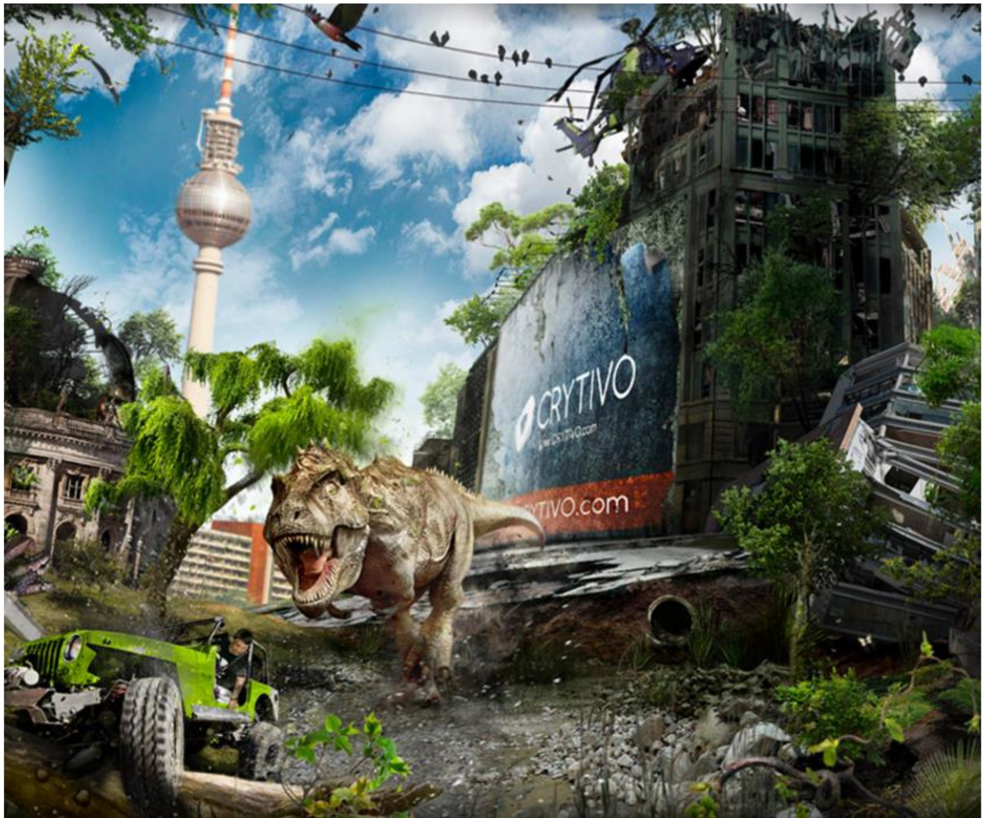
Story starter!

The engine screamed as the wheels spun round. His heart pounded. Tim knew that he only had seconds to act.
There was a long, moss-covered log wedged underneath the jeep, preventing it from moving. The wheels continued to spin pointlessly, smoke starting to billow out from underneath the bonnet.
A terrifying roar filled his ears, and he knew the monster was right behind him. He could feel the ground shake beneath him as its gigantic feet collided with the ground. He knew what would happen if it caught him, and muttered a prayer beneath his breath.
Tim suddenly found himself lunging forward. He realised that the wheels must finally have found some traction, and he breathed out with relief as he sped off onto the path once again; the wheels of the jeep content to be chewing up the firm gravel once again.
The chase was back on, and the T-Rex let out another blood-chilling roar, determined not to let its prey escape...

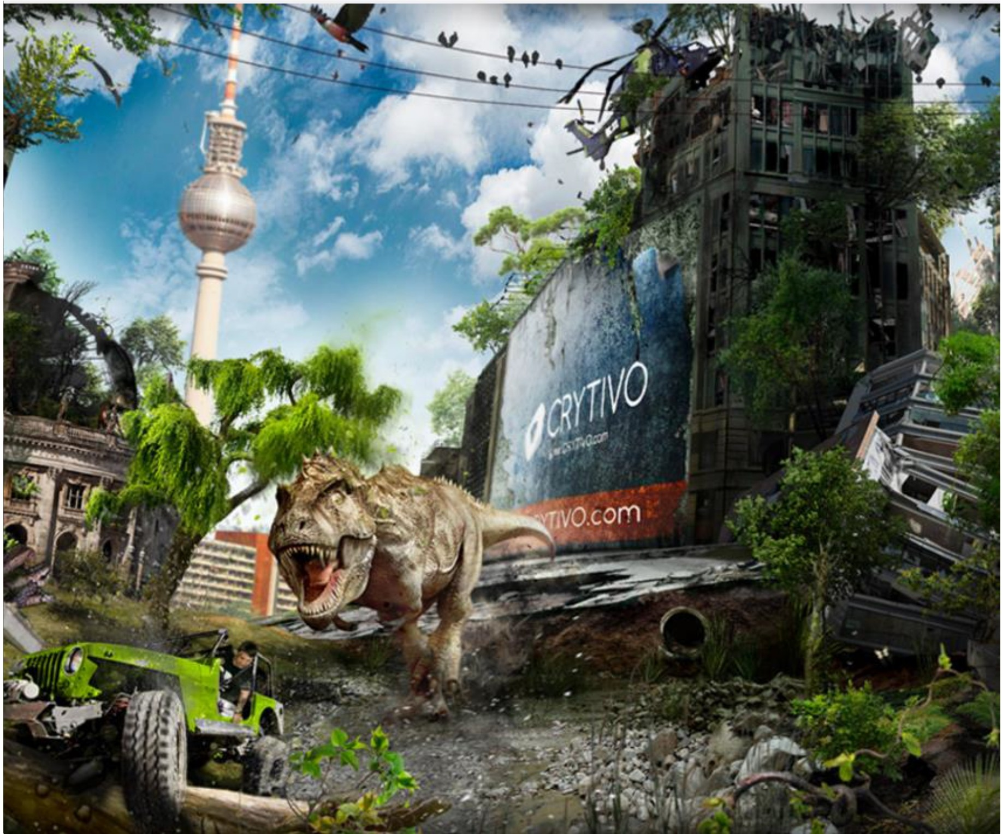
Question time!

- How do you think Tim is feeling?
- What has caused the jeep to stop moving?
- Why is he all alone and being chased by a
dinosaur?
- Are there other dinosaurs or people close by?
- How will Tim manage to escape?
- If you could bring back the dinosaurs, would
you?
- Might it be possible to bring them back one day?

Sentence challenge!

Can you make a list of all of the noises a T-Rex might make whilst pursuing its prey?
Can you use these words in a sentence? They are called onomatopoeia - they sound like their meaning.

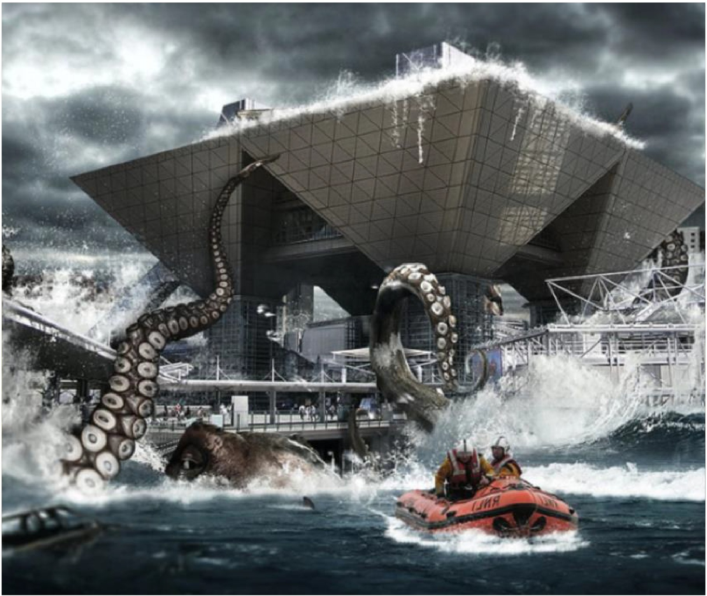
Story starter!

It came from the sea, calmly at first. An enormous, slithering tentacle slowly oozing its way over the top of the sea wall, exploring the metal and concrete shapes with suckers the size of your front door.
Then, as more and more people came, and shrieks and cries of alarm filled the air, the creature became angry. All hell broke loose...
In an almighty tangle of limbs and water and buildings and people, the beast came violently exploding out of the frothing water. The normally sturdy metal supports of the buildings groaned under the extreme weight of the gigantic tentacles crushing them. Panic. Complete panic set in.
But where had the creature come from? What did it want? How could anybody stop it?
There wasn't time for people to think. Only to run...

Question time!

- Where do you think the creature has come from?
- What do you think it usually eats?
- Why do you think it has come up to the surface?
- What do you think its feelings are towards humans?
- Is it possible that there are sea creatures as big as this one lurking in our waters?

Sentence challenge!

Insert commas in the correct places in the sentence below.
Viciously an enormous tentacle exploded out of the frothing bubbling water heading straight towards a crowd of anxious people.

Sick sentences!

These sentences are 'sick' and need help to get better. Can you help?
- A tentacle came out of the water.
- The creature had a big head and big eyes.

Perfect picture!

Imagine the creature is out of the water. Can you draw or describe what its entire body Looks like?

