Hello 5B!
Welcome to your final three week’s work for Year 5! Can you believe that you’re nearly in Year 6 now? All the staff at school are missing you and are sad that we haven’t been able to see you before the end of the year, but the most important thing is keeping safe. I hope you’ll enjoy these tasks and challenges; as before, I’ve written it to make sure that all our Year 5 children are covering roughly the same work, across all classes. If there seems like a lot of work, don’t worry - just complete as much as you can. If you need any help, remember that you can contact me through school on 01400 659001, or by email: enquiries@cranwell.lincs.sch.uk . Mrs Barrett and I wish you all a very happy Summer Holiday and we look forward to seeing your smiling faces again very soon.
Mrs Bullement
Maths – Weeks beginning 29/6, 6/7 and 13/7
Please continue to complete your daily maths lesson, using the White Rose resources from the website. Have a go at the questions on the videos, on a piece of paper. Remember to also follow the links to BBC Bitesize for even more practise. You can find your lessons here: https://whiterosemaths.com/homelearning/year-5/ . Remember, the videos are also available on Facebook, if the website is overloaded.

This next section of work contains some areas that we haven’t covered in class (they are Summer Term topics), so it would be really useful if you could try to complete each lesson. The topics are:
Week 10: angles
Week 11: shape and direction
Week 12: measure

Drawing and measuring angles takes a bit of practise and we are looking for an accuracy of +/- 2°! It would be great if you could practise with a protractor, so I’ve included a sheet to support you in this. You can buy a protractor as part of a simple geometry kit in the supermarket, or you might find that an older brother or sister has one already.

Of course, I’ll continue to set tasks on Mathletics, but only do these if you have spare time!

Want a challenge? I’ve included some extra sheets below and remember to try some of the puzzles in the ‘Daily Rigour’: https://www.cdmasterworks.co.uk/the-daily-rigour/

Literacy – 2 Weeks (w/c 29th June and 6th July)
Please follow the link below to access a home learning booklet called ‘One Chance’ (this can either be printed or you can write your answers and ideas on paper or in a notebook):
https://www.talk4writing.com/wp-content/uploads/2020/05/Y5-One-Chance.pdf

This booklet is designed for you to work on at your own pace: it takes you through a series of literacy tasks related to the story including: reading comprehension, grammar, vocabulary and planning tasks. The booklet culminates in you writing a story about a wish!

Please don’t try to complete this in one sitting; we have used these booklets in class and have found they take more than a week to complete properly. Try to complete a page or two each day and enjoy creating a fantastic story. If you’d like to show me your finished work, you could take a picture of it and ask Mum or Dad to email it to me at school!

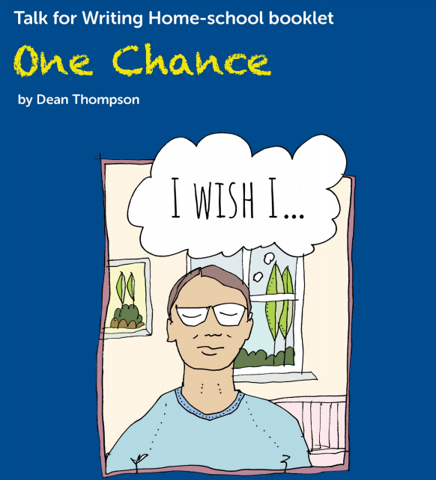

Literacy – Final week!

So here we are at the end of Year 5! It’s been a funny ending, but you have learned so much and discovered more about the world and about yourself over the past 11 months. What were your favourite parts? Did you achieve everything that you had planned? Have you had surprises, made happy (or perhaps sad) memories?

Your final task this year is to write about your time in Year 5. I suggest you go about it like this:

Monday: think back and jot down your memories of the past year. You can include family events as well as school! You could do this as a list or as a mind-map.
Tuesday: plan your writing. Will you choose to write chronologically (in time order) or use subheadings to write about separate events?
Wednesday: draft your piece.
Thursday: read your piece through with an adult or older sibling. Can they suggest any improvements? Now carefully edit your work, checking every sentence makes sense and that your spellings are correct.
Friday: write up your work in best, then share it with your parents. If you’ve done a fabulous piece, I’d love to see it! Ask Mum or Dad to email it to me at enquiries@cranwell.lincs.sch.uk

Reading – The Summer Reading Challenge

Hopefully, you’ve had time to explore the wonderful world of books over the past few weeks, so are you ready for the Summer Reading Challenge? Have a look at this website for details about how to get involved, including helpful tips on how to access new books if you’re stuck in the house: https://summerreadingchallenge.org.uk/

Geography – Week beginning 29/6  Where does our food come from?  We enjoy many foods that aren’t produced in our country – is this a good thing? Your task this week is to find out where the food in your cupboards has come from! Use an atlas or online map to identify the country in which your food item was produced and write down how many miles it has travelled to arrive in the UK. You might find these websites useful:  www.google.com/maps  https://www.distancefromto.net/distance-from-united-kingdom-country  You’ll find a sheet to complete below.  Now think…  - Should we import food from abroad?  - What are the benefits of importing food?  - What are the disadvantages?  You might like to discuss your thoughts with your parents – do they agree? |  | Geography – Week beginning 6/7  Water  We are very lucky: when we turn on a tap, fresh, clean water flows out. We have access to flushing toilets and are able to have a bath or shower when we are dirty. Many people aren’t so fortunate. This week, we’ll explore where our water comes from and think about what life is like for people who don’t have a convenient supply of fresh water.  https://www.bbc.co.uk/bitesize/clips/z8qtfg8 - find out all about the water cycle  https://www.youtube.com/watch?v=4V-KoJGGJ4s – a daily ‘water walk’  https://www.bbc.co.uk/bitesize/guides/zgx382p/revision/1 - this web page tells you about how water is distributed. It’s a GCSE resource, but I think you’ll enjoy looking at it. The video clip is interesting too.  Activity: make a water cycle wheel (see sheets below). Please note that the sheet uses the American spelling of vapour (vapor).  Note: After this task, we will have completed our Geography work, so there’s nothing further to work on next week
Spelling Task – Week beginning 29/6/20  I’ve set you some spelling work on Education City this week, to practise homophones and tricky words. You can find your work by logging onto the website and I’ll be able to see who’s been working hard! | Spelling Task – Week beginning 6/7/20  Can you use a dictionary to find out what these words mean and then learn how to spell them? Don’t worry if you don’t have a dictionary at home: you can, with your parents’ permission, use Google or these online ones:  https://www.wordsmyth.net/  https://kids.britannica.com/kids/browse/dictionary.  Conservation  Evaporation Irrigation  Condensation  Surplus  Deficit  Quality  Salinity  Ocean  Vapour |  | Spelling Task – Week beginning 13/7/20  This week, I’d like you to test yourself on the Year 5/6 words! I’ve included a complete list of these below. Please spend some time revising them, then ask Mum or Dad to rest you on a random selection of 20. How many will you get right?
French  We hope you have been enjoying practising your French, using Duo Lingo. Keep having a quick go each day (5 minutes is fine) – it’s fun and you’ll learn so many new words! https://www.duolingo.com/ |  | Art / DT / Science  Covid 19 has been in the news constantly this year. It has a weird appearance, with lots of spiky projections! Your challenge is to build a 3-d model of the virus. You might like to use papier mache and cardbaord, and lots of brightly coloured paint. Here is an image to inspire you.
ICT  It’s a great skill to be able to type fluently and there is a fantastic free resource, called ‘Dancemat’ available on the BBC Bitesize website to help you to learn how: https://www.bbc.co.uk/bitesize/topics/zf2f9j6/articles/z3c6tfr  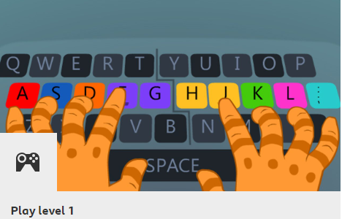  There are different levels to progress through, with the aim of teaching you to type without having to look down at your fingers. I wish I had learned to do this years ago! |  | PE – w/c 29th June  Wheeled sports this week! If you have a bike, a scooter, skateboard or even some roller skates, try to get out each day and enjoy the sunshine. Can you learn a new trick to impress your friends with, once lockdown has ended? Make sure you wear all the right safety kit though!
PE – w/c 6th July
Press-up challenge! It’s tricky to do a press-up correctly, as you’ll know from our PE lessons. How about asking Mum or Dad to show you the correct technique? Then challenge yourself to practise each day and challenge a friend to see who can do the most?
PE – w/c 13th July
Create a scavenger hunt for your family to enjoy! There are some super ideas on this website to give you some inspiration: https://www.goodhousekeeping.com/life/parenting/g32050844/scavenger-hunt-ideas-for-kids/
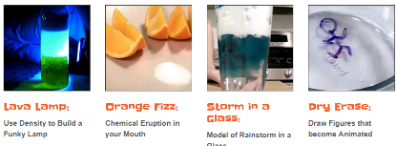  Science  Some fun stuff! There are loads of great ideas for science-based activities in this website: www.sciencefun.org/kidszone/experiments/  Why not have a go at:  - Making a lava lamp or volcano  - Making your own play dough or snow fluff  - Milk art  - Paper hovercraft  I’d love to see some photos of your creations! |  | PSHE  This term, we would normally have been learning about how our bodies change as we get older, focussing on puberty. Everyone goes though these changes and it’s important that you understand what is happening, even if it’s a bit embarrassing! A parent mail has been sent out, giving your mum and dad links to some useful resources. Choose a convenient, quiet time to talk to them about it.

Maths Extra Challenge – Week beginning 29th June
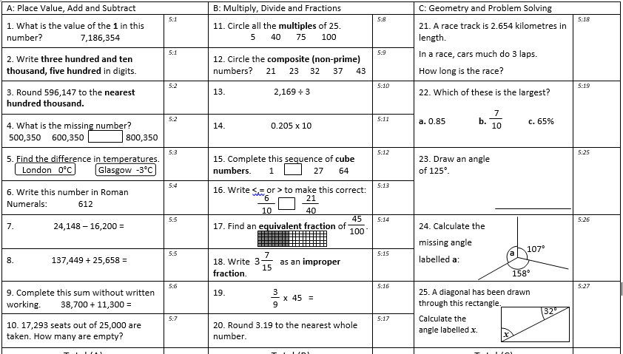

Maths Extra Challenge – Week beginning 6th July
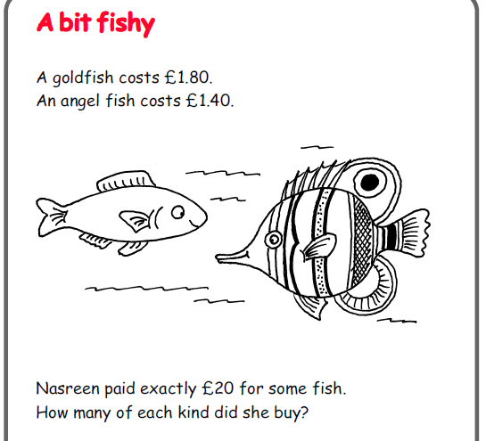

Maths Extra Challenge – Week beginning 13th July
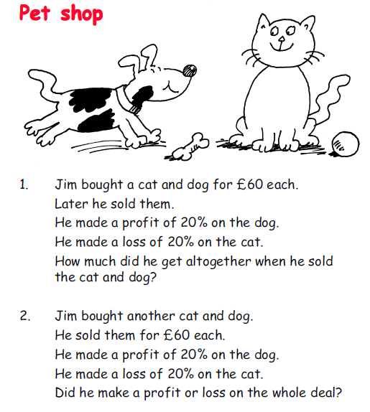

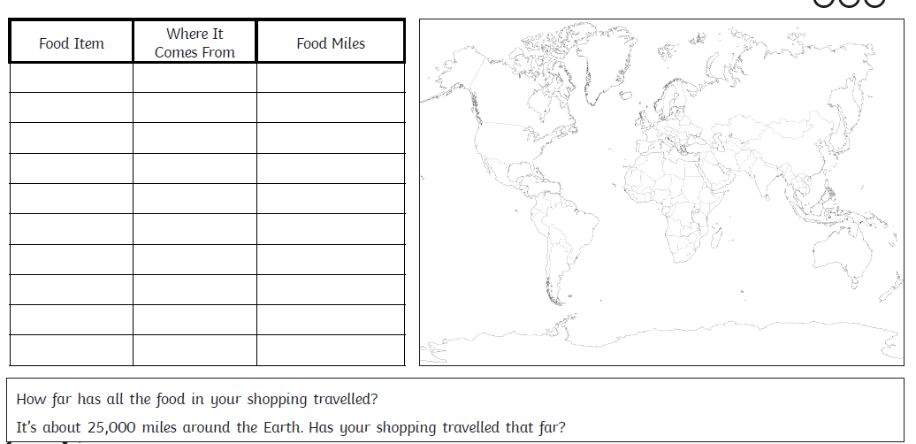
Geography: w/c 29th June
Geography w/c 6th July (2 sheets)
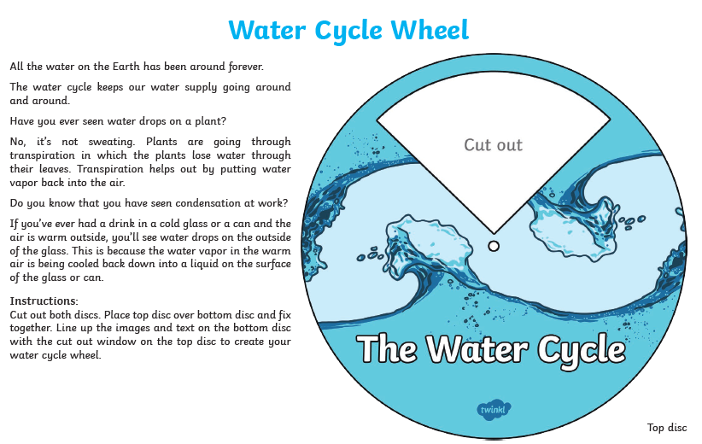
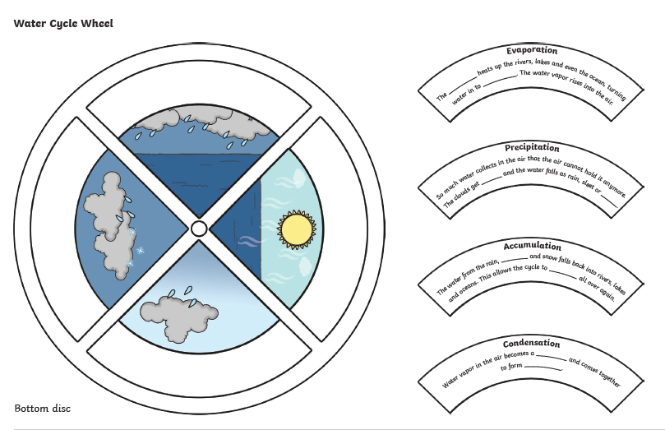

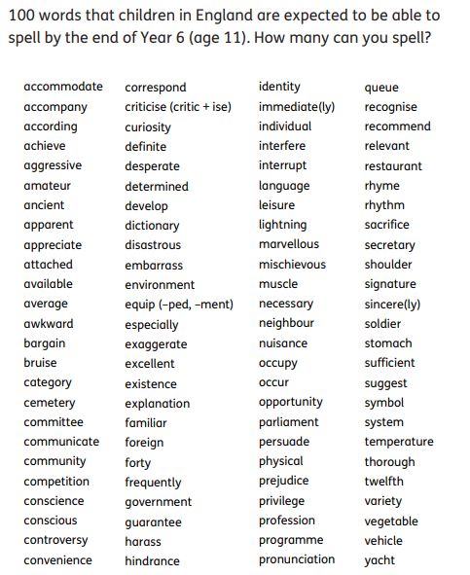
Spelling Challenge:
w/c 13th July
ANSWERS – TOP SECRET!
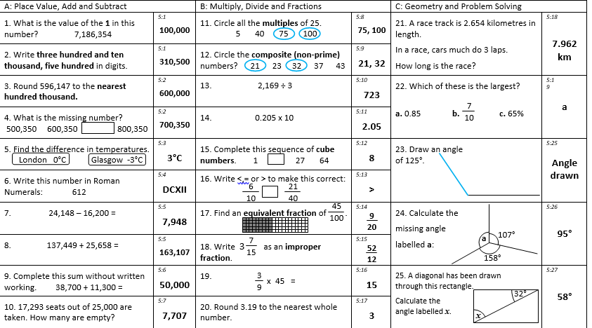
A bit fishy: Nasreen bought 4 angel fish and 8 goldfish.
Pet shop: Jim sold the dog and the cat for £72 and £48 respectively, a total of £120. The dog cost £50 and the cat cost £75, a total of £125. The cat and the dog were sold for a total of £120, so Jim made a loss of £5.

