|  |  |  |
| --- | --- | --- |
| **Class 1MS** | **HOME LEARNING Year 1**  **21/9/20 to 25/9/20** | **AUTUMN TERM** |
| **Literacy –** | **Dear Parents:**  **Please find enclosed some work to keep you busy for the next few weeks. We have included a timetable as guidance for completing the homework.**  **Keep reading with your child and if you complete a book, perhaps, you could re-read it. Don’t forget it is really important to discuss the following with your child: What was the story/text about? Who were the main characters? Did you enjoy the story and what was your favourite part? What did you learn from the text and can you remember the title of the book we read yesterday?**  **Thank you and take care.**  **Mrs Mulhall and Mrs Smith**  **If you have any problems accessing the work, please contact**  [**Charlotte.Mulhall@cranwell.lincs.sch.uk**](mailto:Charlotte.Mulhall@cranwell.lincs.sch.uk) **or** [**Catherine.Smith@cranwell.lincs.sch.uk**](mailto:Catherine.Smith@cranwell.lincs.sch.uk) | **Maths**  We have been learning about place value so far this term and been trying hard to ensure we form numbers correctly. Please tell your child if they write a number the wrong way round or forget to form it properly.  Please use the following link.  <https://whiterosemaths.com/homelearning/year-1/week-2/>  They have some useful presentations for you to watch  **Lesson 1 - Count Forwards.**  Watch the presentation then complete the worksheet below rather than the ones linked to White Rose.  **Lesson 2 - Count Backwards.**  Watch the presentation and again, please complete the worksheet below.  **Lesson 3 - Count One More.**  Again, after watching the presentation, please complete the enclosed worksheet.  **Lesson 4 – Count One Less.**  As before, please complete the worksheet after watching the presentation.  **Lesson 5 – Count One More and One Less.**  Recap with your child finding one more and one less. Ask them questions such as: what is one less than 9? What is one more than 12 etc. Complete the sheet below.  **Practical Activities**  Using items such as marbles or toy cars, place different amounts in front of your child and ask them to count how many there are.  Using items such as marbles or coins, ask your child to count out an amount. Then say, what is one more and what is one less? |
| Please read your school reading books through at least twice.  Practice spelling your first name and surname. Focus on your letter formation. Start and finish each letter in the correct place.  Watch the phonics videos we have uploaded onto Tapestry.  Please follow the lesson outline and video links below.  Lesson 1- Please upload a photograph of you reading in an unusual place. We have enjoyed seeing your photographs so far! Write a simple sentence about your photograph. For example, I am reading on my trampoline. Concentrate on spelling key words. Start your sentence with a capital letter and finish with a full stop.  Lesson 2-5 Please follow the links to Oak National Academy. |
| Free harvest Images, Pictures, and Royalty-Free Stock Photos -  FreeImages.com**Geography & Harvest Day**  Where does our food come from?  Discuss farming i.e. what does a farmer do and what do they grow? Research farming in Lincolnshire. What is grown in this area? Try to draw and label the types of food that are grown here?  What is Harvest Festival and when is it held this year? How do we celebrate it and why is it important?  Art - Can you make a collage of your favourite fruit? If you prefer, you can paint it or make a 3D model. Be as creative as you wish to be. |

|  |  |  |
| --- | --- | --- |
| **Class 1MS** | **HOME LEARNING Year 1**  **28/9/20 to 2/10/20** | **AUTUMN TERM** |
| **Literacy –** | **PSHE – All About Me**  Please use the following lesson from The Oak Academy website. It can be found under Year 1 PSHE – Me, You and Us or using the following link  <https://classroom.thenational.academy/lessons/all-about-me-c5h68d/activities/1>  Task  Draw a picture of yourself and think of some special words to describe you. | Where did maths mastery come from? **Maths**  Use the following link to support the maths this week.  <https://whiterosemaths.com/homelearning/year-1/week-3/>  **Lesson 6 – One to One Correspondence.**  Watch the presentation then complete the worksheet below rather than the ones linked to White Rose.  **Lesson 7 - Compare Objects.**  Watch the presentation and again, please complete the worksheet below.  **Lesson 8 – Introduce < > and = symbols.**  Again, after watching the presentation, please complete the enclosed worksheet.  **Lesson 9 – Compare Numbers.**  As before, please complete the worksheet after watching the presentation.  **Lesson 10 – Comparing Activity.**  Once again, please watch the presentation and then complete the worksheets. |
| Please read your school reading books through at least twice.  Watch the phonics videos and tasks we have uploaded onto Tapestry.  Please follow the lesson outline and video links below.  Lesson 5-10- Please follow the links to Oak National Academy. |
| **Science - Materials**  Please complete the following lessons from Oak Academy. You can access the lessons by going to the Oak Academy Site, and selecting Year 1 Science.  **Lesson 1**  <https://classroom.thenational.academy/lessons/what-is-a-material-74u30t/activities/1>  MCj03559450000[1]You may like to follow up this activity by completing the following. Look around your house and find things made from plastic, wood, fabric, metal, rubber and glass. Can they identify any other materials?  Complete the Materials Detective worksheet.  **Lesson 2**  <https://classroom.thenational.academy/lessons/what-are-objects-made-from-61gp8d/activities/2> |

|  |  |  |  |  |  |
| --- | --- | --- | --- | --- | --- |
| **Home learning- Timetable of tasks** | | | | | |
| Week beginning: 21/9/20 | | | Class: 1MS | Year Group: 1 | |
|  | Monday-21/9/20 | Tuesday- 22/9/20 | Wednesday 23/9/20 | Thursday 24/9/20 | Friday 25/9/20 |
| Objective | Compose and write simple sentences. | Listen and join in with stories | Retell a story- create a story map | Add actions to retell a story | Draw and describe characters |
| Literacy | Tapestry Task 1 –  Compose simple sentences about a photograph (reading in an unfamiliar place). | LESSON 1 – OAK ACADEMY –Lucky Duck  Practice writing your full name. | LESSON 2- Oak ACADEMY  Practice writing your full name. | LESSON 3- Oak ACADEMY  Practice writing your full name. | LESSON 4- Oak ACADEMY  Practice writing your full name. |
| Links to learning |  | <https://classroom.thenational.academy/lessons/to-listen-and-join-in-with-a-story-ccwp6c> | <https://classroom.thenational.academy/lessons/to-map-and-speak-the-story-c4w68c> | <https://classroom.thenational.academy/lessons/to-step-and-speak-the-story-crt3ee> | <https://classroom.thenational.academy/lessons/to-draw-and-describe-characters-69gpct> |
| Objectives | Read phase ‘Tricky’ and decodable words.  Recognise graphemes | Read phase ‘Tricky’ and decodable words.  Recognise graphemes | Spell words with the /n/ sound spelt n before k (nk- bank, wink, think) | Read and spell words with the ‘ee’/ ‘igh’ grapheme.  Recognise graphemes | Read and Spell oa words |
| Phonics | Tapestry video 21/9/20 - ‘Flash cards’ and ‘Reading ‘tricky words’ | Tapestry video 22/9/20 –Tricky words  Spelling ll,ff,ss words  See activity sheet | ‘Reading and spelling ‘nk’ words. Tapestry video- 23/9/20  See activity sheet | Watch - <https://www.bbc.co.uk/bitesize/topics/zvq9bdm/articles/zn9q92p>  <https://www.bbc.co.uk/bitesize/topics/zvq9bdm/articles/zkhvhbk> | Quick recall of graphemes- Tapestry video 25/9/20 |
| Objectives | To be able to count forwards. | To be able to count backwards. | To count one more. | To count one less. | To count one more and on less. |
| Maths | Lesson 1 activity sheet | Lesson 2 activity sheet | Lesson 3 activity sheet | Lesson 4 activity sheet | Lesson 5 activity sheet |
| Links to learning | [whiterosemaths.com/homelearning/year-1/week-2/](https://whiterosemaths.com/homelearning/year-1/week-2/) |  |  |  |  |
| Objectives |  |  |  |  |  |
| Core/  Non- core subjects | **Geography/Harvest**  To understand what farming is and to know what farmers do. | **Geography/Harvest**  To research farming in Lincolnshire. What do we grow? | **Geography/Harvest**  To label and draw the types of food we grow in Lincolnshire. | **Geography/Harvest**  To know what a harvest festival is. To know when harvest is. | **Geography/Harvest**  To know how we celebrate harvest. To know why it is important to mark it. |
| Links to learning |  |  |  |  |  |
| Spellings | See weekly spellings. Please practice daily.  Practice spelling your full name. | See weekly spellings. Please practice daily.  Practice spelling your full name. | See weekly spellings. Please practice daily.  Practice spelling your full name. | See weekly spellings. Please practice daily.  Practice spelling your full name. | See weekly spellings. Please practice daily.  Practice spelling your full name. |
| Mathletics | Please see assigned activities. | Please see assigned activities. | Please see assigned activities. | Please see assigned activities. | Please see assigned activities. |

|  |  |  |  |  |  |
| --- | --- | --- | --- | --- | --- |
| **Home learning- Timetable of tasks** | | | | | |
| Week beginning: 28/9/20 | | | Class: 1MS | Year Group: 1 | |
|  | Monday 28/9/20 | Tuesday 29/9/20 | Wednesday 30/9/20 | Thursday 1/10/20 | Friday 2/10/20 |
| Objective |  |  |  |  |  |
| Literacy | Write speech bubbles | Create a story based on a familiar story. Compose simple sentences. | Create a story based on a familiar story. Compose simple sentences. | Write a simple story.  Compose simple sentences. | Write a simple story.  Compose simple sentences. |
| Links to learning | LESSON 5- Oak ACADEMY  https://classroom.thenational.academy/lessons/to-write-speech-and-thought-bubbles-6njk2e | LESSON 6- Oak ACADEMY  https://classroom.thenational.academy/lessons/to-box-up-a-recycled-story-cgv38d | LESSON 7- Oak ACADEMY  https://classroom.thenational.academy/lessons/to-write-a-recycled-story-part-1-6cvk8d | LESSON 8- Oak ACADEMY  https://classroom.thenational.academy/lessons/to-write-a-recycled-story-part-2-c9j38r | LESSON 9- Oak ACADEMY  https://classroom.thenational.academy/lessons/to-write-a-recycled-story-part-3-6djpac |
| Objectives | Read and spell words with the ‘oa’ grapheme.  Recognise graphemes | Read and spell words with the ‘ar’ grapheme.  Recognise graphemes | Read and spell words with the ‘oo’ grapheme.  Recognise graphemes | Read Ph4 words- ccvc/cvcc words | Read Ph4 words- ccvc/cvcc words |
| Phonics | Tapestry video 6 | Tapestry video 7 | Read Phase 4 key words-  Tapestry video 8 | Read Phase 4 key words-  Tapestry video 9 | Read Phase 4 key words-  Tapestry video 10 |
| Objectives | To understand one to one correspondence. | To compare objects. | To introduce the symbols >< and = | To compare numbers using symbols. | To complete comparing activities. |
| Maths | Lesson 6 activity sheet | Lesson 7 activity sheet | Lesson 8 activity sheet | Lesson 9 activity sheet |  |
| Links to learning | [whiterosemaths.com/homelearning/year-1/week-3/](https://whiterosemaths.com/homelearning/year-1/week-3/) |  |  |  |  |
| Objectives |  |  |  |  |  |
| Core/  Non- core subjects | **Harvest/Art**  To make a collage or painting of fruit. | **Science**  To name what materials different items are made from. | **Science**  To know what objects are made from. | **Science**  To find objects in the home made from different materials. | PSHE  To know what is special about them. |
| Links to learning |  | [classroom.thenational.academy/lessons/what-is-a-material-74u30t/activities/1](https://classroom.thenational.academy/lessons/what-is-a-material-74u30t/activities/1) | [classroom.thenational.academy/lessons/what-are-objects-made-from-61gp8d/activities/2](https://classroom.thenational.academy/lessons/what-are-objects-made-from-61gp8d/activities/2) |  | [classroom.thenational.academy/lessons/all-about-me-c5h68d](http://www.classroom.thenational.academy/lessons/all-about-me-c5h68d) |
| Spellings | See weekly spellings. Please practice daily.  Practice spelling your full name. | See weekly spellings. Please practice daily.  Practice spelling your full name. | See weekly spellings. Please practice daily.  Practice spelling your full name. | See weekly spellings. Please practice daily.  Practice spelling your full name. | See weekly spellings. Please practice daily.  Practice spelling your full name. |
| Mathletics | Please see assigned activities. | Please see assigned activities. | Please see assigned activities. | Please see assigned activities. | Please see assigned activities. |

**I can count forwards in 1s – Lesson 1**

You can use a number square to help you.

|  |  |  |  |  |  |  |  |  |  |
| --- | --- | --- | --- | --- | --- | --- | --- | --- | --- |
| 1 | 2 |  | 4 | 5 | 6 |  | 8 | 9 | 10 |

|  |  |  |  |  |  |  |  |  |  |
| --- | --- | --- | --- | --- | --- | --- | --- | --- | --- |
| 1 |  | 3 | 4 |  | 6 | 7 | 8 |  | 10 |

|  |  |  |  |  |  |  |  |  |  |
| --- | --- | --- | --- | --- | --- | --- | --- | --- | --- |
|  | 2 | 3 |  | 5 |  | 7 |  | 9 | 10 |

|  |  |  |  |  |  |  |  |  |  |
| --- | --- | --- | --- | --- | --- | --- | --- | --- | --- |
| 1 | 2 |  |  | 5 |  |  | 8 |  |  |

|  |  |  |  |  |  |  |  |  |  |
| --- | --- | --- | --- | --- | --- | --- | --- | --- | --- |
| 3 |  | 5 | 6 |  | 8 |  | 10 |  | 12 |

|  |  |  |  |  |  |  |  |  |  |
| --- | --- | --- | --- | --- | --- | --- | --- | --- | --- |
| 5 |  | 7 | 8 |  | 10 |  |  | 13 | 14 |

|  |  |  |  |  |  |  |  |  |  |
| --- | --- | --- | --- | --- | --- | --- | --- | --- | --- |
| 10 |  | 12 |  | 14 | 15 |  |  | 18 |  |

Now write your own number sequences! Feel free to go higher than 20.

|  |  |  |  |  |  |  |  |  |  |
| --- | --- | --- | --- | --- | --- | --- | --- | --- | --- |
|  |  |  |  |  |  |  |  |  |  |

|  |  |  |  |  |  |  |  |  |  |
| --- | --- | --- | --- | --- | --- | --- | --- | --- | --- |
|  |  |  |  |  |  |  |  |  |  |

**I can count backwards in 1s – Lesson 2**

You can use a number square to help you.

|  |  |  |  |  |  |  |  |  |  |
| --- | --- | --- | --- | --- | --- | --- | --- | --- | --- |
| 10 | 9 |  | 7 | 6 |  | 4 | 3 | 2 |  |

|  |  |  |  |  |  |  |  |  |  |
| --- | --- | --- | --- | --- | --- | --- | --- | --- | --- |
| 10 |  | 8 | 7 |  | 5 | 4 | 3 |  |  |

|  |  |  |  |  |  |  |  |  |  |
| --- | --- | --- | --- | --- | --- | --- | --- | --- | --- |
|  | 9 | 8 |  | 6 |  | 4 |  | 2 | 1 |

|  |  |  |  |  |  |  |  |  |  |
| --- | --- | --- | --- | --- | --- | --- | --- | --- | --- |
| 10 |  |  | 7 | 6 |  |  | 3 |  |  |

|  |  |  |  |  |  |  |  |  |  |
| --- | --- | --- | --- | --- | --- | --- | --- | --- | --- |
| 10 |  | 8 |  | 6 |  | 4 |  | 2 |  |

|  |  |  |  |  |  |  |  |  |  |
| --- | --- | --- | --- | --- | --- | --- | --- | --- | --- |
| 12 | 11 |  | 9 |  | 7 | 6 |  | 4 | 3 |

|  |  |  |  |  |  |  |  |  |  |
| --- | --- | --- | --- | --- | --- | --- | --- | --- | --- |
| 13 |  | 11 |  | 9 | 8 |  |  | 5 |  |

Now write your own number sequences! Feel free to go higher than 20.

|  |  |  |  |  |  |  |  |  |  |
| --- | --- | --- | --- | --- | --- | --- | --- | --- | --- |
|  |  |  |  |  |  |  |  |  |  |

|  |  |  |  |  |  |  |  |  |  |
| --- | --- | --- | --- | --- | --- | --- | --- | --- | --- |
|  |  |  |  |  |  |  |  |  |  |

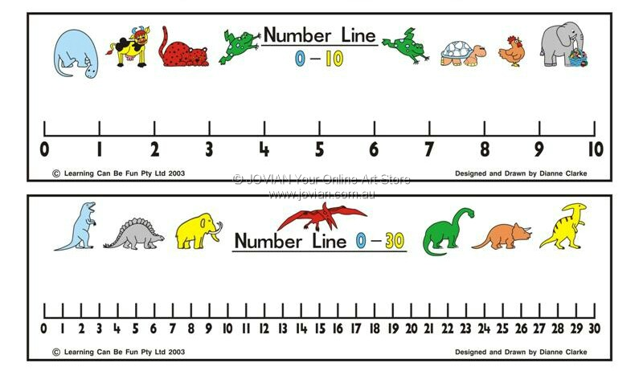**One More – Lesson 3**

**Number 1 more than**

5

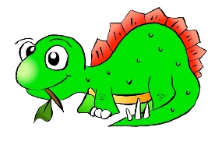

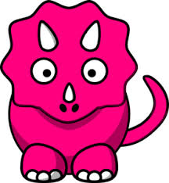

9



1

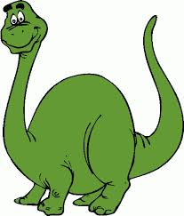

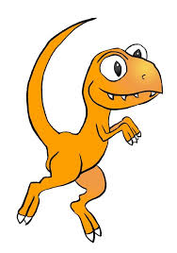

4



10

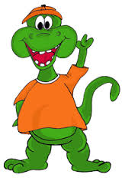

12

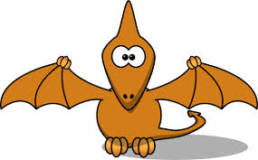

**One Less – Lesson 4**

**Number 1 less than**

7





10



5





13



15



20



One More and One Less – Lesson 5

|  |  |  |
| --- | --- | --- |
| **1 less** | **Number** | **1 more** |
|  | 2 |  |
|  | 7 |  |
|  | 5 |  |
|  | 1 |  |
|  | 6 |  |
|  | 9 |  |
|  | 11 |  |
|  | 17 |  |
|  | 19 |  |
|  | 13 |  |
|  | 12 |  |
|  | 18 |  |
|  | 14 |  |

**MCj03559450000[1]Can you be a Materials Detective?**

Can you find objects in your house which are made from the materials in the table below? Draw or list objects in the table below for each material.

|  |  |
| --- | --- |
| Material | Object |
| **Wood** |  |
| **Metal** |  |
| **Plastic** |  |
| **Glass** |  |

One-To-One Correspondence – Reasoning and Problem Solving – Lesson 6

1. Are there enough bowls for the bears? Draw lines to check.



1. Draw sweets for each child so they all get one.



1. There are four children going to the beach. Can every child have a bucket and spade. If not, why not? Discuss this with your child.



4.

Can the family all travel in a 5 seater car? Explain how you know.

Comparing Objects – Lesson 7

Use the following words to help you compare the objects below. If your child struggles to write these words, you can scribe for them.

Greater than, less than, equal to

[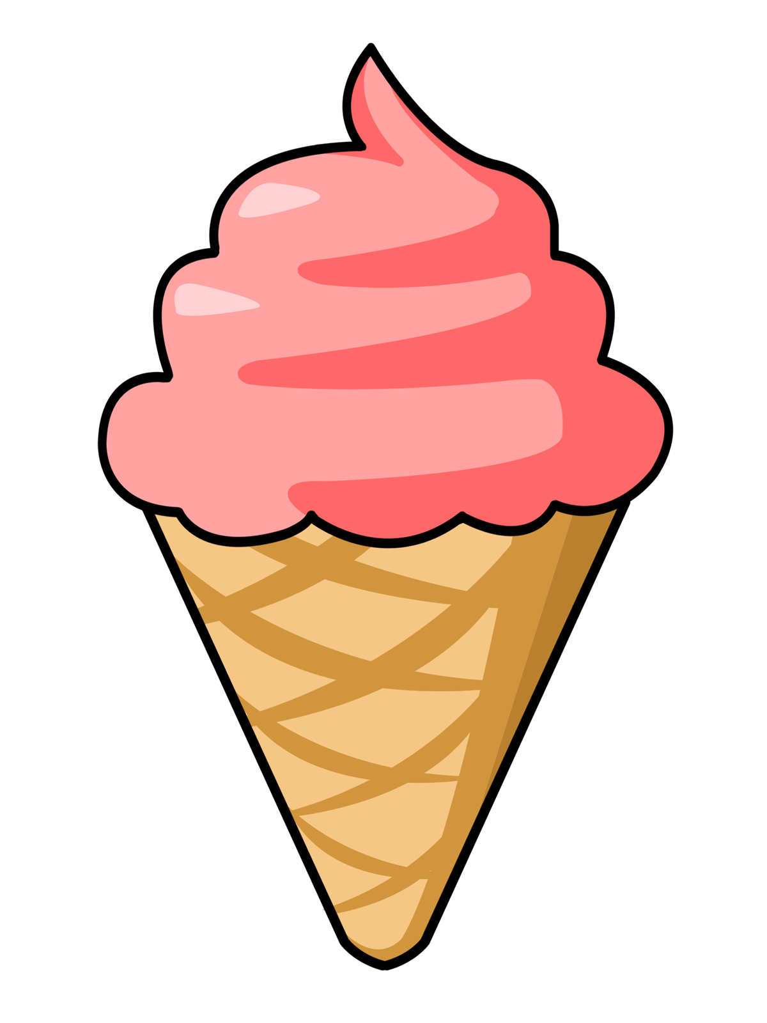](http://www.google.co.uk/url?sa=i&rct=j&q=&esrc=s&source=images&cd=&cad=rja&uact=8&ved=0ahUKEwjFj9Liq8_WAhUC7hoKHb3mAt8QjRwIBw&url=http://clipart-library.com/ice-cream-(cartoon).html&psig=AOvVaw2uMjJ00vngKmr4KldhDeOL&ust=1506944473458358)

[](http://www.google.co.uk/url?sa=i&rct=j&q=&esrc=s&source=images&cd=&cad=rja&uact=8&ved=0ahUKEwjFj9Liq8_WAhUC7hoKHb3mAt8QjRwIBw&url=http://clipart-library.com/ice-cream-(cartoon).html&psig=AOvVaw2uMjJ00vngKmr4KldhDeOL&ust=1506944473458358)

is ____________ than

[](http://www.google.co.uk/url?sa=i&rct=j&q=&esrc=s&source=images&cd=&cad=rja&uact=8&ved=0ahUKEwjFj9Liq8_WAhUC7hoKHb3mAt8QjRwIBw&url=http://clipart-library.com/ice-cream-(cartoon).html&psig=AOvVaw2uMjJ00vngKmr4KldhDeOL&ust=1506944473458358)

[](http://www.google.co.uk/url?sa=i&rct=j&q=&esrc=s&source=images&cd=&cad=rja&uact=8&ved=0ahUKEwjFj9Liq8_WAhUC7hoKHb3mAt8QjRwIBw&url=http://clipart-library.com/ice-cream-(cartoon).html&psig=AOvVaw2uMjJ00vngKmr4KldhDeOL&ust=1506944473458358)

is ____________ than

[](http://www.google.co.uk/url?sa=i&rct=j&q=&esrc=s&source=images&cd=&cad=rja&uact=8&ved=0ahUKEwj-s4O_rM_WAhVGPxoKHZURBGAQjRwIBw&url=http://www.clker.com/clipart-4129.html&psig=AOvVaw2uMjJ00vngKmr4KldhDeOL&ust=1506944473458358)

[](http://www.google.co.uk/url?sa=i&rct=j&q=&esrc=s&source=images&cd=&cad=rja&uact=8&ved=0ahUKEwj-s4O_rM_WAhVGPxoKHZURBGAQjRwIBw&url=http://www.clker.com/clipart-4129.html&psig=AOvVaw2uMjJ00vngKmr4KldhDeOL&ust=1506944473458358)

is ____________ than

[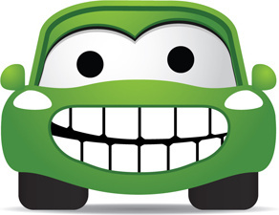](http://www.google.co.uk/url?sa=i&rct=j&q=&esrc=s&source=images&cd=&cad=rja&uact=8&ved=0ahUKEwi7sqiDrc_WAhWH7hoKHQ4fD9cQjRwIBw&url=http://all-free-download.com/free-vector/cartoon-car.html&psig=AOvVaw24RCRPF0b16AVUJEUN99Hb&ust=1506944808699192)

[](http://www.google.co.uk/url?sa=i&rct=j&q=&esrc=s&source=images&cd=&cad=rja&uact=8&ved=0ahUKEwi7sqiDrc_WAhWH7hoKHQ4fD9cQjRwIBw&url=http://all-free-download.com/free-vector/cartoon-car.html&psig=AOvVaw24RCRPF0b16AVUJEUN99Hb&ust=1506944808699192)

[](http://www.google.co.uk/url?sa=i&rct=j&q=&esrc=s&source=images&cd=&cad=rja&uact=8&ved=0ahUKEwi7sqiDrc_WAhWH7hoKHQ4fD9cQjRwIBw&url=http://all-free-download.com/free-vector/cartoon-car.html&psig=AOvVaw24RCRPF0b16AVUJEUN99Hb&ust=1506944808699192) is ____________ than

[](http://www.google.co.uk/url?sa=i&rct=j&q=&esrc=s&source=images&cd=&cad=rja&uact=8&ved=0ahUKEwi7sqiDrc_WAhWH7hoKHQ4fD9cQjRwIBw&url=http://all-free-download.com/free-vector/cartoon-car.html&psig=AOvVaw24RCRPF0b16AVUJEUN99Hb&ust=1506944808699192)

[](http://www.google.co.uk/url?sa=i&rct=j&q=&esrc=s&source=images&cd=&cad=rja&uact=8&ved=0ahUKEwi7sqiDrc_WAhWH7hoKHQ4fD9cQjRwIBw&url=http://all-free-download.com/free-vector/cartoon-car.html&psig=AOvVaw24RCRPF0b16AVUJEUN99Hb&ust=1506944808699192)

is ____________ than

Lesson 8 - Introducing the symbols > < and =

|  |  |  |
| --- | --- | --- |
|  | **<, > or =** |  |
| Image result for sweet clipartImage result for sweet clipartImage result for sweet clipartImage result for sweet clipart  Image result for sweet clipartImage result for sweet clipartImage result for sweet clipart |  | Image result for sweet clipartImage result for sweet clipartImage result for sweet clipart |
| Image result for ball clipartImage result for ball clipartImage result for ball clipart Image result for ball clipart |  | Image result for ball clipart Image result for ball clipart Image result for ball clipart Image result for ball clipart Image result for ball clipart  Image result for ball clipart Image result for ball clipart |
| Related image Related image Related image Related image Related image  Related imageRelated imageRelated imageRelated image |  | Related imageRelated imageRelated imageRelated imageRelated image  Related imageRelated imageRelated imageRelated image |
| Image result for lollipop clipart Image result for lollipop clipart Image result for lollipop clipart Image result for lollipop clipart Image result for lollipop clipart |  | Image result for lollipop clipart Image result for lollipop clipartImage result for lollipop clipartImage result for lollipop clipartImage result for lollipop clipart  Image result for lollipop clipart Image result for lollipop clipart Image result for lollipop clipart Image result for lollipop clipart Image result for lollipop clipart |
| Image result for pumpkin clipart Image result for pumpkin clipart Image result for pumpkin clipart Image result for pumpkin clipart Image result for pumpkin clipart  Image result for pumpkin clipart |  | Image result for pumpkin clipart Image result for pumpkin clipart Image result for pumpkin clipart Image result for pumpkin clipart Image result for pumpkin clipart Image result for pumpkin clipart Image result for pumpkin clipart Image result for pumpkin clipart |
| Image result for ladybird clipart Image result for ladybird clipart Image result for ladybird clipart Image result for ladybird clipart Image result for ladybird clipart  Image result for ladybird clipart |  | Image result for ladybird clipart Image result for ladybird clipart Image result for ladybird clipart Image result for ladybird clipart Image result for ladybird clipart  Image result for ladybird clipart |
| Image result for lego clipart Image result for lego clipart Image result for lego clipart Image result for lego clipart Image result for lego clipart  Image result for lego clipart Image result for lego clipart Image result for lego clipart |  | Image result for lego clipart Image result for lego clipart Image result for lego clipart Image result for lego clipart Image result for lego clipart |

Greater than or less than – Lesson 9

Use the following symbols to help you answer the questions

below.

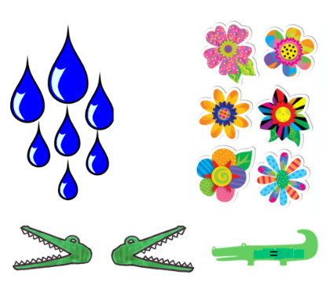

> <

Greater than Less than

10 2 14 8

5 4 7 13

3 9 15 11

5 5 14 14

8 12 20 19

9 8 8 15

Comparing Activities – Lesson 10

1. Circle all the numbers in the track that cannot go in the box.



1. Complete the blank dominoes



Note – The first blank domino should have more than 7 spots. The second blank domino should have 7 or more dots.

1. Game



Both players make a fist.

On 3, show some fingers

Use > < = to compare.

Spell the word to match these pictures. Add on the sound buttons. 22/09/20

|  |  |  |
| --- | --- | --- |
|  |  |  |
|  |  |  |
|  |  |  |
|  |  |  |

Name: ______________________ Date: 23/9/20

|  |  |
| --- | --- |
| I can spell words with the ‘n’ sound before ‘k’ (nk)  **Spell the words to match the picture.** | |
|  |  |
|  |  |
|  |  |
|  |  |
|  |  |

Put these words into a sentence.

**Weekly spelling to practice**- ll, zz, ff, ss (Statutory) 22nd September 2020 Super Spellers

|  |  |  |  |  |  |  |  |
| --- | --- | --- | --- | --- | --- | --- | --- |
|  | **Tuesday** | **Wednesday** | **Thursday** | **Friday** | **Saturday** | **Sunday** | **Monday** |
| jazz |  |  |  |  |  |  |  |
| whizz |  |  |  |  |  |  |  |
| off |  |  |  |  |  |  |  |
| fuss |  |  |  |  |  |  |  |
| miss |  |  |  |  |  |  |  |
| cross |  |  |  |  |  |  |  |
| will |  |  |  |  |  |  |  |
| well |  |  |  |  |  |  |  |
| **full** |  |  |  |  |  |  |  |
| **pull** |  |  |  |  |  |  |  |

**Weekly spelling to practice**- ll, ff, ss (Statutory) 22nd September 2020 Hero Spellers

|  |  |  |  |  |  |  |  |
| --- | --- | --- | --- | --- | --- | --- | --- |
|  | **Tuesday** | **Wednesday** | **Thursday** | **Friday** | **Saturday** | **Sunday** | **Monday** |
| well |  |  |  |  |  |  |  |
| chill |  |  |  |  |  |  |  |
| fill |  |  |  |  |  |  |  |
| pill |  |  |  |  |  |  |  |
| puff |  |  |  |  |  |  |  |
| cuff |  |  |  |  |  |  |  |
| off |  |  |  |  |  |  |  |
| kiss |  |  |  |  |  |  |  |
| **full** |  |  |  |  |  |  |  |
| **pull** |  |  |  |  |  |  |  |

**Weekly spelling to practice**- CVC words (Statutory) 22nd September 2020 Mega Spellers

|  |  |  |  |  |  |  |  |
| --- | --- | --- | --- | --- | --- | --- | --- |
|  | **Tuesday** | **Wednesday** | **Thursday** | **Friday** | **Saturday** | **Sunday** | **Monday** |
| fat |  |  |  |  |  |  |  |
| mat |  |  |  |  |  |  |  |
| sat |  |  |  |  |  |  |  |
| man |  |  |  |  |  |  |  |
| van |  |  |  |  |  |  |  |
| run |  |  |  |  |  |  |  |
| fun |  |  |  |  |  |  |  |
| sun |  |  |  |  |  |  |  |
| fog |  |  |  |  |  |  |  |
| jog |  |  |  |  |  |  |  |

**Weekly spelling to practice**- vc words Whizzy Spellers 20th September 2020

|  |  |  |  |  |  |  |  |
| --- | --- | --- | --- | --- | --- | --- | --- |
|  | **Tuesday** | **Wednesday** | **Thursday** | **Friday** | **Saturday** | **Sunday** | **Monday** |
| on |  |  |  |  |  |  |  |
| up |  |  |  |  |  |  |  |
| if |  |  |  |  |  |  |  |
| an |  |  |  |  |  |  |  |
| as |  |  |  |  |  |  |  |

**Weekly spelling to practice**- nk/ ck (Statutory) words 29th September 2020 Super Spellers

|  |  |  |  |  |  |  |  |
| --- | --- | --- | --- | --- | --- | --- | --- |
|  | **Tuesday** | **Wednesday** | **Thursday** | **Friday** | **Saturday** | **Sunday** | **Monday** |
| thank |  |  |  |  |  |  |  |
| think |  |  |  |  |  |  |  |
| drink |  |  |  |  |  |  |  |
| black |  |  |  |  |  |  |  |
| crack |  |  |  |  |  |  |  |
| stack |  |  |  |  |  |  |  |
| **me** |  |  |  |  |  |  |  |
| **no** |  |  |  |  |  |  |  |
| **she** |  |  |  |  |  |  |  |
| **so** |  |  |  |  |  |  |  |

**Weekly spelling to practice**- nk words (Statutory) 29th September 2020 Hero and Mega Spellers

|  |  |  |  |  |  |  |  |
| --- | --- | --- | --- | --- | --- | --- | --- |
|  | **Tuesday** | **Wednesday** | **Thursday** | **Friday** | **Saturday** | **Sunday** | **Monday** |
| thank |  |  |  |  |  |  |  |
| think |  |  |  |  |  |  |  |
| pink |  |  |  |  |  |  |  |
| drink |  |  |  |  |  |  |  |
| stink |  |  |  |  |  |  |  |
| blink |  |  |  |  |  |  |  |
| sink |  |  |  |  |  |  |  |
| wink |  |  |  |  |  |  |  |
| **me** |  |  |  |  |  |  |  |
| **so** |  |  |  |  |  |  |  |

**Weekly spelling to practice**- nk words (Statutory) 29th September 2020 Whizzy Spellers

|  |  |  |  |  |  |  |  |
| --- | --- | --- | --- | --- | --- | --- | --- |
|  | **Tuesday** | **Wednesday** | **Thursday** | **Friday** | **Saturday** | **Sunday** | **Monday** |
| of |  |  |  |  |  |  |  |
| off |  |  |  |  |  |  |  |
| can |  |  |  |  |  |  |  |
| dad |  |  |  |  |  |  |  |
| had |  |  |  |  |  |  |  |