Maths  We will be working on completing our work on decimals. Please log on to Mathletics and complete the tasks I’ve set. Remember that you can use the ‘i’ button (top right corner of the screen) for help, if you’re not sure how to do the calculations.  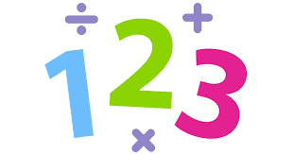  Once this work has been completed, I will set tasks to revise the work we have covered so far this term. Let’s see how many gold bars you can achieve! | English / Geography  As part of our work on persuasive writing, I’d like you to research the topic of Fair Trade and write a fantastic letter to your parents to persuade them to buy more Fair Trade products. You will have to think of some great arguments and research the prices of the products in order to convince them that it’s worth it! | Art  Can you design a poster to persuade people to buy Fair Trade goods? Think about the persuasive features used in the recycling posters we examined:  - Power of 3  - Alliteration  - Rhyme  - Imperative (bossy) verbs  - Rhetorical questions  - Colour  - Animals  - Puns / jokes
SPAG  Let’s revise how to use apostrophes for contractions and for possession. Have a look at BBC Bitesize: there are some short films to watch and some quizzes to do, to check you understand.  Contractions:  https://www.bbc.co.uk/bitesize/topics/zvwwxnb/articles/zcyv4qt  Possession:  https://www.bbc.co.uk/bitesize/topics/zvwwxnb/articles/zx9ydxs | 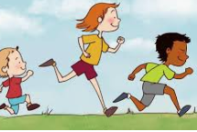  PE  It’s really important that we all stay fit and active. Try to do at least an hour of playing in the garden or walking out with a parent every day. Fresh air makes us all feel better! If you’re stuck inside, try a Joe Wicks workout:  https://www.youtube.com/watch?v=-TGEdzRzSbw | French  I’ve found a fabulous FREE app that you can use to practise your French! Log on and have a go – just 10 mins a day and you’ll be amazing by the summer! Remember to check with your parents that they are happy for you to download it first though.  https://www.duolingo.com/

