Y5 Home Learning Work
Dear children and parents,
I have designed this pack for children to continue their learning at home. There is no requirement to print any material, although I have included attached sheets if you wish to do so. In addition, children were sent home with (or posted) an exercise book for ‘Home Learning’ along with various printed resources, their online logins and a pencil to ensure they have the materials needed to continue their learning at home. In addition to the academic content below, I am sure you have plans to incorporate physical activity (Joe Wicks is live online every weekday at 9am) and learning through play (board games, etc.) while the children are at home.
Please note:
The homework set below is intended to last for 2 weeks. There will be no school/homework set over the Easter holidays.
Twinkl, an education resource support website, have offered free access for parents for one month to assist with home learning, please see the letter attached below for more information (including an access code).
The work set is for the purpose of learning at home while the school remains closed. However, your child’s wellbeing is of paramount importance during this uncertain time and there will be no repercussions for those children who have not managed to complete all tasks.
Should your child wish to further supplement their home learning I can recommend:
- Target Your Maths books by Stephen Pearce. These books are used to consolidate learning in school and they are available on Amazon along with answer books. https://www.amazon.co.uk/s?k=target+your+maths&i=stripbooks&ref=nb_sb_noss_2
- BBC Bitesize (online) has information on a variety of curriculum topics along with handy videos, these are designed specifically for children to help with home-based work. https://www.bbc.co.uk/bitesize
- Currently, Master the Curriculum have free access to mixed objective maths content for respective year groups. I have been using the 10-minute maths with 4/5N and it is a great way to keep prior learning fresh in their minds. Keeping tasks short and practising them often is the best way to reinforce prior learning. Please note not all resources are free on this site – look for ‘mixed objective’ material. https://masterthecurriculum.co.uk/
- Twinkl has a host of resources for all subjects. Please take an opportunity to browse this website (you also have free website access outlined in a below attachment) for any worksheets and activities your child may enjoy. https://www.twinkl.co.uk/search?term=
- Look at books with your child. They might read to you and you could read the same passage, modelling intended expression. You could also ask them questions based on what they have just read. Google reading VIPERS to gain more insight into questions that will support curriculum requirements. https://www.literacyshedblog.com/blog/reading-vipers
- There is a free e-book library on Oxford Owl – you just need to register for a free account to access these. https://home.oxfordowl.co.uk/books/free-ebooks/
- You could even make a scrap book or journal documenting this period of your lives.
- There are free drawing classes provided by famous illustrators as detailed on: https://www.fastcompany.com/90478307/stuck-at-home-take-free-drawing-classes-from-famous-illustrators
Finally, I wish you and your families well and, although the current situation is a challenge for us all, I will endeavour to send home school work to support your child’s learning for as long as necessary but do look forward to the time when we can welcome all children back to school once this has passed. Until then, my thoughts are with all of you – Mrs New.

17.3.20 | Y5
Spellings | You have been sent home with a Statutory Spellings list for Y5/6. Please ask someone at home if they can test you on this at a convenient time. Write the answers in your book and then self-mark using the sheet.  If you got spellings correct, I would like you to highlight these on the spellings sheet provided.  The following week I would like to ask you to be tested again, this time you will only need to be tested on those spellings which are NOT highlighted on the sheet.  If you misplace the sheet, there is an attached copy below.
Times Tables | You have been set the following on Times Table Rockstars:  5 x Studio games per week (questions up to 12 x 12  5 x Soundcheck games per week (6 second limit per question (as per MTC expectations)  I will be monitoring participation by students online, please continue to build on the great progress we’ve had this year – practising little and often will secure this progress.  I have also attached a copy of our weekly times table test for you to complete, please write answers in your book, self-mark and keep a record of your total.  For further challenge, I have also attached a division test for those children who are secure with their times table knowledge.
Maths | There are 10 x maths tasks using your login for Mathletics  This will equate to one maths task  each week day for the set duration of two weeks.
Literacy | You have been sent home with a first draft of your persuasive letter along with resources to help you create a final draft. Unfortunately, some children, due to absence, were not able to get to the first draft stage, but please try to use the resources provided to write a final draft of a persuasive letter to convince your Head teacher of the merit of one of the following ideas:  - That 4/5N should go on a trip to Legoland.  - That we should teach a brand new subject (of your choice) in school.  - That YOU should be the next School Council representative.  I have attached copies of resources sent home in the event these are misplaced.
Reading | Please read for at least 10 minutes every day this week.  Record your reading and Book Reviews in your Home Learning Book, an example Book Review template has been attached to this document.
Grammar | There are 5 literacy-based tasks on Education City.
Special Assignment | Please play a board game with all/some of your family.

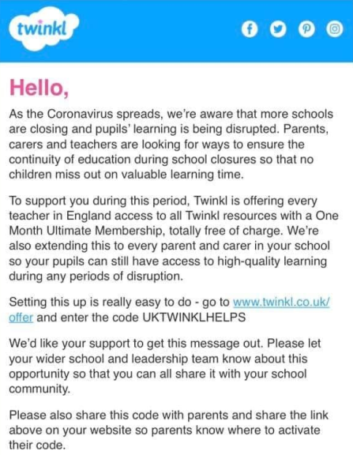

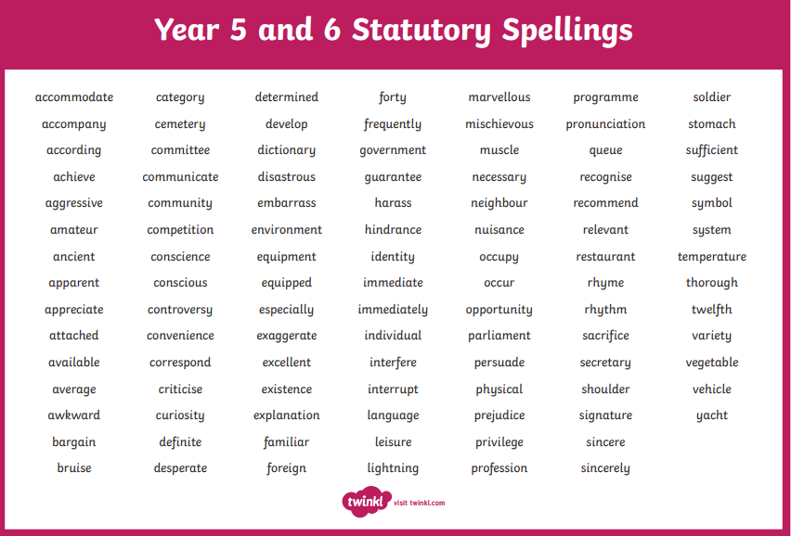

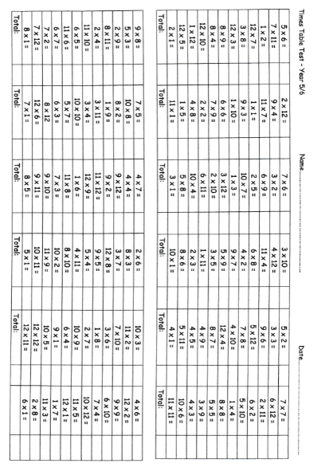
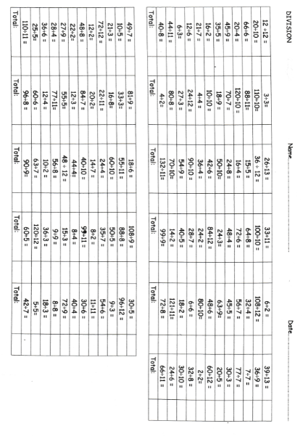

Writing to Persuade Checklist
Rhetorical questions to engage the reader (hook) | Do you want to have an amazing day out?
Groups of 3 | 3 adjectives or phrases: Homework is boring, dull and uninteresting.
Repetition | Remember what it was like to be in school; remember how much work you had.
Exaggeration | If I get one more piece of homework, I am going to move to the moon!
Superlatives | Best, fastest, most amazing
Emotive language | Poor, helpless children or lazy, idle lot
Adverbials to convey a sense of certainty | Surely we can all agree …? Obviously …, without a doubt …
Present tense | are, is, using, doing, am
Connectives to make arguments flow | Because, however, this shows, therefore, furthermore
Time connectives to begin main body paragraphs | Firstly, in addition, finally, etc.
Imperative and modal verbs to convey urgency | Buy it today!  Listen very carefully …
Modal verbs to convey urgency | This product will transform your life!
Short sentences for emphasis | This has to stop!  Vote for change!
Facts & Statistics | To support your arguments
Semi-colons to structure repetition | Bring your friends; bring your children; bring the whole family!
Brackets or dashes, including for emphasis | This is our chance – our only chance – to make a difference.
Relative clauses to provide additional enticement | Our hotel, which has 3 swimming pools, overlooks a beautiful beach
Use commas to make fronted adverbials and subordinate clauses | After your visit, you won’t want to leave.  Once you’ve tasted our delicious sandwiches, you’ll be coming back for more!

