Hello 5B!
As you already know, our FS, Y1 and Y6 children have been invited to return to school on the 1st June and some of them have decided to do so. We haven’t forgotten about everyone else though and will be setting work for you to complete at home as normal, until we can all get back together again. Please don’t think that you’re missing out; school during June will be very different from before and I’m sure you’ll have lots of fun at home.
I am very grateful for Mrs Birchenall’s help in designing your next two weeks of home learning, to make sure that all our Year 5 children are covering roughly the same work, across all classes. We have set a bit more work this time so that it matches what might be going on in Upper KS2 lessons in school, from the 1st June. Please don’t worry about that, just complete as much of the work as you can. If you need any help, remember that you can contact me through school on 01400 659001 or by email: enquiries@cranwell.lincs.sch.uk .
Mrs Barrett and I will be in school daily from the 1st June. It will be a bit of a shock getting up early again! We have both enjoyed being at home with our children over the past few weeks; I wonder if they will keep working hard when we aren’t there to keep an eye on them?!! I have been enjoying the sunshine in my garden and at the stables, looking after my horse. Mrs Barrett has recently managed to find a lake to swim in, which is a bit bigger than her paddling pool. We hope that you and your families are happy and well, and we are really looking forwards to seeing you again soon.
Mrs Bullement
Maths – Week beginning 1/6/20  Please continue to complete your daily maths lesson, using the White Rose resources from the website. Have a go at the questions on the video, on a piece of paper. Remember to also follow the links to BBC Bitesize for even more practise.  You can find your lessons here: https://whiterosemaths.com/homelearning/year-5/ Please move onto the section labelled ‘Summer Term Week 6 w/c 1st June’. The videos are also available on Facebook, if the website is overloaded.  Of course, I’ll continue to set tasks on Mathletics, but only do these if you have spare time!  Want an extra challenge? Complete the horses and hay question below (answers at the end).  Bored? Have a look at this website: it’s a weekly FREE maths ‘newspaper’ which is full of interesting challenges https://www.cdmasterworks.co.uk/the-daily-rigour/ | Maths – Week beginning 8/6/20  Please continue to complete your daily maths lesson, using the White Rose resources from the website. Have a go at the questions on the video, on a piece of paper. Remember to also follow the links to BBC Bitesize for even more practise.  You can find your lessons here: https://whiterosemaths.com/homelearning/year-5/ Please move onto the section labelled ‘Summer Term Week 7 w/c 8th June’. The videos are also available on Facebook, if the website is overloaded.  Of course, I’ll continue to set tasks on Mathletics, but only do these if you have spare time!  Want an extra challenge? Try the fraction problem below (there’s a hint and answers at the end, but try not to cheat!).  Bored? Have a go at this week’s maths challenges in the Daily Rigour! https://www.cdmasterworks.co.uk/the-daily-rigour/
Literacy – Week beginning 1/6/20  Attached below is a booklet from ‘Talk for Writing’ called “One Chance”. It takes the form of a booklet which I have included below this table. Inside it you will find lots of things to work through that will help with your reading and writing skills and build on the work that we do in school.  It all begins with a moral…be careful what you wish for!  Monday – complete the section called Just One Wish – what would you wish for? Think very carefully! When you have done that, complete the next section - The Downside. When you have finished that section then move on to The Mirror of Wishes, followed by The Mirror of Despair.  Tuesday – Read or listen to the story (there is a link in the booklet to an audio version if you need some support or if you prefer to listen to it). After reading the text and completing the small tasks, move to the section What do the Words Mean? If you are finding it hard and don’t have a thesaurus or dictionary at home then try an online one such as: https://www.wordsmyth.net/ or https://kids.britannica.com/kids/browse/dictionary. Next complete Similar Meaning or Opposite Meaning.  Wednesday – Complete Likes, Dislikes, Puzzles and Surprises, before moving on to Closer Reading.  Thursday – Complete Creating a Mood with a Sentence of 3(a) followed by (b) before completing Writing Speech Effectively.  Friday – Time to write your story! Complete the section Now Plan Your Own Wishing Story. When you are happy with your planning, Use Your Plan to Draft Your New Wishing Tale. Share your tale with another human being or even maybe your pet. | Literacy – Week beginning 8/6/20  NEWSFLASH – you have reached the grand old age of 99! Happy Birthday!! You have decided it is time to write your autobiography (auto=self; bio=life; graphy=to write).  We are giving you the chance to look back on your life to reflect on the wonderful things you have done, the places you have been, and the inspirational people you have met.  You will need to ensure that you are mentioning any major events (the Coronavirus pandemic would probably be one of these as it is a global event and you can record what it was like to have been a child during this unprecedented time). You could also include being invited back to your school when you were 60 to open a Covid-19 time capsule, buried by Mr Wilson in 2020!  What other major or memorable events might happen in your lifetime? Could anything happen in space travel? Will all vehicles be electric? Will something have been invented to replace aeroplanes? Will we still be a country of dog and cat lovers or are we all now bee keepers?  Will you have had children? Grandchildren? Great-grandchildren? Perhaps you could include an imaginary family tree within your autobiography, to make it seem authentic?  Who will be on the throne when you are 99? Who will have been on the throne between now and then (remember our learning in the Autumn Term, about the Royal Family)? Thinking about how music has changed throughout the decades, what will you be listening to when you are 99?  What career did you choose? Did you have more than one career choice? Try to keep it realistic – most people don’t tend to be famous footballers, famous popstars or famous YouTubers! What experiences did you enjoy in your working life? If you became a vet, did you manage to go overseas to work with big cats in a Kenyan wildlife reserve, for instance? If you became a volcanologist, which volcanoes have you visited in your research? Maybe your love of dancing led to you creating your own dance school after a career in a ballet company?  Tell me all about your exciting life-to-come!
Reading/Art task – Week beginning 1/6/20  This week we would like you to create a new book cover for the book that you are currently reading. Have a good look at the existing book cover. Why did the illustrator choose that image for the book’s front cover? Does the picture on the front cover give anything important away or just enough to get you interested? What image do you think would represent the book well and make people want to read it? Don’t forget the title, author, illustrator and publisher information. You will need to write a blurb for the back cover too.  Remember to allow yourself some time to continue reading your book – at least 20 minutes a day. You could even create a den in the garden to relax in with your lovely book, and allow the author to transport you somewhere else! You don’t always need to leave your home to have an adventure. | Reading/Art task – Week beginning 8/6/20  This week we would like you to think about your favourite book that you have ever read. I remember, when I was a very young child, I loved the ‘Mog’ books by Judith Kerr, especially at bedtime, and I have read all of them to my own children too. When I was about your age, I was (still am!) pony-mad, so my favourite books were the ‘Jill’ series, by Ruby Ferguson. I used to read them by torchlight, under my duvet, after ‘lights out’! Later on, I particularly enjoyed reading The Lord of the Rings books, by Tolkien, which were exciting, scary and ‘unputdownable’!  There are lots of interesting and wonderful books out there, whether you crave adventure or sci-fi; animals or ‘Gangsta Grannies’. Give yourself time to think about which you feel would be your favourite still, when you are 99 years old.  Once you have decided, design and create a new book cover for it. Remember the book cover should give a hint of the story within without giving anything away; it needs the title, author and publisher information. You will also need to include the blurb for the back cover and perhaps the price.  Remember to find time to read undisturbed too!
Geography – Week beginning 1/6/20  WHAT ARE NATURAL RESOURCES?  Jot down what you think natural resources are before watching the following clip from BBC Bitesize and see if you were right: https://www.bbc.co.uk/bitesize/topics/zshp34j/articles/z62qy9q - the end made me chuckle! Watch the clip again and this time make notes – you could just use a spider diagram like we do on the board at school.  Next have a look at the nine pictures included below. What is happening in each of the pictures? Ask older siblings or your parents if you are stuck – or even share them with other relatives, if you video call them.  Some other countries also have valuable natural resources. For example: South Africa has gold; New Zealanders farm sheep, which suit their landscape perfectly; Venezuela has lots of oil, and Iceland has plenty of ocean to fish.  Your task this week is to find out as much as you can about the countries in the example above (South Africa, New Zealand, Venezuela and Iceland) and their amazing natural resources. You could make a min-fact file for each or a PowerPoint, if you have the chance to use the computer. I will leave the presentation and format up to you! | Geography – Week beginning 8/6/20  RENEWABLE AND NON-RENEWABLE RESOURCES – WHICH IS WHICH?  Jot down as many different energy sources as you can think of. Ask siblings, parents and relatives to help you. Now watch the short video clip on BBC Bitesize: https://www.bbc.co.uk/bitesize/topics/zshp34j/articles/zntxgwx  Have a look at the list you created before the video clip. Have you been able to add any more to it?  There are some ENERGY CARDS attached below. Sort the cards into two groups: renewable energy sources and non-renewable energy sources. Don’t worry if you can’t print them off: you could look at them on the screen and write them in two columns. Next explain to another human being why you chose them to be in each group – how good are you at explaining?  Draw an annotated (labelled) poster for each of the two groups, to show which energy sources belong in which. Make sure you label them clearly!  Ask a sibling, parent or relative (via the phone) what they think the advantages of renewable energy might be. Do they all agree? What do you think? Now ask what they think the disadvantages might be. Do they all agree? What do you think? You could use the activity sheet attached below (ADVANTAGES AND DISADVANTAGES SHEET), if you are finding it hard.  Your task this week is to choose one of the following energy sources and to research it and create a fact file or PowerPoint about it. Here is the list to choose from (the ones in green are trickier if you want a challenge!):  Renewable – wind, geo-thermal, biomass, hydro-electricity.  Non-renewable – coal, natural gas, oil, nuclear.
Spelling Task – Week beginning 1/6/20  Can you use a dictionary to find out what these words and terms mean, and then learn how to spell them? Don’t worry if you don’t have a dictionary at home, you can, with your parents’ permission, use Google, https://www.wordsmyth.net/ or https://kids.britannica.com/kids/browse/dictionary.  Here are this week’s topical words / terms:  - Natural resources  - Agricultural resources  - Geological resources  - Crops  - Oil  - Wind  - Rivers  - Tides  - Minerals  - Fossils fuels  - Renewable energy  - Non-renewable energy | Spelling Task – Week beginning 8/6/20  Just like last week, can you use a dictionary to find out what these words mean and then learn how to spell them? Try to use the words in your work in your Geography work. Remember, if you don’t have a dictionary at home, with your parents’ permission, try one of the online ones: https://www.wordsmyth.net/ or https://kids.britannica.com/kids/browse/dictionary.  Here are this week’s topical words:  - Geothermal  - Biomass  - Hydroelectricity  - Nuclear  - Natural gas  - Coal  - Oil  - Distribution  - Imbalance  - Starvation  - Conservation
French  We hope you have been enjoying practising your French, using Duo Lingo. Keep having a quick go each day (5 minutes is fine) – it’s fun and you’ll learn so many new words! https://www.duolingo.com/ | PSHE  At times like this people can often experience a wide range of emotions. You are missing those you love, like family and friends; missing normal routines and school; missing your clubs and activities; missing going shopping for toys and games; missing birthday parties and celebrations outside your home; missing being free to move around the country and to travel on a plane; missing eating out in restaurants and going to the cinema.  There are lots of things that I am sure you all miss that I haven’t mentioned. It’s ok to feel like this. It’s ok to miss people, things and opportunities. It is all perfectly natural.  What can we do about it? Well we can’t change how things are, that’s for certain, but we can think of ways to tell people how much we miss them. Why not try one of these ways below:  - You could create a “hug” out of paper for someone you miss, make sure the arms are long enough! Then write all the things you love about them along each of the paper arms and put it in an envelope to send to the person you miss, perhaps your grandparents or another relative.  - You could write a letter, thanking someone for being them, or just to say “hi”. It’s nice to receive a letter through the post, that someone has taken the time to write; maybe you will be lucky and receive one back?  - You could write a gratitude diary listing all of the things you are grateful to have in your life and all the things that you are looking forward to doing one day soon. They will be worth the wait!
Art/Relaxation
If you would like to colour in some mindfulness pictures, then there are some attached below. Colouring in is great food for your soul. It helps relax your brain and gives you space to just “be”.

Here is a link to a bumper pack of free colouring pages from Twinkl: https://www.twinkl.co.uk/resource/t-c-1551-mindfulness-colouring-sheets-bumper-pack

Or…
Like Andy Goldsworthy, https://www.kidzworld.com/article/29663-andy-goldsworthy-the-art-of-nature can you try a pebble balance challenge? https://www.youtube.com/watch?v=HBvgaOlR9J4 or this https://www.youtube.com/watch?v=hdjPYsPZaks have lots of fun but be careful and remember to ask permission from your parents/carers before deciding where to create your challenge.
PE  Keep up with Joe Wicks every day or if you prefer to move around to music try Just Dance. Perhaps yoga is your thing? https://www.youtube.com/user/CosmicKidsYoga  Mrs Owen has sent lots of ideas via Parent Mail which I hope you are enjoying completing. | PE  Keep up with Joe Wicks every day – it is important to keep moving around and to be active.  If you fancy a change, why not try skipping? Here is a link for an explanation of how to begin to skip if you can’t already do so https://www.youtube.com/watch?v=OKu5s-2RyiQ and then once you have mastered the skill, there are many more challenges to complete: https://www.youtube.com/results?sp=mAEB&search_query=dan+skipping+man

Maths Extra Challenge – Week beginning 1st June

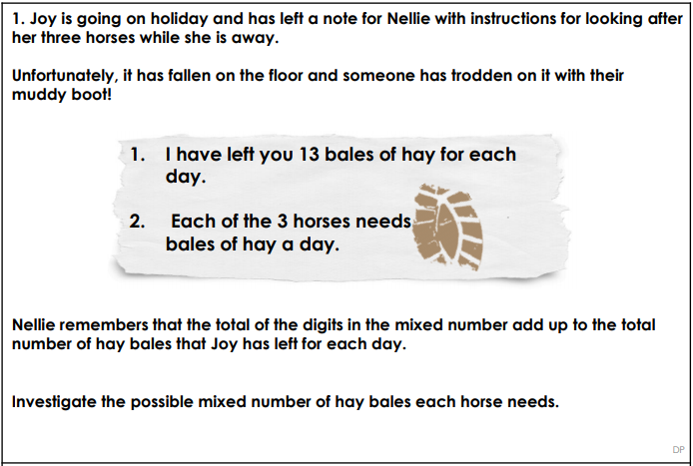
Maths Extra Challenge – Week beginning 8th June
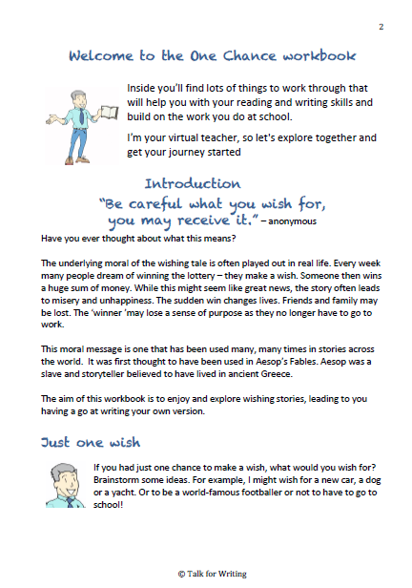
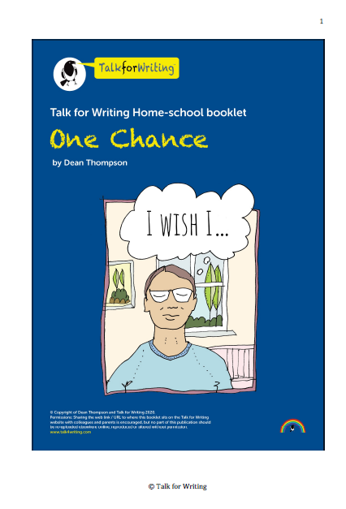
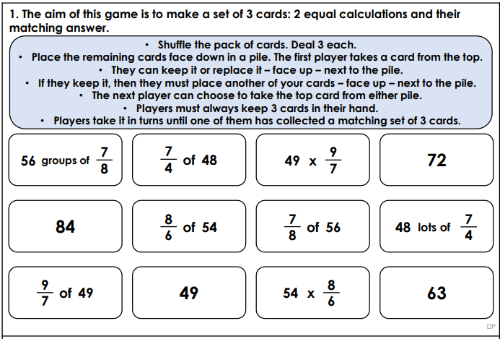

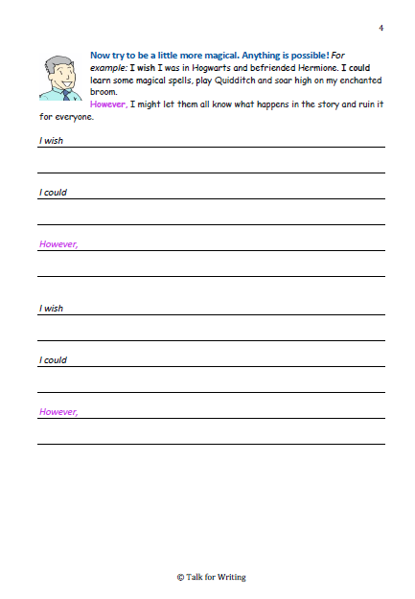
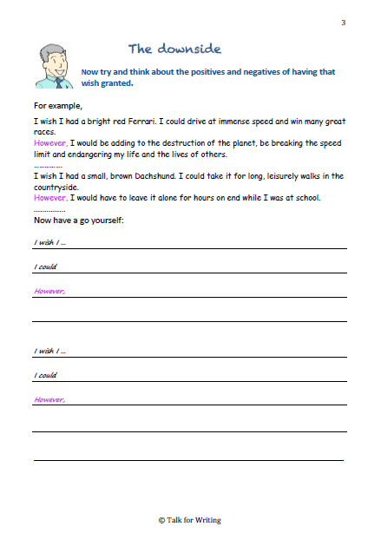
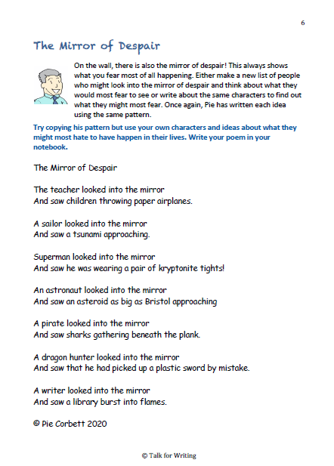
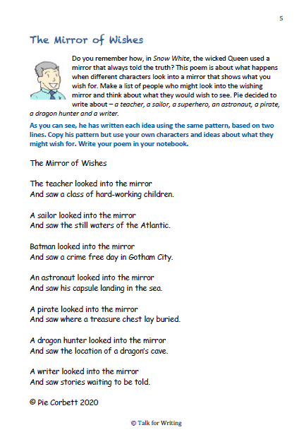
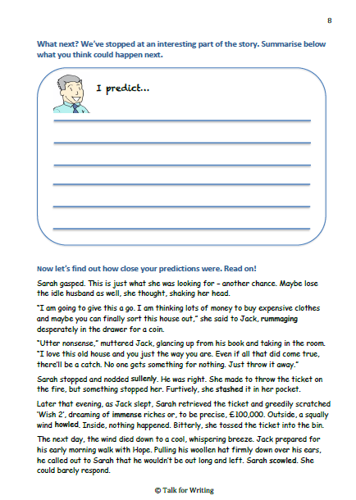
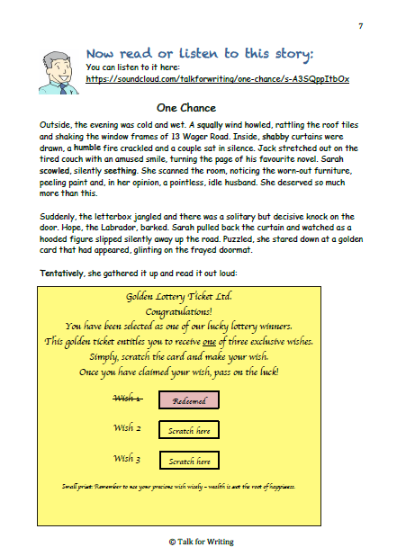
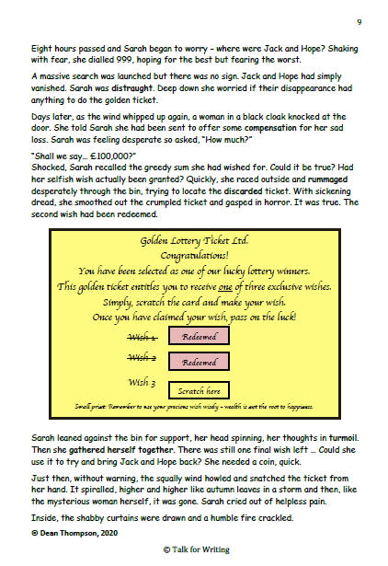
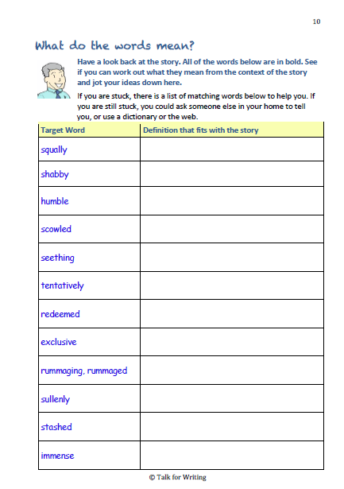
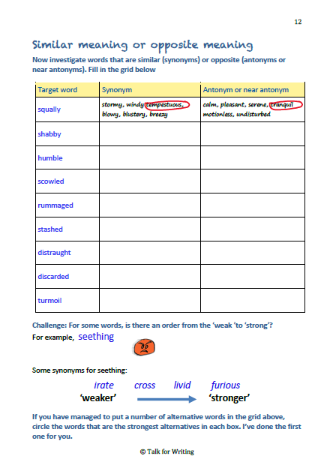
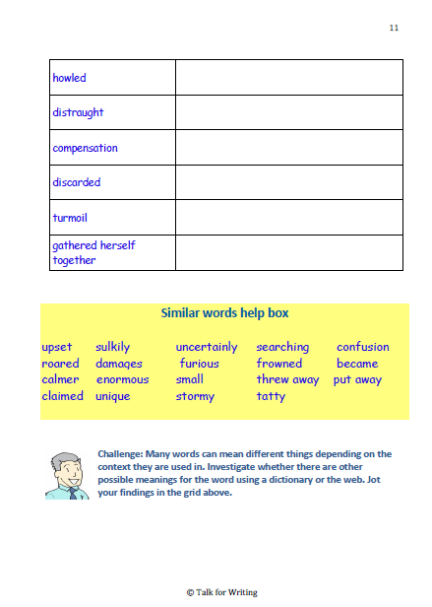

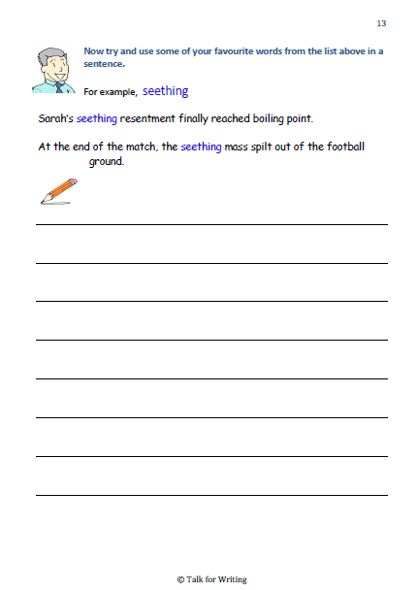
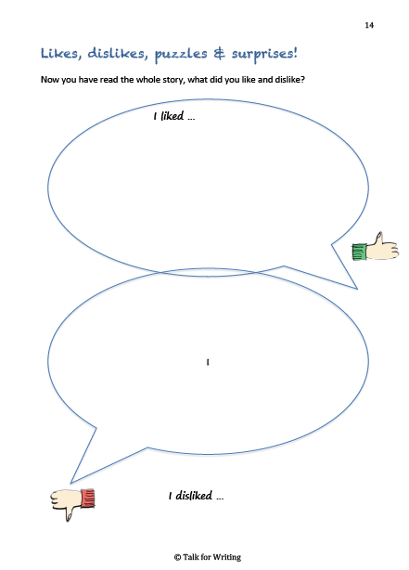
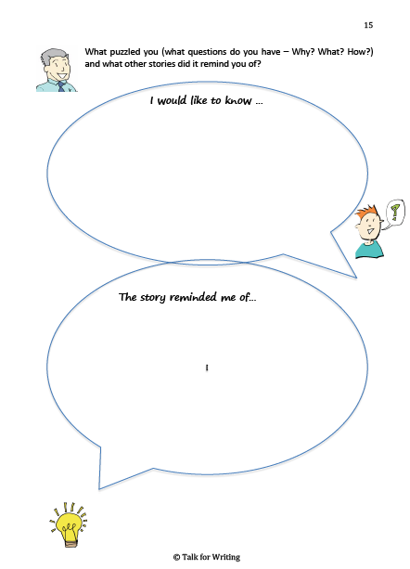
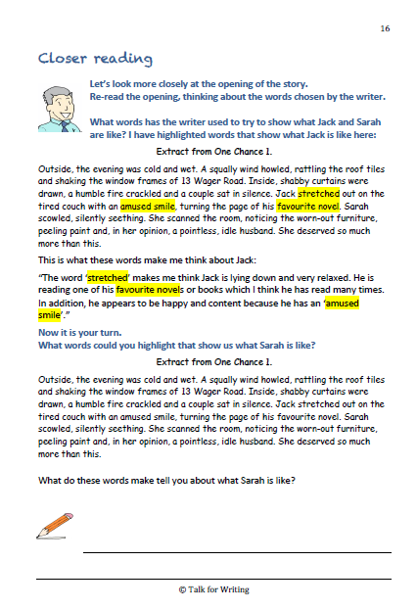

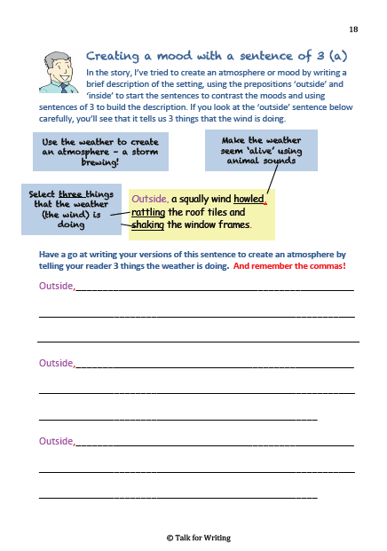
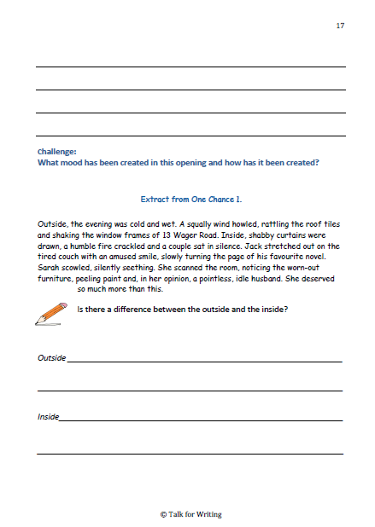

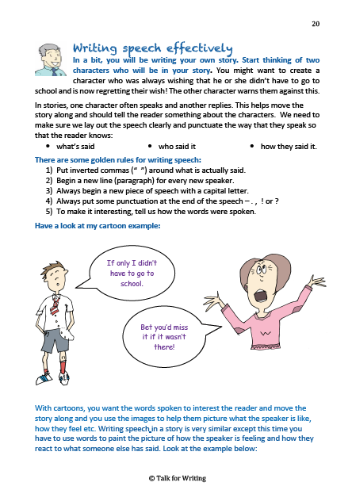
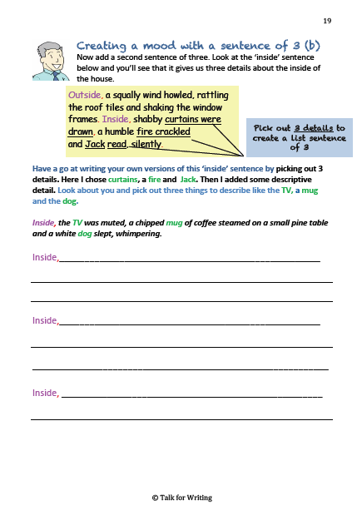

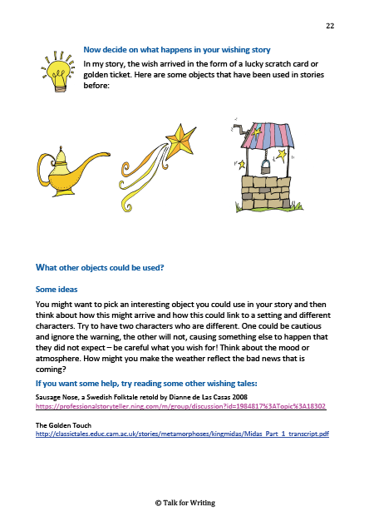
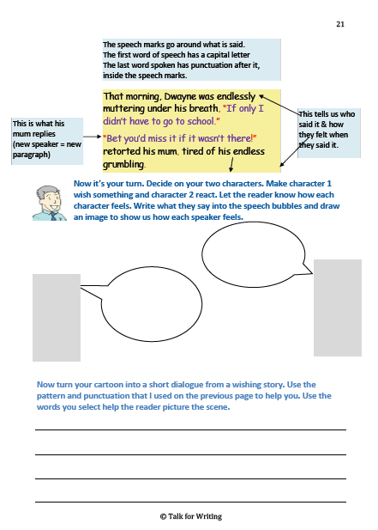
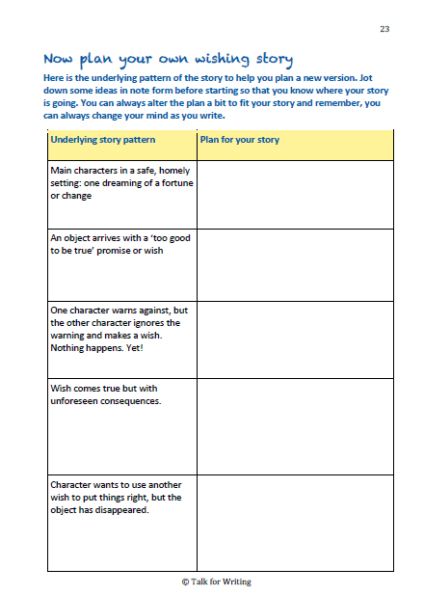
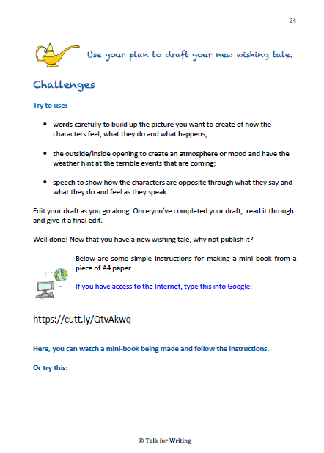
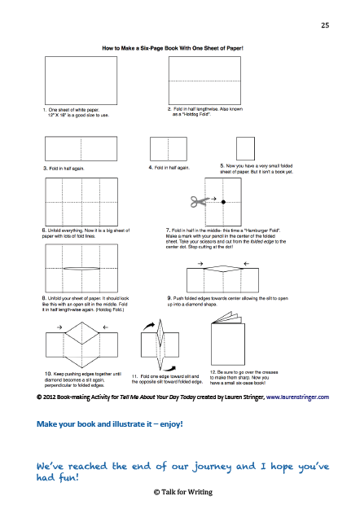

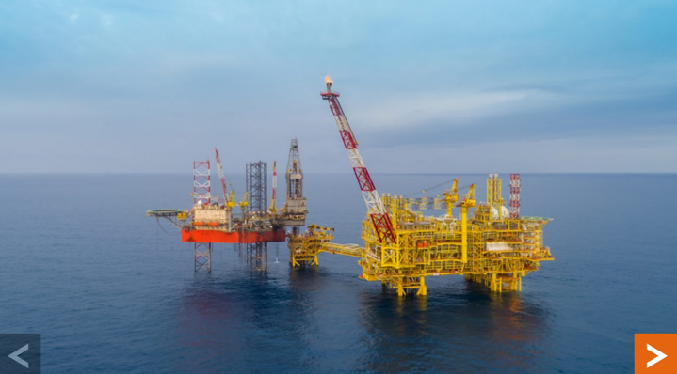 | 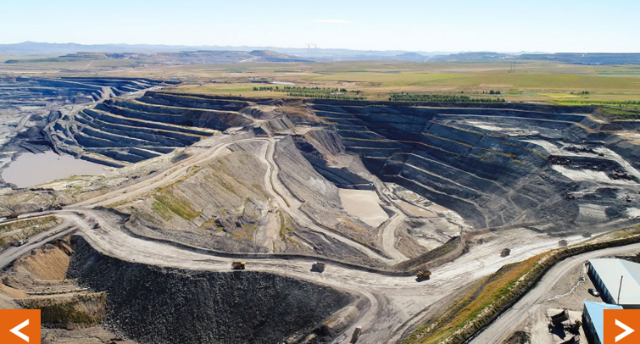 | 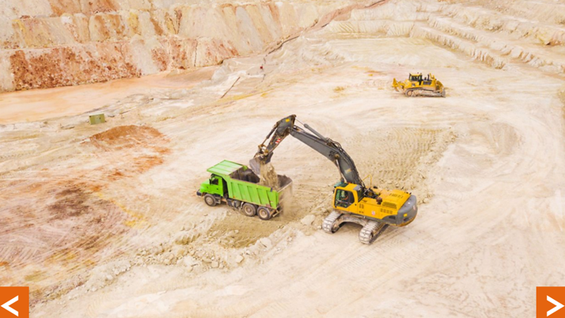
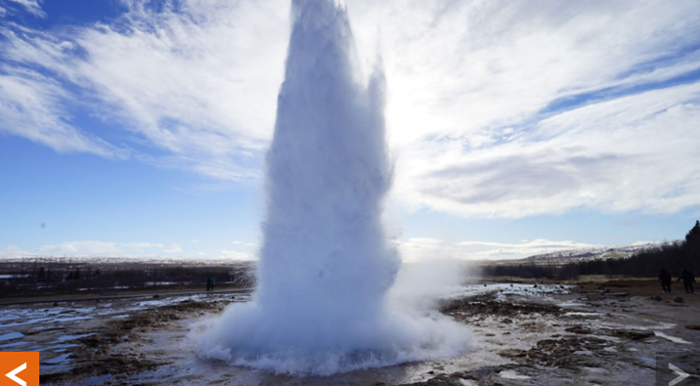 | 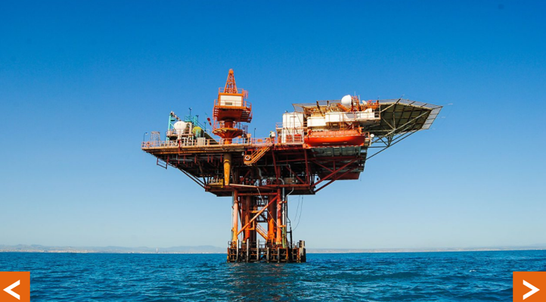 | 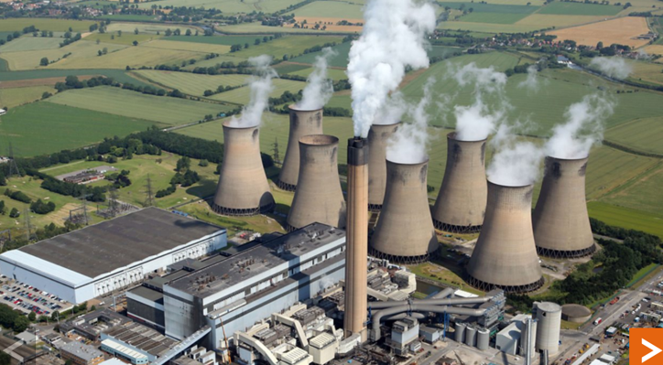
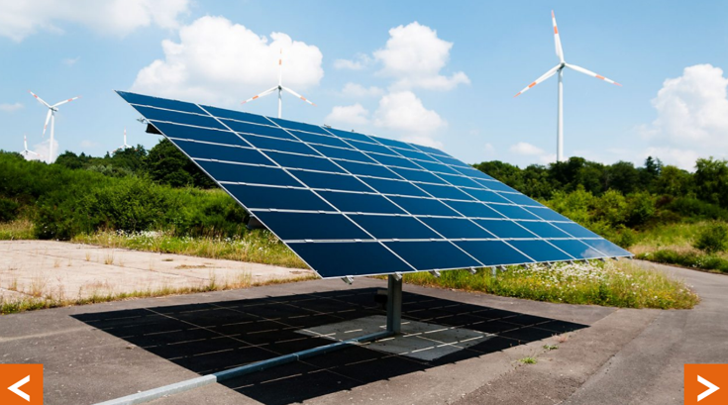 | 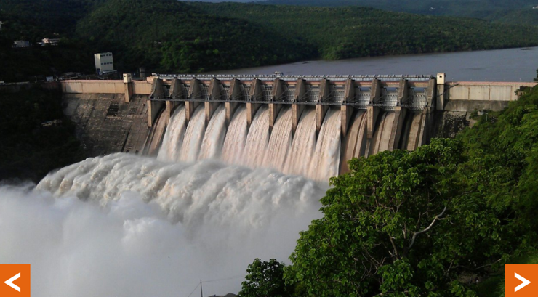 | 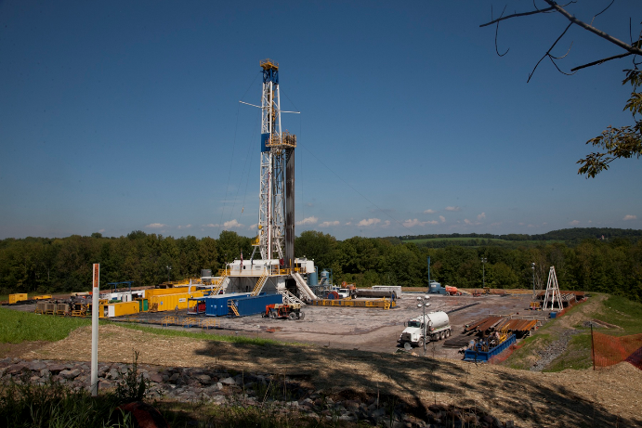  W
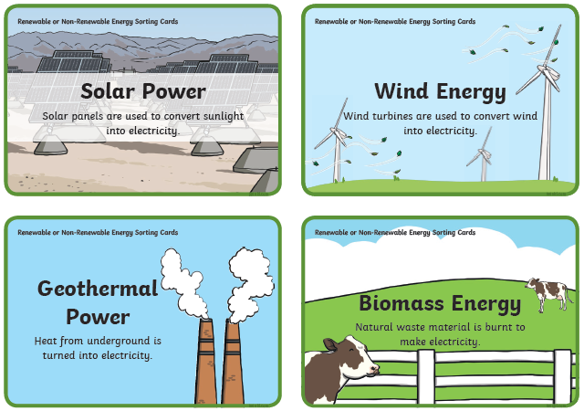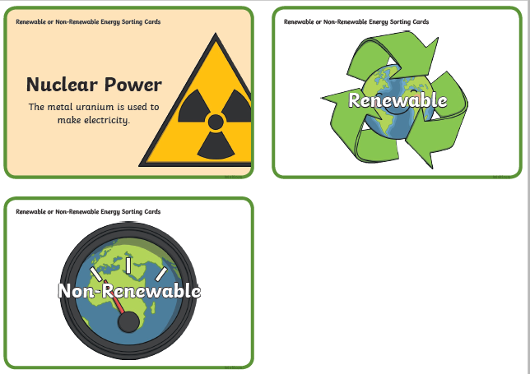
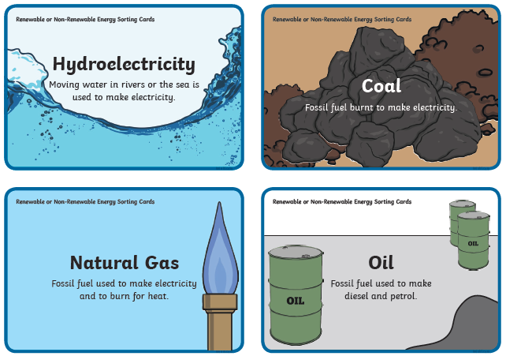
Geog for Week beginning 8/6/20 – Advantages and disadvantages of renewable and non-renewable energy sources
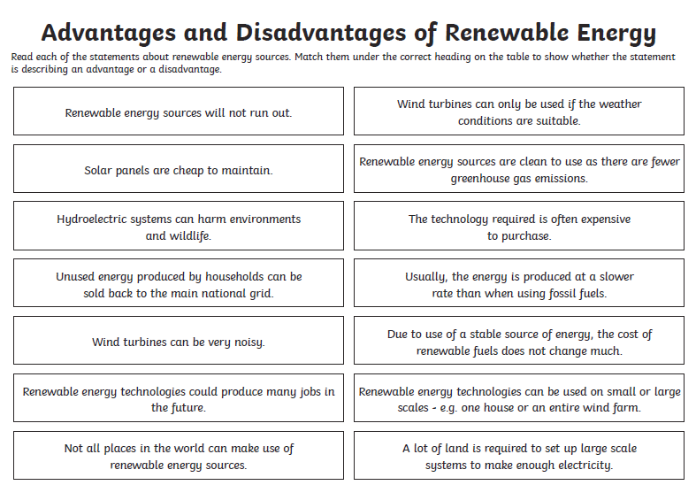
ANSWER SECTION – TOP SECRET – ANSWER SECTION – TOP SECRET – ANSWER SECTION – TOP SECRET – ANSWER SECTION – TOP SECRET – ANSWER SECTION – TOP SECRET

