Maths
Fir the next two weeks we are using the White Rose alternative plan for summer week 5 and 6.
The topic is addition and subtraction.
Times tables
You need to keep practising your times tables. Have a look on the times table page for websites to help you.
Writing/Topic
We will be focusing on literacy for the next two weeks. Please see the literacy page and the extra resources for more information.

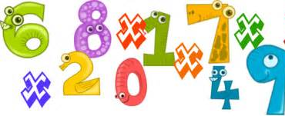

Extras – MFL
In Years 3 & 4 we have been learning some basic French. Explore the Duolingo website to help you improve your French!
https://www.duolingo.com/

Reading
We would normally read every day in class – try to read every day and record this in your reading record. If you have finished your reading record could you make your own or just write down your page number on paper.
Reading activities are included in our literacy planning.

Spelling Punctuation and Grammar
Use this time to learn the words from the 3/ 4 Word list you can find in the front of your planner.
SPaG activities are included in our literacy planning.
Maths Activities
It was great to hear that you all have been working hard on your maths whether that is through the White Rose videos, bitesize or mathletics! This work is to last you two weeks.
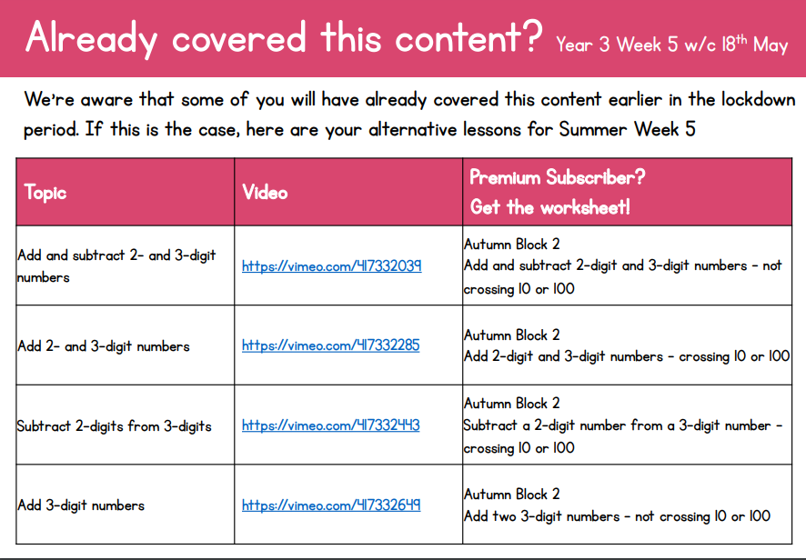
These topics are from the White Rose alternative plan as we have already completed their fractions work. Click the purple box to download the alternative plan or click this link. https://wrm-13b48.kxcdn.com/wp-content/uploads/2020/05/Y3-Week-5-Alternative-Plan.pdf

Click on the links provided on your online version to watch the videos and I have included the corresponding worksheets in the extra resources.
Week beg 8th June: https://wrm-13b48.kxcdn.com/wp-content/uploads/2020/05/Year-3-Week-6-Alternative-Plan.pdf
You still have the option to go on Mathletics and education city and these will match up to the addition and subtraction topics.
https://login.mathletics.com/ https://www.educationcity.com/
Extra Maths Games
https://play.prodigygame.com/ - Pokemon style game with maths questions!
https://play.edshed.com/ - practise your number bonds, power of 10 and addition and subtraction
www.topmarks.co.uk –interactive games
https://www.oxfordowl.co.uk/for-home/kids-activities/fun-maths-games-and-activities/#maths-7-9 – games and activities
https://www.mathswithparents.com/KWeb?startTime=1584558592239#menu584883 – Free access to parents – videos and activities across the maths curriculum.

Times Table Activities
I have had a few questions about the expectations of times tables in Year 3 so to make you all aware by the end of Year 3 children should be able to know (off by heart and in any order) the 2,3,10,3,4 & 8 times tables. Year 4’s are expected to know all of their times tables by the end of the year ready for the National Multiplication check.

https://play.ttrockstars.com/auth/school - Times Table Rock Stars is a great way to practise your times tables
https://www.timestables.co.uk/ - Learn and practise
https://www.topmarks.co.uk/maths-games/7-11-years/times-tables
https://www.oxfordowl.co.uk/for-home/maths/help-with-times-tables/
Literacy Activities
For this next set of Home Learning we are focusing on Literacy. Within this pack there are daily lessons with all resources included. There are however, around 3 tasks per day which I understand is quite a lot so I am setting the Week 5 pack for both weeks. Please divide the tasks up as you see fit. If you finish Week 5 and would like to start Week 6 that is fine but your choice.
https://www.hamilton-trust.org.uk/blog/learning-home-packs/ Year 3 English Week 5
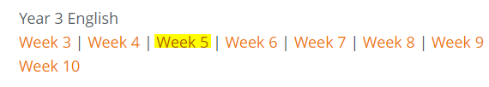
The ‘timetable’ for Week 5 (1st June) is as follows
- Day 1 – Children read a version of King Midas and the Donkey Ears. They order and illustrate the event and tell the story to somebody else. They answer questions about the characters in the story.
- Day 2 – Go through the dialogue PowerPoint, they will hear the voice-over teaching. Children re-read the story and then punctuate provided speech.
- Day 3 – Children read a version of King Midas and the Golden Touch. They make a summary of the story. They imagine a conversation from the story and then write it as properly punctuated direct speech.
- Day 4 –Children read a description of the Harry Potter Studio Tour. They make notes about the report. They explore a website and make further notes about their own preferences and choices.
- Day 5 –Children read two contrasting reviews of visits to the Harry Potter Studio. They speculate about the writers of the reviews and then write their own review about a brilliant or an awful day out.

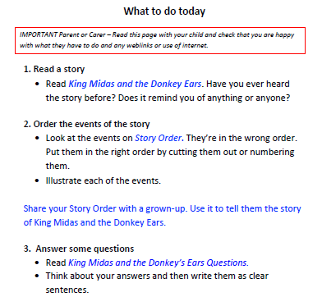

Spelling Punctuation and Grammar Activities
R.E. Topic Work
There are SPaG activities included in the Hamilton Trust English pack this week but if you would like more practise these are some websites that can help you out.
You have a list of words in your planner than you need to know by the end of Year 4. Learn some of these that you did not know before. Find them in a dictionary and write them in a sentence.

https://go.educationcity.com/ - Log in and select classwork to find a selection of SPaG activities to complete.

https://www.topmarks.co.uk/english-games/7-11-years/spelling-and-grammar - A selection of different games and activities to help you learn and practise SPaG topics.

https://www.bbc.co.uk/bitesize/dailylessons - If you want to extend your learning this is a great resource which may teach new concepts but also revisits previously learned material and is a great way to refresh your knowledge whilst on lockdown.

Extras!
https://www.duolingo.com/ - You don’t need to make an account – select French and then school. Click beginner and work your way through different activities.
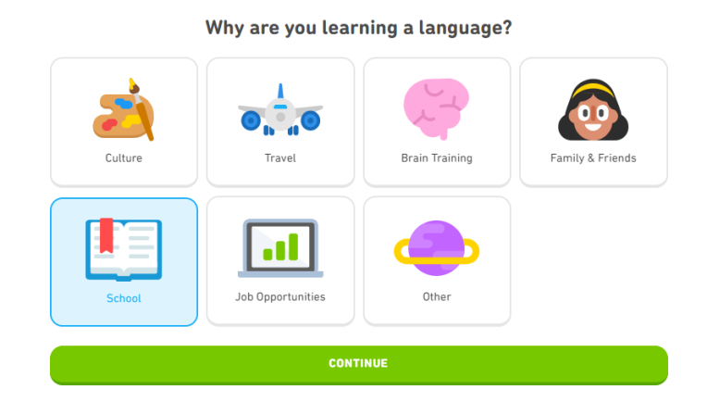
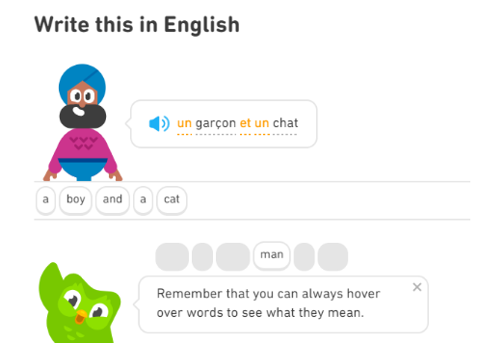
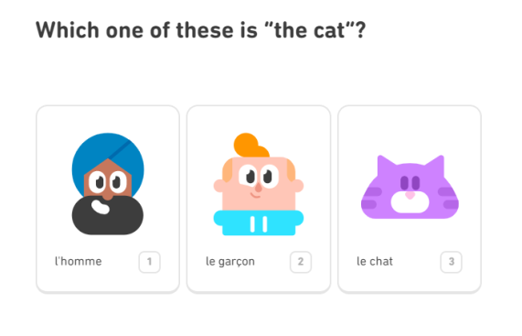

If you want some extra PE resources these are things we use in class;
https://www.cosmickids.com/ - Yoga
https://www.youtube.com/watch?v=gCzgc_RelBA – Just Dance
https://www.youtube.com/watch?v=mhHY8mOQ5eo – Joe Wicks Fitness video

