WEEK COMMENCING: 1/06/20 |  | HOME ACTIVITIES |  | CLASS 2C
Continue to read every day!  You can find some of the books we have in school as e-books here. Can you write a review about your favourite book? |  |  |  | Maybe you could have a go at a science experiment, follow the instructions here to make a lava lamp.
Compare plants  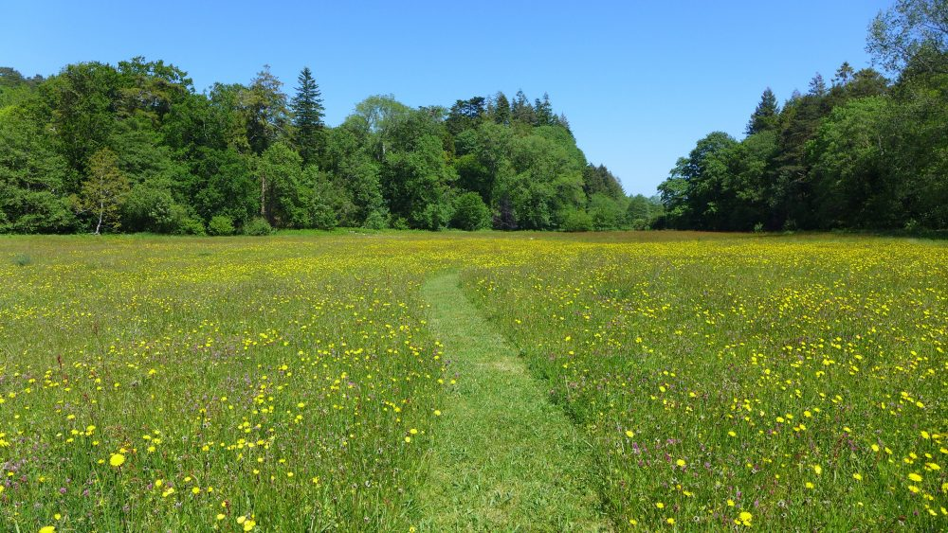  On your walk or in your garden look closely at 2 plants.  Compare the 2 plants.  Draw the plants and describe how they are  different or the same.  You might want to count the leaves, compare their height, colours and smell.  Why do you think some flowers are beautiful and smell nice?  Can you label the parts of your plant or flower? Use this link to help you. |  | Grow your own  Have a go at growing your own plants.  What do you think plants need to be able to grow and survive?  Seeds you might like to plant  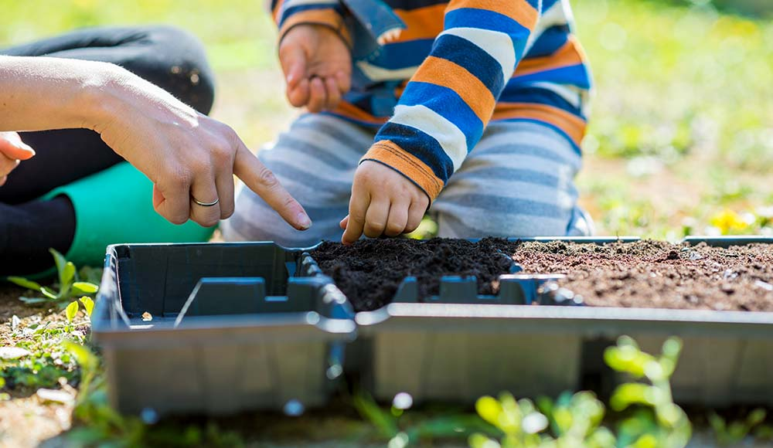  - Cress  - Sunflower seeds  - Sweet pea seeds  If you can’t plant your own seeds, observe how plants in your garden are changing.  Help your adult in the garden. |  | Observing your plant grow  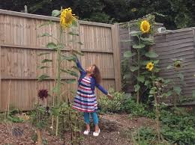  Using the sheet below observe what happens to your plant over time. Or other plants in your garden.  Draw or take pictures of how your plant is changing and write about the changes.  If you are growing a sunflower measure its height.  Have a go at the sunflower plant life cycle comprehension sheet. This might help you look after your plant.
If you haven’t already seen BBC bitesize are providing daily lessons in all subjects. Take a look and have a go. https://www.bbc.co.uk/bitesize/tags/z7s22sg/year-2-and-p3-lessons/3 |  |  |  | Could you plant your seeds in different conditions and see if they grow the same? For example, in a dark or light place with or without water.
 |  | Plants
ICT  You all have your log-ins; they are in the front of your Reading Record.  Mathletics  Explore Mathletics, try improving your score on previous activities you have attempted.  Education City  I have selected a variety of plant related tasks for you to work through to help your understanding on how plants grow. |  | Maths  Have a go at the arithmetic sheets below, think carefully about the strategies we use to do addition, subtraction, multiplication, division and finding fractions of numbers.  Explore the White Rose Maths home learning resources here. |  | Literacy  See if you can correct the spelling mistakes below.  Write some instructions how to grow and take care of your own plant. Use the checklist below to help you structure your instructions.
Could you encourage more wildlife into your garden? Have a go at making a minibeast hotel using things you find on your walk or garden such as twigs, leaves, soils, petal or stones. Or could you make a bird feeder and watch birds enjoy a treat.
Can you correct the spelling mistakes below? Re-write the sentence with the correct spelling.

Lee went swimming arftr school.
The garden looked very prity.
‘I wood like to come to your party’ said Kelly.
Thomas wore his coat becoz he was cold.
I can clym over the rocks.
The shop was full of peepl.
I jumpt over the log.
Teddy wos eating some peanuts.
The burds were singing in the ski.
On Wednesday I go swiming at the powl.

Plant diary

Week 1
What I can see at the beginning of the week (draw a picture). | Describe any changes
 | Day 1
 | Day 2
 | Day 3
 | Day 4
 | Day 5
 | Day 6
 | Day 7
Are there any changes in the plant’s height?  Day 1  Day 2  Day 3  Day 4  Day 5  Day 6  Day 7 | What I can see at the end of the week (draw a picture).

Instructions check list
- Things you need/equipment list
- Capital letters, full stops, question marks
- Title- How to…
- Opening sentence
- Closing sentence
- Numbered steps in order
- Bossy verbs to tell the reader what to do
- Adverbs (slowly, carefully, gently)
- Short and snappy steps
- Technical vocabulary
- Diagrams and picture

