|  |  |
| --- | --- |
| **HOME LEARNING ACTIVITIES – Year 2 (15th -26th June)**  **Hello everyone! It was lovely to chat to your parents and some of you last week. Your Home Learning Tasks look a little different this time. Try to complete one English and one Maths task every day. Remember to carry on reading and getting as much physical exercise as possible! Your handwriting and sentence work is vital. So keep practising those. Maths is equally important.**  **Do log on to mathletics and try different questions from different topics. Revision will help you remember your concepts. Keep smiling and stay safe. Look after yourself and remember to help your parents too!**  **Mrs Hall** | |
| **ENGLISH**  **The Magical Teaching Box.** | **MATHS** |
| **ACTIVITY 1**  Read through the story of ‘The Myth of Pandora’s Box.’ Talk about the story with someone on your house.  What do you think the box looked like? Draw the box.  What do you think might be in the box? Draw or write your ideas. | **Practise counting in multiples of 5 from 0-100.**  **This will help you tell the time when reading the time to the five minute interval!** |
| **ACTIVITY 2**  Continue reading the story of ‘The Myth of Pandora’s Box’  What do you think the evil looked like that came out of the box? Look at the example given… then draw your own.  Did you like the story? Why did you like it? | **What do you do in the morning? afternoon? early evening or late in the evening?**  Think of 5 different activities you might do at the different times of the day. Insert these into to correct part of the table. Can you record exactly what time you ate your lunch? Took a bath? Ate your breakfast. |
| **ACTIVITY 3**  Read all about Zeus.  Sketch your own picture of Zeus and label the features listed in the description. | **Clock wise & Anti-clockwise**  Study an analogue clock carefully. Watch the direction in which the hands move around the clock. Practise turning in a clockwise and anti-clockwise direction. |
| **ACTIVITY 4**  Re-read the whole story.  Complete the comprehension questions.  Remember to write using complete sentences, don’t forget your capital letters and full stops… oh… don’t forget to use your best handwriting! | **CRAFT – CLOCKS**  Make your own clock face, you could use the template provided or you could create your own design. (I’ve used a paper plate, card for the hands and a paper fastener to fasten the minute and hour hand before!)  Make your hands so they move clockwise and anti-clockwise. |
| **ACTIVITY 5**  Alphabetical Order.  Look at the list of words Apollo the Greek god of knowledge found in the story.  Record these words into alphabetical order. | **O’clock / Half past**  [**https://resources.whiterosemaths.com/wp-content/uploads/2020/05/Y2-Summer-Block-3-PPT1-O_clock-and-half-past-2020.pptx**](https://resources.whiterosemaths.com/wp-content/uploads/2020/05/Y2-Summer-Block-3-PPT1-O_clock-and-half-past-2020.pptx)  **Complete the activity –**  [**https://resources.whiterosemaths.com/wp-content/uploads/2020/04/Y2-Summer-Block-3-WO1-O_clock-and-half-past-2020.pdf**](https://resources.whiterosemaths.com/wp-content/uploads/2020/04/Y2-Summer-Block-3-WO1-O_clock-and-half-past-2020.pdf) |
| **ACTIVITY 6**  Vocabulary - Look at some of the amazing vocabulary used in the story.  Some of these words you will have heard before, some you won’t. Use the dictionary to find the meaning of these words then match the word to the correct meaning. | **QUARTER TO…. QUARTER PAST**  [**https://resources.whiterosemaths.com/wp-content/uploads/2020/05/Y2-Summer-Block-3-PPT2-Quarter-past-and-quarter-to-2020.pptx**](https://resources.whiterosemaths.com/wp-content/uploads/2020/05/Y2-Summer-Block-3-PPT2-Quarter-past-and-quarter-to-2020.pptx)  **Complete the activity –**  [**https://resources.whiterosemaths.com/wp-content/uploads/2020/04/Y2-Summer-Block-3-WO2-Quarter-past-and-quarter-to-2020.pdf**](https://resources.whiterosemaths.com/wp-content/uploads/2020/04/Y2-Summer-Block-3-WO2-Quarter-past-and-quarter-to-2020.pdf) |
| **ACTIVITY 7 -**  Sentences. Now you know what these words means can you select 5 of the words and create your own sentences? Remember to punctuate your sentences correctly and write using your neatest handwriting. | **TELLING THE TIME IN 5 MINUTE INTERVAL**  [**https://resources.whiterosemaths.com/wp-content/uploads/2020/05/Y2-Summer-Block-3-PPT3-Telling-time-to-5-minutes-2020.pptx**](https://resources.whiterosemaths.com/wp-content/uploads/2020/05/Y2-Summer-Block-3-PPT3-Telling-time-to-5-minutes-2020.pptx)  **Complete the activity –**  [**https://resources.whiterosemaths.com/wp-content/uploads/2020/04/Y2-Summer-Block-3-WO3-Telling-time-to-5-minutes-2020.pdf**](https://resources.whiterosemaths.com/wp-content/uploads/2020/04/Y2-Summer-Block-3-WO3-Telling-time-to-5-minutes-2020.pdf) |
| **ACTIVITY 8**  Read the poem ‘The Magic Box’ written by Kit Wright. You could also listen to poem at [*https://www.bbc.co.uk/bitesize/clips/zkpmhyc*](https://www.bbc.co.uk/bitesize/clips/zkpmhyc)  *Talk about the poem… What is your favourite item in the box? Why?*  *Is it a happy or sad poem? What makes you think that?* | **5 MINUTE INTERVALS**  Use the clock that you made. Work with your Mum or Dad, ask them to put the hands in different positions to show different times of the day. (5 minute intervals, quarter to and quarter past) Practise reading the times on the clock face. This is tricky… you will need lots of practise! |
| **ACTIVITY 9**  Create your own ‘Magic Box’  You could make your own using a shoe box or make your own using junk modelling bits and bobs. | **HOURS IN A DAY**  [**https://resources.whiterosemaths.com/wp-content/uploads/2020/05/Y2-Summer-Block-3-PPT4-Hours-and-days-2020.pptx**](https://resources.whiterosemaths.com/wp-content/uploads/2020/05/Y2-Summer-Block-3-PPT4-Hours-and-days-2020.pptx)  **Complete the activity –**  [**https://resources.whiterosemaths.com/wp-content/uploads/2020/04/Y2-Summer-Block-3-WO4-Hours-and-days-2020.pdf**](https://resources.whiterosemaths.com/wp-content/uploads/2020/04/Y2-Summer-Block-3-WO4-Hours-and-days-2020.pdf) |
| **ACTIVITY 10**  Write your own Magic Box Poem. Use the writing frames to help you…  Brainstorm and record 9 of your favourite things people or places.  Organise your ideas into three verses.  Describe your magic box, what is it made of? What is on or in it?  Complete your final verse. | **FINDING AND COMPARING DURATION OF TIMES**  [**https://resources.whiterosemaths.com/wp-content/uploads/2020/05/Y2-Summer-Block-3-PPT5-Find-durations-of-time-2020.pptx**](https://resources.whiterosemaths.com/wp-content/uploads/2020/05/Y2-Summer-Block-3-PPT5-Find-durations-of-time-2020.pptx)  [**https://resources.whiterosemaths.com/wp-content/uploads/2020/05/Y2-Summer-Block-3-PPT6-Compare-durations-of-time-2020.pptx**](https://resources.whiterosemaths.com/wp-content/uploads/2020/05/Y2-Summer-Block-3-PPT6-Compare-durations-of-time-2020.pptx)  **Complete the following activities -**  [**https://resources.whiterosemaths.com/wp-content/uploads/2020/04/Y2-Summer-Block-3-WO5-Find-durations-of-time-2020-1.pdf**](https://resources.whiterosemaths.com/wp-content/uploads/2020/04/Y2-Summer-Block-3-WO5-Find-durations-of-time-2020-1.pdf)  [**https://resources.whiterosemaths.com/wp-content/uploads/2020/04/Y2-Summer-Block-3-WO6-Compare-durations-of-time-2020-1.pdf**](https://resources.whiterosemaths.com/wp-content/uploads/2020/04/Y2-Summer-Block-3-WO6-Compare-durations-of-time-2020-1.pdf) |



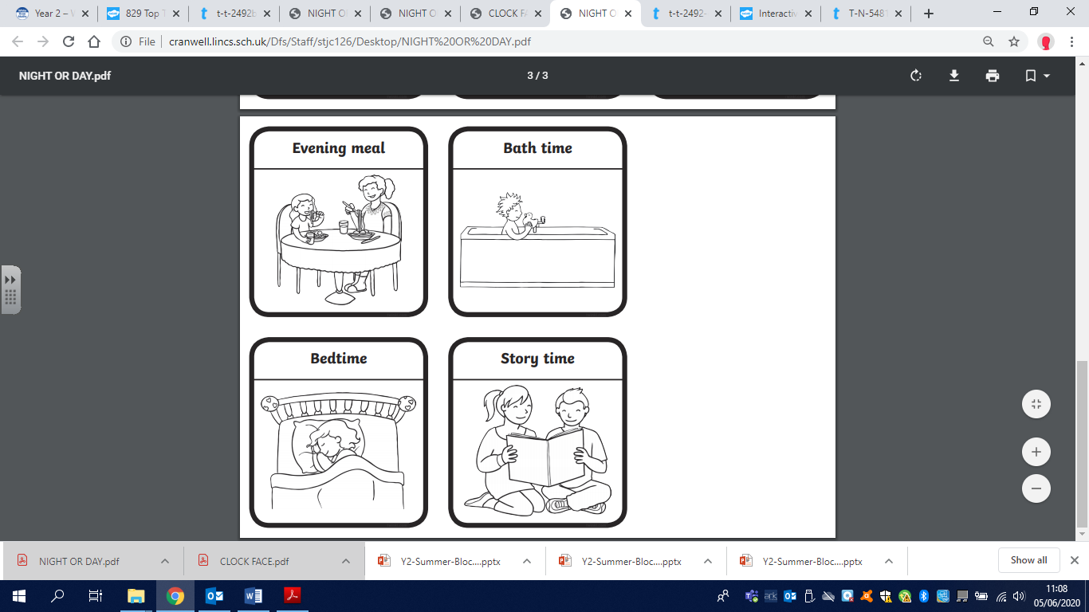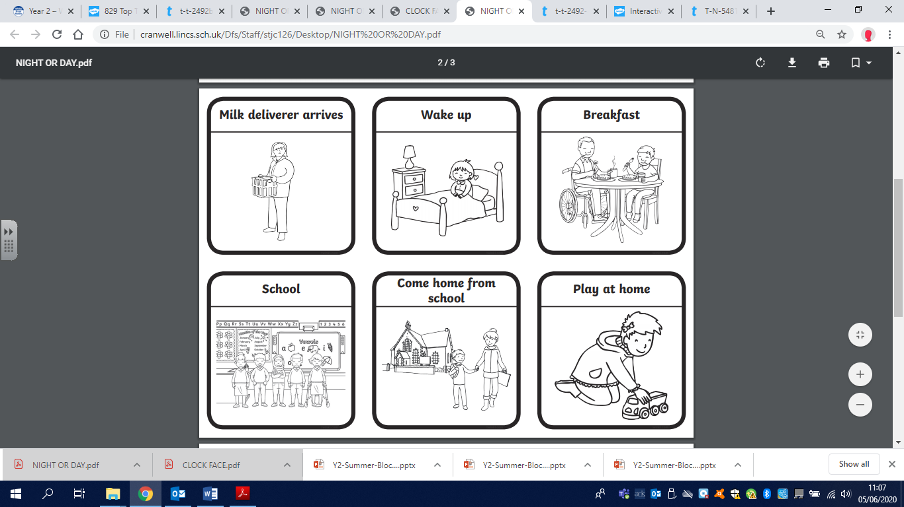

Think of 10 other activities you do during a 24-hour period and place them into the sorting table.

|  |  |  |  |
| --- | --- | --- | --- |
| MORNING  6:00AM – 12:00PM | AFETRNOON  12:00PM – 4:00PM | EARLY EVENING  4:00PM – 10:00PM | LATE EVENING – EARLY MORNING  10:00PM – 6:00AM |
|  |  |  |  |