Hello 4/5N,

I hope you are all keeping well, it was lovely to speak to you and your parents recently.

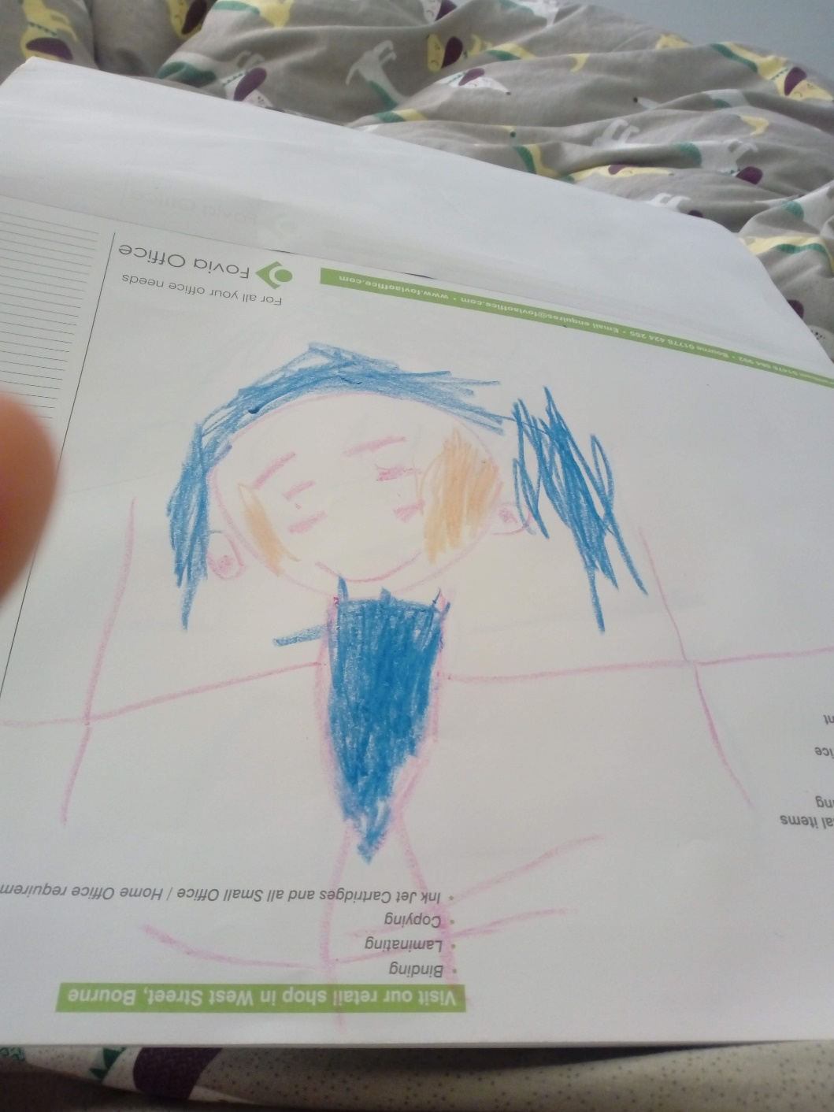For those of you not in school, please be reassured that we are mirroring the same work you have access to at home. I miss having you in class, but look forward to when it is safe for us all to return. Until then, try to help out at home as much as you can – even if this means simply getting on with your work. Your parents have a lot on their plates at the moment (trying to juggle their work and to help you with yours) so, in return, try to be thoughtful and anticipate what you can do to make everyone’s day a little easier.

In case you may have forgotten what I look like, I have included a picture of me drawn by my daughter. Other than the blue hair and two pairs of eyes, I think it’s a good likeness.

I have compiled and created a variety of activities. You can start with the tasks that you are most interested in, but please remember to allow for some daily maths and literacy work. **You *should* be able to complete the tasks set below independently, but ask Mum or Dad if you need help**. If you have any problems with log-ins etc., you can ask an adult to ring school, as we are still there to help you.

Parents and children, if you would like to supplement your learning further, I highly recommend online BBC Bitesize daily lessons. This is a wonderful resource which may teach new concepts but also revisits previously learned material and is a great way for our class to refresh knowledge whilst on lockdown. Find your year group on <https://www.bbc.co.uk/bitesize/dailylessons>

Take care and hope to see you all soon, Mrs New

|  |  |  |  |  |
| --- | --- | --- | --- | --- |
|  |  | | | |
| Please continue to complete your daily maths lesson, using the White Rose resources from the website.  Each day, watch a short video of a lesson. If there is a worksheet use it, otherwise write your answers in your exercise book.    You can find your lessons on this website: <https://whiterosemaths.com/homelearning/year-4/> Please move onto the section labelled ‘**Summer Term Week 6-7**’. The videos are also available on Facebook, if the website is overloaded.  In addition, Mathletics tasks will be set.    Extension challenge: You can extend your maths knowledge through the following site which is free to all users at the moment (charges may apply in the future): <https://kids.classroomsecrets.co.uk/> | Please follow the link below to access a home learning booklet called ‘Amazing Aliens’ (this can either be printed or you can write your answers and ideas in your exercise books):  <https://www.talk4writing.com/wp-content/uploads/2020/04/Y4-Maria-Aliens.pdf>  This booklet is designed for you to work at your own pace, taking you through a series of literacy tasks related to the story including: reading comprehension, grammar, vocabulary and planning tasks. The booklet culminates in you producing your own persuasive leaflet about the planet Zargon 10!  Please don’t try to complete this in one sitting. Try to complete a couple of pages per session as you work towards creating a fantastic leaflet – good luck! | | | |
| Image result for reading  **Reading – The Ickabog by J.K.Rowling**  J.K. Rowling, author of the Harry Potter series, has recently released a new book which is available, in instalments, for free online!  It is a wonderful book (from what I’ve read so far) which we will be reading in school.  Please follow this link to read the chapters online:  <https://www.theickabog.com/read-the-story/>  J.K.Rowling is inviting children to create illustrations for each chapter and she will suggest themes for these illustrations (<https://theickabogcompetition.com/illustration-themes>)  In addition, the publisher for the book (Hachette) are running a competition open to 7-12 year olds whereby a parent/guardian can enter your drawings or paintings (<https://theickabogcompetition.com/>) for a chance for your illustration to be featured in the print version of the book with an intended due date of November 2020. Plus, you would receive a signed copy of the printed book, plus a school or public library of your choice will receive £500 of Hachette children’s books! What a fantastic set of prizes!  If you choose to enter the competition, please be mindful of the illustration instructions, these are quite specific and non-adherence can mean your entry could be rejected: <https://theickabogcompetition.com/illustration-instructions> Please be sure to read all the instructions on the competition website as I am unable to include all the details here.  J.K. Rowling has also written the following advice on The Ickabog site:  *I won’t be judging the competition. Each publisher will decide what works best for their editions. However, if you, your parent or your guardian would like to share your artwork on Twitter using the hashtag #TheIckabog, I’ll be able to see it and maybe share and comment on it!*  I hope you enjoy creating your own illustrations, and perhaps entering the competition, but, most of all, I hope you enjoy the story as much as I have been. | | | | |
| **Science – Understanding the spread of germs**  <https://www.e-bug.eu/junior_pack.aspx?cc=eng&ss=2&t=e-Bug%20Lesson%20Pack>  Access the E-Bug website using the link above.  Explore the sections:  Microorganisms – An Introduction  Spread of Infection – Respiratory Hygiene  Prevention of infection – Immunity  Prevention of Infection – Vaccinations  There are PowerPoints to watch and activities to have a go at. Make sure that an adult at home gives you permission to have a go at any of the practical activities. In school, we will not be able to do the practical activities obviously due to the current circumstances but some you may wish to do with your family at home.  Perhaps you can show your parents the ‘pepper and soap’ experiment that we investigated as a class prior to Lockdown; I have attached the experiment instructions and explanation to the sheets below titled ‘Horrid Hands’. | | | this art video will *NOT* have 1 million views - YouTube  **Art**  Make a poster about Health & Hygiene Rules, below is an example. You might like to display this at home as a reminder for your family.  Remember – you can always use the E-Bug website from last week for reminders as you will find numerous advice that we could inform others about! | |
|  | | |  | |
| Image result for spellings  Please access the following links which will take you to spelling games, which use words from the statutory spelling list for your year:  Spooky Spellings: This spelling game uses the words listed in the UK National Curriculum as being ‘Common Exception Words’ or tricky words.  <http://www.ictgames.com/mobilePage/spookySpellings/index.html>  Look, Cover, Write, Check: Test yourself on high frequency words, spellings patterns, tricky words or enter your own words easily to test your knowledge.  <http://www.ictgames.com/mobilePage/lcwc/index.html> | | Image result for spellings  Can you use a dictionary to find out what these words mean and then learn how to spell them?  Don’t worry if you don’t have a dictionary at home, you can, with your parents’ permission, google it or use these online ones:  <https://www.wordsmyth.net/>  <https://kids.britannica.com/kids/browse/dictionary>.   |  |  | | --- | --- | | 1. Bacteria 2. Bug 3. Cell 4. Disease 5. Fungi 6. Germ | 1. Microbe 2. Micro-organism 3. Microscope 4. Pathogen 5. Probiotic 6. Viruses | | |

|  |
| --- |
| **ICT**  **Data collection**  At school, our class have been enjoying the data collection task. Students have focussed on their own interests including: researching birds of prey; looking at differences in dog breeds; gathering statistics on famous footballers and even comparing motorsports, to name a few.  I would like to build upon your knowledge of Excel by producing line graph, which requires the collection of a series of data for which the values can then be compared over a period of time. For example, you could produce a line graph by measuring the amount of rainfall over a period (see link for ideas of how to set up this investigation: <https://www.science-sparks.com/weather-make-a-rain-gauge/>) though this idea may prove difficult if the weather is fine.  I have listed some more ideas for data collection below, but feel free to think of your own investigation – just remember you need to be able to record values over a period of time:   * You could count how many times in a row you can bounce a ball on a tennis racket. If you practise this over a period of week, recording your results daily, you may find that your total increases over the week! * You could count the number of birds that visit your garden over a particular time period every day for a week. * You could set yourself a challenge of completing your (normally weekly) times table test every day – just remember to allow yourself 5 minutes each day so we can compare results reliably. * If you have a thermometer your parents allow you to use, you could find out how the temperature of a cup of tea changes every 5 minutes. Please try this activity with an adult as you will be investigated a hot liquid and must take care.   Do not worry if you don’t have access to Excel, the data collection is the important part of this task. If you can produce a table with all the data, we can hopefully produce the line graph at a future date in school. You could even have a go at producing a graph manually (draw it yourself).  If you are able to produce graphs for this set of data or our previous data collection exercise, feel free to send them in as I would love to take a look at your results! |
| School Wellbeing - PSHE  **PSHE – ‘Pay it Forward’**  I remember watching ‘Pay it Forward’ and, although I ended up in tears by the end of the movie, I enjoyed it because of the message it conveyed: to ‘pass on’ acts of goodwill. The main character in the movie devises a plan whereby if you receive an act of kindness, you then perform three acts of kindness to others. What a brilliant idea!  This made me think of 4/5N; you are all very different children but you have all shown me instances of how kind and helpful you are to others. I remember Josh, without being prompted, offering the ball he was enjoying playing with to another child because they wanted to join a game; I remember Eleanor choosing her own name out of the Raffle Ticket box and immediately deciding to give up her prize and select another ticket (I made sure Eleanor got one too); I remember Jakob being distressed by the fact that he had forgotten his swim bag when two children quickly came to his rescue – one with swim shorts, the other with goggles. The list goes on, but I can remember observing instances of kindness by each of you.  With this in mind, I have a special task for you. I would like you, over the next week, to record 10 acts of kindness. I have included a form on the next sheet that you are welcome to use for this purpose. Once you have completed 10 acts of kindness, please can you ask your parents to email this to school – I will let Mr Wilson know about what you have done and hope he will see fit to issue Headteacher stickers to acknowledge your efforts (though I will have to keep these safe for you until your return to school).  Here are some suggestions for ‘acts of kindness’:   * **I completed my Home Learning work this morning, which meant my parents were able to attend to their jobs rather than spend time and energy to persuade me to do my work.** * **I made a ‘thank you’ card for my parents/siblings to show them how much I appreciate the time they have spent to try and help me with my learning.** * **I helped my little brother/sister to do their homework (or get dressed/fed) so my mum/dad could have a well-deserved break.** * **With permission from my mum/dad, I made a video call to someone I care about to let them know I am thinking of them.** * **I set/cleared the dining table to help my parents.** * **I tidied my bedroom, without being asked.** * **I asked my mum/dad/brother/sister how they are feeling and asked what I could do to make things easier for them.**   I have full faith that all of you will be able to complete this exercise and I look forward to finding out about all the inventive ways you have been able to ‘pay it forward’.  Name: Date:  Acts of Kindness  This week I have:   |  | | --- | |  | |  | |  | |  | |  | |  | |  | |  | |  | |  | |
| this art video will *NOT* have 1 million views - YouTube  **Art**  Meet the Rhi-swano-zeb-tah!  Can you guess how this creature got its name? It is a hybrid (mix) of four different creatures, can you guess what they are?    Use your creativity to combine some of your favourite real or imagined creatures into a drawing or painting of a fabulous hybrid. You can play around with ideas on the following site: <https://switchzoo.com/zoo.htm>  Think about the different textures your hybrid may have (scales, feathers, fur) and how you can represent this in your picture – remember our guest artist, Mrs Wainwright, who came to our class to show us how to use shading to create texture and dimension? This video may help you too: <https://www.youtube.com/watch?v=OezMavBqWXc> |
| Adorable funny german shepherd - PaST PReSENcE ArT - Photography ...  Germany - Wikipedia  **Modern Foreign Languages - German**  This is a great opportunity to learn languages: at your own pace and in your own home. In class, we will be learning the basics of German.  Try Duo Lingo, which is a free language course online, to help you grasp the basics of German.  <https://www.duolingo.com/>  When you register you can choose the pace at which you would like to learn.  In addition, the fabulous Bitesize has plenty of lessons to help you learn German, which can be found via the following link:  <https://www.bbc.co.uk/bitesize/subjects/zg8jmp3> |

|  |  |  |
| --- | --- | --- |
| Image result for spellings | The Cedars Primary School - Education City@home |  |
| Please try to learn spellings from the Statutory spelling list provided, and remember to highlight any you get correct on the sheet. | SPAG (spelling, punctuation and grammar) activities will be set online. | Mathletics activities will be set in addition to White Rose tasks. |
|  | Image result for reading |  |
| Please complete your weekly times table test, giving yourself 5 minutes to write answers in your book, then self-mark and keep a record of your total along with the date.  For further challenge, you can choose to complete the division test. | Please read for at least **30 minutes** every day this week.  Try to read aloud with an adult, at least once, and discuss what you’ve read with them.  Once you have read a book, please complete a book review in your exercise books. | Lightbot – Hour of code  This is a computer coding activity that can be accessed for free online, using the following link:  <https://lightbot.com/flash.html>  In Lightbot, students must program a robot with commands to solve puzzles. I have used Lightbot with some children at school as part of my Computing Club and it was well received. This starts off at a fairly basic level but soon increases in complexity. A nice introduction to coding -enjoy! |
|  |  |  |
|  |  |  |
|  |  |  |

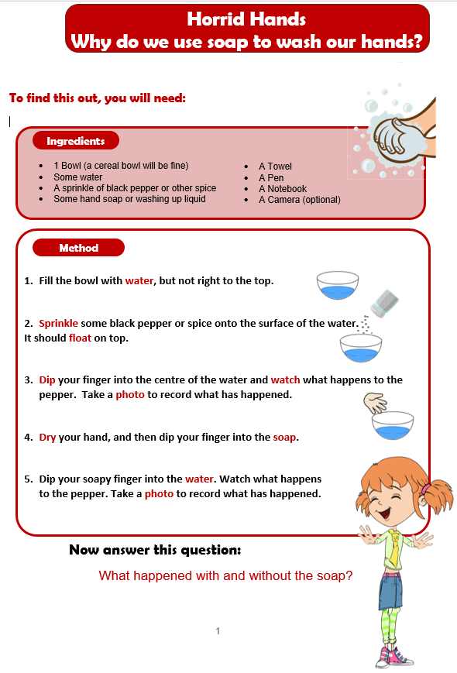

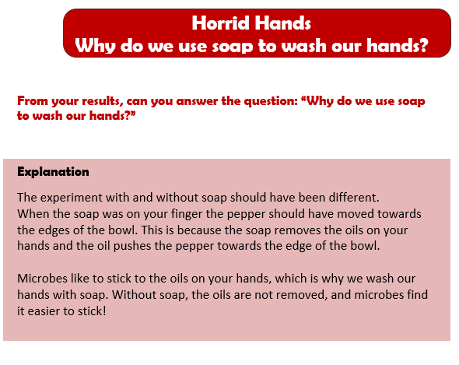

Keep working out and keep sending in pictures, it’s lovely to see you looking after your physical and mental wellbeing.

Take a look at some fabulous pictures sent in from the past two weeks:

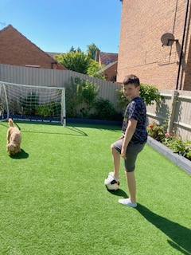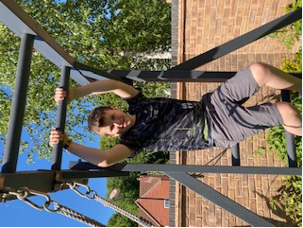

Z spent a day trying lots of different sports, here are just a few. From the smile on his face, he looks like he is enjoying keeping active. Well done, Z!

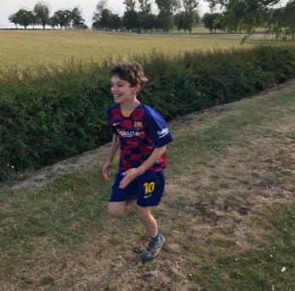

L has been regularly walking, running and exploring in the surrounding fields and woodlands.

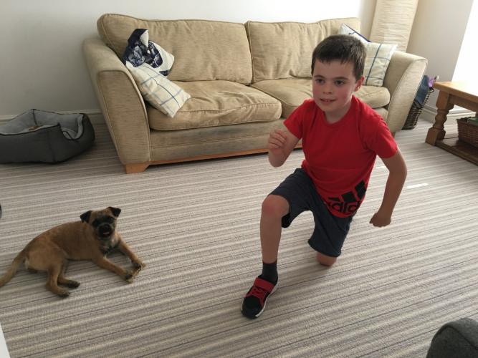

J is concentrating very hard while following Joe Wicks’ daily routine. I can attest to how strenuous this workout can be – the dog looks exhausted just watching!

Great job J!