Numeracy  Focus on finishing all Mathletics activities for year 3 now and try the mental maths/decimals below that will practise all your number skills. It’s a good idea to write sums/draw pictures to help you.  You might want to do the home learning lesson each day on the White Rose website for year 3 if you can.  Try Education City or Prodigy and Times Table Rockstars.  For fun reasoning activities try-  https://nrich.maths.org/ or the TopMarks website. | Literacy  Practise spelling another ten key words each week and keep reading.  Can you improve your grammar with the activities below?  Also try to write your own poems like the ones on the sheets.  If you want to do more writing, draw the map of a farm or zoo and create an information leaflet. You could also design the café menu and shop. | PE  Keep doing your regular exercise/sport.  If you want to try new things, have a look at these on Youtube.  Get kids moving- Harry Potter and other themes including Supergirl.  Pop sugar family fun cardio workout  Go noodle  BBC supermovers  Kidz bop daily dance break  Debbie Doo dance and movement  Little sports
If you have run out of reading books sign up to www.oxfordowl.co.uk for free e books.  PSHE  It’s sometimes hard to stay positive especially in lockdown. “Everybody worries” is a free e book on Oxford Owl or you could watch “Silly Billy” on YouTube and then make your own worry doll to tell your troubles to before you go to sleep.  Maybe your family could make a worry box so that you can discuss the worries everyone has and help to think of positive solutions. | 3CO  We would love to see your photos and work.  tamasin.craven@cranwell.lincs.sch.uk  jill.owen@cranwell.lincs.sch.uk  This is for the weeks  15th to 26th June.  We are really missing you all! | Geography  Our Topic this half term is all about the United Kingdom. Find out about the main cities, seas surrounding the UK and rivers.  What is the difference between the British Isles, Great Britain and the United Kingdom?  Record your findings on the map below. Can you label the countries and capitals of the UK and some of the cities and rivers?  What seas/oceans surround the UK?
Music/Art  Try this website to create your own tunes with different layers of instruments.  https://musiclab.chromeexperiments.com/Song-Maker/  Draw/paint the four flags of the United Kingdom.  Can you draw the Union jack too?  Challenge yourself to draw the royal coat of arms and invent your own for your family. | Home learning for 3CO  Keep trying to do an hour’s exercise, some numeracy and some literacy or another subject.  However, imaginative play, baking, art work, playing card and board games and chatting to friends and family is just as important to keep happy and healthy.  Just do the best you can! | ICT  Choose a country of the United kingdom to research in more detail and present your information as a PowerPoint. Add pictures and photos if you have been there. Maybe you could record yourself speaking too and include a quiz.  Can you try cooking a popular savoury dish from your chosen country?

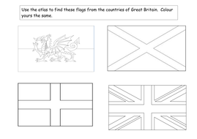

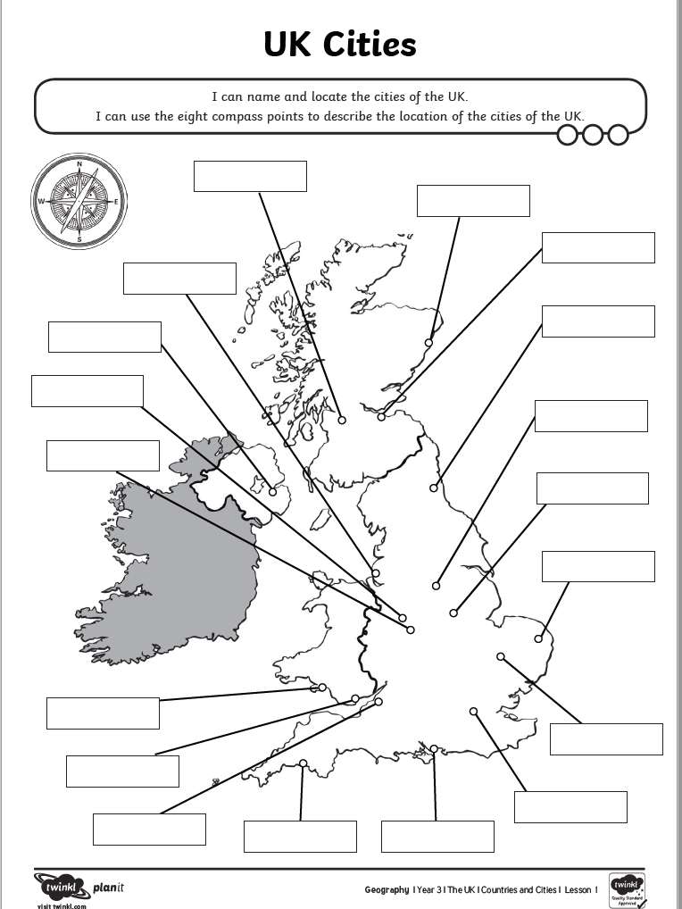

L.O. Ice cream sundae poem.
Circle the Capitals and punctuation then underline the rhymes.

I scream, you scream,
We all scream for ice cream!

Vanilla, strawberry, mint choc chip,
Lick it, bite it or use a straw to sip.

So many flavours! What to choose?
This is harder than picking out shoes!

Banana split, other fruit from the shop?
Sprinkles, nuts or a cherry on the top?

Finally to finish squeeze lots of sauce,
It might be chocolate or fudge of course!

So until the next time you scream, I scream,
We all scream for ice cream!

L.O. Now invent your own ice cream sundae and describe it.

Ingredient | Adjectives/similes/rhymes  e.g. a banana is ripe and as yellow as the sun (rhymes = sun and fun)
Fruit

Cream

Sprinkles

Sauces

Ice creams
Other

Now draft your own poem then, when you are happy with it, draw an ice cream sundae and write your poem around the shapes. Enjoy!
Maybe you can make your own fruit ice-lollies too?

L.O. Understanding poetry.
(“Summer” by Kenn Nesbitt.)

1. Circle the CAPITALS and punctuation. What do you notice?

I'm dreaming of warm, sandy beaches.
I'm dreaming of days by the pool.
I'm dreaming of fun in the afternoon sun,
And week after week of no school.

I'm thinking of swimsuits and sprinklers,
Imagining lemonade stands.
I'm lost in a daydream of squirt guns and ice cream
And plenty of time on my hands.

I'm picturing baseball and hot dogs,
Envisioning games at the park,
And how it stays light until late every night,
And seems like it never gets dark.

I long to ride skateboards and scooters.
I want to wear t-shirts and shorts.
I'd go for a hike, or I'd ride on my bike,
Or play lots of summertime sports.

My reverie turns to a yearning
To draw on the driveway with chalk.
It's really a bummer to daydream of summer,
While shoveling snow from the walk!

2. Underline rhymes. (some are within the line)
3. Now brainstorm your own Summer ideas.
(Weather, clothes, activities, food, drink, holidays, day trips, feelings etc.)
4. Then add VCOP e.g. adjectives, adverbs, alliteration, similes and rhyme. Add????? and !!!!!.
5. Draft your poem in lines, edit it then copy it out neatly with pictures.
Mental arithmetic C Name Date

1. 16 + 80 = | 14. 28 divided by 2 =
2. 860 – 100 = | 15. 130 divided by 10 =
3. 719 + 9 = | 16. 170 – 50 – 40 =
4. 15 + 7 + 4 = | 17. 145 + 27 =
5. 754 - 113 = | 18. 9 x 0 =
6. 200 + 62 = | 19. ¾ of 20 =
7. 860 - 40 = | 20. 135 + 36 + 10 =
8. 80 + 6 + 9= | 21. 42 + ____ = 100
9. 126 + ____ =154 | 22. 48 divided by 8 =
10. 172 - 148 = | 23. 1/3 0f 15 =
11. 10 x 17 = | 24. ___- 135 = 18
12. 420 + 57 = | 25. 2/3 of 15 =
13. 7 x 8 = 32? Yes or No? | 26. ½ of 34 =

Now carry on these counting patterns.
154, 152, 150,

155, 153, 151,

140, 135, 130,

139, 136, 133,

Challenge.
Just using some of the digits 1 to 9 only once can you make a 2-digit divided by 1 digit sum that gives the answers 1 or 2 or 3 or 4 or 5 with no remainders? Try to find 5 sums.
You will have to try lots of combinations and think about place value.
Mental arithmetic D Name Date

1. 150 + 8 = | 14. 100 x 7 =
2. 231 – 100 = | 15. ½ 0f 600 =
3. 190 + 7 + 8 = | 16. 42 divided by 3 =
4. 156 + 13 = | 17. 136 + 44 =
5. 134 – 6 = | 18. 12 x 5 =
6. 155 + 27 = | 19. ¾ of 12 =
7. 238 – 17 = | 20. 548 – 26 =
8. 60 + ____= 130 | 21. 659 – 28 =
9. 184 – 30 = | 22. ¼ of 120 =
10. 355 + 15 = | 23. 350 + 420 + 25 =
11. 0 x 99 = | 24. 147 + ____ = 165
12. 142 + 10 + 5 = | 25. 2/3 of 120 =
13. 800 - ____= 600 | 26. 300 divided by 2 =

Now carry on these counting patterns.
180, 178, 176, 174

179, 177, 175,

180, 175, 170,

169, 166, 163,
Challenge.
Just using some of the digits 1 to 9 only once can you make a 2-digit divided by 1 digit sum that gives the answers 6 or 7 or 8 or 9 with the remainder of 1? Try to find 5 sums.
You will have to try lots of combinations and think about place value.

L.O. Decimals – counting in tenths.

Every ten pence piece is one tenth (1/10) of a pound = £ 0.10 = ten p = 0.1
We can count in ten pence, which is counting in tenths of a pound.
Decimals are just another way of writing fractions so 1/10 is the same as 0.1.
We can count in decimals 0.1, 0.2, 0.3, 0.4, 0.5, 0.6, 0.7, 0.8, 0.9, 1.
We can count £0.10, £0.20, £0.30, £0.40, £0.50, £0.60, £0.70, £0.80, £0.90, £1.

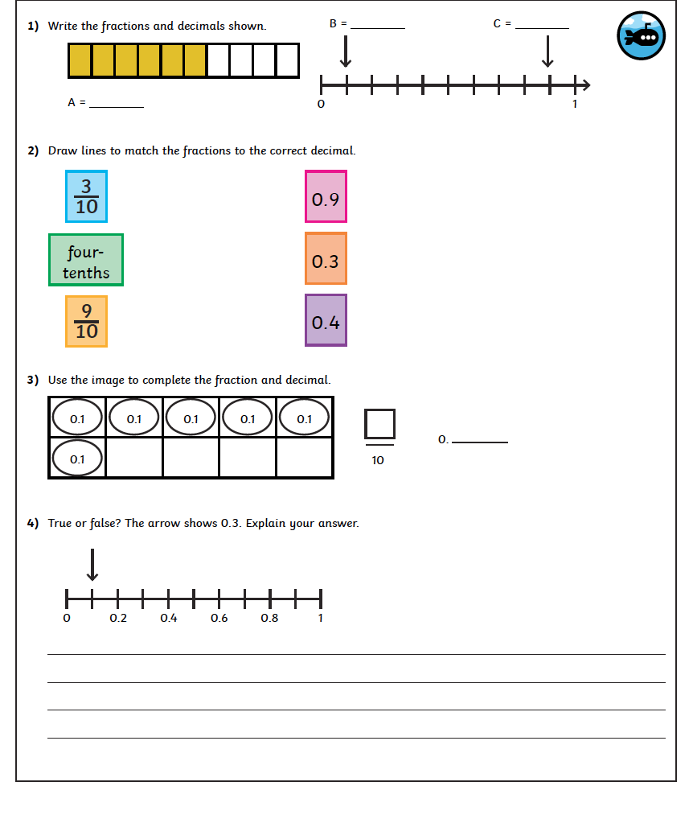

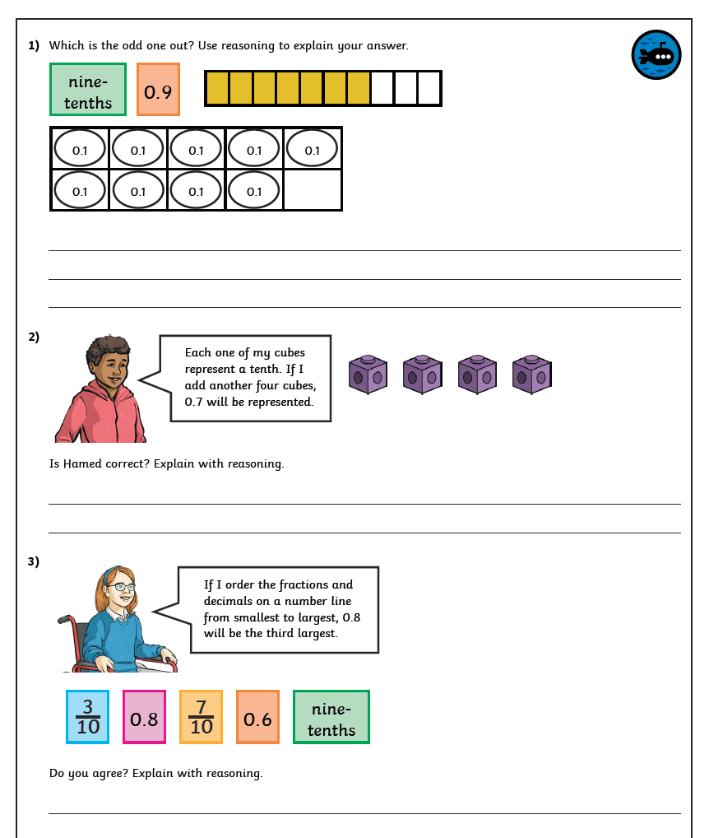

Challenge.

Now make up your own money word problems for someone else to solve.
Try to use the decimal way of writing pounds and pence. (£ 1.00 is a pound.)
Maybe you can use your Zoo or Farm park to invent totals and change problems with entrance and café prices.

