WEEK COMMENCING: 15th June |  | HOME ACTIVITIES |  | CLASS 1MS/ 1H
Numeracy  - To find ½ and ¼ of shapes.  - To find ½ and ¼ of different amounts.  - Can you make a list of items that are taller/shorter than you?  - Can you order items from shortest to tallest?  - Can you compare weights of different items?  Below are some activities for you to try:  https://www.twinkl.co.uk/resource/t-he-440-year-1-maths-fractions-learning-from-home-activity-booklet-activity-booklet  https://www.twinkl.co.uk/resource/measuring-caterpillar-lengths-maths-activity-t-m-31786  https://www.twinkl.co.uk/resource/tp-n-81-heavy-or-light-activity-sheet  Home learning lessons are still available on www.whiterosemaths.com |  | Dear Parents and Children,  I hope you are all well. We will be making phone call home to you all this week and we are looking forward to hearing about what you have been doing. Don’t forget, you can email us to show us your fantastic work or just to keep in touch. We can see a lot of you have been very busy on Mathletics and some fantastic scores have been achieved! Very well done to everyone.  Mrs Mulhall, Mrs Hall and Mrs Smith |  | Geography  Can you remember the work you did about Kenya? Which continent is Kenya a part of? Can you remember any facts you learned about the country?  Research the following. What is the capital city of Kenya? What is the name of the longest river in Kenya?  Did you know, Mount Kenya is the highest mountain in Kenya and the country was named after the mountain?  Map Reading  Find a map of Africa in an atlas. Look for Kenya and then find Nairobi, Mount Kenya and the Tana River. Name two cities that are on the Kenyan coast.  Name three countries that border Kenya.  Watch the following BBC clip ‘Introduction to Kenya’ on https://www.bbc.co.uk/bitesize/clips/zrsgkqt  Can you make a fact file about Kenya? You may use the template that is included in this pack or produce your own. You might want to include a drawing of the continent and label where Kenya is. You could explain the weather in Kenya or the animals that live there. https://www.twinkl.co.uk/resource/kenya-fact-file-ks1-t-g-664  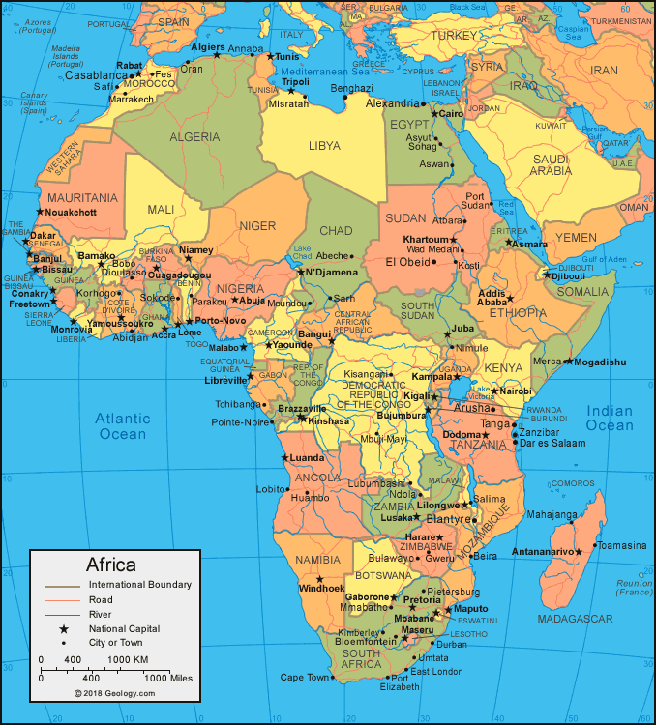  https://www.twinkl.co.uk/resource/fact-file-layout-t-l-4553
PSHE
Mae Jemison was born in Alabama, on October 17, 1956. From a young age Mae knew that she wanted to study science and become an astronaut. Mae later became the first African-American woman to go into space.
You may like to watch the following video https://www.youtube.com/watch?v=sF6CYDVdhyA
Dreams
Can you chat to your family about your dreams? Would you like to be an astronaut? Perhaps you could draw a picture about what you would like to do in the future.

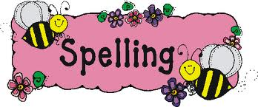
Please try to learn spellings from the Statutory spelling list provided, and remember to highlight any you get correct on the sheet.  Practice spelling numbers as words  https://www.twinkl.co.uk/resource/phase-5-spelling-activity-pack-t-l-9310 | Practice forming all your letters correctly. Think carefully about which letters should be tall and which letters should come below the line.  Practice writing capital letters. Ensure that they taller than lower case letters. | Mathletics activities will be set in addition to White Rose tasks for children at home. It has been fantastic to see so many children login on!
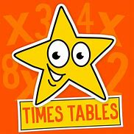 |  | 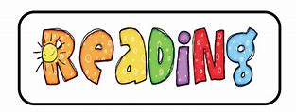
Please practice counting in sets of 10 forwards and backwards. Chose a number to start on and count in tens from that number.  60, 70, 80, 90, 100  What would ten less than 60 be?  What would ten more than 40?  Practice number bonds up to 10 and then 20. | We have set you some activities to try. | Please continue to read every day. Use the online books onhttps://home.oxfordowl.co.uk/  https://www.twinkl.co.uk/resource/t-l-5489-year-1-phonics-screening-check-2015-childrens-materials-powerpoint  https://www.twinkl.co.uk/resource/t-c-1275-year-1-phonics-screening-check-childrens-materials-powerpoint-pack  Watch these online phonics and spelling lessons:  https://www.youtube.com/watch?v=wGz_B5xpOo4  https://www.youtube.com/watch?v=hxLuwD2wbDU  https://www.youtube.com/watch?v=zGaxFjRgn_M

Literacy: Pippety Skycap A tale of mischief! 8th June and 15th June
 | Input | Activity | Follow up
1 | Common exception words  Flash cards of common exception words- read together. https://www.twinkl.co.uk/resource/t-l-5268-year-1-common-exception-words-powerpoint  Spell words together on whiteboards. Which part is the tricky? Why? | Common ex words searches. https://www.twinkl.co.uk/resource/t-l-526941-year-1-common-exception-words-word-search-activity-pack  https://www.twinkl.co.uk/resource/year-1-common-exception-words-handwriting-activity-sheets-t-e-2549617 | Say the alphabet  Sing alphabet songs
2 | Talk for Writing Booklet – Pippety Skycap  Download the resources from  https://www.talk4writing.com/wp-content/uploads/2020/04/Y1-Jane-Pippety.pdf  Read the story of Pippety Skycap on pages 3-4 of the booklet (with an adult to help). You may want to listen to the story while following the words by playing the audio version of the story (https://soundcloud.com/talkforwriting/pippety/s-P2LOxhx3Hmn) Talk about the story with an adult, thinking about the events and commenting on what happened, before completing Pippety’s sticky notes on page 5. | Talk about the story and fill in Pippety’s sticky notes. For an extension, try to write down your own questions about the story in full sentences. | Discuss their ideas for each post it note.
3 | Read the story together again. Can you remember who said what? Match up the character to the speech bubble. | Read and/or listen to the story of Pippety Skycap again. Try and link the characters to what they said on page 7 of the booklet, then answer the quiz questions on page 8. Try to answer the questions in sentences if you can. Be careful to include capital letters and full stops at the right places! | Discuss some other books which have mischievous characters.
 | Read the story again. What type of character is Pippety? Discuss words and actions that inform their reasons. | Design a warning poster for people to look out for Pippety’s tricks. There are some ideas for what to include on page 11 of the booklet. You can use the provided template on this page, or make your own if you prefer. Try to make the poster as bold, attention-grabbing and interesting as possible! | Share the poster. Which character traits did they include?
4 | Discuss features of a pixie. What would your pixie look like? What would your pixie like or collect? | Design your own Pixie fact file. | Share the fact files. What is your pixie like? Are the naughty or good? Are they helpful? What do they collect?
5 | Read the poem to find out what is in the pixie’s pocket. Discuss the poem. How many of each object did he have? How are numbers used in the poem? | Solve the riddles. What did he have in his pocket?  Extension: Draw what would be in a giant’s pocket. Draw and write sentences focusing on capital letters to start a sentence and for names. | Share ideas for the giant’s pocket.  Correct spelling errors
6 | Read the poem ‘If I had wings’ Read with intonation and discuss the poem. | Read it aloud and perform the poem.
7 | Model using the template to write their own poem based on the one they practiced performing. | Write your own poem using the ‘If I had wings’ template. | Read you poem aloud to someone else

