4A Distant Learning: 11th May to 22th May

Hello 4A!
Welcome to your next 2 weeks’ worth of home learning! I hope you and your family are all well! Did any of you celebrate VE day? I would love to see your pictures; the school email address is on the website! I have loved being able to enjoy my lunchbreak in the garden, listening to the sound of nature and especially hearing lots of families laughing and enjoying spending time with one another. I don’t know about you but we have so many birds in our garden at the minute and they are very noisy; waking me up at the crack of dawn most mornings!
This unit of work is for the next 2 weeks, with your project work based on our new Science topic; Plants! What a lovely topic for this time of year! I have enclosed lots of lovely ideas that involve you being in the garden and practical investigations. Please see ‘Plant resources’ under the 4A downloads section for extra resources.
If you would like to further your learning, I highly recommend online BBC Bitesize daily lessons. This is a wonderful resource which may teach new concepts but also revisits previously learned material and is a great way to refresh our knowledge whilst on lockdown. Find your year group on https://www.bbc.co.uk/bitesize/dailylessons
Stay safe and I look forward to the day we meet again!
Mrs Allen

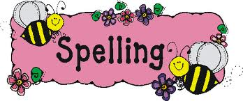

Literacy
BREAKING NEWS: WHEN WE RETURN TO SCHOOL, MR WILSON IS CANCELLING PLAYTIMES FOREVER!!
Using the persuasive techniques you used for your leaflet, can you write a persuasive letter to Mr Wilson convincing him that this is a bad idea? I have attached the layout and features of a persuasive letter to remind you and a planning template to help you when planning your letter. I also thought it would be useful to include an example of a persuasive letter for you to have a read through.

Spellings

Alongside learning the Year 3 and 4 National Curriculum spelling can you mark Mr Woops’ work and find his mistakes?! Why not use coloured pens like Mrs Allen does in your books when marking your work!

Reading
We read in class every day, so it would be really nice if you could spend some time every day reading a book. This can be a home book, a newspaper, magazine or anything alike. Do not forget to record this in your reading record.
It would also be good practise to complete some book reviews in the back of you reading record.

Extras
11th May is World Migratory Bird Day. Whilst in your garden, can you identify any birds? Perhaps you could ask a parent to help you or take photographs and use the following website to identify the species of bird. https://www.rspb.org.uk/birds-and-wildlife/wildlife-guides/identify-a-bird

Maths
Please see ‘Maths’ information page, which explains your daily tasks.
Times Tables
I have provided you with the times tables test you complete weekly in school. Once you have completed and scored full marks on the multiplication sheet in 5 minutes then you can move onto the division sheet. You have 5 minutes to complete as many as you can, column by column. You could also have a look on the times tables page for websites to help you.
Science
Our science topic this term is plants.
See the grid below for some experiments and project based ideas for you to complete.
Extra resources will be found in the 4A section of downloads labelled ‘Plant resources’.

Spelling Activities

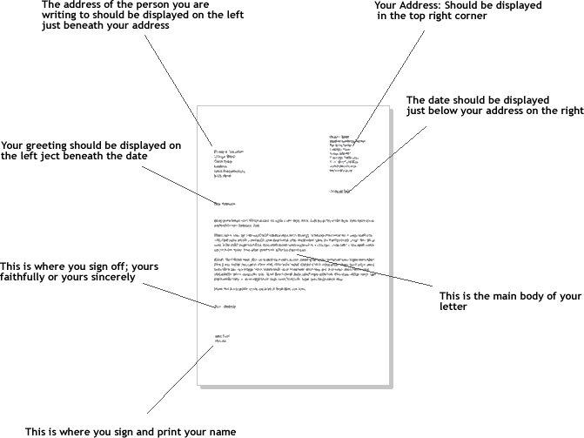

Features of a Persuasive Letter

- Correct layout of a letter
- An opening sentence that hooks the reader and explains why you are writing.
- Has an introduction, at least 3 paragraphs and a conclusion.
- Each paragraph has a different point.
- Each point has facts and evidence to support it.
- The letter only shows one point of view.
- It includes connectives such as: however, therefore, furthermore.
- The letter includes powerful adjectives.
- Includes rhetorical questions to make the reader think.
- The conclusion summarises the main points and gives an opinion.

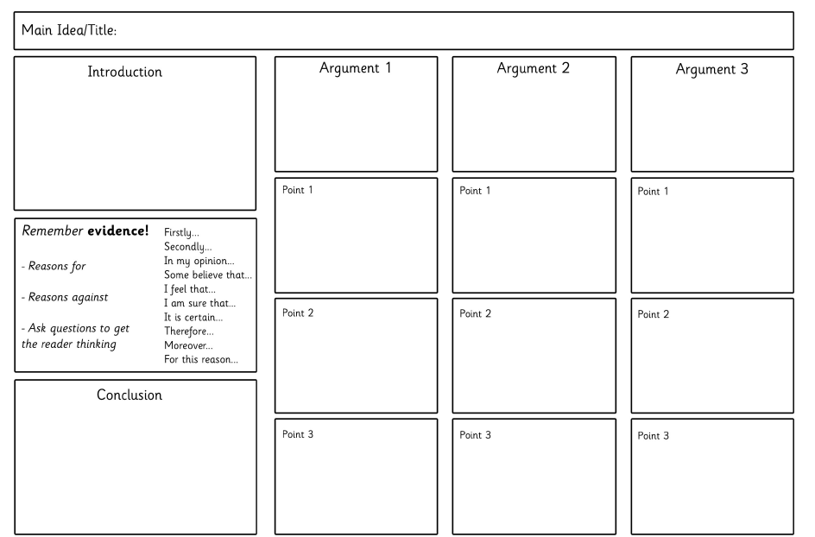
101 Smith Street
Sutton
CR4 5DR

27th April 2020

Miss Green
North Tyneside Council,
Gosforth,
Newcastle
NE34 9FS

Dear Miss Green,

It has come to my attention that the council are planning on closing my local swimming pool in Gosforth. I am extremely concerned about this.
I have been a long-standing member of your community and have swum in this swimming pool twice a week for the last 20 years. I have set up three swimming clubs and regularly teach private lessons at your pool. So as you can see I have brought a lot of business and money to this pool.
Swimming is the best form of exercise for many people with disabilities. It is the only time that people with physical disabilities are able to move freely without the restriction of their wheelchairs. A true relief, wouldn’t you agree? If you continue with your plan to close our swimming pool then the nearest pool with disabled access is over 50 miles away, how on earth are these people going to be able to travel this distance?

Lastly, swimming is a life skill. If you close our local swimming pool, those people who do not have access to transport and therefore, access to other swimming pools will not be able to learn to swim. Swimming is a sport and activity that can save someone’s life. Being comfortable in the water is a necessity in life. Do you want children to be scared of going near water?
I am adamantly opposed to this closure and I recommend that a public consultation must be called upon so that you can hear the voice of our faithful community.

Yours sincerely

Mr T Harvey

Times Table Activities

https://play.ttrockstars.com/auth/school - Times Table Rock Stars is a great way to practise your times tables
https://play.edshed.com/ - Practise your times tables
https://www.timestables.co.uk/ - learn and practise
https://www.topmarks.co.uk/maths-games/7-11-years/times-tables
https://www.oxfordowl.co.uk/for-home/maths/help-with-times-tables/ -
https://www.themathsfactor.com/times-tables-check/#/- A Times Tables Check in the same format the Multiplication Test will be.

Maths Activities

Please continue to complete your daily maths lesson, on the White Rose website. You should now be ready to move onto ‘Summer term- Week 4 (w/c 11th May)’ and ‘Summer term-Week 5 (w/c 18th May)’.
Each day, there will be a short video of a lesson to watch, which will contain questions for you to answer on paper. The lesson videos will also be linked to the BBC Bitesize website, where you will find further explanations and activities.
Follow this link to find your daily lessons and follow the instructions on the website: https://whiterosemaths.com/homelearning/year-4/
In addition to this, Mathletics activities will be set and don’t forget you always have access to Times Tables Rockstars and Education city.
Extra Maths Games
https://play.prodigygame.com/ - Pokemon style game with maths questions!
https://play.edshed.com/ - practise your number bonds, power of 10 and addition and subtraction
www.topmarks.co.uk –interactive games
https://www.oxfordowl.co.uk/for-home/kids-activities/fun-maths-games-and-activities/#maths-7-9 – games and activities
https://www.mathswithparents.com/KWeb?startTime=1584558592239#menu584883 – Free access to parents – videos and activities across the maths curriculum.

2x table |  | 5x table |  | 10x table |  | 3x table |  | 4x table |  | 8x table
1 x 2 = |  | 3 x 5 = |  | 2 x 10 = |  | 4 x 3 = |  | 3 x 4 = |  | 2 x 8 =
6 x 2 = |  | 8 x 5 = |  | 6 x 10 = |  | 10 x 3 = |  | 1 x 4 = |  | 10 x 8 =
10 x 2 = |  | 11 x 5 = |  | 8 x 10 = |  | 1 x 3 = |  | 9 x 4 = |  | 8 x 8 =
2 x 2 = |  | 2 x 5 = |  | 3 x 10 = |  | 5 x 3 = |  | 7 x 4 = |  | 1 x 8 =
4 x 2 = |  | 4 x 5 = |  | 7 x 10 = |  | 9 x 3 = |  | 2 x 4 = |  | 5 x 8 =
5 x 2 = |  | 6 x 5 = |  | 10 x 10 = |  | 6 x 3 = |  | 12 x 4 = |  | 7 x 8 =
7 x 2 = |  | 10 x 5 = |  | 4 x 10 = |  | 2 x 3 = |  | 8 x 4 = |  | 9 x 8 =
12 x 2 = |  | 1 x 5 = |  | 11 x 10 = |  | 11 x 3 = |  | 11 x 4 = |  | 3 x 8 =
3 x 2 = |  | 5 x 5 = |  | 9 x 10 = |  | 8 x 3 = |  | 5 x 4 = |  | 6 x 8 =
8 x 2 = |  | 9 x 5 = |  | 1 x 10 = |  | 12 x 3 = |  | 10 x 4 = |  | 11 x 8 =
11 x 2 = |  | 12 x 5 = |  | 12 x 10 = |  | 3 x 3 = |  | 6 x 4 = |  | 4 x 8 =
9 x 2 = |  | 7 x 5 = |  | 5 x 10 = |  | 7 x 3 = |  | 4 x 4 = |  | 12 x 8 =
Total: |  | Total: |  | Total: |  | Total: |  | Total: |  | Total:
6 x table |  | 7 x table |  | 9 x table |  | 11 x table |  | 12 x table
2 x 6 = |  | 2 x 7 = |  | 1 x 9 = |  | 4 x 11 = |  | 3 x 12 =
6 x 6 = |  | 10 x 7 = |  | 6 x 9 = |  | 10 x 11 = |  | 1 x 12 =
8 x 6 = |  | 8 x 7 = |  | 10 x 9 = |  | 1 x 11 = |  | 9 x 12 =
3 x 6 = |  | 1 x 7 = |  | 2 x 9 = |  | 5 x 11 = |  | 7 x 12 =
7 x 6 = |  | 5 x 7 = |  | 4 x 9 = |  | 9 x 11 = |  | 2 x 12 =
10 x 6 = |  | 7 x 7 = |  | 5 x 9 = |  | 6 x 11 = |  | 4 x 12 =
4 x 6 = |  | 9 x 7 = |  | 7 x 9 = |  | 2 x 11 = |  | 8 x 12 =
11 x 6 = |  | 3 x 7 = |  | 12 x 9 = |  | 3 x 11 = |  | 11 x 12 =
9 x 6 = |  | 6 x 7 = |  | 3 x 9 = |  | 8 x 11 = |  | 5 x 12 =
1 x 6 = |  | 11 x 7 = |  | 8 x 9 = |  | 12 x 11 = |  | 10 x 12 =
12 x 6 = |  | 4 x 7 = |  | 11 x 9 = |  | 11 x 11 = |  | 6 x 12 =
5 x 6 = |  | 12 x 7 = |  | 9 x 9 = |  | 7 x 11 = |  | 12 x 12 =
Total: |  | Total: |  | Total: |  | Total: |  | Total:

2÷ table |  |  | 5÷ table |  |  | 10÷ table |  |  | 3÷ table |  | 4÷ table |  |  | 8÷ table
2÷2 = |  |  | 15 ÷ 5 = |  |  | 20 ÷ 10 = |  |  | 12 ÷ 3 = |  | 12 ÷ 4 = |  |  | 16 ÷ 8 =
12÷ 2 = |  |  | 40 ÷ 5 = |  |  | 60 ÷ 10 = |  |  | 30 ÷ 3 = |  | 4 ÷ 4 = |  |  | 80 ÷ 8 =
20 ÷ 2 = |  |  | 55 ÷ 5 = |  |  | 80 ÷ 10 = |  |  | 3 ÷ 3 = |  | 36 ÷ 4 = |  |  | 64 ÷ 8 =
2 ÷ 2 = |  |  | 10 ÷ 5 = |  |  | 30 ÷ 10 = |  |  | 15 ÷ 3 = |  | 28 ÷ 4 = |  |  | 8 ÷ 8 =
8 ÷ 2 = |  |  | 20 ÷ 5 = |  |  | 70 ÷ 10 = |  |  | 27 ÷ 3 = |  | 8 ÷ 4 = |  |  | 40 ÷ 8 =
10 ÷ 2 = |  |  | 30 ÷ 5 = |  |  | 10 ÷ 10 = |  |  | 18 ÷ 3 = |  | 48 ÷ 4 = |  |  | 56 ÷ 8 =
14 ÷ 2 = |  |  | 50 ÷ 5 = |  |  | 40 ÷ 10 = |  |  | 6 ÷ 3 = |  | 32 ÷ 4 = |  |  | 72 ÷ 8 =
24 ÷ 2 = |  |  | 5 ÷ 5 = |  |  | 110 ÷ 10 = |  |  | 33 ÷ 3 = |  | 44 ÷ 4 = |  |  | 24 ÷ 8 =
6 ÷ 2 = |  |  | 25 ÷ 5 = |  |  | 90 ÷ 10 = |  |  | 24 ÷ 3 = |  | 20 ÷ 4 = |  |  | 48 ÷ 8 =
16 ÷ 2 = |  |  | 45 ÷ 5 = |  |  | 10 ÷ 10 = |  |  | 36 ÷ 3 = |  | 40 ÷ 4 = |  |  | 88 ÷ 8 =
22 ÷ 2 = |  |  | 60 ÷ 5 = |  |  | 120 ÷ 10 = |  |  | 9 ÷ 3 = |  | 24 ÷ 4 = |  |  | 32 ÷ 8 =
18 ÷ 2 = |  |  | 35 ÷ 5 = |  |  | 50 ÷ 10 = |  |  | 21 ÷ 3 = |  | 16 ÷ 4 = |  |  | 96 ÷ 8 =
Total: |  |  | Total: |  |  | Total: |  |  | Total: |  | Total: |  |  | Total:
6 ÷ table |  | 7 ÷ table |  |  | 9 ÷ table |  |  | 11 ÷ table |  |  |  | 12 ÷ table
12 ÷ 6 = |  | 14 ÷ 7 = |  |  | 9 ÷ 9 = |  |  | 44 ÷ 11 = |  |  |  | 36 ÷ 12 =
36 ÷ 6 = |  | 70 ÷ 7 = |  |  | 54 ÷ 9 = |  |  | 110 ÷ 11 = |  |  |  | 12 ÷ 12 =
48 ÷ 6 = |  | 56 ÷ 7 = |  |  | 90 ÷ 9 = |  |  | 11 ÷ 11 = |  |  |  | 108 ÷ 12 =
18 ÷ 6 = |  | 7 ÷ 7 = |  |  | 18 ÷ 9 = |  |  | 55 ÷ 11 = |  |  |  | 84 ÷ 12 =
42 ÷ 6 = |  | 35 ÷ 7 = |  |  | 36 ÷ 9 = |  |  | 99 ÷ 11 = |  |  |  | 24 ÷ 12 =
60 ÷ 6 = |  | 49 ÷ 7 = |  |  | 45 ÷ 9 = |  |  | 66 ÷ 11 = |  |  |  | 48 ÷ 12 =
24 ÷ 6 = |  | 63 ÷ 7 = |  |  | 63 ÷ 9 = |  |  | 22 ÷ 11 = |  |  |  | 96 ÷ 12 =
66 ÷ 6 = |  | 21 ÷ 7 = |  |  | 108 ÷ 9 = |  |  | 33 ÷ 11 = |  |  |  | 132 ÷ 12 =
54 ÷ 6 = |  | 42 ÷ 7 = |  |  | 27 ÷ 9 = |  |  | 88 ÷ 11 = |  |  |  | 60 ÷ 12 =
6 ÷ 6 = |  | 77 ÷ 7 = |  |  | 72 ÷ 9 = |  |  | 132 ÷ 11 = |  |  |  | 120 ÷ 12 =
72 ÷ 6 = |  | 28 ÷ 7 = |  |  | 99 ÷ 9 = |  |  | 121 ÷ 11 = |  |  |  | 72 ÷ 12 =
30 ÷ 6 = |  | 84 ÷ 7 = |  |  | 81 ÷ 9 = |  |  | 77 ÷ 11 = |  |  |  | 144 ÷ 12 =
Total: |  | Total: |  |  | Total: |  |  | Total: |  |  |  | Total:

Have a look at the pollination activities in the extra resources and bare these in mind when you are next in your garden or on a walk.  What signs of spring can you see? Can you spot some plants in your local area that attract pollinators (like bees) in different ways? |  | 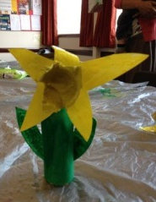  Create a junk model of a flower using different materials.
Dissect a flower (carefully with an adult), looking at what is on the inside of the flower.  (See ‘Plant resources’ for tips on how to do this and label the parts). | Find a weed and gently pull it up. Can you lay it on a piece of paper and label the different parts of the plant? Clue: flower, leaves, stem and roots. Take a picture or draw your plant with your labels. | Van Gogh- Sunflowers  https://www.bbc.co.uk/bitesize/clips/z8fgkqt  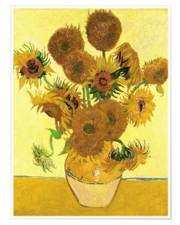  Can you recreate Van Gogh’s painting? Use any material you would like- paint, collage, colouring pencil, cake.  There is some information and sheets to help you in the ‘Plant resources’ in the 4A section under downloads.
What happens to a daisy if you put food colouring in its water?
What experiment could you design to answer this question? Write up your experiment- equipment, diagram, method and conclusion.
You could take pictures to help you write up your investigation.
Colouring a flowering plant game- Using a dice roll a number, then colour that corresponding number on the plant (see ‘Plant resources’) | Create a fact file/ powerpoint/ poster on the life cycle of a flowering plant. You may need to do some research to help you.  Can you include these words? Germination, roots, leaves, flowering, seed dispersal.  https://www.bbc.co.uk/bitesize/clips/zgqyrdm
Science- Plant topic activities
Science Plant Topic Activities

PE Activities

https://www.cosmickids.com/category/watch/- Cosmic Kids Yoga. These activities vary from under 10 minutes to over 15 minutes.
https://www.youtube.com/results?search_query=body+coach+kids- Tune in with Joe Wicks for some HITT sessions!
https://www.youtube.com/user/thebodycoach1 - Joe Wicks is also providing live workout, every morning at 9am, called "PE with Joe" on his YouTube channel The Body Coach TV.
https://www.cranwell.lincs.sch.uk/ Follow our school twitter feed on the school website or visit our twitter page, or Carre’s Grammar School Outreach support https://twitter.com/CranwellSchool, https://twitter.com/CGSOutreach for fun daily challenges and virtual competitions you can enter.

Additional Websites

These websites are offering free, fun and interactive resources to help learning at home.

Twinkl- https://www.twinkl.co.uk/resources/parents
Mrs Mactivity- You can claim a free resource pack by signing up with your email- https://www.mrsmactivity.co.uk/
White Rose Maths- This is the Maths scheme we follow in school. They have provided free, really helpful lessons online that include a short video showing you clearly and simply how to help your child to complete the activity-.https://whiterosemaths.com/homelearning/
Classroom Secrets- They have created fun, interactive and practical home learning packs to ensure all children can continue to learn- https://classroomsecrets.co.uk/
Teach Starter- They are offering a 1 month free membership and a collection of free home learning packs-https://www.teachstarter.com/
Newsround- Watch Newsround live at 9:15am, 12:10pm and 4:00pm for the latest news- https://www.bbc.co.uk/newsround

